Mars UP Church
Come Holy Spirit, Come
Before the Service – Speak to God!
During the Service – Let God speak to you!
After the Service – Speak to each other!

(*Please stand, if able)
Welcome and Mars Messages

Prelude

Apostles’ Creed
I believe in God the Father Almighty, Maker of heaven and earth; and in Jesus Christ His only Son our Lord; who was conceived by the Holy Ghost, born of the Virgin Mary, suffered under Pontius Pilate, was crucified, dead and buried; He descended into hell; the third day He rose again from the dead; He ascended into heaven, and sitteth on the right hand of God the Father Almighty; from thence He shall come to judge the quick and the dead. I believe in the Holy Ghost, the holy catholic church; the communion of saints; the forgiveness of sins; the resurrection of the body; and the life everlasting. Amen.

Gloria Patri
Glory be to the Father, and to the Son, and to the Holy Ghost. As it was in the beginning, is now and ever shall be,
world without end.
Amen. Amen.

The
Lord’s Prayer

Our Father,
who art in heaven,

hallowed be Thy
name,

Thy kingdom come,

Thy will be done,
on earth
as it is in heaven.

Give us this day
our daily bread;

and forgive us
our debts,
as we forgive
our debtors;

and lead us not
into temptation,
but deliver us
from evil.

For Thine
is the kingdom,
and the power,
and the glory,
forever. Amen.

The Doxology

Praise God
from whom
all blessings flow;
praise Him
all creatures
here below;
praise Him above,
ye heavenly host;
praise Father, Son,
and Holy Ghost.
Amen.

Pastoral Invocation

The Call to Worship
Leader: The Lord is my shepherd; I shall not want.
People: He makes me lie down in green pastures; he
leads me beside still waters; he restores my
soul.
Leader: He leads me in paths of righteousness for his
name’s sake.
People: Even though I walk through the valley of the
shadow of death, I fear no evil; for thou art
with me; thy rod and thy staff, they comfort
me.
Leader: Thou prepares a table before me in the presence
of my enemies; thou anointest my head with oil;
my cup overflows.
People: Surely goodness and mercy shall follow me all
the days of my life, and I shall dwell in the
house of the Lord forever.
All: Let all those assembled in the house of the Lord
worship him in Spirit and in Truth.

Hymn of Praise 21 (v. 1,2,3,5)
“O for a Thousand Tongues to Sing”

Apostles’ Creed
*Doxology
*Prayer for the Offering

*Distant Socializing (greet your fellow worshippers with a wave and a smile)

Children’s Chat

Choral Anthem Chancel Choir
"One Word, One Communion"

Sharing Joys and Concerns

Pastoral Prayer and Lord’s Prayer

Hymn of Praise 393
“Breathe on Me, Breath of God”

Prayer for Illumination

Scripture Ezekiel 37:1-14

Morning Message Pastor Karl Kennedy
“Any Dry Bones in the Valley?”

Prayer of Commitment
Celebration of the Lord’s Supper
Invitation to the Lord’s Table
Communion Hymn (seated) 390
“Spirit of God, Descend upon My Heart”
Great Prayer of Thanksgiving
The Lord be with you.
And also with you.
Lift up your hearts.
We lift them up to the Lord our God.
Let us give thanks to the Lord our God.
It is right to give our thanks and praise.
(prayer continues…)
…May we forever sing to the glory of your name…:
Hymn #3 “Holy, Holy, Holy” (verses 1 & 4, seated)
(…prayer concludes)
Words of the Institution
Breaking of the Bread
Pouring of the Cup
Communion of the People
Prayer after Communion

Hymn of Commitment 406
“Wonderful Words of Life”

*Benediction
*Congregational Response (Everyone sings)
The time has come, O Lord, for us to leave this place;
Guide us and protect us and lead us in Thy grace;
Wherever life may take us as we go our separate ways;
Help us share with others the things we’ve shared today;
May the peace of God the Father
And the love of Christ His Son
Guide us in the days ahead and strengthen us each one;
May the blessings of the Spirit fill us from within;
God bless us and return us to this fellowship once again. Amen.

Church Staff
Rev. Paul Aiello
Interim Pastor
pastor@mars-up.org
724-591-1849

Ms. Jamie Daugherty
Choir Director & Organist
JamieD0714@gmail.com

Mrs. Shelly Bocheff
Administrative Assistant
marsup@mars-up.org

AV TEAM
Alma Staskiewicz, Lisa Barbour, Marie Matthews, Bill Guesman, John Ivory, Keith Nichols, Mike Bocheff

Mars United Presbyterian Church

232 Crowe Ave
PO Box 805
Mars, Pennsylvania 16046
724-625-1365
www.mars-up.org
marsup@mars-up.org

Church Office Hours:
Mon -Thurs from 9 a.m. -2:30 p.m.

*Postlude

Flowers are presented today to the Glory of God and in loving memory of Ruth’s brother, Robert D. Keil by Jay and Ruth Wilson.

Morning Worship:
10:00 am

3rd Sunday of Lent

Prayer of Preparation
Come among us, living Lord, we come to hear your living Word.

We meet together in the name of Christ to share your mission and your sacrifice; to receive the power that only you can give, that we might live!

Come fill this time of silence with your presence. Amen.

Mars United Presbyterian Church
Welcome!

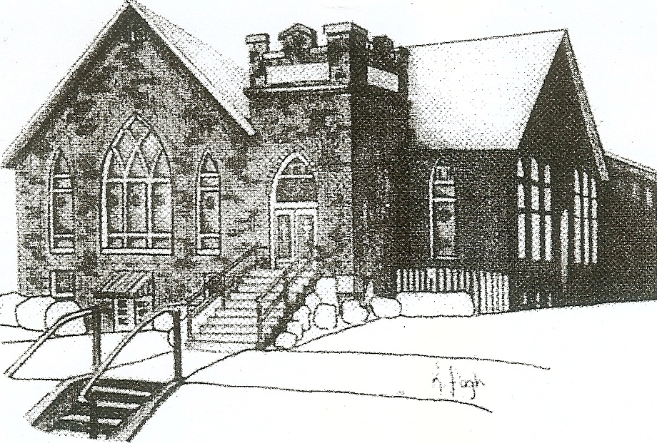
We are your hometown church: Faithful to Tradition, Loving in Fellowship, & Reaching for Tomorrow!

March 7, 2021

We welcome you and we are glad you’ve chosen to worship with us today!

CALENDAR: March 7th thru March 14th

Church Office Hours: Monday -Thursday from 9 a.m. – 2:30 p.m.

Today, March 7, 2021 Communion Sunday
VOLUNTEERS☺

LAST SUNDAY’S In-House ATTENDANCE: 38

LAST SUNDAY’S OFFERING:
Operating Funds: $2400.00
Mission: $10.00
Kindness: $30.00
Per Capita: $285.74
Total: $2725.74

9:00 a.m. The Sunday School Hour
10:00 a.m. THE MORNING WORSHIP SERVICE
11:00 p.m. Deacon Meeting
Monday, March 8, 2021
6:00 pm Griefshare
6:00 p.m. Cub Scouts
7:00 p.m. Greater Cranberry Chorus
7:30 p.m. Boy Scouts
Tuesday, March 9, 2021
9:00 a.m. A-Team
7:00 pm AA
Wednesday, March 10 2021
7:00 p.m. PNC Meeting
7:00 p.m. Chancel Choir Rehearsal
Thursday, March 11, 2021
Friday, March 12, 2021
Saturday, March 13, 2021
Sunday, March 14, 2021
9:00 a.m. The Sunday School Hour
10:00 a.m. THE MORNING WORSHIP SERVICE
Welcome to all who are Worshiping with us today!

Guests
We sincerely hope our service is a blessing to you. We ask that our guests please take a few minutes to complete one of the Connect Cards found in the pew holder.

Should you have questions regarding any aspect of our church, including membership, please contact the church office during the week at 724-625-1365. Thank you for being with us today.

PRAYER – JOYS & CONCERNS
Pat Jackson Kennedy (Great Granddaughter of Marlene Edwards
Lou Beckwith Paige Barbour (daughter of Andrew and Steph Barbour)
Reid Christopher Hall (June Stirling’s nephew) Maria Elizabeth McKaveney (June Stirling’s niece)
Cathy Loeffler(friend of Mary Ann Croop) Sue Morris
Diane (Kennedy) McDonald(Steve McDonald Daughter-in-law) Mary Ellen Grau

ANNOUNCEMENTS
Bulletins are printed Thursday mornings; let us know if you have an announcement…

THE QUIET HOUR The Spring Quiet Hour devotional booklets are in Tarry N Talk for your daily walk with God. The Quiet Hour Series will help your time of devotion become an important part of your day.
MARCH NEWSLETTER Hard copies of the MUP newsletter are in the Tarry N Talk. If you would like to receive the newsletter via email or mail, please contact the office.
EASTER FLOWER ORDER It is that time again for Easter Flowers! If you would like to order flowers to enhance the beauty of our church sanctuary, please fill out the enclosed order form and place in the offering. All orders must be placed by March 21, 2021. If you have any questions, please contact the office.
DEACON POTATO SOUP KINDNESS EVENT MUP Deacons will be making Potato Soup on March 17th as a fundraiser for the Deacon Kindness Fund. All orders will contain one quart of potato soup, crackers, and cookies. All pick-ups will be on Wednesday the 17th from 1:00pm until 3:00pm. All donations will go toward the Deacon Kindness fund. Please place order forms in the offering, give to a deacon member or the office.
ST. JOHN’S LUTHERAN CHURCH FOOD BANK
St. John would like to share in the announcement that this past weekend, our Board of Deacons introduced our new outreach food pantry. A box has been crafted to hold the food pantry items. The Box is accessible via the Pine Street parking lot near our side entrance. We invite anyone who is in need, to visit and take items they may need. For more information contact St. John’s Lutheran Church, 420 Beaver Street, Mars @ 724-625-1830
WALK 4 WATER SATURDAY, MARCH 20TH 10:00am to 11:00am
Adams Township Community Park, 698 Valencia Road
Rotary Clubs and Honduras Hope Mission are sponsoring this educational and fundraising event focused on providing safe drinking water to poor communities. Here’s a great opportunity for our church to get outside, get some healthy exercise, and learn about meeting the need for clean water. Register as an individual, family or group. Donations are not required. All masking and social distancing guidelines will be observed. Call Gary Weston at 724-816-0573 for further information.

