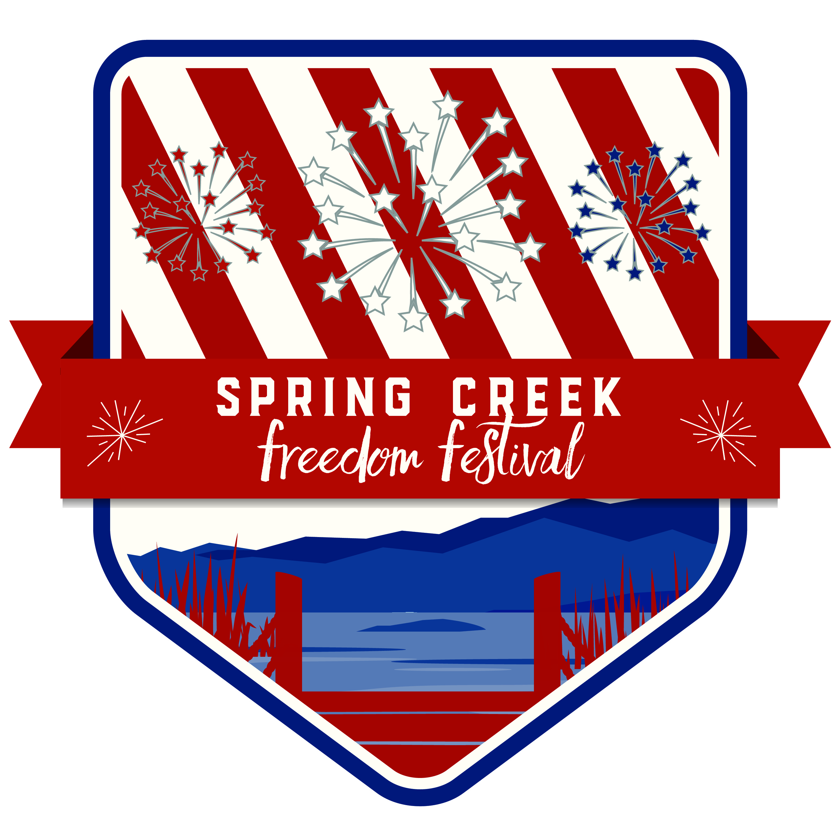
Spring Creek Freedom Festival Committee
401 Fairway Blvd.
Spring Creek, Nevada 89815
Phone: (775)753-6295
Fax: (775) 753-9539
Email: frontdesk@springcreeknv.org
mcromwell@springcreeknv.org

February 2019

The Spring Creek Freedom Festival Committee is seeking sponsorship for our 12th annual community event. Last year’s event was a huge success with hundreds of families attending. Participation in the activities increased with many people coming in from out of town. The Festival will include the following: a 5k fun run/walk, the parade, and marina activities which will include games, inflatables, home run derby, princess meet and greet, vendors, band, DJ, and the 14th annual Lake of Fire 4th of July Show to end the day.

Our goal is to raise $20,000 to cover all of these events including the fireworks. Posters advertising the event will be displayed throughout Spring Creek and Elko starting June 1st. The deadline for those wanting to be advertised on the poster will be Friday May 17. The benefits tier is as follows:

Level | Amount | Benefits
Bronze | $100 | Small spot on poster and booth space at Marina.
Silver | $250 | Medium spot on poster and booth space at Marina.
Gold | $500 | Large spot on poster, booth space at Marina, and a gift certificate to play 4 rounds of 18 holes of golf with cart at the Spring Creek Golf Course. A 4 x 4 banner with your business logo which will be displayed, at the Marina, during the event.
Platinum | $1000 | Extra large spot on poster, booth space at Marina, and a gift certificate to play 8 rounds of 18 holes of golf with cart at Spring Creek Golf Course. A 4 x 8 banner with your business name/logo which will be displayed, at the Marina, during the event. Mention in social media, website and radio advertising.

All sponsors will receive recognition in the local newspaper and on social media (Facebook and SCA web page). Sponsors are also invited to set up a display area, booth or concession at the Marina for this celebration.

The mission of the Spring Creek Freedom Festival is to celebrate Independence Day and inspire patriotism and to unite the community by inviting all to participate and enjoy. This year’s theme is “Let Freedom Ring” and the Festival will be held on Thursday, July 4th.

We hope we can count on you to sponsor this great event. Thank you for your time in considering this worthy cause. Please call if you have any questions or comments.

Sincerely,

Spring Creek Freedom Festival Committee

