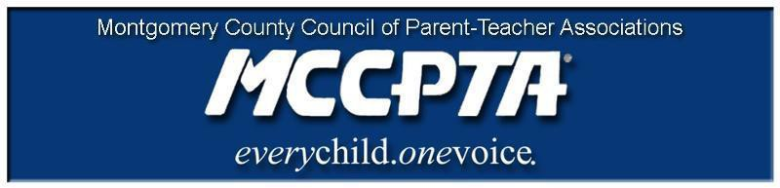

DELEGATES’ ASSEMBLY MEETING AGENDA
Tuesday, April 27, 2021
Meeting Held on Zoom

7:00 pm WELCOME

- Approve Agenda; Approve March/April minutes

7:05 pm INFORMATIONAL UPDATES

- National/MDPTA Update

7:15 pm NEW BUSINESS

- Election of MCCPTA Officers for 2021-2022
- Local Unit Elections FAQ
- Area Vice President/Cluster Coordinator Elections FAQ
- Training Needs Discussion
- MCCPTA Annual Report

8:00 pm OFFICER REPORTS

- Cynthia Simonson, President
- Rodney Peele, Vice President- Educational Issues
- Rochelle Fink, Vice President- Administration
- James Modrick, Vice President- Programs
- Laura Stewart, Vice President- Advocacy
- Khristy Kartsakalis, Treasurer
- All Reports - https://mccpta-my.sharepoint.com/:f:/g/personal/office_mccpta_org/EmhAFbgg6j5AnuPC8AhlfNwB6HuT3j2I_iygWmn5ZQyRug?e=5zskzZ

8:25 pm COMMITTEE REPORTS

- All Reports – https://mccpta-my.sharepoint.com/:f:/g/personal/office_mccpta_org/EmhAFbgg6j5AnuPC8AhlfNwB6HuT3j2I_iygWmn5ZQyRug?e=5zskzZ

8:45 pm OLD BUSINESS

8:55 pm ANNOUNCEMENTS & ADJOURNMENT

DATES:

- May 6, 2021– Gaithersburg Cluster Meeting
- May 27, 2021 – MCCPTA Celebration of Excellence, Virtual Event

