**St. Luke’s Episcopal Church**

**The Tenth Sunday after Pentecost**

**1 August 2021  10:00 A.M.**

**Holy Baptism & Eucharist**

The Reverend Michael L. Delk, *Celebrant & Preacher*

***Wearing a mask on the St. Luke's campus is no longer required if you are fully vaccinated. However, if you feel more comfortable wearing a mask and maintaining social distancing, please let the ushers know and they have reserved pews for distancing.***

**THE WORD OF GOD**

**Prelude “O Gott, du frommer Gott” J. S. Bach**

**(O God, you righteous God)**

**[ CONTINUE TO NEXT PAGE ]**

**Processional Hymn “I am the bread of life” Hymnal, 335**

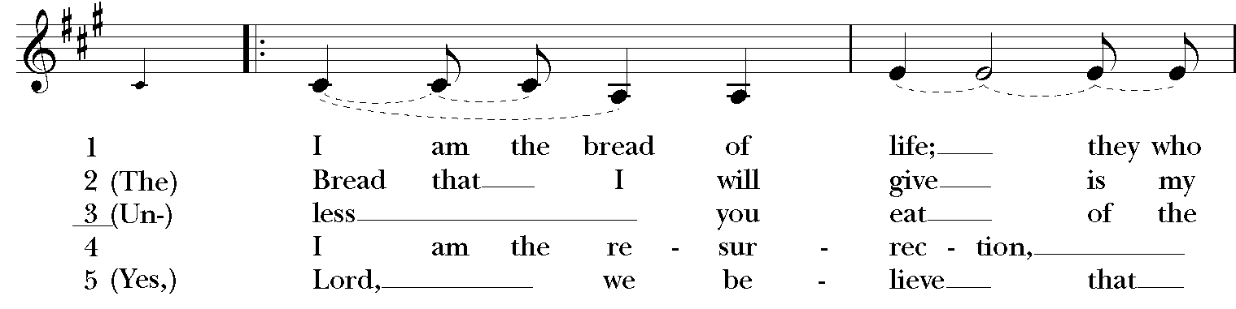

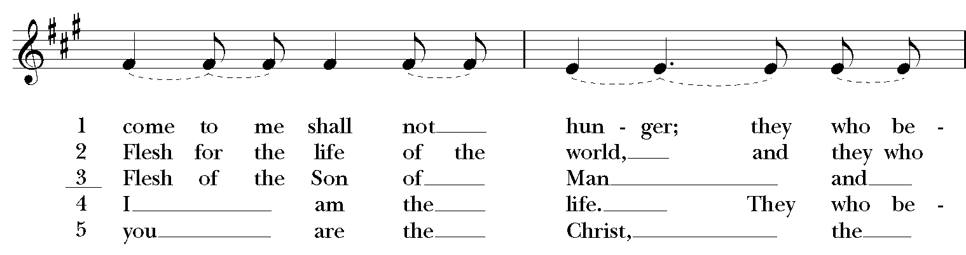

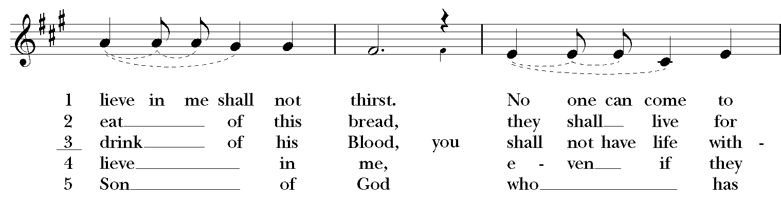

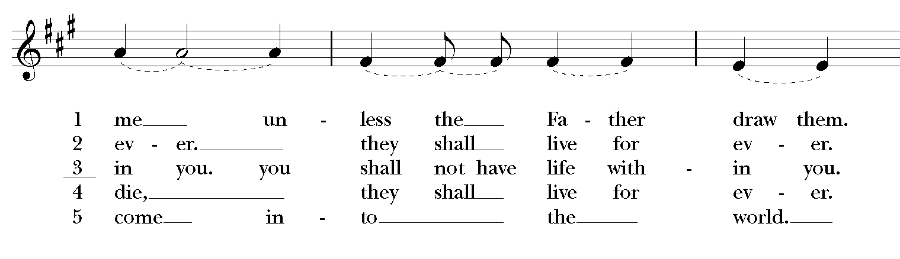

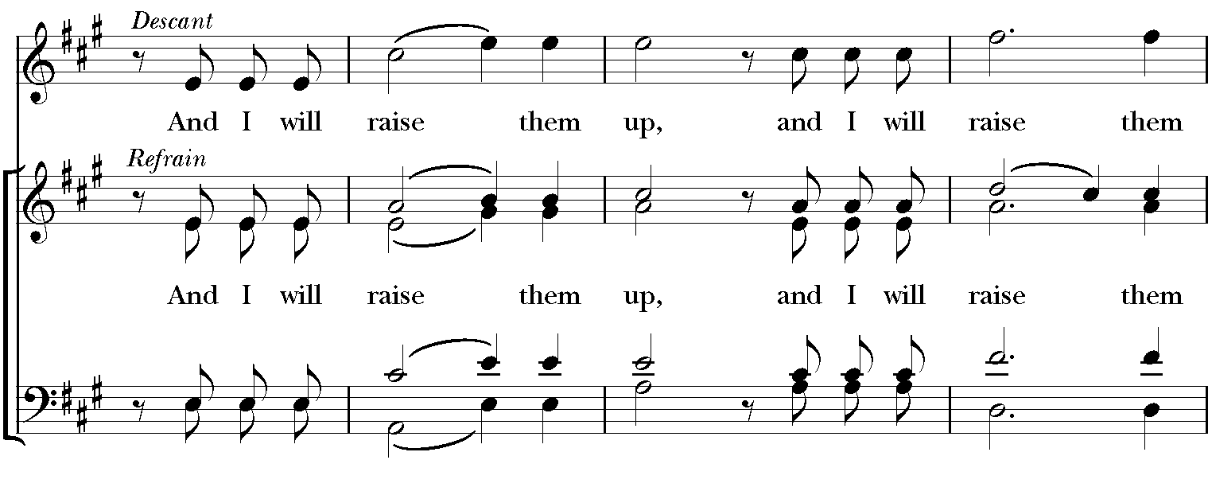

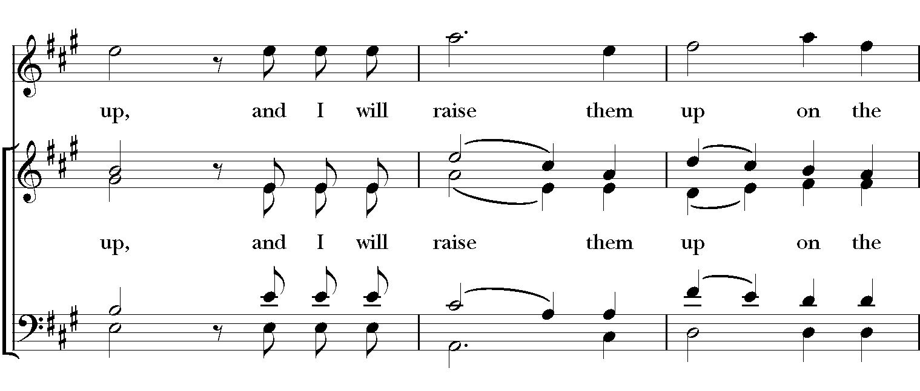

**[ CONTINUE TO NEXT PAGE ]**

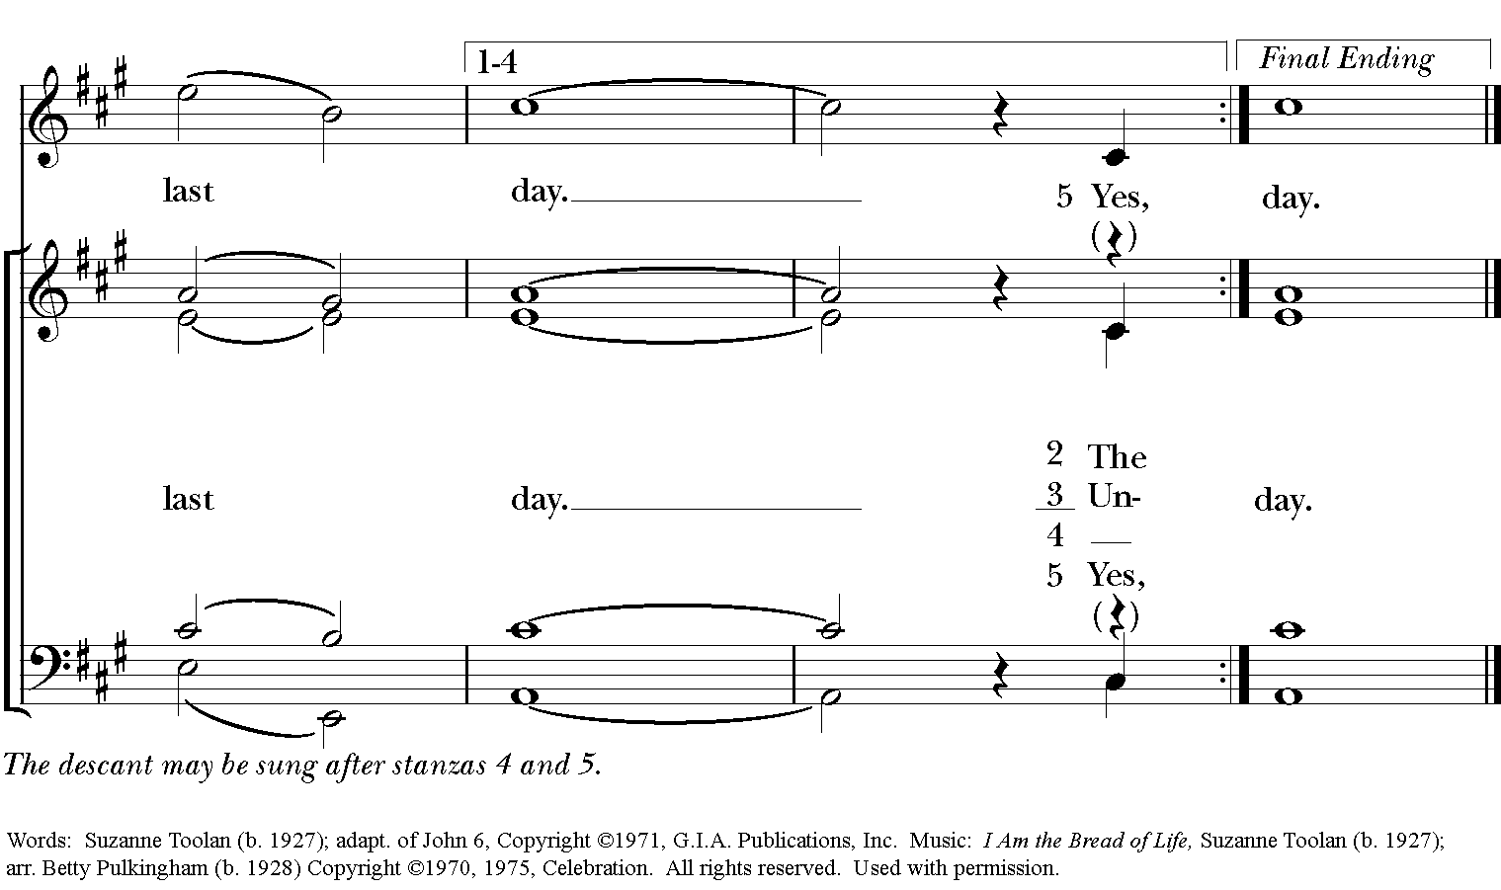

**The Opening Acclamation Page 355**

***Celebrant*** Alleluia. Christ is risen.

***People* The Lord is risen indeed. Alleluia.**

***Celebrant*** There is one Body and one Spirit;

***People* There is one hope in God’s call to us;**

***Celebrant*** One Lord, one Faith, one Baptism;

***People* One God and Father of all.**

**The Salutation & Collect of the Day Page 357**

***Celebrant*** The Lord be with you.

***People* And also with you.**

***Celebrant*** Let us pray.

Let your continual mercy, O Lord, cleanse and defend your Church; and, because it cannot continue in safety without your help, protect and govern it always by your goodness; through Jesus Christ our Lord, who lives and reigns with you and the Holy Spirit, one God, for ever and ever. ***Amen***

**The First Lesson II Samuel 11:26 – 12:13a**

When the wife of Uriah heard that her husband was dead, she made lamentation for him. When the mourning was over, David sent and brought her to his house, and she became his wife, and bore him a son. But the thing that David had done displeased the LORD, and the LORD sent Nathan to David. He came to him, and said to him, "There were two men in a certain city, the one rich and the other poor. The rich man had very many flocks and herds; but the poor man had nothing but one little ewe lamb, which he had bought. He brought it up, and it grew up with him and with his children; it used to eat of his meager fare, and drink from his cup, and lie in his bosom, and it was like a daughter to him. Now there came a traveler to the rich man, and he was loath to take one of his own flock or herd to prepare for the wayfarer who had come to him, but he took the poor man's lamb, and prepared that for the guest who had come to him." Then David's anger was greatly kindled against the man. He said to Nathan, "As the LORD lives, the man who has done this deserves to die; he shall restore the lamb fourfold, because he did this thing, and because he had no pity." Nathan said to David, "You are the man! Thus says the LORD, the God of Israel: I anointed you king over Israel, and I rescued you from the hand of Saul; I gave you your master's house, and your master's wives into your bosom, and gave you the house of Israel and of Judah; and if that had been too little, I would have added as much more. Why have you despised the word of the LORD, to do what is evil in his sight? You have struck down Uriah the Hittite with the sword, and have taken his wife to be your wife, and have killed him with the sword of the Ammonites. Now therefore the sword shall never depart from your house, for you have despised me, and have taken the wife of Uriah the Hittite to be your wife. Thus says the LORD: I will raise up trouble against you from within your own house; and I will take your wives before your eyes, and give them to your neighbor, and he shall lie with your wives in the sight of this very sun. For you did it secretly; but I will do this thing before all Israel, and before the sun." David said to Nathan, "I have sinned against the LORD."

The Word of the Lord.

***People* Thanks be to God.**

**Psalm 51:1-13 Anglican Chant**

1 Have mercy on me, O God, according to your lovingkindness;*

in your great compassion blot out my offenses.

2 Wash me through and through from my wickedness*

and cleanse me from my sin.

3 For I know my transgressions,*

and my sin is ever before me.

4 Against you only have I sinned*

and done what is evil in your sight.

5 And so you are justified when you speak*

and upright in your judgment.

6I Indeed, I have been wicked from my birth,*

a sinner from my mother’s womb.

7 For behold, you look for truth deep within me,*

and will make me understand wisdom secretly.

8 Purge me from my sin, and I shall be pure;*

wash me, and I shall be clean indeed.

9 Make me hear of joy and gladness,*

that the body you have broken may rejoice.

10 Hide your face from my sins*

and blot out all my iniquities.

11 Create in me a new heart, O God,*

and renew a right spirit within me.

12 Cast me not away from your presence*

and take not your holy Spirit from me.

13 Give me the joy of your saving help again*

and sustain me with your bountiful Spirit.

**The Second Lesson Ephesians 4:1-16**

I therefore, the prisoner in the Lord, beg you to lead a life worthy of the calling to which you have been called, with all humility and gentleness, with patience, bearing with one another in love, making every effort to maintain the unity of the Spirit in the bond of peace. There is one body and one Spirit, just as you were called to the one hope of your calling, one Lord, one faith, one baptism, one God and Father of all, who is above all and through all and in all. But each of us was given grace according to the measure of Christ's gift. Therefore it is said, "When he ascended on high he made captivity itself a captive; he gave gifts to his people." (When it says, "He ascended," what does it mean but that he had also descended into the lower parts of the earth? He who descended is the same one who ascended far above all the heavens, so that he might fill all things.) The gifts he gave were that some would be apostles, some prophets, some evangelists, some pastors and teachers, to equip the saints for the work of ministry, for building up the body of Christ, until all of us come to the unity of the faith and of the knowledge of the Son of God, to maturity, to the measure of the full stature of Christ. We must no longer be children, tossed to and fro and blown about by every wind of doctrine, by people's trickery, by their craftiness in deceitful scheming. But speaking the truth in love, we must grow up in every way into him who is the head, into Christ, from whom the whole body, joined and knit together by every ligament with which it is equipped, as each part is working properly, promotes the body's growth in building itself up in love.

The Word of the Lord.

***People* Thanks be to God.**

**The Sequence “We know that Christ is raised and dies no more” Hymnal, 296**

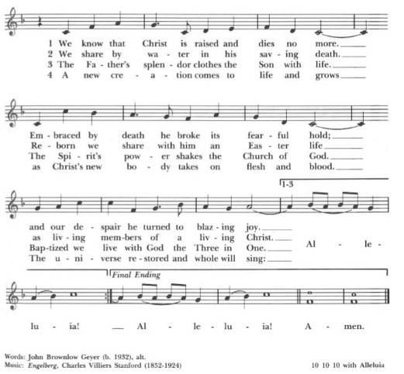

**The Holy Gospel John 6:24-35**

***The people remain standing. The Celebrant says***

The Holy Gospel of our Lord Jesus Christ according to John.

***People* Glory to you, Lord Christ.**

So when the crowd saw that neither Jesus nor his disciples were there, they themselves got into the boats and went to Capernaum looking for Jesus. When they found him on the other side of the sea, they said to him, "Rabbi, when did you come here?" Jesus answered them, "Very truly, I tell you, you are looking for me, not because you saw signs, but because you ate your fill of the loaves. Do not work for the food that perishes, but for the food that endures for eternal life, which the Son of Man will give you. For it is on him that God the Father has set his seal." Then they said to him, "What must we do to perform the works of God?" Jesus answered them, "This is the work of God, that you believe in him whom he has sent." So they said to him, "What sign are you going to give us then, so that we may see it and believe you? What work are you performing? Our ancestors ate the manna in the wilderness; as it is written, 'He gave them bread from heaven to eat.'" Then Jesus said to them, "Very truly, I tell you, it was not Moses who gave you the bread from heaven, but it is my Father who gives you the true bread from heaven. For the bread of God is that which comes down from heaven and gives life to the world." They said to him, "Sir, give us this bread always." Jesus said to them, "I am the bread of life. Whoever comes to me will never be hungry, and whoever believes in me will never be thirsty.

***After the reading, the Celebrant says***

The Gospel of the Lord.

***People* Praise to you, Lord Christ.**

**The Sermon**

## PRESENTATION AND EXAMINATION OF THE CANDIDATE

*The Celebrant says*

The Candidate for Holy Baptism will now be presented.

*Parents and Godparents*  
**I present N. to receive the Sacrament of Baptism.**

*When all have been presented the Celebrant asks the parents and godparents*Will you be responsible for seeing that the child you present is brought up in the Christian faith and life?

*Parents and Godparents*   
**I will, with God's help.**

*Celebrant*   
Will you by your prayers and witness help this child to grow into the full stature of Christ?

*Parents and Godparents*   
**I will, with God's help.**

*Question* Do you renounce Satan and all the spiritual forces of wickedness that rebel against God?   
*Answer* **I renounce them**.

*Question* Do you renounce the evil powers of this world which corrupt and destroy the creatures of God?   
*Answer* **I renounce them**.

*Question* Do you renounce all sinful desires that draw you from the love of God?   
*Answer* **I renounce them**.

*Question* Do you turn to Jesus Christ and accept him as your Savior?   
*Answer* **I do**.

*Question* Do you put your whole trust in his grace and love?   
*Answer* **I do**.

*Question* Do you promise to follow and obey him as your Lord?   
*Answer* **I do**.

*After all have been presented, the Celebrant addresses the congregation, saying*

Will you who witness these vows do all in your power to support *this person* in *her* life in Christ?   
*People* **We will.**

*The Celebrant then says these or similar words*   
Let us join with *those* who are committing *themselves* to Christ and renew our own baptismal covenant.

**THE BAPTISMAL COVENANT**

|  |  |  |
| --- | --- | --- |
| ***Celebrant*** | Do you believe in God the Father? | |
| ***People*** | **I believe in God, the Father almighty, creator of heaven and earth**. | |
| ***Celebrant*** | Do you believe in Jesus Christ, the Son of God? | |
| ***People*** | **I believe in Jesus Christ, his only Son, our Lord.**  **He was conceived by the Holy Spirit and born of the Virgin Mary.**  **He suffered under Pontius Pilate, was crucified, died, and was buried.**  **He descended to the dead.**  **On the third day he rose again.**  **He ascended into heaven, and is seated at the right hand of the Father.**  **He will come again to judge the living and the dead.** | |
| ***Celebrant*** | Do you believe in God the holy Spirit? | |
| ***People*** | **I believe in the Holy Spirit, the holy catholic Church, the communion**  **of saints, the forgiveness of sins, the resurrection of the body, and the life everlasting.** | |
| ***Celebrant*** | Will you continue in the apostles' teaching and fellowship, in the breaking of bread, and in the prayers? | |
| ***People*** | **I will, with God's help.** | |
| ***Celebrant*** | Will you persevere in resisting evil, and, whenever you fall into sin, repent and return to the Lord. | |
| ***People*** | **I will, with God's help.** | |
| ***Celebrant*** | Will you proclaim by word and example the Good News of God in Christ? |
| ***People*** | **I will, with God's help**. |
| ***Celebrant*** | Will you seek and serve Christ in all persons, loving your neighbor as yourself? |
| ***People*** | **I will, with God's help**. |
| ***Celebrant*** | Will you strive for justice and peace among all people, and respect the dignity of every human being? |
| ***People*** | **I will, with God's help**. |

**Prayers for the Candidates**

*The Celebrant then says to the congregation*  
Let us now pray for *this person* who are to receive the Sacrament of new birth.

*A Person appointed leads the following petitions*

|  |  |
| --- | --- |
| *Leader* | Deliver her, O Lord, from the way of sin and death. |
| *People* | **Lord, hear our prayer**. |
| *Leader* | Open her *heart* to your grace and truth. |
| *People* | **Lord, hear our prayer.** |
| *Leader* | Fill *her* with your holy and life-giving Spirit. |
| *People* | **Lord, hear our prayer**. |
| *Leader* | Keep her in the faith and communion of your holy Church. |
| *People* | **Lord, hear our prayer**. |
| *Leader* | Teach her to love others in the power of the Spirit. |
| *People* | **Lord, hear our prayer**. |
| *Leader* | Send her into the world in witness to your love. |
| *People* | **Lord, hear our prayer**. |
| *Leader* | Bring her to the fullness of your peace and glory. |
| *People* | **Lord, hear our prayer**. |

*The Celebrant says*   
Grant, O Lord, that all who are baptized into the death of Jesus Christ your Son may live in the power of his resurrection and look for him to come again in glory; who lives and reigns now and forever. ***Amen****.*

**Thanksgiving over the Water**

***Celebrant*** The Lord be with you.

***People*****And also with you.**

***Celebrant*** Let us give thanks to the Lord our God.

***People*****It is right to give him thanks and praise.**

*When all have been baptized, the Celebrant says*  
Let us welcome the newly baptized.

*Celebrant and People*   
**We receive you into the household of God. Confess the faith of Christ crucified, proclaim his resurrection, and share with us in his eternal priesthood.**

**The Peace**

***Celebrant*** The peace of the Lord be always with you.

***People* And also with you.**

**Prayers for Healing**

**Birthday and Anniversary Prayers**

**THE HOLY COMMUNION**

**Offertory Sentence**

**Offertory Anthem “Create in me, O God” Johannes Brahms**

**[ CONTINUE TO NEXT PAGE ]**

**Presentation Hymn “From all that dwell below the skies” Hymnal, 380**

**(vs. 3)**

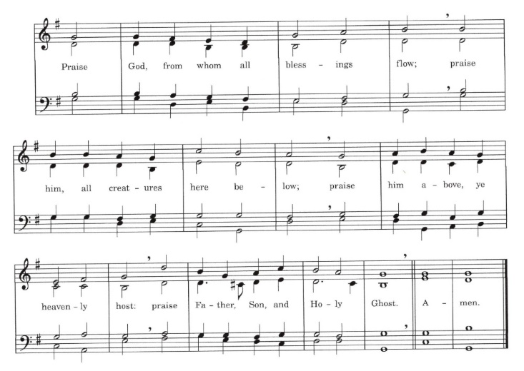

**[ CONTINUE TO NEXT PAGE ]**

**The Great Thanksgiving: Eucharistic Prayer A Page 361**

*S120a*

*Celebrant* It is right and a good and joyful thing, always and everywhere to give thanks to you, Father Almighty, Creator of heaven and earth.

*Here the Celebrant adds a Proper Preface*

Therefore we praise you, joining our voices with Angels and Archangels and with all the company of heaven, who for ever sing this hymn to proclaim the glory of your Name.

*Celebrant and people*

**Sanctus: S-125 in the Hymnal 1982**

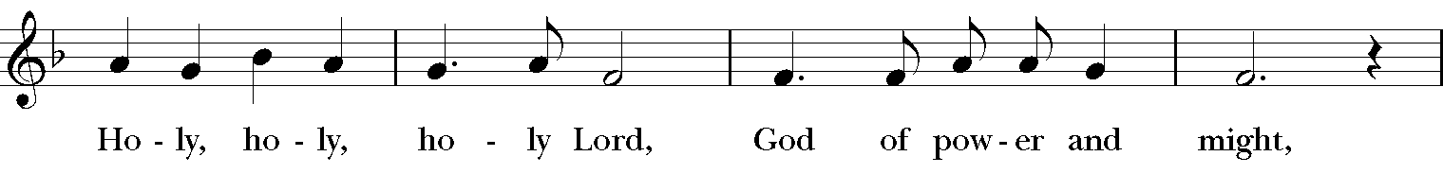

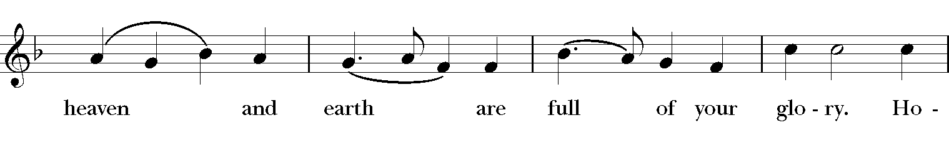

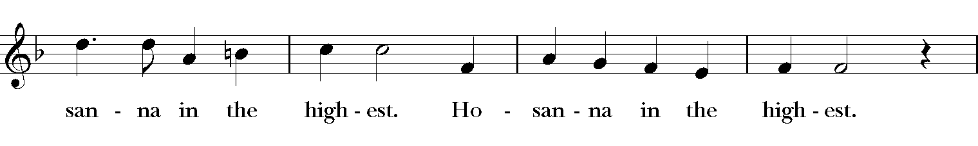

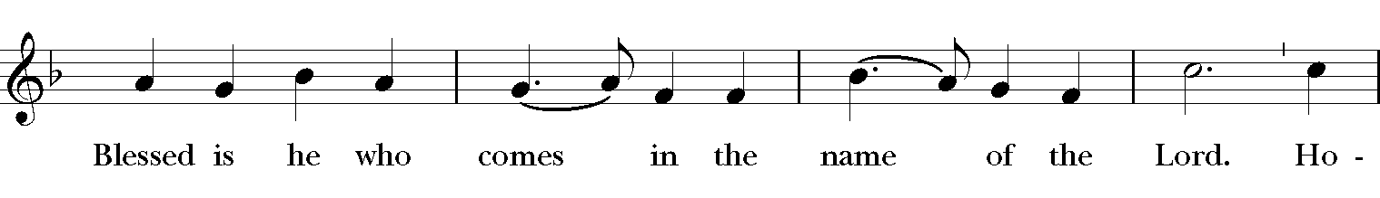

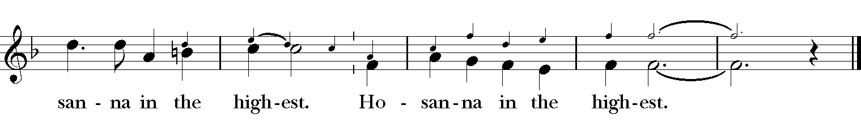

*The Celebrant continues*

Holy and gracious Father: In your infinite love you made us for yourself; and, when we had fallen into sin and become subject to evil and death, you, in your mercy, sent Jesus Christ, your only and eternal Son, to share our human nature, to live and die as one of us, to reconcile us to you, the God and Father of all. He stretched out his arms upon the cross, and offered himself, in obedience to your will, a perfect sacrifice for the whole world.

On the night he was handed over to suffering and death, our Lord Jesus Christ took bread; and when he had given thanks to you, he broke it, and gave it to his disciples, and said, “Take, eat: This is my Body, which is given for you. Do this for the remembrance of me.”

After supper he took the cup of wine; and when he had given thanks, he gave it to them, and said, “Drink this, all of you: This is my Blood of the new Covenant, which is shed for you and for many for the forgiveness of sins. Whenever you drink it, do this for the remembrance of me.”

Therefore we proclaim the mystery of faith:

**People Christ has died.**

**Christ is risen.**

**Christ will come again.**

*The Celebrant continues*

We celebrate the memorial of our redemption, O Father, in this sacrifice of praise and thanksgiving. Recalling his death, resurrection, and ascension, we offer you these gifts.

Sanctify them by your Holy Spirit to be for your people the Body and Blood of your Son, the holy food and drink of new and unending life in him. Sanctify us also that we may faithfully receive this holy Sacrament, and serve you in unity, constancy, and peace; and at the last day, bring us with all your saints into the joy of your eternal kingdom.

All this we ask through your Son Jesus Christ. By him, and with him, and in him, in the unity of the Holy Spirit all honor and glory is yours, Almighty Father, now and for ever. **AMEN**.

**The Lord’s Prayer**

**Our Father, who art in heaven, hallowed be Thy Name. Thy kingdom come, Thy will be done, on Earth as it is in heaven. Give us this day our daily bread, and forgive us our trespasses, as we forgive those who trespass against us, and lead us not into temptation, but deliver us from evil, for thine is the kingdom and the power and the glory, for ever and ever. Amen.**

**The Breaking of the Bread**

A period of silence is kept.

**The Fraction Anthem: S-151**

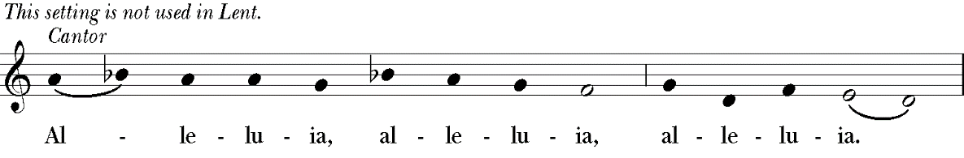

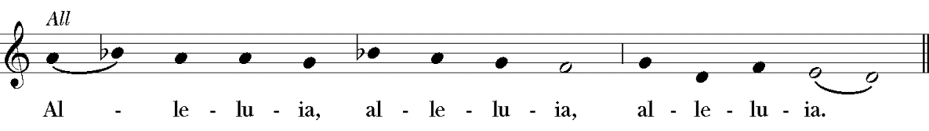

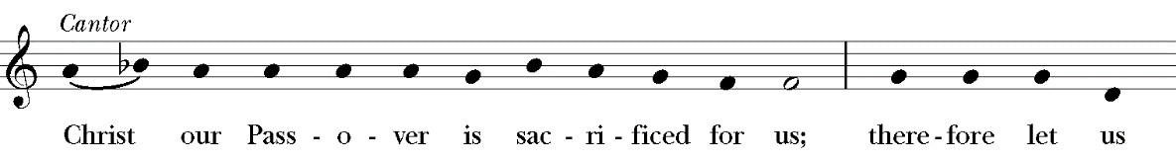

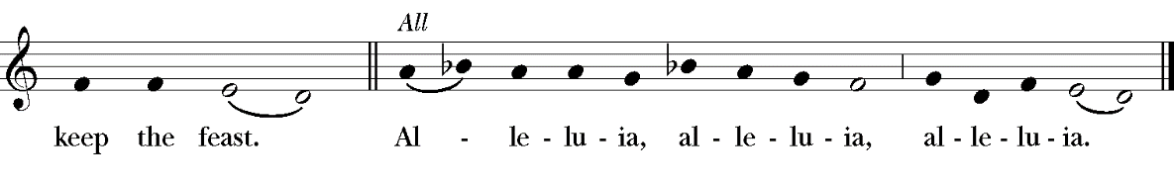

**Communion Anthem “Lord, for thy tender mercy’s sake” Richard Farrant**

*After Communion, the Celebrant says*

Let us pray.

*Celebrant and People*

**Eternal God, heavenly Father, you have graciously accepted us as living members of your Son our Savior Jesus Christ, and you have fed us with spiritual food in the Sacrament of his Body and Blood. Send us now into the world in peace, and grant us strength and courage to love and serve you with gladness and singleness of heart; through Christ our Lord. Amen.**

**Sending Forth of Lay Eucharistic Ministers**

***Celebrant*** In the name of God and of St. Luke’s, we send you forth bearing these holy gifts, that those to whom you go may share with us in the communion of Christ’s Body and Blood.

***People* We who are many are one body, because we all share one bread, one cup.**

**The Blessing**

**[ CONTINUE TO NEXT PAGE ]**

**Recessional Hymn “Jesus, lover of my soul” Hymnal, 699**

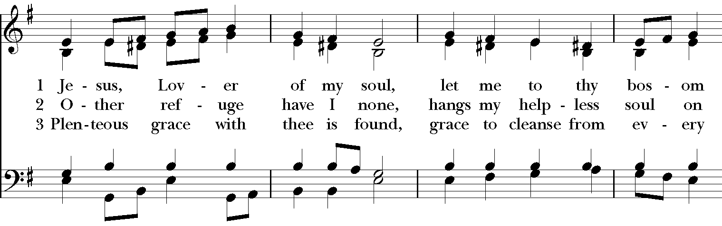

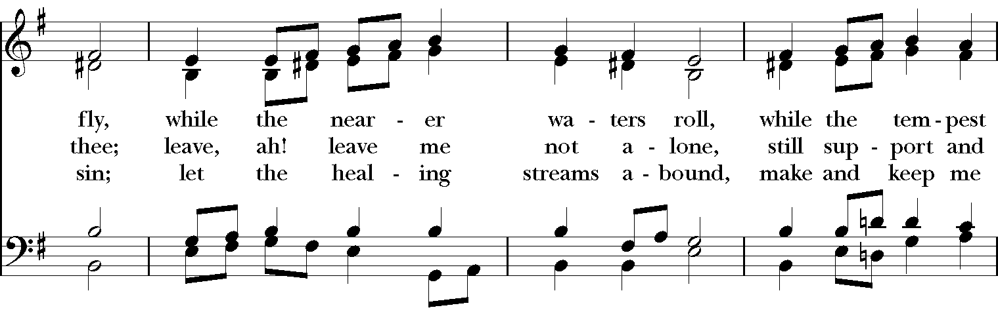

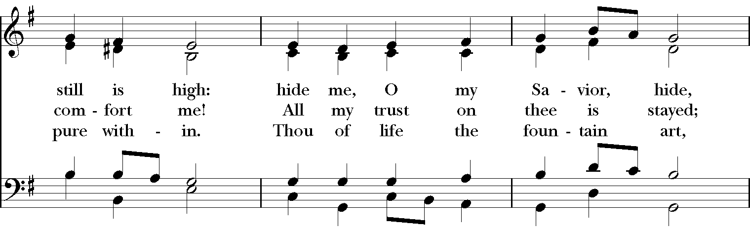

**[ CONTINUE TO NEXT PAGE ]**

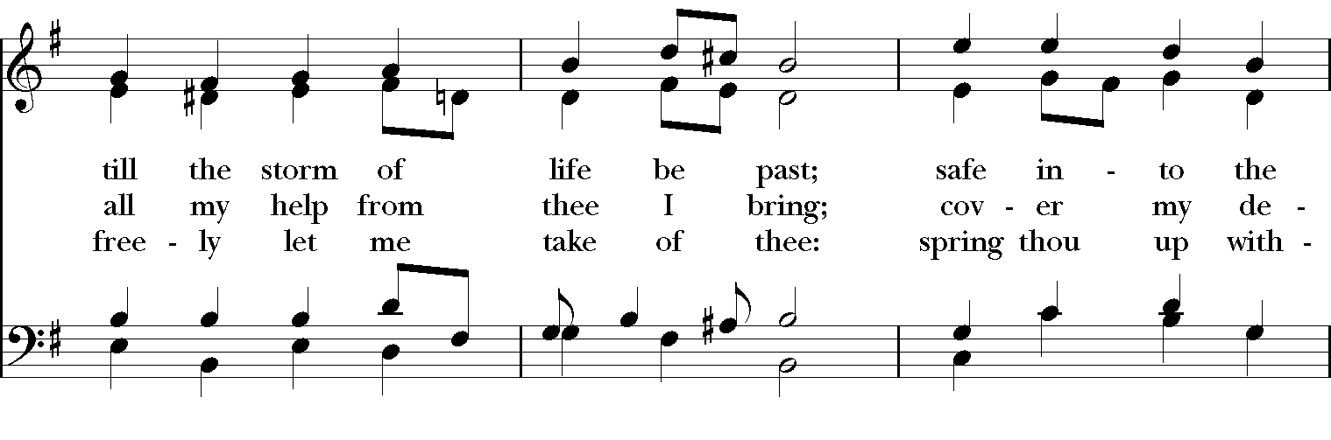

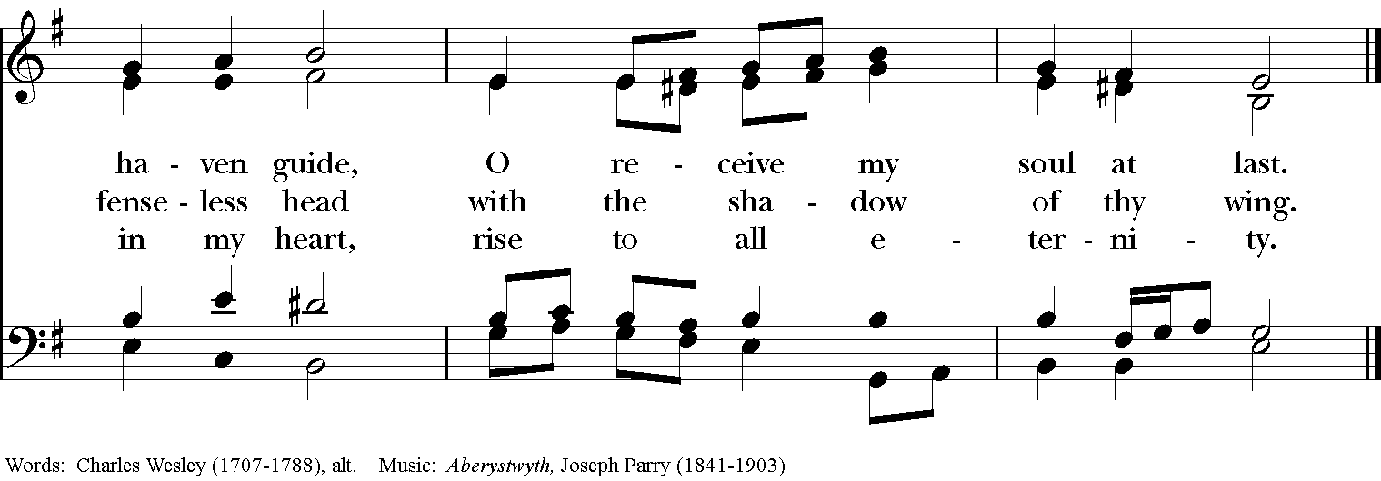

***Please remain in your pew to enjoy the Postlude.***

***We are so grateful you have joined us today and look forward***

***to gathering again very soon.***

**Postlude “Prelude on ‘Aberystwyth’” Healey Willan**

**The Dismissal**

***People* Thanks be to God.**

Permission to reprint, podcast, and/or stream the music in the service obtained from ONE LICENSE # A-736775. All rights reserved.

To Give, go to

**https://www.stlukesanchorage.org/giving.html**

**ANNOUNCEMENTS**

*Here at St. Luke’s, we welcome everyone to participate in everything freely, member or non-member. If you are a visitor, please fill out one of the visitor cards and place it in the offering plate. If you would like to become an official member of our parish family, please call our office, 245-8827, or speak with Father Michael.*

**Organ Recital**

Mark your calendars for our next in person organ recital on the Martin Pasi organ, Opus 22 at St. Luke’s Episcopal Church. This recital will also be livestreamed on St. Luke’s Facebook page.

*August 15 at 3:30* : Dr. Steven E. Plank, Andrew B. Meldrum Professor of Musicology, Director, Division of Musicology and Director, Collegium Musicum at Oberlin Conservatory of Music, Oberlin, Ohio. Works by Heinrich Scheidemann, Samuel Scheidt and Jan Pieterszoon Sweelinck.

**Wednesday AM Bible Study**

The Wednesday morning 9:45 am bible study meets in person in the **LYMAN HOUSE**. You can join this lay-led discussion of the core stories of our faith **either in person or on Zoom** every Wednesday at 9:45. We are currently using The Path, a Bible Study published by Forward Movement, as a guide among other sources. It is not necessary to have a copy of The Path to participate. Just bring your Bible.

**Contemporary Anglican Saints**

We meet in person on the church campus in the Dudley House (the house attached to the back side of Board Hall) as we continue to broadcast on Zoom for those who do not or cannot come in person, to create a Hybrid class.

The British Isles and the greater Anglican Communion has been the home and origin of many great saints. These saints are people with fascinating stories, and great impact on global Christianity. Please join us as we learn about these saints and discuss their influence and ideas. For more information, email Dave Kirchinger at [**episcopaliandave@gmail.com**](mailto:episcopaliandave@gmail.com).

The link to the class is: [**https://us02web.zoom.us/j/85144530030**](https://us02web.zoom.us/j/85144530030) / Meeting ID: **851 4453 0030**

If prompted to enter a password, please enter our parish office phone number - 2458827

**Centering Prayer**

Centering Prayer has changed to every **FIRST** and **THIRD** Tuesday. Join us on **August 3 & 17 from 6 – 7pm** in the Lyman Office.

**Birthdays & Anniversaries**

**If you've had a birthday or anniversary over the past several weeks, or have one coming up in the weeks ahead,** please let Dawn know, [admin@stlukesanchorage.org](mailto:admin@stlukesanchorage.org).  Let her know your birthday, or the date of your wedding anniversary and how many years you've been married, and we will offer a blessing over you during our recorded worship.

VPOD: Shaun McEntire / Lay Readers: Marc Harris, Geoffrey Durham-Smith / Chalice Bearers: Peter Finnis, Geoffrey Durham-Smith / Audio: Jacob Anderson.

***The Flowers on the Altar*** are given by Wave & Brenda Townes in loving memory of his mother, Anne Theweatt Townes, who passed on 8/1/20 at 101 years old.

In our prayers ... for **Al, Allen, Amy, Ann, Annie, Barbara, Beecher, Bethann, Beverly, Bill, Braden, Bud, Carol, Chris, Christy, Danny, Darla, Dave, David, Diana, Dorothy, Doug, E.J., Eleanor, Elizabeth, Erma, Gene, Helga, Hugh, Ira, Jen, Jenni, Jerry, Jewell, Jim, Joan, Joe, John, Joyce, Karen, Kathy, Kelly, Ken, Laura, Lauren, Lee, Linda, Lisette, Liz, Lynn, Martha, Mary, MaryBeth, Matt, Meg, Mike, Milo, Monica, Morgan, Nancy, Nelson, Nina (Nine-ah), Patricia, Rob, Ronald, Rueben, Sandy, Stefanie, Steve, Sue, Susan, Susie, Terry, Tim, Tracy, Trent, Ursula, Vicki, Walt, Whitney, Wynn, and the Regneri family;** and our men and women serving in our armed forces and their families. We offer prayers of blessing and thanksgiving for all men and women serving in the armed services, especially these persons known to us: **Alex, Casey, Christian, Griffin, Pat, Seth, Trey**. We pray that they have safe journeys and know the loving concern of friends and family. May God watch over them and grant them strength and courage to face perils which beset them.

**Readings for:**

**August 8: II Samuel 18:5-9, 15, 31-33; Psalm 130;**

**Pentecost 11 Ephesians 4:15 – 5:2; John 6:35, 41-51.**

**ST. LUKE’S EPISCOPAL CHURCH**

**DIOCESE OF KENTUCKY**

The Right Reverend Terry Allen White, *Bishop*

STAFF

The Reverend Michael L. Delk, *Rector*

The Reverend Dru Kemp, *Deacon*

The Reverend Art Chard, *Priest Associate*

Lisa Lewis, *Minister of Music*

Brench Boden, *Parish Composer*

Judy Chard*, Bookkeeper*

Dawn White, *Parish Administrator*

William Tsueda, *Sexton*

**St. Luke’s Vestry Members**

Term Expires 2022 Term Expires 2023 Term Expires 2024

Walt Anderson Fofo Johnson Jane Casada

Priscilla Bond* John F. Ridoux** Caroline Eddleman

Lynn Cline Barbara Staats Bob LaMontagne

Shaun McEntire Nelson Toebbe Doug Sanders

**\*** Senior Warden; **\*\*** Junior Warden

The Vestry Person On Duty (**VPOD**) has the responsibility for assisting the Rector with

welcoming newcomers and closing the church after worship has concluded.

St. Luke’s Episcopal Church

1206 Maple Lane

Anchorage, KY 40223

SERVICE TIMES

Saturday: 5:30pm (Rite II); Sunday: 8am (Rite I) & Sunday: 10am (Rite II)

OFFICE HOURS

Office Staff are currently working from home.

Call to arrange an appointment.

Phone: 502-245-8827 Fax: 502-245-5595

Email: [admin@stlukesanchorage.org](mailto:admin@stlukesanchorage.org)

[www.stlukesanchorage.org](http://www.stlukesanchorage.org)