2/7/2016

There are 7 events that all point to 6/5/2016. The 7th event is North Korea testing a nuclear device on 2/11/2013. This fact falls in line with the context of the rest of the information revealed in the series, and helps to confirm it. This 7th event was revealed to me the evening of 2/7/2016, and is timely information since North Korea launched a long range missile on 2/7/2016 that may be capable of delivering a nuclear weapon to the United States.

The explanation in items 5 & 6 may be hard to understand. The time of day has to be figured into the calculations to arrive at the dates involved because different countries are located in different time zones other than UT. There is also the fact that the Hebrew day changes at sunset while the Roman day changes at midnight that must be considered in point 5 concerning the Day of Trumpets.

7 Pointers to 6/5/2016
1. Author Drew Simmons
6/5/2016 is also the day that author Drew Simmons has settled on for the nuclear destruction of America in his book "Quenched Like a Wick".
2. The Four Tavs
6/5/2016 is also the day pointed to by the inner 2 Tavs of the 4 Tav solar eclipse sequence noted on this page. The central theme of the inner 2 Tav eclipses is Russia and the United States, the global nuclear superpowers.
3. Ramadan
Muslim Ramadan also begins 6/5/2016 at sunset in Mecca. "Ramadan" comes from a root word that means "scorching heat".
4. Israel Six Day War
6/5/2016 is the end of 49 years from the beginning of the Israeli Six Days War in 1967, and the very 1st day of a 50th (Jubilee, year of return to the land) year.
5. Pope Benedict
6/5/2016 is the center date of a "Hidden Tav" involving Pope Benedict who resigned from office on 2/11/2013. The length of each of the 4 astronomical solar eclipse Tavs is 2422 days. Each midpoint is at the 1211th day. If we measure 2422 days from 2/11/2013 we arrive at the Day of Trumpets 9/29/2019 after sunset at 11:10 PM UT. The Hebrew day 9/30/2019, the Day of Trumpets, starts at sunset on Roman calendar 9/29. This is case where one day can be a different day depending upon the time of day and the cultures involved. The exact midpoint of the Hidden Tav is 6/5/2016, at 11:10 PM UT, 1211 days from 2/11/2013 when Pope Benedict resigned.
6. The Modern Olympics, Symbolic of the Ancient Nephilim
The exact center of the 121 day period, with the time of day figured in, from 4/6/2016 to 8/5/2016 is 6/5/2016 at 11 PM (23:00) UT. This is a bit uncanny because the exact center of the lunar eclipses on 12/10/2011 and 4/15/2014 with the time figured in is 6/5/2016 at 11:10 PM (23:10) UT, 10 minutes later. Also, it may look like 2/11/2013 + 1211 days = 6/6/2016, but in reality the center date of the Lunar eclipses is 2/10/2013 at 23:10 UT, which is 2/11/2013 at 12:10 AM local time in Italy. When the times are figured in, the day is 2/11/2013 in North Korea and Italy while the day is still 2/10/2013 in England at the lunar eclipse midpoints. So it's necessary to figure in the times to the minute just to arrive at the proper dates because of time zones.

The Modern Olympics
The modern Olympics began on 4/6/1896. According to the Septuagint, 120 years were allotted to "these men", in context in Genesis 6:1-5 meaning the Nephilim, by YaHuWaH Elohim in the days of Noah.
The modern Olympics were symbolic of the return of the Nephilim of Noah's flood.
The 120 years of the modern Olympics, symbolic of the ancient Nephilim, would terminate on 4/6/2016.
Precisely on 4/6/2016 the crescent moon will pass between the earth and Venus, causing the Islamic sign of the crescent moon and star to be visible only in Rio de Janeiro and the surrounding region. Because of the motions of the moon and Venus, the occultation of Venus by the moon will NOT appear to produce the Islamic sign in Europe and Asia.
In Rio de Janeiro, where the Olympics will be held this summer, the Islamic crescent moon and "star" sign in the sky will be visible before sunrise on 4/6/2016.
121 days after 4/6/2016, on 8/5/2016 the Brazil Olympics will begin. This 121 day period is mindful of the end of 120 complete years from 1896 to 2016, and the beginning of the 1st day of the 121st year on 4/6/2016.

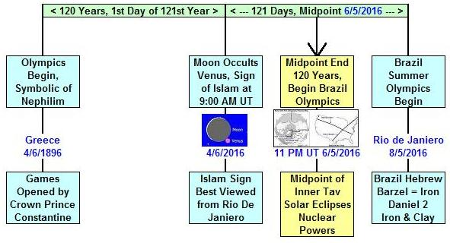

This information regarding the Olympics was revealed on 2/5/2016. 6/5/2016 is just 121 days from 2/5/2016. The midpoint from 2/5/2016 to 6/5/2016 is 4/6/2016, a date listed on the graphic above. The precise timing is a 60.6 days, or 2 months interval, between 2/5/2016 and each of the dates on the graphic above. So the date this information was revealed, 2/5/2016, could be placed on the graphic above and it would synchronize perfectly with it.

On 11/29/2014 I received the thought to investigate the center dates of the outer Tav eclipses. The center date is 11/29/2016, exactly 2 years to the day from when I was given the information on 11/29/2014.

It appears that YaHuWaH Elohim is precisely timing the revelation of this information.

7. The North Korea Nuclear Test
North Korea tested an atomic device on 2/11/2013, the same day that Pope Benedict resigned from office and lightning struck the Vatican.

It appears that YaHuWaH Elohim continues to precisely time the revelation of this information since a North Korea missile test occurred on 2/7/2016, the day the North Korean nuclear test of 2/11/2013 was revealed to me.

There are plenty of nails in this coffin. I hope nothing happens, but we are deserving of judgment, and be assured it will definitely come at some time.

The graphics are also available on this page: http://www.joybysurprise.com/Graphics.html

