Saturday/Sunday,

April 26 & 27, 2025

Second Sunday After Easter

*Christ Lutheran Church*

**“A Place Where You are Always Welcome”**

**Services: Saturday 5:30 pm and Sunday 10:00 am**

**Sunday School: 9:00 am (September- May)**

600 North Main Street, Stockton, IL   61085 Office: 815-947-2033

Email:christlutheranchurch70@gmail.com http://www.christlutheranstockton.com

**Ministers:** **ALL members of the congregation**

***Pastor: Rev. Chrissy Salser*** [***chrissytherev@att.net***](mailto:chrissytherev@att.net) ***815-988-9450***

From Sundays and Seasons.com. Copyright 2017 Augsburg Fortress. All rights reserved. Reprinted by permission under Augsburg Fortress Liturgies Annual License #40643.New Revised Standard Version Bible, copyright 1989, Division of Christian Education of the National Council of the Churches of Christ in the United States of America. Used by permission. All rights reserved.

***WELCOME:*** *Thank you for joining us for worship today. We are glad you are with us. Communion will be served in the aisle or in your pew. All are welcome to share this meal. Jesus is our host and invites everyone. Those who would like to come forward, bread and wine will also be available in the front. When directed by the usher, come forward down the center aisle, Pr Chrissy will give you bread (she will be masked and wearing cloves) and then you will take a cup of wine (grape juice) from the tray. After taking communion, you will return to your seat by the side aisle.* *For those who are unable to come forward, communion elements can be found as you entered worship. At that part of the service, you are invited to take the bread and wine (or grape juice) when Pr. Chrissy leads. On Saturdays offering is collected as you enter or leave worship. On Sunday we will pass the plate as a response to God’s grace. Online giving is available. Please see QR code on back of bulletin or visit our website.*

### Introduction: In spite of all we have heard and all we have seen, it is often hard to believe. Because it is hard to believe, we will invest ourselves in the Easter mystery for fifty days (a week of weeks). Because it is hard to believe, John the evangelist will provide sign after sign celebrating Jesus’ victory over death. Because it is hard to believe, the risen Jesus will return to us again and again in the mystery of holy communion, inviting us to touch and taste his presence, and offering us his peace.

**Gathering:** *The Holy Spirit calls us together as the people of God.*

**PRELUDE**

**WELCOME AND ANNOUNCEMENTS**

🕇**EASTER THANKSGIVING FOR BAPTISM** (*please stand if you are able*)

P: Christ is risen. **C: Christ is risen indeed. Alleluia!**

P: Blessed be God, the one who promises salvation, Blessed be Jesus the Christ, the one who provides salvation, Blessed be the Holy Spirit, the one who inspires salvation.

Blessed be the Holy Trinity, + One God, who saves us all.   **C: Amen.**

P: People of God, in the baptismal waters we travel with Christ from death to life. Our past, our sin, our failure, our doubt, and our shame are drowned and gone here.

**C: You, O God, wash us clean.**

P: Our fear, our confusion, our self-righteousness, our despair—ALL are washed away by grace.  **C: You, O God, wash us clean.**

P: Our pride, our hypocrisy, and other people’s opinions of us no longer have the power to define us.  **C: You, O God, give us new life.**

P: The Spirit lives and moves through us now, a great and joyful mystery, so we may bring love and mercy into the world as the body of Christ.

**C: You, O God, give us new life.**

P: Rejoice that God has claimed us in this baptismal grace, not by our own doing or believing but by God’s mercy alone.   **C: You, O God, give us new life.**

P: And so, as we worship, we give thanks to God for the gracious gift of baptism that joins us together in Christ by the Spirit’s power.  **C: Amen**

🕇**GATHERING HYMN** **Arise Your Light has Come ELW 314**

🕇**Greeting:**

P: The grace of our Lord Jesus Christ, the love of God, and the communion of the Holy Spirit be with you all. **C. And also with you.**

🕇**PRAYER OF THE DAY**

P: O God of life, **C: you reach out to us amid our fears with the wounded hands of your risen Son. By your Spirit’s breath revive our faith in your mercy and strengthen us to be the body of your Son, Jesus Christ, our Savior and Lord, who lives and reigns with you and the Holy Spirit, one God, now and forever. Amen**

***Word:*** *God speaks to us in scripture reading, preaching, and song.*

### First Reading: Acts 5:27-32

*Peter has been arrested for proclaiming the good news of Jesus’ death and resurrection. His response to the charges of the high priest summarizes the early church’s proclamation of forgiveness of sin through repentance.*

27 When they had brought [the apostles,] they had them stand before the council. The high priest questioned them, 28 saying, “We gave you strict orders not to teach in this name, yet here you have filled Jerusalem with your teaching and you are determined to bring this man’s blood on us.” 29 But Peter and the apostles answered, “We must obey God rather than any human authority. 30 The God of our ancestors raised up Jesus, whom you had killed by hanging him on a tree. 31 God exalted him at his right hand as Leader and Savior that he might give repentance to Israel and forgiveness of sins. 32 And we are witnesses to these things, and so is the Holy Spirit whom God has given to those who obey him.” L: The word the Lord **C.**  **Thanks be to God.**

**Psalm: Psalm 118:14-29**

14 The Lord is my strength and my song, and has become my salvation.  
15 **Shouts of rejoicing and salvation echo in the tents of the righteous:**  
  **“The right hand of the Lord acts valiantly**  
16 The right hand of the Lord is exalted! The right hand of the Lord acts valiantly!”  
17 **I shall not die, but live, and declare the works of the Lord.**  
18 The Lord indeed punished me sorely, but did not hand me over to death.  
19 **Open for me the gates of righteousness;**  
  **I will enter them and give thanks o the Lord.**  
20 “This is the gate of the Lord; here the righteous may enter.”  
21 **I give thanks to you, for you have answered me**  
  **and you have become my salvation.**  
22 The stone that the builders rejected has become the chief cornerstone.  
23 **By the Lord has this been done; it is marvelous in our eyes.**  
24 This is the day that the Lord has made; let us rejoice and be glad in it.  
25 **Hosanna! O Lord, save us! We pray to you, Lord, prosper our days!**  
26 Blessed is the one who comes in the name of the Lord;  
  we bless you from the house of the Lord.  
27 **The Lord is God and has given us light.**  
  **Form a procession with branches up to the corners of the altar.**  
28 You are my God, and will thank you; you are my God, and I will exalt you.  
29 **Give thanks to the Lord, for the Lord is good;** **God’s mercy endures forever.**

**Second Reading: Revelation 1:4-8**

*The book of Revelation recounts a mystical vision of the risen Christ experienced by a Christian prophet named John. Here he describes Christ as a timeless redeemer, the beginning, present, and end of all time.*

4 John to the seven churches that are in Asia: Grace to you and peace from him who is and who was and who is to come, and from the seven spirits who are before his throne, 5 and from Jesus Christ, the faithful witness, the firstborn of the dead, and the ruler of the kings of the earth. To him who loves us and freed us from our sins by his blood, 6 and made us to be a kingdom, priests serving his God and Father, to him be glory and dominion forever and ever. Amen.7 Look! He is coming with the clouds;  
every eye will see him, even those who pierced him; and on his account all the tribes of the earth will wail. So it is to be. Amen. 8 “I am the Alpha and the Omega,” says the Lord God, who is and who was and who is to come, the Almighty.

L: The word the Lord **C.**  **Thanks be to God.**

🕇**GOSPEL ACCLAMATION Thine is the Glory ELW 376**

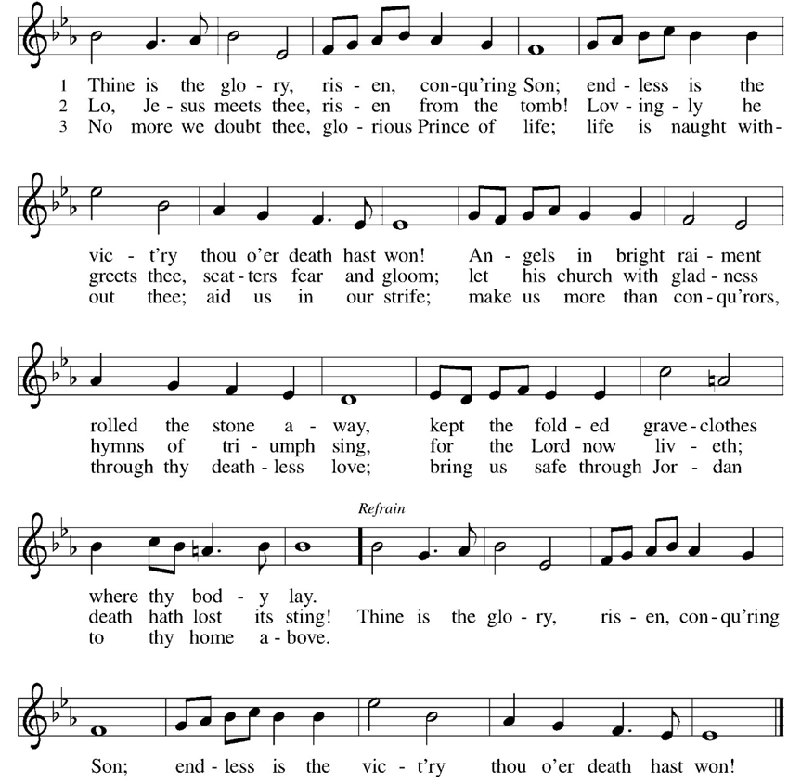

### 🕇 Gospel: John 20:19-31

*The unprecedented events of the day of resurrection continue as the risen Jesus appears to his fearful disciples. A week later, after Thomas worships Jesus, Jesus pronounces that the blessings of the resurrection are also for those who “have not seen and yet believe.”*

19 When it was evening on that day, the first day of the week, and the doors of the house where the disciples had met were locked for fear of the Jews, Jesus came and stood among them and said, “Peace be with you.” 20 After he said this, he showed them his hands and his side. Then the disciples rejoiced when they saw the Lord. 21 Jesus said to them again, “Peace be with you. As the Father has sent me, so I send you.” 22 When he had said this, he breathed on them and said to them, “Receive the Holy Spirit. 23 If you forgive the sins of any, they are forgiven them; if you retain the sins of any, they are retained.”  
  24 But Thomas (who was called the Twin), one of the twelve, was not with them when Jesus came. 25 So the other disciples told him, “We have seen the Lord.” But he said to them, “Unless I see the mark of the nails in his hands, and put my finger in the mark of the nails and my hand in his side, I will not believe.”  
  26 A week later his disciples were again in the house, and Thomas was with them. Although the doors were shut, Jesus came and stood among them and said, “Peace be with you.” 27 Then he said to Thomas, “Put your finger here and see my hands. Reach out your hand and put it in my side. Do not doubt but believe.” 28 Thomas answered him, “My Lord and my God!” 29 Jesus said to him, “Have you believed because you have seen me? Blessed are those who have not seen and yet have come to believe.”  
  30 Now Jesus did many other signs in the presence of his disciples, which are not written in this book. 31 But these are written so that you may come to believe that Jesus is the Messiah, the Son of God, and that through believing you may have life in his name.

P: The Gospel of Our Lord. **C. Praise to you, O Christ.**

**CHILDREN’S MESSAGE**

**MESSAGE**

**HYMN OF THE DAY: We Walk by Faith ELW 635**

🕇**APOSTLES’ CREED:**

**I believe in God, the Father almighty, creator of heaven and earth.**

**I believe in Jesus Christ, God’s only Son, our Lord, who was conceived by the Holy Spirit, born of the virgin Mary, suffered under Pontius Pilate, was crucified, died, and was buried; he descended to the dead. On the third day he rose again; he ascended into heaven, he is seated at the right hand of the Father, and he will come to judge the living and the dead.**

**I believe in the Holy Spirit, the holy catholic church, the communion of saints, the forgiveness of sins, the resurrection of the body, and the life everlasting. Amen.**

🕇**PRAYERS OF INTERCESSION:**

P. Hear us, O God **C: your mercy is great.**

🕇**PEACE**

**P:** The peace of Christ be with you always. C. **And also with you.**

**OFFERING:** *Our offering is a significant act of worship; we worship God through our giving. The ministry of this congregation is completely dependent upon your partnership and generosity. Offering is collected as you enter worship on Saturday. We will pass the offering plate on Sundays. Online giving is available.*

**

**OFFERING PRAYER:**

P: Gracious Provider, **C: you set your immense treasures among us, opening your heart to the world. As we prepare to feast on your bountiful love, deepen our commitment to sharing those treasures with others, through our Savior, Jesus Christ. Amen.**

**COMMUNION LITURGY:**

In the night in which he was betrayed, our Lord Jesus took bread, and gave thanks, broke it and gave it to his disciples, saying: take and eat; this is my body, given for you. Do this for the remembrance of me. Again, after supper, he took the cup, gave thanks and gave it for all the drink, saying: this cup is the new covenant in my blood, shed for you and for all people for the forgiveness of sin. Do this for the remembrance of me.

**THE LORD’S PRAYER:**

**Our Father, who art in heaven, hallowed be thy name, thy kingdom come, thy will be done on earth as it is in heaven. Give us this day our daily bread; and forgive us our trespasses, as we forgive those who trespass against us; and lead us not into temptation but deliver us from evil. For thine is the kingdom, and power, and the glory, forever and ever. Amen**

**INVITATION TO COMMUNION:**

P: Come to the table of grace. Receive the gift of new life.

*Please come down the center aisle, take the bread, then receive a cup (wine is dark, juice is light, return to your seats via side aisle.) Those who prefer to take communion in your pews, we will take all together after all is served.*

**DISTRIBUTION OF COMMUNION**

P: This is the body of Christ given for you. *(All take bread).*

P: This is the blood of Christ shed for you. *(All take the wine).*

🕇**TABLE BLESSING:**

P. May the body and blood of our Lord Jesus Christ strengthen you and keep you in his grace. **C. Amen.**

🕇**PRAYER AFTER COMMUNION:**

P: Let Generous Host **C: you have shared your feast with us and made us new. Send us now to set tables of love and grace in our communities, that your liberating love might nourish the world into freedom, in the name of the crucified one, Jesus Christ our Lord. Amen**

**SENDING:** *God blesses us and sends us in mission to the world.*

🕇**BLESSING:** P: God our tender parent, God the crucified one, God the reconciling Spirit,

☩ bless you now and forever. **C: Amen.**

🕇**SENDING HYMN Jesus Christ is Risen Today ELW 365**

🕇**DISMISSAL:**

P: Go in peace. Care for others as God cares for you. **C:** **Thanks be to God.**

**POSTLUDE**

**IN OUR PRAYERS TODAY**: Gunnar Stich, Teresa Hesselbacher, Darlene and Walt Steffes, Bob Schreck, Delores Wampfler, Marge and Gerald Arnold, Josie Bonjour, Elaine Schlichting, Verla Rhyner, Don Brudi, James Dieter, Christine Happ, Kay Hesselbacher, Mary Lou Bunker, Lillian Sefford, , Judy Wilson, Jody Dascher, Russ Synder, ***To add someone to the prayer list please contact Pastor Chrissy***

**CELEBRATING BIRTHDAYS / ANNIVERSARIES:**  Lillian Jordan, Taylor Brudi, Thomas Eden, Elizabeth Eden, Ken Schubert

**Anderson Birthdays**

|  |  |  |  |  |
| --- | --- | --- | --- | --- |
| Christine | F | May 22 | 71 | Children cat books/color books/ puzzle’s/dolls |
| Rebecca | F | May 29 | 53 | Craft kits/ stuffed animals/word searches |

*Please send Birthday cards to Anderson House 200 East King Avenue Stockton Il 61085*

**ANNOUNCEMENTS**

|  |  |  |  |  |  |
| --- | --- | --- | --- | --- | --- |
| Thanks be to God for your gifts for the ministry of  Christ Lutheran Church \***these numbers do not reflect online giving- only offering in worship** | | | | Offering/ Attendance  April 19& 20 | |
| Current Expense | 2,590.00 | Building Fund | 30.00 | April 17 | **27** |
| Benevolence  folder | 12.00  65.00 | Easter | 380.00 | April 18  April 19 | **29**  **39** |
| Maundy Thursday  Good Friday | 226.85  257.00 | **Total** | **$3,560.85** | April 20 7 am  10 am | **61**  **53** |
|  |  |  |  | Sunday School | **13** |

**March Totals**:As a way to improve communication around finances, we are sharing the following information: \***these numbers reflect online giving contribution**

|  |  |  |
| --- | --- | --- |
| **2025** | | |
|  | **March** | **Year to date** |
| Offerings: | ***$14,697*** | **$30,431** |
| Expenses: | ***$10,979*** | **$31,490** |
| ***Overall  Gain / Loss*** | ***$3,718*** | ***($1,060)*** |

**ANNOUNCEMENTS**

**ONLINE GIVING:** Your gift has a big impact on our ministries and those we serve. Scan this code or visit our website to give online today.

**THE COMMUNITY TABLE:** The Community Table is an opportunity for outreach to the local community. This is a bi-weekly meal on the first and third Tuesday of the month at 11:30, here at Christ to gather for food, fellowship and fun. This is an outreach that will begin in May 6th at 11:30. If you are interested in volunteering please talk with Janet Haas or Debbie Goebel.

**NW CONFERENCE WELCA SPRING GATHERING:** Thursday May 15th at Lord of Love Lutheran Church 219 Summit St Galena Il 61036 Registration 9:30 Cost $15 Brunch & Program is Lord of Love Giving and Charitable Missions in the Community Forms Available in Narthex. They are due by May 8th.

**SUNDAY SCHOOL**: April 27th will be the last day of Sunday School for this school year. Don’t miss you. We would love to see your kids as we finish out the year. Don’t forget to mark Vacation Bible School on your calendar June 2-6 from 9-11:30.

**SAVE THE DATE:** WELCA is coordinating a fellowship event for Thursday, May 22 in Dubuque, a lunch cruise on the Mississippi. More info to come.

**AMAZON WISH LIST:** did you know that everyday items used at the church are items you could contribute? Find our list here or on our Facebook page. Thank you! <https://www.amazon.com/hz/wishlist/ls/TWP5U0RAGGAY?ref_=wl_share>

**COWORKERS IN THE GOSPEL**: Consider being a part of one our leadership teams. As of this month, three teams will be helping connect the council and congregation as we work together to do ministry together. Three teams have formed; **Worship Team, Building Team and Education Team.** If you are interested in being a part of one of the teams, please see Pr Chrissy or someone on the team.

* **Worship team leader is Janet Haas -**anyone who is interested in serving in any area of worship, especially baking communion bread, communion set up, serving or clean up.
* **The Property team** will access, and address issues related to the building. Please see **Cory Haas, team leader,** if you would like to help with the building. We are also looking for people interested in helping with **mowing the lawn** come spring.
* The **Education Team** over sees Confirmation, Sunday School and Vacation Bible School. Vacation Bible School is going to happen **June 2-6. from 9-11:30.** If you would like to be a part of the education team or help with VBS Campfire Adventure please see **Leisa Hubb (team leader).**

**Upcoming Events**

* April 26- 5:30 pm Worship
* April 27- 9 am last Sunday School of the year
* April 27- 10 am Worship
* April 31- 9 am Bible Study
* *A black and white logo

  AI-generated content may be incorrect.*May 4- 10 am Confirmation Sunday
* May 4- 2 pm Stockton Baccalaureate
* May 15 – 9:30 am WELCA Northwest Conference at Lord of Love Galena, IL
* May 22- WELCA Fellowship Event in Dubuque
* May 25- LSSI Good Shepherd Sunday
* June 2-6 Vacation Bible School