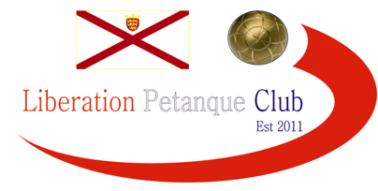

Winter 2012/2013 Weekly Report

End of Season Report

Date 2nd March 2013

New Premier League Champion Matt Ryan seals the Singles title with a 100% record, which means I had to settle for second place for the first time since the club started, but I am looking forward to defending my Summer League title, 3rd place went to a constantly improving Andrew Bellamy an impressive 7 points above 4th placed Ross Payne.

Ann Ellis also had a 100% record, but that was the opposite to Matt losing every match, also relegated unfortunately due to illness, Brian had to withdraw and Alice’s defeat against Ross in the last match of the season means next Winters Singles Premier will be an all male league.

Division 1 saw Alan Oliveira defy all the odds to win the league above four of the Islands top players after handing Brigitte her first defeat of the season and also costing her a promotion spot.

Jake Romeril out did his father Chris to take second place on points difference above Keith Pinel who drew with his son Matt to take 3rd and cost his son a promotion place. 4th, 5th and 6th place all finished on 14 points, just 2 points off 2nd and 3rd. Chris Hoegsburg although finishing bottom of the table got his first points of the season with a fantastic win over Alex Stewart to at least finish off the season with a smile on his face.

Premier League Singles Division 1 Singles
Winner Matt Ryan Alan Oliveira
Runner Up Toby Northern Jake Romeril
3rd Place Andrew Bellamy Keith Pinel

Premier League Doubles Division 1 Doubles
Winner Matt Ryan & David Ibitson Chris & Jake Romeril
Runners Up Ross Payne & Antony Di Santo Paul Le Moine & Celine Gimenez
3rd Place Toby Northern & Andrew Le Breton Colin Myers & Steve Simpkin

Well no more playing in the cold wet and snowy conditions for another year, hope you all enjoyed the season and we look forward to welcoming you back in the Summer League starting 3rd April 2013.

End of Season Presentation Saturday 16th March at the Jersey Bowl, if you haven’t already done so please email David Ibitson your menu choices, it would be great to have you all there for a fun evening.

Liberation Doubles Open Saturday 23rd March 2013 at the Weighbridge (hopefully!), only 2 spaces left.

Kind Regards,
Toby Northern,
Chairman

