Dry Cargo Container
20' Steel Dry Cargo Container
Exterior |  |  | 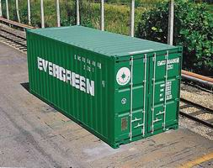
Length | Width | Height
20'-0" | 8'-0" | 8'-6"
6.058 m | 2.438 m | 2.591 m
Interior
Length | Width | Height
19'-4 13/16" | 7'-8 19/32" | 7'-9 57/64"
5.898 m | 2.352 m | 2.385 m
Weight |  |  | Door Opening
MGW | TARE | NET | Width | Height
52,910 lb | 5,140 lb | 47,770 lb | 7'-8 1/8" | 7'-5 3/4"
67,200 lb | 5,290 lb | 61,910 lb | 2.343 m | 2.280 m
24,000 kg | 2,330 kg | 21,670 kg | CU.M | CU.FT
30,480 kg | 2,400 kg | 28,080 kg | 33.1 | 1,169
Purpose
1.Captioned units(MGW 30,480 KG) can be coordinated from EMCU 3204073 and EISU 3568118.
2.Used for all kinds of general cargo.

40' Steel Dry Cargo Container
Exterior |  |  | 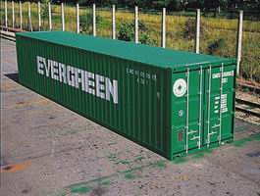
Length | Width | Height
40'-0" | 8'-0" | 8'-6"
12.192 m | 2.438 m | 2.591 m
Interior
Length | Width | Height
39'-5 45/64" | 7'-8 19/32" | 7'-9 57/64"
12.032 m | 2.352 m | 2.385 m
Weight |  |  | Door Opening
MGW | TARE | NET | Width | Height
67,200 lb | 8,820 lb | 58,380 lb | 7'-8 1/8" | 7'-5 3/4"
67,200 lb | 8,820 lb | 58,380 lb | 2.343 m | 2.280 m
30,480 kg | 4,000 kg | 26,480 kg | CU.M | CU.FT
30,480 kg | 4,000 kg | 26,480 kg | 67.5 | 2,385
Purpose
Used for all kinds of general cargo.

40' Hi-Cube Steel Dry Cargo Container
Exterior |  |  | 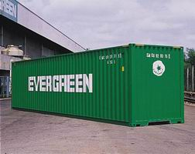
Length | Width | Height
40'-0" | 8'-0" | 9'-6"
12.192 m | 2.438 m | 2.896 m
Interior
Length | Width | Height
39'-5 45/64" | 7'-8 19/32" | 8'-9 15/16"
12.032 m | 2.352 m | 2.69 m
Weight |  |  | Door Opening
MGW | TARE | NET | Width | Height
67,200 lb | 9,260 lb | 57,940 lb | 7'-8 1/8" | 8'-5 49/64"
67,200 lb | 9,260 lb | 57,940 lb | 2.343 m | 2.585 m
30,480 kg | 4,200 kg | 26,280 kg | CU.M | CU.FT
30,480 kg | 4,200 kg | 26,280 kg | 76.2 | 2,690
Purpose
Used for all kinds of general cargo.

45' Hi-Cube Steel Dry Cargo Container
Exterior |  |  | 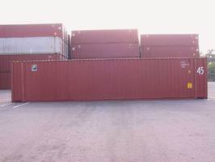
Length | Width | Height
45'-0" | 8'-0" | 9'-6"
13.716 m | 2.438 m | 2.896 m
Interior
Length | Width | Height
44'-5 7/10'' | 7'-8 19/32'' | 8'-10 17/64''
13.556 m | 2.352 m | 2.698 m
Weight |  |  | Door Opening
MGW | TARE | NET | Width | Height
67,200 lb | 10,580 lb | 56,620 lb | 7'-8 1/8" | 8'-5 3/4"
67,200 lb | 10,580 lb | 56,620 lb | 2.340 m | 2.585 m
30,480 kg | 4,800 kg | 25,680 kg | CU.M | CU.FT
30,480 kg | 4,800 kg | 25,680 kg | 86.1 | 3,040
Purpose
Used for all kinds of general cargo.

Exterior |  |  | 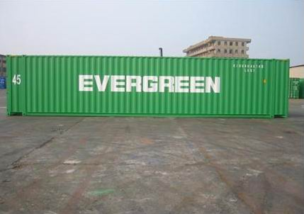
Length | Width | Height
45'-0" | 8'-0" | 9'-6"
13.716 m | 2.438 m | 2.896 m
Interior
Length | Width | Height
44'-5 7/10'' | 7'-8 19/32'' | 8'-10 17/64''
13.556 m | 2.352 m | 2.698 m
Weight |  |  | Door Opening
MGW | TARE | NET | Width | Height
67,200 lb | 10,858 lb | 56,342 lb | 7'-8 1/8" | 8'-5 3/4"
67,200 lb | 10,858 lb | 56,342 lb | 2.340 m | 2.585 m
30,480 kg | 4,870 kg | 25,610 kg | CU.M | CU.FT
30,480 kg | 4,870 kg | 25,610 kg | 86 | 3,040
Purpose
Captioned units can be coordinated from EISU 804001~EISU 804500 and EMCU 801001~EMCU 80250.

Exterior |  |  | 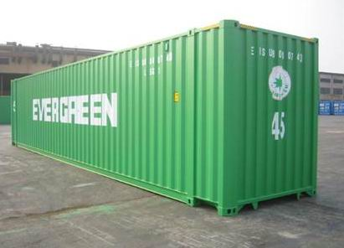
Length | Width | Height
45'-0" | 8'-0" | 9'-6"
13.716 m | 2.438 m | 2.896 m
Interior
Length | Width | Height
44'-5 7/10'' | 7'-8 19/32'' | 8'-10 17/64''
13.556 m | 2.352 m | 2.698 m
Weight |  |  | Door Opening
MGW | TARE | NET | Width | Height
71,650 lb | 10,360 lb | 61,290 lb | 7'-8" | 8'-6"
71,650 lb | 10,360 lb | 61,290 lb | 2.340 m | 2.585 m
32,500 kg | 4,700 kg | 27,800 kg | CU.M | CU.FT
32,500 kg | 4,700 kg | 27,800 kg | 86 | 3,040
Purpose
Captioned units can be coordinated from EISU 802001~EISU 804000.

Refrigerated Container
20' M.G.S.S. Refrigerated Container
Exterior |  |  | 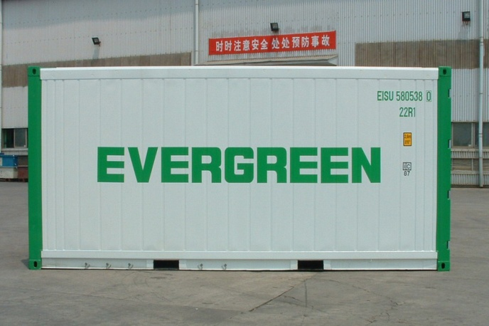
Length | Width | Height
20'-0" | 8'-0" | 8'-6"
6.058 m | 2.438 m | 2.591 m
Interior
Length | Width | Height
18'- 17/32" | 7'-6 15/32" | 7'-5 39/54"
5.500 m | 2.298 m | 2.276 m
Nominal |  |  | Weight
Cubic Capacity |  |  | MGW | TARE
1,016 cu.ft. |  |  | 67,180 lb | 6,700 lb
28.8 cu.m. |  |  | 30,480 kg | 3,020 kg
Cooling capacity | Air exchange rate |  | Type | Temp.  control precision
w(kcal)/C(F) | CFM | cu.m/hr | Type | Temp.  control precision
11,000(9,460)/1.7(35)  6,280(5,400)/-18(0) | 0-106 | 0-180 | MHI  CPE14-2BAIIIEU | +-0.25C
10,550(9,073)/2(35)  6,150(5,289)/-18(0) | 0-142 | 0-240 | CARRIER  69NT40-551-501 | +-0.25C

20' Aluminum Refrigerated Container
Exterior |  |  | 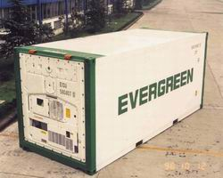
Length | Width | Height
20'-0" | 8'-0" | 8'-6"
6.058 m | 2.438 m | 2.591 m
Interior
Length | Width | Height
17'-0" | 7'-6" | 7'-3"
5.480 m | 2.286 m | 2.235 m
Nominal |  |  | Weight
Cubic Capacity |  |  | MGW | TARE
989 cu.ft. |  |  | 52,800 lb | 6,170 lb
28 cu.m. |  |  | 24,000 kg | 2,800 kg
Cooling capacity | Air exchange rate |  | Type | Temp.  control precision
w(kcal)/C(F) | CFM | cu.m/hr | Type | Temp.  control precision
11,000(9,460)/1.7(35)  6,280(5,400)/-18(0) | 0-106 | 0-180 | MHI  CPE14-2BAIIIEU | +-0.25C

40' M.G.S.S. Hi-Cube Refrigerated Container
Exterior |  |  | 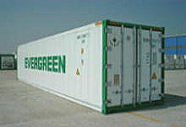
Length | Width | Height
40'-0" | 8'-0" | 9'-6"
12.192 m | 2.438 m | 2.896 m
Interior
Length | Width | Height
37'-11 55/64" | 7'-6 15/32" | 8'-4 5/32"
11.585 m | 2.290 m | 2.544 m
Nominal |  |  | Weight
Cubic Capacity |  |  | MGW | TARE
2,384 cu.ft. |  |  | 74,960 lb | 10,490 lb
67.5 cu.m. |  |  | 34,000 kg | 4,760 kg
Cooling capacity | Air exchange rate |  | Type | Temp.  control precision
w(kcal)/C(F) | CFM | cu.m/hr | Type | Temp.  control precision
11,000(9,460)/1.7(35)  6,280(5,400)/-18(0) | 0-106 | 0-180 | MHI  CPE16-2BAIIIEV | +-0.25C
10,550(9,073)/2(35)  6,150(5,289)/-18(0) | 0-142 | 0-240 | CARRIER  69NT40-551-501 | +-0.25C

40' Hi-Cube Aluminum Refrigerated Container
Exterior |  |  | 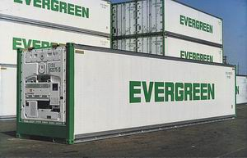
Length | Width | Height
40'-0" | 8'-0" | 9'-6"
12.192 m | 2.438 m | 2.896 m
Interior
Length | Width | Height
37'-11" | 7'-6" | 8'-2"
11.563 m | 2.286 m | 2.507 m
Nominal |  |  | Weight
Cubic Capacity |  |  | MGW | TARE
2,340 cu.ft. |  |  | 67,200 lb | 9,480 lb
66.27 cu.m. |  |  | 30,480 kg | 4,300 kg
Cooling capacity | Air exchange rate |  | Type | Temp.  control precision
CFM | cu.m/hr | w(kcal)/C(F) | Type | Temp.  control precision
11,000(9,460)/1.7(35)  6,280(5,400)/-18(0) | 0-106 | 0-180 | MHI  CPE14-2BAIIIA/ES | +-0.25C

Special Container
20' Full Height Open Top Container
Exterior |  |  | 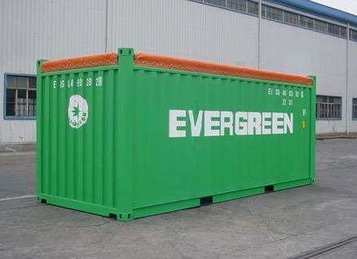
Length | Width | Height
20'-0" | 8'-0" | 8'-6"
6.058 m | 2.438 m | 2.591 m
Interior
Length | Width | Height
19'-4" | 7'-8 1/2" | 7'-8 1/8"
5.898 m | 2.352 m | 2.342 m
Weight
MGW | TARE | NET
44,800 lb | 4,850 lb | 39,950 lb
20,320 kg | 2,200 kg | 18,120 kg
CU.M |  |  | CU.FT
32.5 |  |  | 1,148
Purpose
Captioned units can be coordinated from UGMU 490001~UGMU 490150, EMCU 460261~EMUC 460520 and
EISU 460001~EISU 460400.

20 ' Flat Rack Container with Four Freestanding Posts
Exterior |  |  | 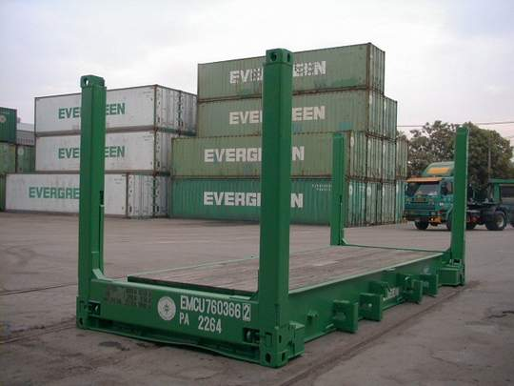
Length | Width | Height
20'-0" | 8'-0" | 8'-6"
6.058 m | 2.438 m | 2.591 m
Interior
Length | Width | Height
18'-6 7/16" | 6'-7 59/64" | 6'-9 39/64"
5.650 m | 2.030 m | 2.073 m
Weight
MGW | TARE | NET
66,140 lb | 6,150 lb | 59,990 lb
30,000 kg | 2,790 kg | 27,210 kg
Purpose
Captioned units can be coordinated from EMCU 760321~EMCU 760520.

20' Flat Rack Container with Collapsible End
Exterior |  |  | 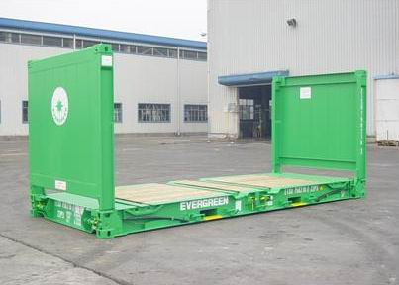
Length | Width | Height
20'-0" | 8'-0" | 8'-6"
6.058 m | 2.438 m | 2.591 m
Interior
Length | Width | Height
18'-5 62/64" | 7'-3 46/64" | 7'-3 59/64"
5.638 m | 2.228 m | 2.233 m
Weight
MGW | TARE | NET
74,950 lb | 6,370 lb | 68,580 lb
34,000 kg | 2,890 kg | 31,110 kg
Purpose
Captioned units can be coordinated from EISU 750000 to EISU 750300.

20' Fuel Tank Container
Exterior |  |  | 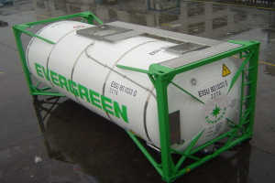
Length | Width | Height
20'-0" | 8'-0" | 8'-6"
6.058 m | 2.438 m | 2.591 m
Weight
MGW | TARE | NET
36,000 kg | 3,385 kg | 32,615 kg
Capacity |  |  | Design Temp.
24,000 litres |  |  | -20°C to 130°C
Purpose
Captioned units can be coordinated from EISU 8010010 to EISU 8010453, and
are need for power pack generators equipped on group vessels, not for export or import purpose.

20' Power Pack Generator Container
Exterior |  |  | 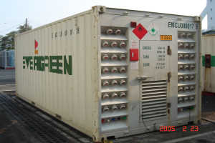
Length | Width | Height
20'-0" | 8'-0" | 8'-6"
6.058 m | 2.438 m | 2.591 m
Interior
Length | Width | Height
19'-4 13/16" | 7'-8 19/32" | 7'-9 57/64"
5.898 m | 2.352 m | 2.385 m
Weight
MGW | TARE | MACHINE
8,500 kg | 2,400 kg | 6,100 kg
Power Supply |  |  | Socket
450 kw |  |  | 40
Purpose
Captioned units can be coordinated from EMCU 0000013 to EMCU 0000409.

40' Flat Rack Container with Four Freestanding Posts
Exterior |  |  | 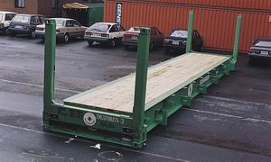
Length | Width | Height
40'-0" | 8'-0" | 8'-6"
12.192 m | 2.438 m | 2.591 m
Interior
Length | Width | Height
38'-7 15/16" | 6'-7 59/64" | 6'-4 1/2"
11.784 m | 2.030 m | 1.943 m
Weight
MGW | TARE | NET
99,210 lb | 11,908 lb | 87,302 lb
45,000 kg | 5,400 kg | 39,600 kg
Purpose
Captioned units can be coordinated from UGMU 707001~UGMU 707050; EMCU 700251~EMCU 700450.

40' Flat Rack Container with Collapsible End
Exterior |  |  | 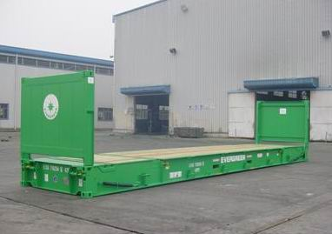
Length | Width | Height
40'-0" | 8'-0" | 8'-6"
12.192 m | 2.438 m | 2.591 m
Interior
Length | Width | Height
38'-7 39/64" | 7'-3 46/64" | 6'-4 61/64"
11.776 m | 2.228 m | 1.955 m
Weight
MGW | TARE | NET
99,210 lb | 10,140 lb | 89,070 lb
45,000 kg | 4,600 kg | 40,400 kg
Purpose
Captioned units can be coordinated from EISU 710000~EISU 710500, EMCU 700451~EMCU 700650

40' Flat Rack Hi-Cube Container
Exterior |  |  | 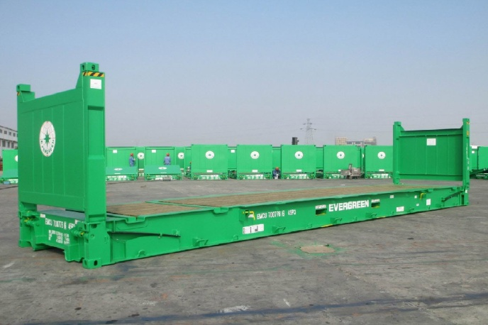
Length | Width | Height
40'-0" | 8'-0" | 9'-6"
12.192 m | 2.438 m | 2.896 m
Interior
Length | Width | Height
38'-2 3/4" | 7'-9 7/16" | 7'-5 1/8"
11.652 m | 2.374 m | 2.264 m
Weight
MGW | TARE | NET
115,740 lb | 11,460 lb | 104,280 lb
52,500 kg | 5,200 kg | 47,300 kg
Purpose
Captioned units can be coordinated from EMCU700681-700780

40' Full Height Open Top Container
Exterior |  |  | 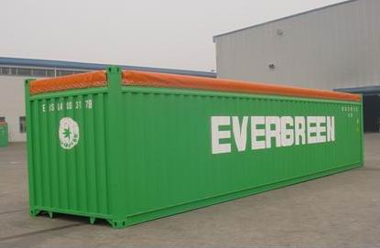
Length | Width | Height
40'-0" | 8'-0" | 8'-6"
12.192 m | 2.438 m | 2.591 m
Interior
Length | Width | Height
39'-5" | 7'-8 1/2" | 7'-8 1/8"
12.034 m | 2.352 m | 2.330 m
Weight
MGW | TARE | NET
67,200 lb | 9,040 lb | 58,160 lb
30,480 kg | 4,100 kg | 26,380 kg
CU.M |  |  | CU.FT
65.9 |  |  | 2,327
Purpose
Captioned units can be coordinated from EMCU 400362~EMCU 400810,
UGMU 407001~UGMU 407050 and EISU 400001~EISU 400600.

40' Hi-Cube Open Top Container
Exterior |  |  | 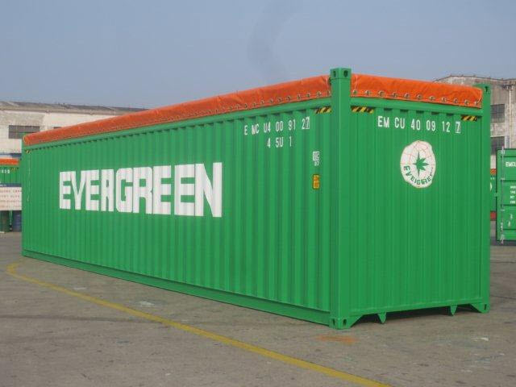
Length | Width | Height
40'-0" | 8'-0" | 9'-6"
12.192 m | 2.438 m | 2.896 m
Interior
Length | Width | Height
39'-6" | 7'-9" | 8'-8 7/16"
12.032 m | 2.352 m | 2.653 m
Weight
MGW | TARE | NET
67,200 lb | 9,390 lb | 57,810 lb
30,480 kg | 4,260 kg | 26,220 kg
CU.M |  |  | CU.FT
75.1 |  |  | 2,650
Purpose
Captioned units can be coordinated from EMCU400911-401010

40' Hi-Cube Hanger Container
Exterior |  |  | 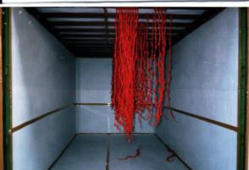
Length | Width | Height
40'-0" | 8'-0" | 9'-6"
12.19 m | 2.44 m | 2.90 m
Interior
Length | Width | Height
39'-5 45/64" | 7'-8 19/32" | 8'-9 15/16"
12.03 m | 2.35 m | 2.69 m
Weight |  |  | Door Opening
MGW | TARE | NET | Width | Height
67,200 lb | 9,172 lb | 58,028 lb | 7'-8 1/8" | 8'-5 49/64"
30,480 kg | 4,200 kg | 26,280 kg | 2.343 m | 2.585 m
Purpose
Used for all kinds of garment.

