Color Country Corvette Club
Presents
Monument Valley, Moab & Colorado River Country
Hosted by Derek & Shelby Hall
October 21-23, 2021
Itinerary:
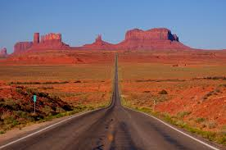
Thursday, October 21
10:00am Depart - Exit 13 Terrible’s Gas Station
11:00am Stretch Break - Kanab, UT
Noon Lunch - Page, AZ
1:30pm Depart – Page, AZ
3:30pm Arrive - Kayenta Monument Valley Inn, Kayenta, AZ
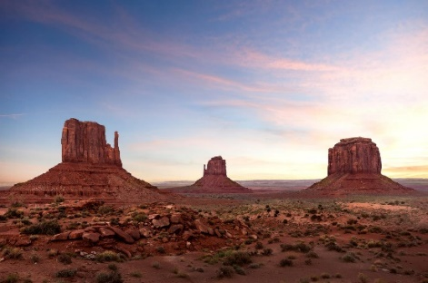
6:00pm Group Dinner - TBA
Friday, October 22
10:00am Depart – Hotel
Noon Group Lunch - Goulding Lodge @ Monument Valley
2:00pm Depart - Goulding Lodge
3:30pm Stretch Break - Blanding, UT
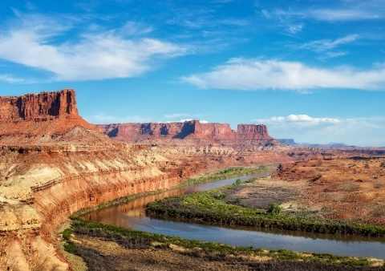
5:00pm Arrive – River Canyon Lodge, Moab, UT
6:30pm Group Dinner - TBA
Saturday, October 23
9:30am Depart - Hotel
11:00am Stretch Break – Green River, UT
12:00pm Group Lunch - Richfield, UT
1:30pm Depart – Richfield for St. George

Note: All times are Mountain Daylight Time
We have negotiated a room block and group rates as follows:
1. Kayenta Monument Valley Inn, Kayenta, AZ ($104) When making your reservation you must call (866) 306-5458 and refer to Color Country Corvette Club group reservation, and Thursday, October 21 as the reservation date. All reservations must be made by September 21, 2021.
2. River Canyon Lodge, Moab, UT ($132) When making your reservation you must call (435) 564-8888 and refer to Color Country Corvette Club group reservation and Friday, October 22 as the reservation date.

