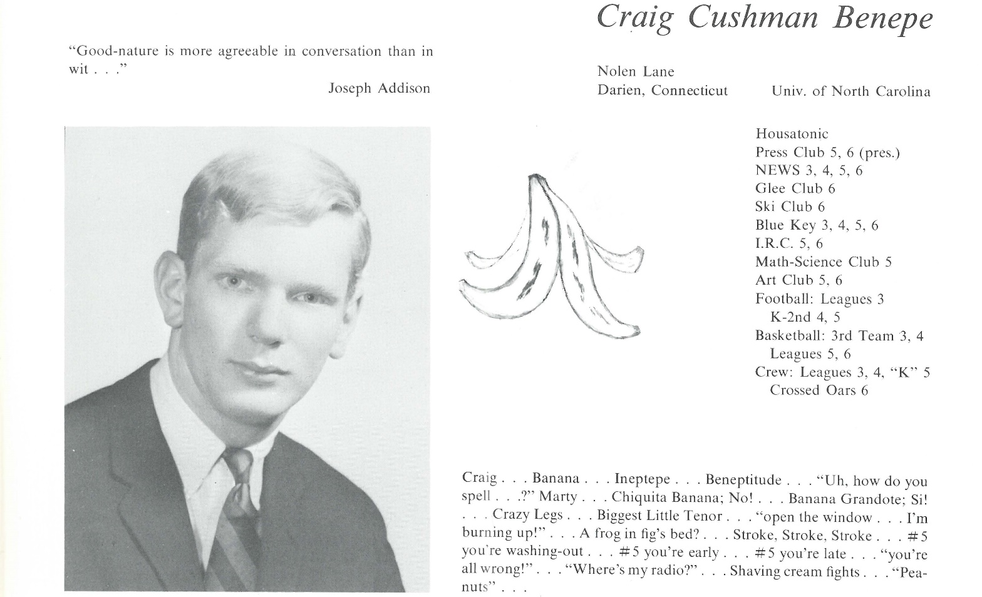

Craig C. Benepe

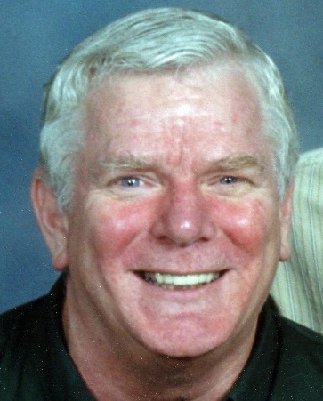Since graduating from Kent, here a brief list of events and accomplishments:

Founded The University of North Carolina Boat Club (crew) and “coached” and competed in 1970 and 1971. Proud to say the UNC crew is still going strong as a club sport for men and varsity for women;

Elected one of the class of 1971 officers (treasurer);

Commissioned in the US Navy on May 30th 1971 and served 2 tours in Vietnam with the 7th fleet. Advance to a full Lieutenant before leaving active duty in early 1974;

Married on the 5th of June 1971 to Mieke Klaassen;

Worked in the home furnishings textile industry since 1974, mostly in sales and product development and sourcing and have traveled a good part of the world to work with factories to develop home textile products;

Adopted my daughter, Amanda, on July 1st, 1983 and my son, Robert, on July 3rd, 1987;

Became a grandfather on August 11th, 2000 with my daughter giving birth to Sierra;

Started my own company, WorldTex Textile Product Development and Sourcing in February 2013;

Do not anticipate retiring anytime in the foreseeable future.



______________________________________________________________

______________________________________________________________ ______________________________________________________________ ______________________________________________________________ ______________________________________________________________ ______________________________________________________________ ______________________________________________________________ ______________________________________________________________ ______________________________________________________________

Attach Picture in .jpg Format

______________________________________________________________

______________________________________________________________

___________________________________________________________________________________ _________________________________________________________________________________________________________________________________________________________________________________________________________________________________________________________________________________________________________________________________________________________________________________________________________________________________________________________________________________________________________________________________________________________________________________________________________________________________________________________________________________________________________________________________________________________________________________________________________________________________________________________________________________________________________________________________________________________________________________________________________________________________________________________________________________________________________________________________________________________________________________________________________________________________________________________________________________________________________________________________________________________________________________________________________________________________________________________________________________________________________________________________________________________________________________________________________________________________________

___________________________________________________________________________________