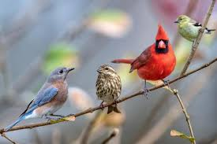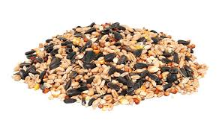

Special Orders always available! We can track down almost anything you’re looking for!

Pet Feeds

Cat – 40# Bags

* Diamond Cat Maintenance
* Ranchers Choice Cat

Dog – 50# Bags

* True Adult Maintenance
* True Active Adult
* True Professional

Dog Treats

* Pig Ears
* K-9 Burger Sliders
* Dr. Choice Fido-Vite
* Wholesomes Rewards Grain Free Treats: Cheese, Smoky, etc
* Many more!

Rabbit

* Ranchers Choice 18% 40#

Llama

* Prince pellet 15% 40#

Wild Bird & Squirrel Feed

* Hohl’s Premium Bird 50#
* Nyjer Seed 25# & 50#
* Finch Mix 25# & 50#
* Black Oil Sunflower 50#
* Fine Sunflower Chips 50#
* Medium Sunflower Chips 50#
* White Millet 50#
* Safflower 50#
* Cardinal Mix 36#
* Peanut Pick-outs 50#
* Ear Corn 40#
* Peanuts in Shell 25#
* Suet Cakes – Case of 12, Individual, Mix n Match case
* Large Suet Cakes
* Many more!



W11942 Hwy 33

Portage, WI 53901