**Halloween Yard of the Month**   
The Halloween Yard of the Month recipient is the Lenski Family, 2512 Eagleview Circle. Lenski’s display includes a variety of seasonal items that look great during the day and at night. The front and east side of the yard includes lots of tombstones, spiders, cobwebs and bones. The center piece is a large inflatable spider. Toward the front entrance of the home are two more large spiders, bones and cobwebs hanging from the porch. The entire front yard is sectioned off with boundary tape, also known as “crime tape”. A laser light with flying witches and ghosts projects on the front of the house. It’s obvious that the Lenski family including the children enjoy Halloween. Congratulations to the Lenski’s for their “spooktacular” display.

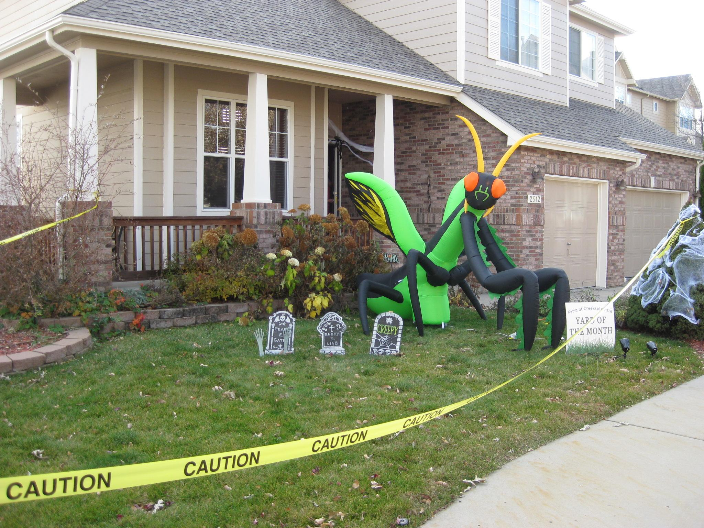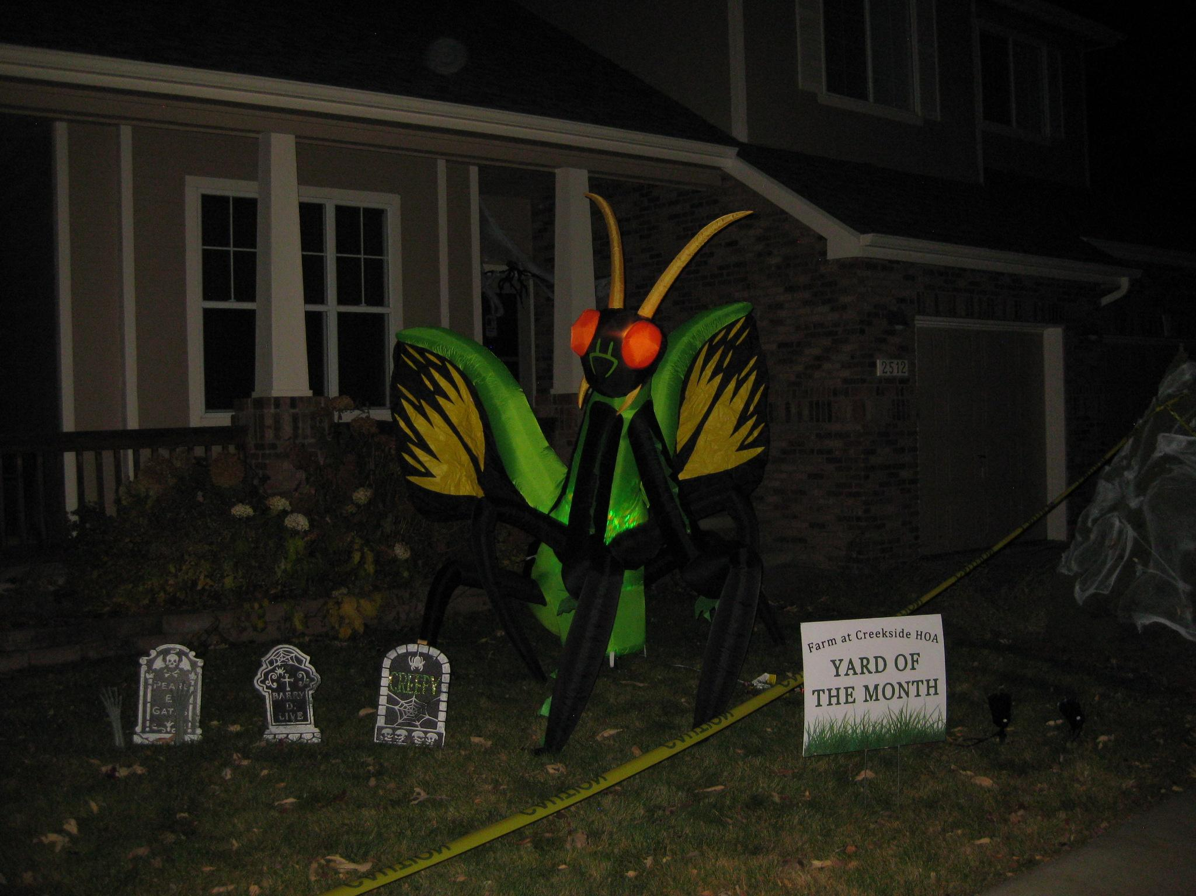

**Upcoming Vacant Board Positions**

The board is currently planning on holding the next annual meeting around the March timeframe, as we have in the past. There will be 2 vacant positions. The terms for Vann, our current treasurer, and Adam, our current president, are expiring and we will need to find 2 additional board members to replacement them on the board. New members will not immediately take over those positions, the board will vote on new positions after the annual meeting. Email [hoa@fachoa.org](mailto:hoa@fachoa.org) if you are interested in learning anything more or pay attention to the newsletter for more information about the annual meeting.