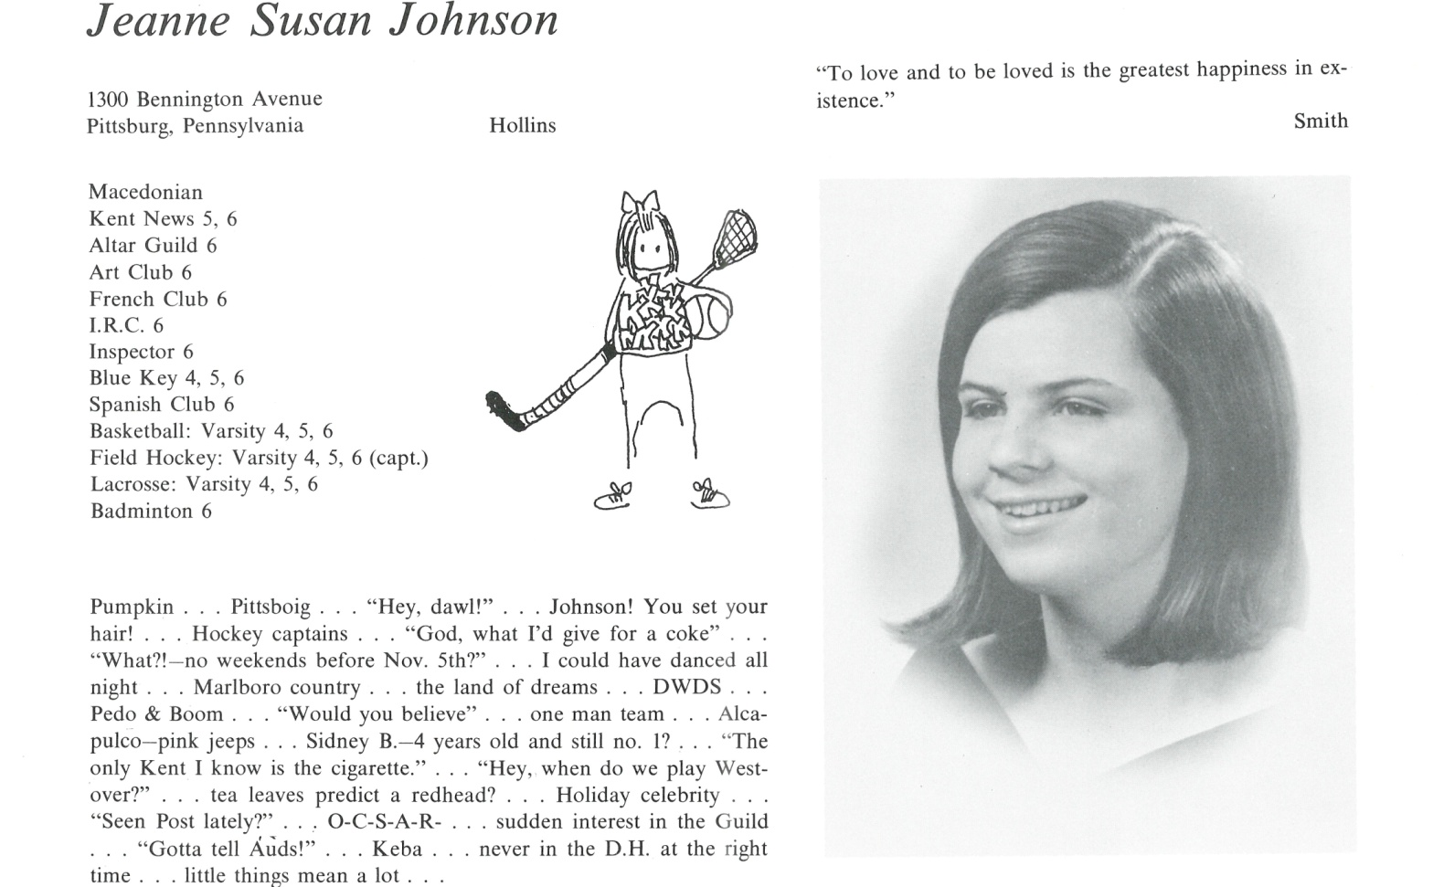

Jeanne S. Johnson Thompson

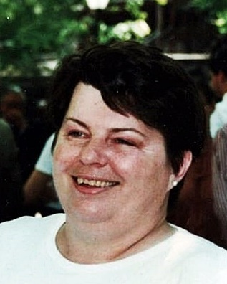After Kent graduation, I just missed seeing the Beatles live, on stage because I had to be @ college (Hollins) one day before they arrived in Pittsburgh. Worse, a friend’s parents managed to bag about 18 front and second row seats. Tragic. However, I did have the highlight of my young life abroad while studying & playing in Paris/Europe for my Junior year (’69-’70). Came back totally transformed to a country rattled by student unrest. Despite feeling a bit lost & confused, I managed to graduate in June ’71 in Politics.

Went to DC to work for a Senator from PA for nearly a decade, including leaving the payroll for a time to work on his ‘74 re-election campaign. I also had a brush with Presidential politics when my Senator was asked to run for Vice President with Ronald Reagan. They lost @ the Convention but Reagan won four years later and tapped the Senator for Secretary of Health and Human Services. I went with him & ultimately left HHS when the Secretary did in ‘83. I had also come to the undeniable conclusion that I actually was a Democrat, not a “liberal Republican,” (remember them?) as previously thought.

My husband and I (married ’77) then left DC for good. We moved around the northeast for his work and I focused on renovating old houses. I eventually followed my heart, though, attending grad school at Penn for three years to earn my Master’s in Landscape Architecture ’93-‘96. Was divorced in there somewhere. After Penn, I practiced @ Sasaki Associates in Boston and then for “Lead Safe Cambridge,” a ground breaking program to mediate lead in residential soils and spread awareness of the dangers of leaded soil.

Then began a very difficult period full of hospitals, operations and awful, mean treatments bringing heartbreak down on me and my siblings. It is better known to us as “the (near) decade from hell.” Ultimately, I returned to Philly to recover my balance. I started exploring the possibility of moving to Italy or France to set up an art workshop business. This involved several long trips to all the places I loved best in Europe. In the end, I was ruthlessly blocked by French bureaucracy when I was already on the 2 yard line. C’est la vie, I suppose.

I returned stateside and took up life in the desert in Tucson AZ. I have loved living in this extreme and fascinating ecosystem but following this 50th Reunion, I plan on selling my recently renovated home and return to the East and my landscape work – few desert dwellers feel a need for garden designers. The real irony is that I hope to end up in Litchfield County, thereby closing my geographical circle neatly and completely.



______________________________________________________________

______________________________________________________________ ______________________________________________________________ ______________________________________________________________ ______________________________________________________________ ______________________________________________________________ ______________________________________________________________ ______________________________________________________________ ______________________________________________________________

Attach Picture in .jpg Format

______________________________________________________________

______________________________________________________________

___________________________________________________________________________________ _________________________________________________________________________________________________________________________________________________________________________________________________________________________________________________________________________________________________________________________________________________________________________________________________________________________________________________________________________________________________________________________________________________________________________________________________________________________________________________________________________________________________________________________________________________________________________________________________________________________________________________________________________________________________________________________________________________________________________________________________________________________________________________________________________________________________________________________________________________________________________________________________________________________________________________________________________________________________________________________________________________________________________________________________________________________________________________________________________________________________________________________________________________________________________________________________________________________________________