Here's the latest information that YHWH has revealed to me concerning the sign of 9/23/2017 being the sign of the " Woman Clothed with the Sun" of Revelation 12:1-2.

Messiah told His people to "lift up their heads" when they saw signs in the sun, moon and stars, with distress of nations, perplexity, and unusual bad weather.

Luke 21:25 And there shall be signs in the sun, and in the moon, and in the stars; and upon the earth distress of nations, with perplexity; the sea and the waves roaring;
26 Men’s hearts failing them for fear, and for looking after those things which are coming on the earth: for the powers of heaven shall be shaken.
27 And then shall they see the Son of man coming in a cloud with power and great glory.
28 And when these things begin to come to pass, then look up, and lift up your heads; for your redemption draweth nigh.

The word meaning "lift up" in Hebrew is Strong's 05375 - Nasa. Speaking in Hebrew, YAHUSHUA told His disciples and us to Nasa our heads at the end of the age.

David chose 5 smooth stones when he went to face Goliath. Perhaps because Goliath had 4 brothers. I had noticed that Comet Holmes that crossed AlGol on 1/22/2008 had a 2514 day period. That's just 6 days short of 2520 days. YHWH said that He would shorten the days in the tribulation period for the sake of the Elect. So I went looking for comets. I immediately found four comets that have periods as follows:

17P / Holmes 2514 days
103P / Hartley 2358 days
9P / Tempel 1 2016.85 days
81P / Wild 2339 Days

I began to investigate Tempel 1 because of it's name sounds like "Temple". Here's the scoop:

Tempel 1 was discovered in 1867 by Wilhelm Tempel, 100 years before Israel took Jerusalem. The comet was lost and unable to be found after 1879. In 1968 astronomer Elizabeth Roemer was looking through old photographic plates and found Tempel 1 again on a photo that had been taken previously on 6/8/1967, one day after Israel took Jerusalem.

NASA launched a mission on 1/12/2005 to fly to comet Tempel 1 and have an 820 lb. projectile blast into it's surface to investigate the results. The misson was called "Deep Impact" and the comet was impacted by the probe on 7/4/2005.

Here's a picture of the comet being impacted by the probe at 5:52 UT on 7/4/2005:
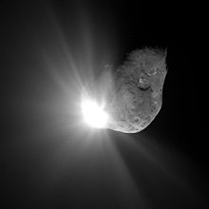
Image courtesy NASA

The impact caused so much dust that NASA had to send another mission named NExT (New Exploration of Tempel 1) to take pictures. That mission was approved on 7/3/2007 and NASA used the existing Stardust spacecraft to do a flyby.

The thing about this "Deep Impact" event that caught my eye was that it occurred in the constellation Virgo.

First an image of Tempel 1's location as it appeared to fly through Virgo in 2005:

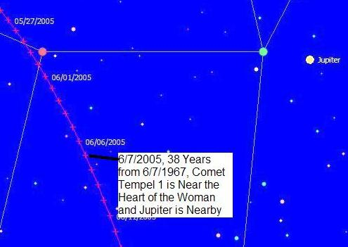

Next an image of the "Sun Clothed Woman" sign on 9/23/2017 with the path of Tempel 1 in 2005 superimposed on it below.

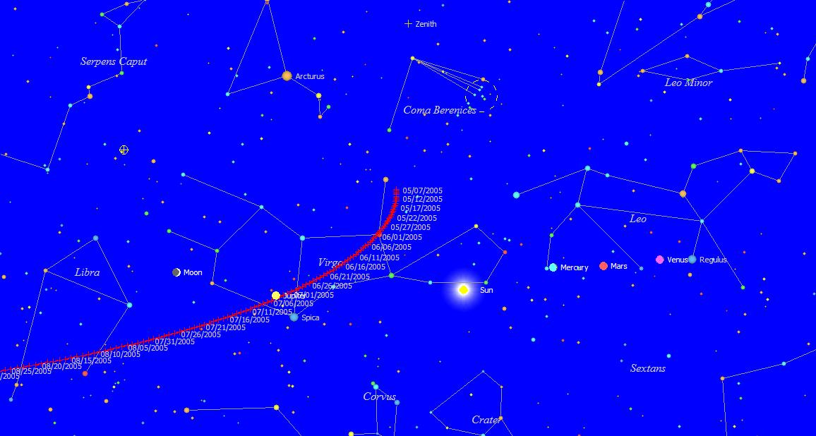

Next an extreme closeup of the sun clothed woman on 9/23/2017 with the Tempel 1 2005 path superimposed on the image below.

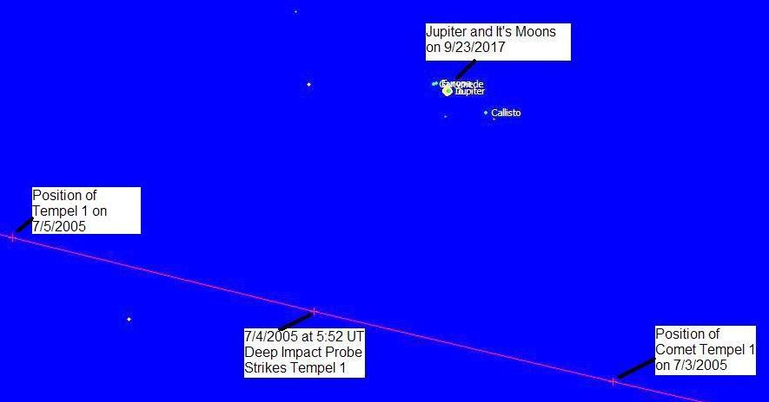

Comet Tempel 1 was impacted by NASA's "Deep Impact" 820 lb. probe on 7/4/2005 at the location in Virgo shown above. The image above is an extreme closeup of the sun clothed woman on 9/23/2017 with the Tempel 1' path superimposed and Jupiter very close nearby. The impact by the probe takes place in the "womb" of the "Sun Clothed Woman" very close to where Jupiter is located at the time of the sign of 9/23/2017 as pictured above.

Summary:

Linking comet Tempel 1 to Jerusalem and the Temple Mount:
1. Comet Tempel 1 was discovered in 1867, 100 years before Israel took the Temple Mount in the 1967 Six Day War.
2. The comet was lost in 1879, only to be re-discovered on a photographic plate taken on 6/8/1967 during the Six Day War, 100 years after the comet was first discovered.

Linking NASA's Deep Impact Mission to comet Tempel 1 with the Sun Clothed Woman of Revelation 12:1-2:
1. The comet passes near Virgo's heart on 6/7/2005, 38 years after it was re-discovered in 1967, with Jupiter being nearby.
2. On 7/4/2005 the comet "happens" to be very near a place in the sky where Jupiter will "happen" to appear in the sign of the "Sun Clothed Woman" of Revelation 12:1-2 on 9/23/2017.
3. NASA "marks" comet Tempel 1 with a probe on 7/4/2005 at the point of the comet's nearest approach to what will be Jupiter's future location on 9/23/2017.

I think this NASA "Deep Impact" mission was ordained by the Creator and that it confirms that the sign of the "Sun Clothed Woman" of Revelation 12:1-2 on 9/23/2017 is indeed valid.

