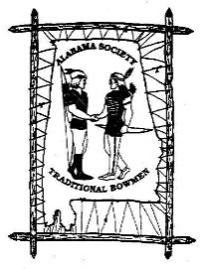
Alabama Society of
Traditional Bowmen

State Championship Registration Form
ASTBarchers@outlook.com / www.astb.club

Name: ___________________________________________Division (*see note below): ___________
Street Address: _____________________________________________ City: _______________________________________________________ State: __________________________ Zip: _________________________
Phone #: ______________________
Email Address (opt.): __________________________________________

Reserved for Additional Family Member Registration

Name: ___________________________________________ Division: ___________
Name: ___________________________________________ Division: ___________
Name: ___________________________________________ Division: ___________
Name: ___________________________________________ Division: ___________
(If more, write on back of application)

Divisions
Men’s Longbow Women’s Longbow Juniors (13-16)
Men’s Recurve Women’s Recurve Youth (9-12)
Men’s Primitive Women’s Primitive Cubs (8 & under)
Men’s Senior Women’s Senior

*NOTE – ONLY one division permitted for State Shoot

Shooting Fees
(Includes Competition and Fun Courses)
ASTB Member - $30 Non-Member - $35
Family Weekend (Members and Non-Members)- $50

Current ASTB Member? Yes _____ No _____ (Ask about Membership Benefits)

ASTB Waiver: I understand that I’m participating in a sport with some risk and understand that I do so at my own risk. I understand that if I am not an ASTB member, I am not covered by the ASTB Group insurance policy.

Signature_______________________________________ Date

