Pleasant Township Board of Trustees Meeting Highlights
Date _May 14, 2024______________ Next Resolution No._ 43—5-14-2024_ _

- Call to Order -- The meeting tonight will also be on WebEx.
- Please stand for moment of silence. --Pledge of Allegiance--Roll Call
- Visitors –
- Hanna Poling with the Southwest Messenger via WebEx.
- Joe Garrett with Trebel Energy Consultants – Resolution 43 to amend to confirm certain specific and limited agency authority up to 3 years that Trebel has to act in our behalf for rates 6.5 or less and the authority to send a notification letter to residents.
- Minutes to approve- No minutes
- Financial Reports – Motion to pay expenditures.
- Department Reports
- Franklin County Sheriff’s Report- Community Liaison, Deputy Adkins- (Cell: 614-809-5843)
04/30/2024 through 05/14/2024
Total Calls for Service/Self-Initiated Runs: 122
Total Reports Taken: 12
Total Arrests/Citations: 6
Burglaries: 0
Traffic Crashes: 17
Medic Runs: 18
Thefts: 2
Missing Persons: 1
Stolen Vehicles: 0
Suspicious Persons/Vehicles: 12
Vandalism:0
Traffic Offenses: 9
Motorcycle/ATV/Bike Complaints: 0
On April 30th, Deputies responded to the 4500 block of London Groveport Road on the report of a theft. The homeowner had responded to an online ad and sent a deposit through a mobile payment service to purchase several items listed for sale. After the victim had sent the deposit, the ad was removed, and the victim could not receive a refund. This investigation is ongoing.
On May 2nd, Deputies responded to the 6500 Block of London Groveport Road on the report of a theft from a barn. Once on scene, it was determined that an unknown individual(s) had entered an unlocked barn and taken a 2018 4-wheeler. This investigation is ongoing.
On May 4th, Deputies responded to Battelle Darby Metro Park to assist Park Rangers with an intoxicated individual. The individual became unruly and combative and eventually was arrested and transported to 2460 Jackson Pike. Also working on a dog barking complaint in Oakhurst.
- Road Department- Robert Bausch, Superintendent
- Spring clean up was the busiest one we have had.
- Seasonal help started yesterday and doing well.
- Gerich Rd. bridge update finished enough to open for traffic.
- Creamer Rd. berm repair after heavy rain.
- Family wants to bury their mothers cremains.
  - This was brought up from a lady who wanted to know if her family could bury their mother cremains at Oak Grove to avoid the 150.00 dollar charge. I told her I will ask at the meeting and get back to her. I just wanted to see what the boards thought are. I have never been asked that before and I think it would be wise to have an opinion from the board for future use. After discussion, decided it would not be a good idea to start this practice.
Unresolved items
- Any updates on the rocks/boulders in the right-of-way on Oakhurst Dr.
- Any updates on Gay Rd. about repairs due to heavy rains washing the roadway and gravel away. (meeting on 8-8-23 we said we’d keep it on the agenda till resolved in some way.)
- Fire Dept. – Lt. Kuno for Chief Whiting
- Apparatus
- M-231 was in the shop for general maintenance. Also did work on GF231.
- Personnel
- Resignation Letter from Cole Smoot, effective April 22, 2024.
- Resolution __44__ to hire Travis Baisden for part-time firefighter/paramedic.
- Equipment
- Division four gas meter has numerous unrepairable issues. Ordering a new meter at a cost of approximately $1200.00.
- Water rescue exposure suits have significant damage; one is unrepairable, and the other will require extensive repairs. Two new Mustang exposure suits will be replaced for $1200.00 each, for a total of $2,400.00. We keep a total of 5 in stock.
- Training
- Continue to use the training house on Biggert Rd.
- Paramedic school on-going.
- Resolution_45__ to authorize the Fire Chief to enter into a contract with Medicount for EMS billing.
- Announcements-
- Memorial Day Service will be held Monday, May 27, 2024, 1:00 p.m. at Oak Grove Cemetery.

  - A big thank you to West Jefferson VFW Post 7005 for graciously taking over the ceremony for the VFW Post who did it for years and now had to disband for lack of participation. **Lt. Kuno will you please pass on to your dept. for participation that day.
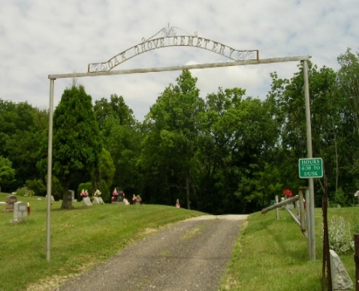
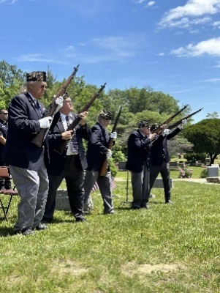

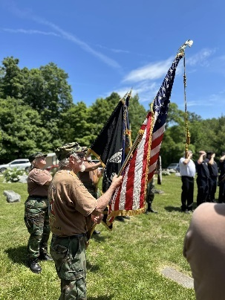

- Clerk Updates- Paula
- Miscellaneous correspondence
- Adjourn

