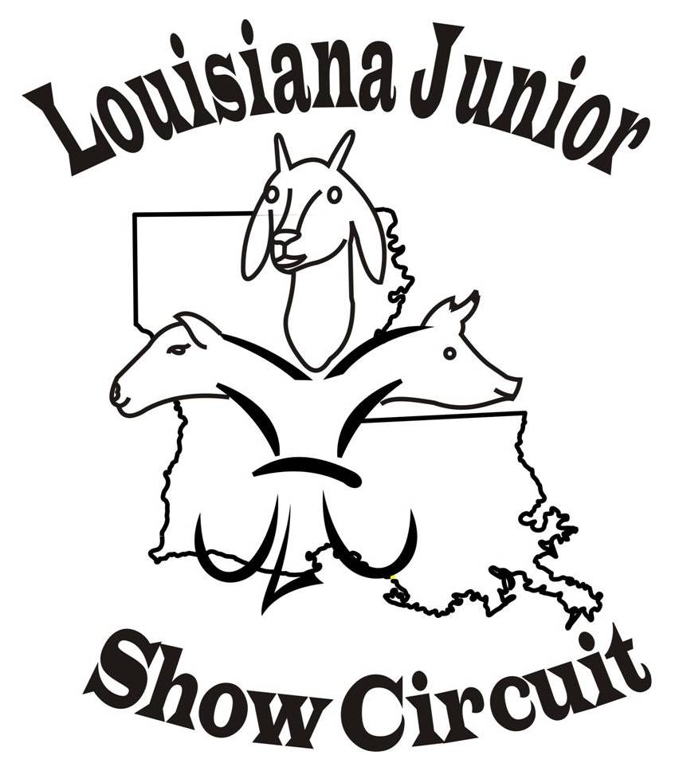
2023 LJSC SHOW Schedule

June 23th & 24th Watermelon Festival, Deridder, LA
July 7th & 8th Red River Showdown, Coushatta, LA
July 14th & 15th Claiborne Classic, Haynesville, LA
July 28th & July 29th Black & Gold Showdown, Winnfield, LA
August 4th & 5th Rockin’ on the Red, Coushatta, LA
August 11th & 12th Summer Sizzler, LA, Winnfield, LA
August 18th & 19th Gulf Coast Classic, Crowley, LA
Website (www.louisianajuniorshowcircuit.org.) and Facebook Louisiana Junior Show
Circuit (page and group) for updates. If interested in hosted a sanctioned show
please contact Nancy Nettles.
LJSC Contact Information
For Comments or questions concerning Louisiana Junior Show Circuit (LJSC) ~~~ Contacts:
Nancy Nettles - President Stephanie Chamberlin Secretary
(318) 455-2905
Email Membynancy1@aol.com
Lauribeth Padgett - Vice-President Judy Latiolais – Treasurer
Board Members: Dana Broussard, Guy Sanders, Jenifer Winslett,
Josh Johnson, and Melinda Miles

