514 North Broadway
Joshua, TX 76058
817-295-6871

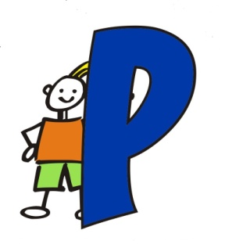
unkin Patch

Daycare Center, Inc.

1. All about Punkin Patch
2. Abuse & Neglect
3. Infant-Toddler Program (Including Safe Sleep)
4. Preschool Program
5. K-Prep Program
6. Kid Space Program
7. Hours of Operation & Closing Dates
8. Food Service & Preparation
9. School Safety Policies/Gang Free Zone
10. Illness & Health Practices
11. Safe Sleep
12. Discipline Policy
13. Suspension and Expulsion
14. Emergency Preparedness Plan
15. Personal Belongings
16. Documents Needed for enrollment
17. Tuition
18. Extra Fees
19. Referral Progra
20. Contact Information

About Punkin Patch
Punkin Patch is Johnson County’s leading child care provider. Our program gives children ages 6 weeks through 12 years enriching opportunities to develop the whole child. We focus on learning though child directed play experiences and curriculum time. We believe a balance of play and preschool enhances growth and development in all areas: physically, socially, emotionally, creatively, and intellectually. This is achieved in a safe and loving environment with caregivers who are dedicated to enriching children’s lives.
Abuse & Neglect
Upon employment all staff must be trained on the Abuse/Neglect standard according to Minimum Standards and annually thereafter. By using handouts and brochures (located upon request) we will increase employee and parent awareness of issues regarding child abuse and neglect, including warning signs that a child may be a victim of abuse or neglect. Using videos at staff meetings, handouts and fliers we will increase employee awareness of prevention techniques for child abuse and neglect. Our center will coordinate communication between our center, parents and appropriate community organizations for information to handle specific situations or questions from parents or employees including actions that the parent of a child who is a victim of abuse or neglect should take to obtain assistance and intervention. All staff members are trained to be alert of anything “out of the ordinary” with a child in how they appear, act and what they say. Staff members are trained to be observant in the relationships between family members and a child. This training is for recognizing abuse/neglect whether it be physical, sexual or emotional. All information for training was taken off the DFPS website. The Texas Abuse Hotline number is 1-800-252-5400 or go to Texas Abuse Hotline e-Report Site to report anything suspicious.

Hours of Operation & Closing Dates

Punkin Patch is open from 6:000am-6:30pm Monday - Friday, January - December. We close to observe the following holidays: New Years Day, Memorial Day, Independence Day, Labor Day, Thanksgiving Day & the following Friday, Christmas Eve & Christmas Day. (Depending on when the Holiday falls our days may vary. We post notices on the door to keep parents informed). In the event of overnight “Bad Weather” we will follow GISD’s closing procedure. If JISD has a delayed start time we will open at 8:00am. If JISD is closed we will remain closed for the day until school resumes. We will also post on our facebook page if we are closed or delayed. We ask that you have your child at the center by 9:30 AM unless you have prior approval from the office.

Infant-Toddler Program
Caregivers are specially trained to care for Infants and Toddlers. Each caregiver is certified in Infant CPR & First Aid as well as Sudden Infant Death Syndrome (SIDS), Shaken Baby Syndrome (SBS) & Early Brain Development. Certification is renewed on a yearly basis through a licensed instructor. Caregivers must also receive career enrichment training hours in Child Development throughout the year. The infants and toddlers are grouped in a small group setting ensuring individual attention is given. The Curriculum Director has
Planned enrichment activities for each morning and afternoon for these little ones. A daily communication
sheet is sent home each evening detailing the events of the day.

Safe Sleep Policy:
Infants are placed on their back to sleep without any blankets or other items (by state regulations), They are placed in a crib with a tight fitting sheet only. If they fall asleep in a restrictive device (such as a bouncy chair or swing, or arrives to care asleep in a car seat), the infant will be moved to a crib immediately. Infants are actively observed by sight and sound to ensure their safety. You can furnish a knapsack for your child if you choose. Pacifiers are allowed in the crib with an infant but the pacifier may not be attached to a stuffed animal or the infant’s clothing by a string, cord or any other attaching mechanism.
.
**As a parent you have the right to supply Breast Milk or to Breast feed in our facility. The breast feeding station is located in the Staff Workroom or in a private location.

Preschool Program
The early preschool program is designed to develop the whole child with emphasis on meeting their individual needs. This program offers developmentally appropriate activities for children who are two and three years old. Our curriculum is theme based and is enhanced with the use of learning centers in the classrooms & outdoor play during recess. Each classroom is equipped with 7 exploration centers to offer hands on experiences. These learning areas are: Construction Center; Dramatic Play; Art & Writing Center; Reading Center; Manipulative Center; Science Center; Music & Movement Center. Children are grouped in small settings in order to receive the individual attention they so desire.

Yes! We can assist you with potty training and other challenges that two year old children encounter. We encourage our parents to communicate the ever-changing needs you may have and how we can help.

K Prep Program
The preschool program is a Christian based program that is taught to the 3 year old & 4 year old children. This program is taught September – May from 8:30-11:00. Children are placed in small groups according to their age and when they enter public school. Parents enjoy the progress reports that are sent home throughout the year to track the learning process. At the completion of the K-Prep program we honor the kids who will enter Kindergarten with a ceremony. In addition to the preschool curriculum, the children have learning centers in their classrooms to use during free play. Outdoor recess is also scheduled each day. If you would like more information regarding the learning opportunities scheduled each day please see the lesson plan placed on the bulletin board in your child’s classroom.

Kid’s Club
We provide transportation to Joshua schools and surrounding private schools. We reserve the right to limit the schools we transport due to the response. Transportation is also provided for field trips. After school, these children have the opportunity to complete homework, enjoy free play time in the learning centers, and play outside. During school breaks and summer the children stay busy with planned themed activities to do throughout the day at the center as well as field trips away from the school. Children in the Kid Club program do attend water activities that are provided at a city monitored Pool.

Food Service & Prep
Punkin Patch is a participant of the USDA’s Special Nutrition Programs. We do not charge an extra fee for meals or snacks. In accordance with Federal Law and U.S. Department of Agriculture policy, this institution is prohibited from discriminating on the basis of race, color, national origin, sex, age, or disability. To file a complaint of discrimination, write to USDA Director, Office of Civil Rights, 1400 Independence Avenue, SW, Washington DC 20250-9410 or call (800) 795-3272.

Punkin Patch supplies iron fortified formula, cereal, & baby foods for infants. Parents are asked to complete an “Infant Feeding Sheet” at the beginning of each month. This instructs us on how to feed your baby according to your directions.

Punkin Patch provides breakfast @ 6:30am (for children in public school) and 8:00am. Lunch at 11:00 and Snack at 2:00pm and 4:00pm (for children in public school). Menus are available at the beginning of the month. Please advise the center of any allergies. Your are welcome to send food for your child to be eaten during the meal times.
Punkin Patch is a Peanut Free School.

School Safety Policies & Gang Free Zone

Parents need to personally escort their child(ren) inside the building to sign in and out when their children enter and leave the facility. Visitors picking up children must show valid identification before the children are released. (Space is provided to list emergency contacts on the registration forms). Extra security is provided by surveillance cameras that are placed in each classroom, play areas & outside playgrounds. Classroom’s also have a window for viewing activity from the hallway. Parents are welcome to visit the center any time during the day to observe their child without prior approval. However if you would like to stay and spend time with your child during activities, please see the office so we can do a proper criminal history check. Fire and Tornado drills are practiced monthly. Emergency drills and Lockdown drills are practiced quarterly. Evacuation Plans are posted in the classrooms and lobby for your viewing.
. A special alarm is installed in each vehicle that transports children to ensure no child is left behind. This is called a “Child Check Monitor”.
You will be notified of any incidents other than minor scrapes or bumps with a phone call. We will also give you a written report at pick up time. First Aid will be applied to minor incidents. In the event medical attention is required we will notify you immediately. Parents are responsible for all medical fees.
Punkin Patch follows all policies outlined in the Texas Minimum Standards for childcare centers. Please if you have any concerns feel free to contact your director. You can also contact our state licensing representative at 817-321-8604, or at www.dfps.state.tx.us, or view the latest report in the front lobby. Punkin Patch is a Gang Free Zone. Any area within 1000 feet of the child-care center is and will be a criminal offense. Any organized criminal activity will be related to harsher penalty.

Illness & Health Practices
Children who are ill should not attend daycare. Punkin Patch observes the standards set by TDHS for ill children. The most common standards for exclusion are:
- Illness prevents the child from participating in child care activities including outdoor play.
- The illness results in a greater need for care, than caregivers can provide without compromising the health, safety & supervision of the other children.
- Oral temperature of 101 or armpit temperature of 100
- Symptoms & signs of possible severe illness such as lethargy, abnormal breathing, uncontrollable diarrhea, 2 or more vomiting episodes in 24 hours
- If a child becomes ill while in care, we will notify the parent immediately. You will then have a maximum of 1 hour to arrive to pick your child up. If the child is experiencing a fever he/she must be fever free for 24 hours before returning to daycare. The only exception is if there is a doctor’s note stating that the child has a non-contagious illness and may return the following day.
Our teachers are not required to have immunizations but we encourage each employee to receive a flu shot at the beginning of flu season.
Health Check: If a teacher has visual signs that a child might be feeling sick, has a rash, injury or anything out of the ordinary she will contact the Director or Assistant Director. In turn, they will assess the child by doing a Health Check and contacting the parent. The definition of a health check is a visual or physical assessment of a child to identify potential concerns about a child’s health, including signs or symptoms of illness and injury, in response to changes in the child’s behavior since the last date of attendance
If a child becomes ill while in our care we will contact the parent immediately, we will care for the child apart from the other children with proper supervision & give extra attention to hand washing & sanitation practices.
We will not administer medications to children with the exceptions being an Epi-Pen, inhaler, or prescribed afternoon dose of any mental health medication. Medication may be given to children with a signed medical information sheet. These are located in the front lobby.
Immunization records must be current for all children enrolled in the Infant-Toddler, Preschool & K-Prep programs. A copy must be in the child’s file.
Hearing & Vision Screening for possible vision and hearing problems is required by the Special Senses and Communication Disorders Act, Texas Health & Safety Code, Chapter 36 for children who are 4 years old. Punkin Patch conducts this screening on a quarterly basis throughout the year. You will be informed of any areas of concern to seek further testing.

Discipline Policy
Punkin Patch staff members are trained to use a positive method of discipline & guidance that encourage self-esteem, self-control, & self direction. Just a few examples used in this situation are praise & encouragement of good behavior instead of focusing only upon unacceptable behavior; reminding a child of behavior expectations daily by using clear, positive statements and redirecting behaviors. There may be times during the day when a supervised separation time is needed. This is “time-out” and is used according to the child’s age & development and limited to one minute per year of the child’s age. Punkin Patch staff will never use Corporal Punishment or negative discipline that may hurt or humiliate a child.
Research has shown that positive guidance teaches children skills which help them get along in their physical and social environment. This aim is to develop personal standards in self-discipline, not to enforce a set of inflexible rules. Giving children understandable guidelines and redirecting their behavior helps them to develop internal control of their actions and encourages acceptable behavior.
Punkin Patch reserves the right to dis-enroll a child for discipline problems at any time.
(Please see Suspension and Expulsion below)

Suspension and Expulsion
In the event that your child exhibits severe unacceptable behavior that proves to be unsafe for the other children and redirection and time out methods have not been successful in alleviating the problem, a parent conference will be called. Both parents and director will create a plan of action with suggestions on what can be done to make the situation better. If in 2 weeks there are no changes in the child’s behavior, Punkin Patch Daycare then reserves the right to to dis-enroll the child and the parents will be advised that they will need to find another childcare facility.
Biting is an age appropriate behavior for children under the age of two. The do not have the words to communicate their frustrations and sometimes this leads to biting. We will do our very best to prevent this from happening but sometimes it is impossible. After the age of two this is considered an aggressive behavior. If your child bites more than 1 time in a day or more than 3 times in a week you will be required to pick them up. If the behavior continues your child will be suspended for 2 days. If they continue to bite after the suspension their child care may be terminated.

Emergency Preparedness Plan
In an emergency situation this center will relocate to First Baptist Church located at 3231 Wilshire Blvd. Joshua, TX 76058. 817-645-2402. Please see parent board for more information on the Emergency Preparedness Plan. Copies are available for you to review.
Personal Belongings
Parents must supply all diapers, wipes & diapering accessories for their child. Clean Bottles & “Sippy Cups” must be brought to school each day. These will be sent home at the end of the day for cleaning. Children who are not completely “potty trained” should have an extra change of clothing at the center at all times. Please label everything with your child’s first and last name. Each child will have a cot provided to sleep on at naptime. You may bring a small blanket (excluding infants) and/or pillow. These must be small enough to store in your child’s cubby. Please take the blanket and pillow home each Friday to wash.
We use washable crayons, markers & paint during art time. Although, the children’s clothing may get stained from just being kids! Please dress your children in play clothes and close toed shoes with backs on them since PLAY is what we do!!
Please apply sunscreen every day before arriving to school.
Please leave all valuable items at home since Punkin Patch cannot be responsible for broken or lost items.

Documents Required for Enrollment
- Completed and signed enrollment forms
- Registration Fee
- Signed Tuition Agreement
- Completed & Signed Tuition Express Authorization Agreement (Optional)
- Current Immunization Records
(Infant-Toddler, Preschool, & K-Prep Programs only)
- Signed statement from a health care provider who has examined your child within the past 12 months indicating that the child is physically able to participate in the child care program
(Infant-Toddler, Preschool, & K-Prep Programs only)

Parents will be notified in writing of any changes made to the parent policies.

2019-2020 Tuition
Infant Program (6wks -11mths) $185
Older Infant Program (12mths -17mths) $170
Drop In: $50
Toddler Program (18mth-23mth) $160
Drop In: $45
2’s Program $150
Drop In: $40
3’s, 4’s, 5’s Program $140
Drop In: $35
Kids Club (School Age Children):
B- $45 A- $45 B&A - $60 school / $120 summer
Drop In B/A $15 All Day: $35 school
$15 extra per day per child for ISD’s school holidays/vacations
Multi child discount: 2 children 5.00 discount, 3+ children 10.00 discount, ISD & City & Military Employees5.00 discount

Registration Fee: $50 First Child, $25 Each Additional Child

Tuition is due Monday morning of each week. Cash, Checks, or Credit Cards may be used to make payments. An NSF fee will be charged in the amount of $30.00 for all returned checks. If two payments are returned, you will be required to pay your account by cash, cashier’s check, money order or swiping a credit/debit card. If tuition is not paid by Tuesday at 6:30 pm your account is considered delinquent and you may be asked to withdraw your child until your account is made current. A late fee in the amount of $10.00 will be charged to the account for all accounts with a balance on Wednesday’s.

Vacation Credit:
Tuition is charged regardless of the number of days present. Vacation Credit is issued when the child(ren) is absent the full week. Each family has access to three (3) weeks of vacation credit per year beginning September 1st. Any weeks remaining do not transfer. The vacation credit is equal to the tuition rate. Accounts must have a 0.00 balance the prior week to use this credit.

Extra Fees
A non-refundable registration fee is due at the time of enrollment. Children enrolled in the Infant thru Toddler’s & School age Programs are charged a supply fee in the amount of $50.00 September 1st. Children enrolled in the 2’s-Pre-K Programs are charged a supply fee in the amount of $50.00 on the first day of September and the first day of February. This pays for extra activities & consumable toys & supplies. The School Age Program kids will have additional field trip fees that apply when school is out. A Curriculum fee in the amount of $75.00 will be charged on September 1st for all children enrolled in the Three’s & Four’s Programs.

Punkin Patch closes at 6:30pm. In the event your child is not picked up by 6:30pm a late fee of $1.00 per child per minute starting at 6:31.

Referral Program
We appreciate your business. If you are pleased with our services, the best thank you we can receive is your referral. If you refer a family to us we will credit your tuition account$100 after the new family is enrolled for 90 days.

Visit us at
www.punkinpatchloveskids.com
or
facebook.com/punkinpatchjoshua1
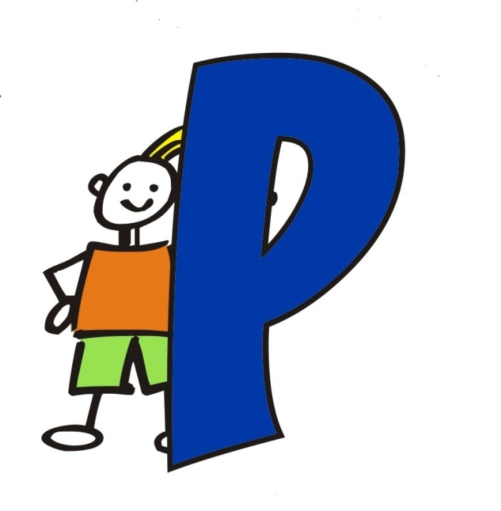

Contact us at the Joshua Center
817-295-6871
Director: Amanda Cogdill
Assistant: Duranda Walentiny

Please initial each of the following stating you have read and understand our parent handbook
____Abuse & Neglect
____Programs (Including Safe Sleep)
____Hours of Operation & Closing Dates
____Food Service & Preparation
____School Safety Policy & Gang Free Zone
____Illness & Health Practices
____Discipline Policy
____Suspension & Expulsion
____Emergency Preparedness Plan
____Personal Belongings
____Documents Needed for Enrollment
____Tuition
____Extra Fees

I have read and understand the parent handbook.

Sign & Date

