St. Paul African Methodist Episcopal Church

The Rev. Robert Hodges, Pastor * Sis. Delores Hodges, First Lady

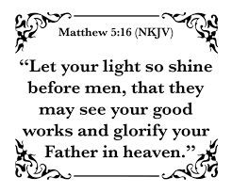 :

WInGS Bible Study - “Women In God’s Service”

January 28, 2023
P. E. (Ret.) Ella Samuels, Teacher
Sis. Paulette Motley, Technical Assistant
Teleconference #: 716-427-1082 * Code: 506451
Opening Prayer  Sis. Robin Starr | Scripture Reader: Sis. Alison Smith  Ephesians 5:8  1Peter 3:15  John 4:39 | Scripture Reader Sis. Diane Tawwab  Ephesians 5:11  John 4:28-29  John 4:42
 | Sis. Daphne Wright | 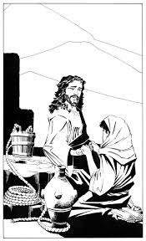
When we receive the Holy Spirit, the light of Jesus – which is the Fruit of the
Spirit or the nature of Christ, comes to live in us. Jesus said: “Let your light so
shine before men, that they may see your good works and glorify your Father in
heaven.” The question is: “What if we don’t want to shine?” “Is this any of us?” If
we refuse to let our light shine; we have chosen to stay in darkness. If we stay
in darkness, we will be condemned along with others who have chosen to live in
darkness. (Sis. Alison Smith: Ephesians 5:8) If we are truly saved, we have been
delivered out of darkness. We are now children of light; therefore, we are to live
as children of light by allowing the Fruit of the Spirit, or the Nature of Christ to
shine through us. (Sis. Diane Tawwab: Ephesians 5:11) As we allow our light to
shine, we will expose that which is darkness, or sinful. If we are servants of the
Most High God, and if we say Jesus lives in us, we must be willing to stand out.
(Sis. Alison Smith: 1Peter 3:15) When others want to know why we are
not participating in a certain behavior, Peter tells us to always be ready
to give a reason for our hope. In other words, Peter is saying - those who
observe us will notice a difference in us. We will look the same, but our
behavior – even when we are suffering or being persecuted will be different.
Our speech, things we participate in, etc. will also be different. We are to be
ready to share the good news of our redemption, through our vocal testimonies
and our visible behavior. There will even be times when our behavior will be more
effective, because as it is said, “Actions speak louder than words.”
C. S. Lewis who, at one time, confessed to be an atheist, but later accepted
Christ and became best known for his works in Christianity, is quoted as saying:
“Don’t shine so others can see you. Shine so that through you, others can see
Him (Jesus)”
In the 4th chapter of John, we meet an unnamed woman. We only know her as
a Samaritan. She was from a race that the Jews did not associate with. She had
had five husbands and she was living with a man who she was not married to.
In her cultural, the women typically gathered, in a group, at the well in the
morning to draw water. This woman came alone in the midday – an indication
that she was an outcast. She had an encounter which led her to believe in Jesus
as the Messiah. (Sis. Diane Tawwab: John 4:28-29) When she came to the well,
her life was a mess, but after her encounter with Jesus – with her faith being only
a few minutes old, she decided to let her light shine. She left her waterpots. Her
past was her past. She was beginning a new life as an ambassador for Jesus. She
began by taking her light into the city to share her redemptive story. (Sis. Alison
Smith: John 4:39) When she invited the people to come see Jesus, I’m sure
they followed her because they saw something different about her, she looked
the same; she still had a history; but there was something different that inspired
them to believe her; leave the city; and follow her to the well where Jesus was.
She led others to find the living water whom she had found, which was Jesus.
(Sis. Diane Tawwab: John 4:42) After the woman led them to Jesus, the people
exercised their personal faith. They realized that Jesus was indeed the Messiah.
They asked Him to stay with them. He stayed two days, and because of His Words,
many others became believers. However, it all started with the Samaritan woman,
whose name was never mentioned, allowing her light to shine.
This is why Jesus tells us to let OUR light shine.

Current Series: “Let Your Light Shine” (Matthew 5:14-16)Jesus said:
Lesson Taught by Presiding Elder Ella Mae Samuels (Retired)

The Closing Prayer | The Parting Peace
Sis. Gloria Feimster | The Leader  The Peace of God be with you. | The People’s Response  And also with you.

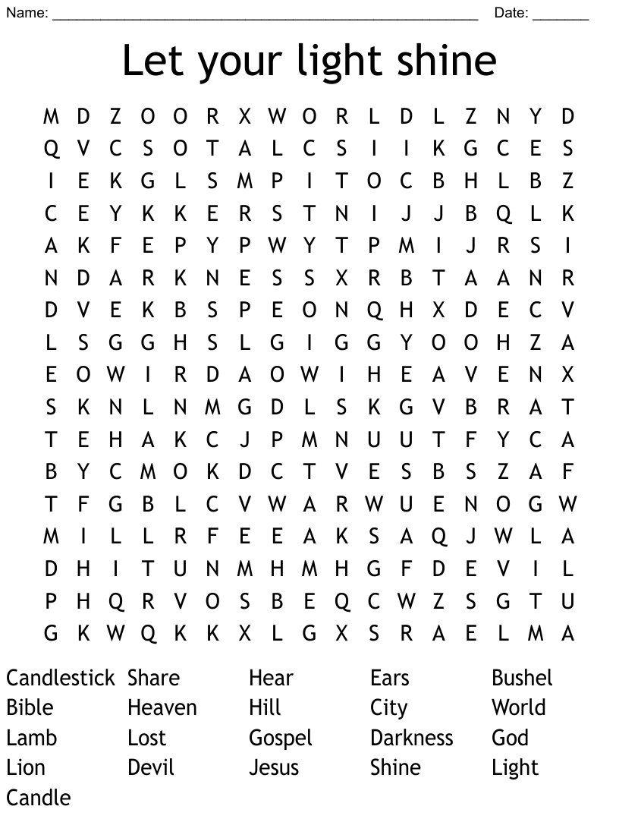
Sis. Alison Smith’s
Introduction Scriptures for January 28, 2023

Ephesians 5:8 * New Century Version
⁸ In the past you were full of darkness, but now you are full of light in the Lord. So live like children who belong to the light.

1 Peter 3:15-16 * Contemporary English Version
¹⁵ Honor Christ and let him be the Lord of your life.
Always be ready to give an answer when someone asks you about your hope.

John 4:39 * Easy-to-Read Version
³⁹ Many of the Samaritan people in that town believed in Jesus. They believed because of what the woman had told them about him. She had told them, “He told me everything I have ever done.”

Sis. Diane Tawwab’s
Introduction Scriptures for January 28, 2023

Ephesians 5:11 * Easy-to-Read Version
¹¹ Have no part in the things that people in darkness do, which produce nothing good. Instead, tell everyone how wrong those things are.

John 4:28-29 * GOD’S WORD Translation
²⁸ Then the woman left her water jar and went back into the city. She told the people, ²⁹ “Come with me, and meet a man who told me everything I’ve ever done. Could he be the Messiah?”

John 4:42 * GOD’S WORD Translation
⁴² They told the woman, “Our faith is no longer based on what you’ve said. We have heard him ourselves, and we know that he really is the savior of the world.”

