|  |  |  |  |  |  |
| --- | --- | --- | --- | --- | --- |
| **MONTH OF JULY 2021 – Toddlers, 2’s, 3’s, 4’s** | | | | | |
|  | **MONDAY** | **TUESDAY** | **WEDNESDAY** | **THURSDAY** | **FRIDAY** |
| **Happy**  **Birthday**  **America** | Circle Time  9:00 am  Handprint  Flag | Circle Time  9:00 am  Make A  Patriotic Necklace | Circle Time  9:00 am  Pom Pom  Flag Painting | 1  Circle Time  9:00 am  Fireworks  Art | 2  CLOSED  FOR  JULY 4TH  Have a safe & fun holiday!! |
| **Sensational**  **Science**  **Week** | 5  CLOSED  FOR  JULY 4TH  Have a safe & fun holiday!! | 6  Circle Time  9:00 am  Fun With  Baking Soda  And Vinegar | 7  Circle Time  9:00 am  Homemade  Slime | 8  Circle Time  9:00 am  Elephant  Toothpaste | 9  Circle Time  9:00 am  Let’s Make  Ice Cream Sundaes!! |
| **Outer Space**  **Week** | 12  Circle Time  9:00 am  Handprint  Alien | 13  Circle Time  9:00 am  Paper Plate  UFO | 14  Circle Time  9:00 am  Galaxy  Playdough | 15  Circle Time  9:00 am  Outer Space  Discovery Bottles | 16  Circle Time  9:00 am    Outer Space  Picture |
| **The World**  **Of**  **Insects** | 19  Circle Time  9:00 am  Bumblebee | 20  Circle Time  9:00 am  Dragonfly | 21  Circle Time  9:00 am  Butterfly | 22  Circle Time  9:00 am  Ladybug | 23  Circle Time  9:00 am  Ants On A  Log |
| **End Of**  **Summer** | 26  Circle Time  9:00 am  Paper Plate  Watermelon | 27  Circle Time  9:00 am  Handprint  Sun | 28  Circle Time  9:00 am  Water Gun  Fun | 29  Circle Time  9:00 am  Marble  Painting | 30  Circle Time  9:00 am  Pizza Party  $3.00 |

C:\Users\robertsondx2@aol.com\AppData\Local\Microsoft\Windows\Temporary Internet Files\Low\Content.IE5\1DQ3VEJ9\MC900015889[1].WMF



[This Photo](https://commons.wikimedia.org/wiki/File:Creative-Tail-rocket.svg) by Unknown Author is licensed under [CC BY-SA](https://creativecommons.org/licenses/by-sa/3.0/)

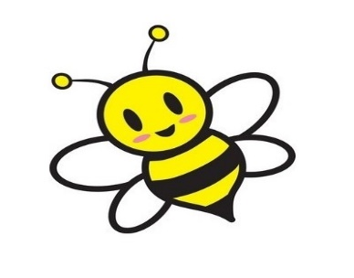

[This Photo](https://commons.wikimedia.org/wiki/File:Tyagibeefarm_logo.jpg) by Unknown Author is licensed under [CC BY-SA](https://creativecommons.org/licenses/by-sa/3.0/)