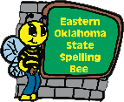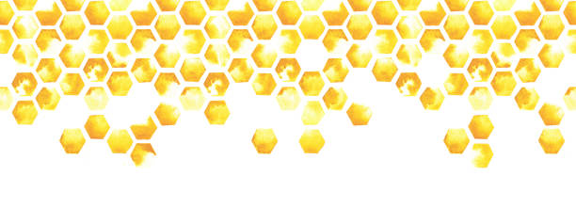

**EOSSB State Spelling Bee**

# For participating in

# (your SCHOOL’S name) Spelling bee

# This certificate is hereby awarded to

Certificate Of participation

John Smith

A.S. 2022-2023 Intern