Eco Orca Class APRIL 2025 Spring and Planting
SUNDAY |  |  | MONDAY | TUESDAY | WEDNESDAY | THURSDAY | FRIDAY | SATURDAY
 |  | 30 | 31 | 1 | 2 | 3 | 4 | 5
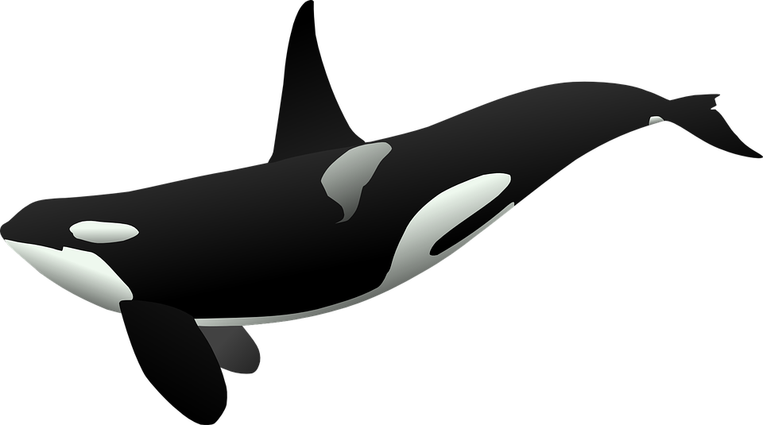 |  |  | Elk Lake Trails  Bug Hunt | Pink Elephant Park | Humpback Park | Sooke Pothole’s  Pebble Beach | Butterfly Garden $5 | 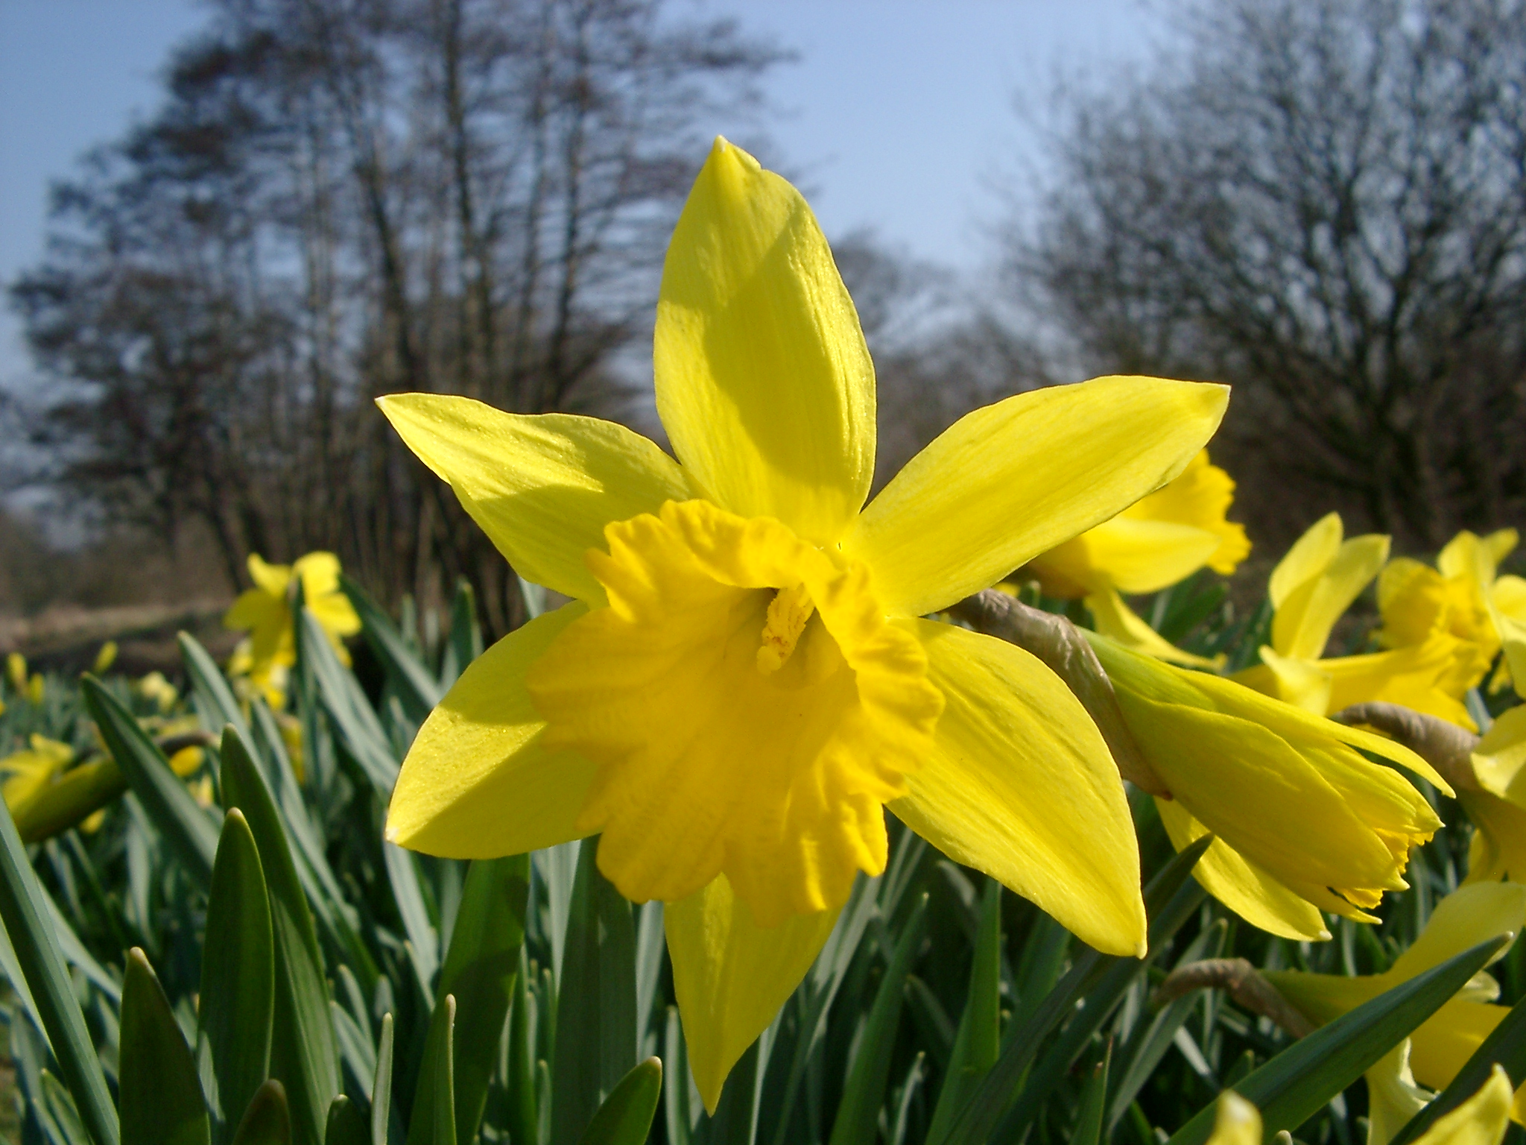  This Photo by Unknown Author is licensed under CC BY
 | 6 |  | 7 | 8 | 9 | 10 | 11 | 12
 |  |  | Swan Lake Trails | Beacon Hill Petting Farm $3 | Taylor  Beach | 9-11am Class Time Only | Pro Day  No Class
 | 13 |  | 14 | 15 | 16 | 17 | 18 | 19
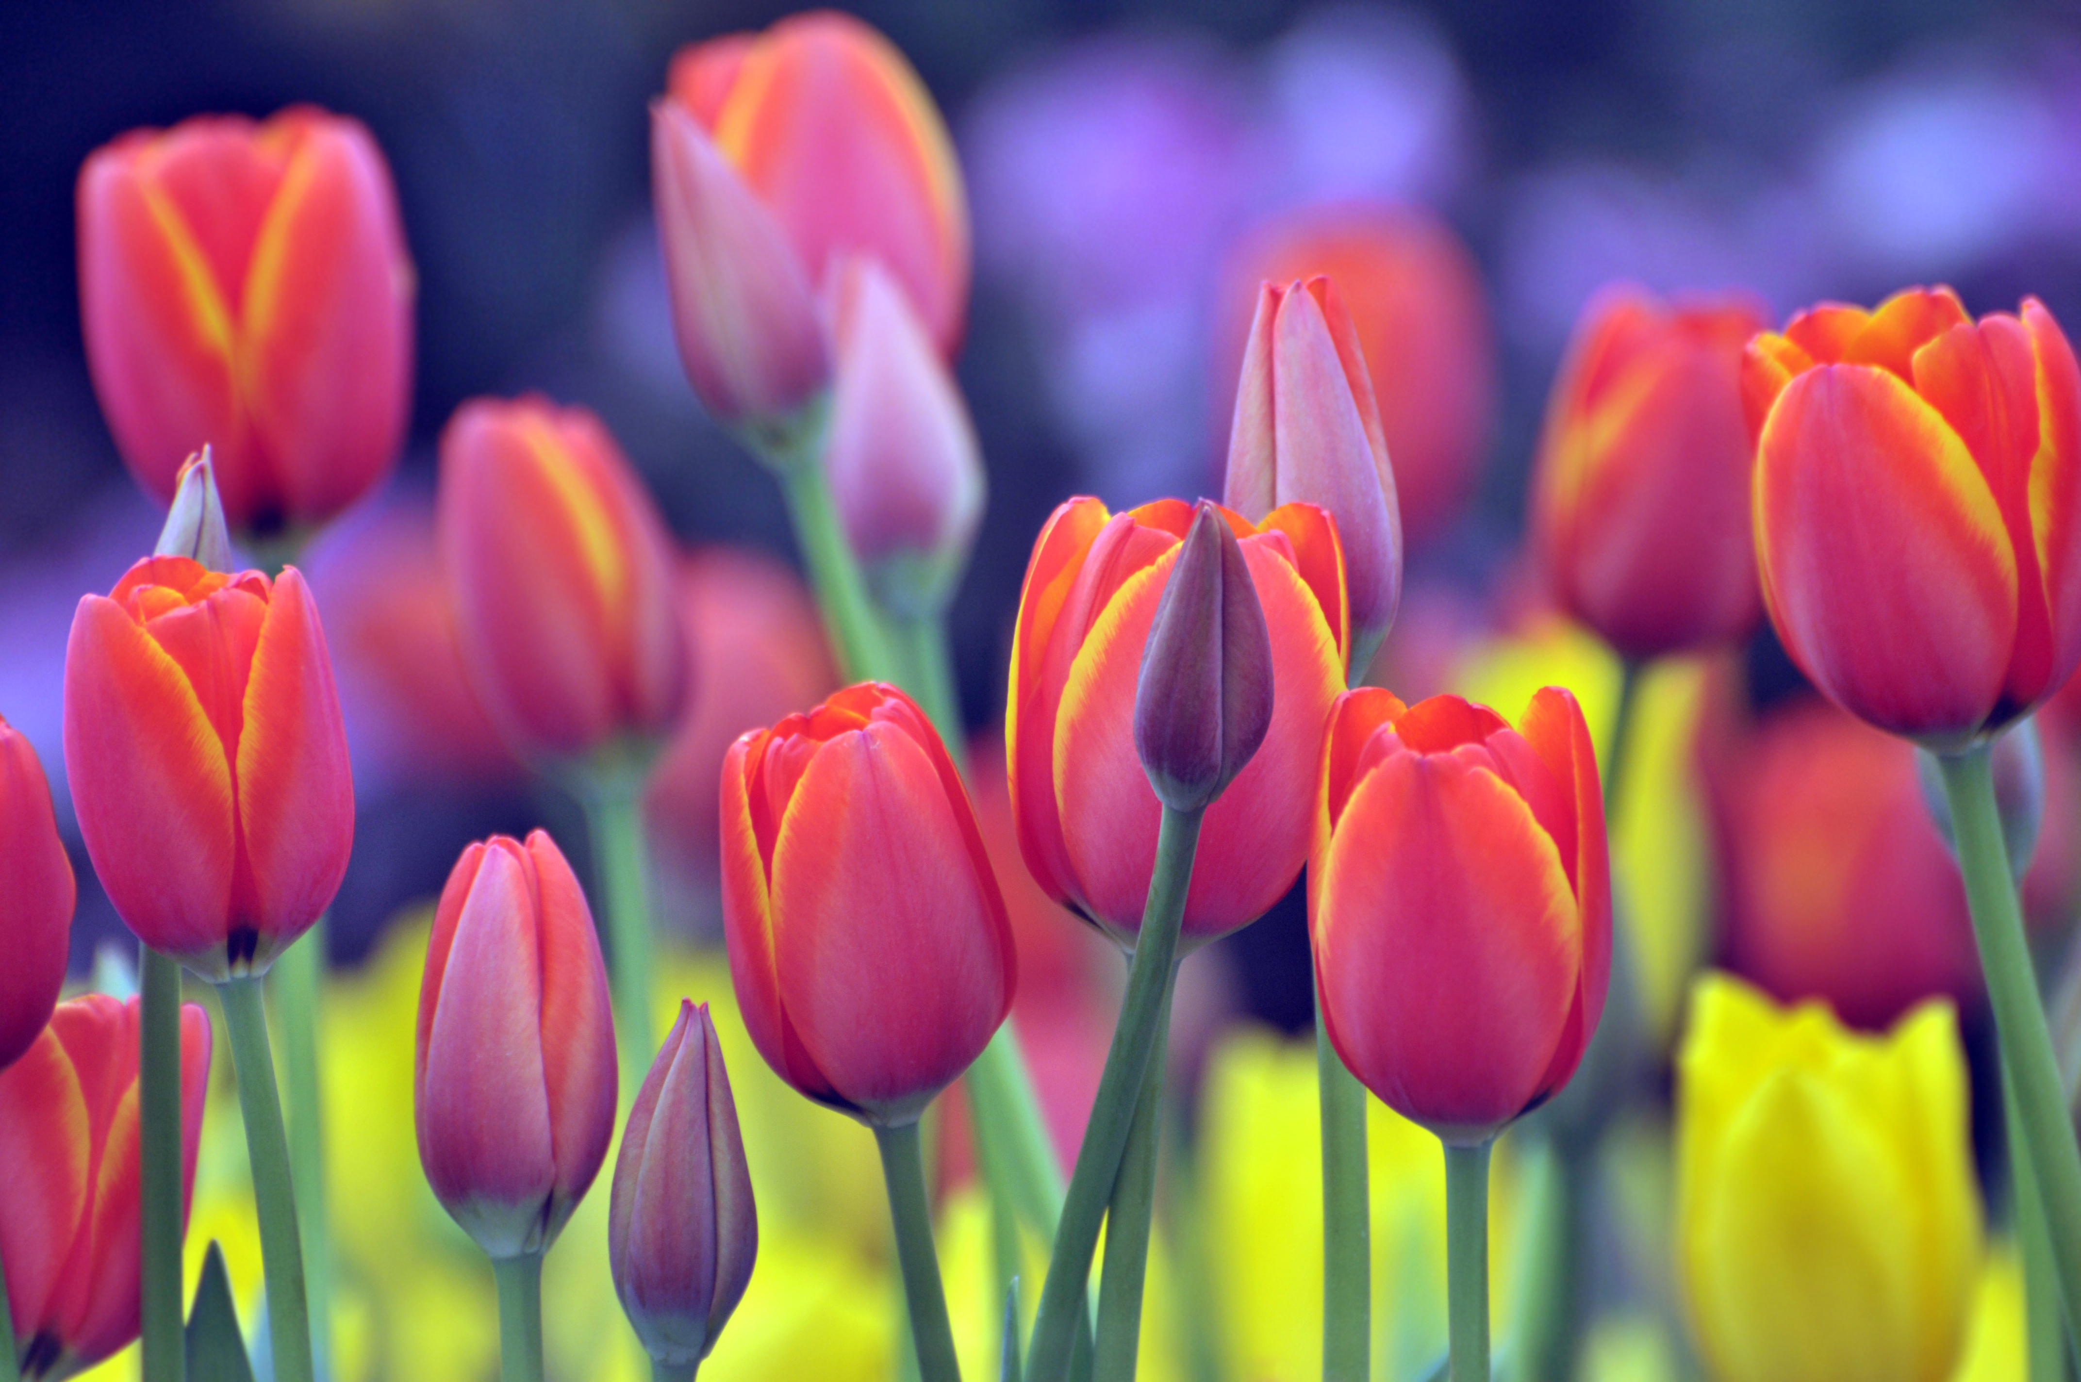 |  |  | Beaver Lake Trails | Humpback Water Shed | Westhills  Park | Compost Centre $5 | Closed  Good Friday | 
 | 20 |  | 21 | 22 | 23 | 24 | 25 | 26
Easter Sunday |  |  | Closed  Easter Monday | Central Saanich Park | Goldstream Nature House $2 | Colwood Creek Park | Gorge Japanese Garden
 | 27 |  | 28 | 29 | 30 | 1 | 2 | 3
 |  |  | Island View Beach | Sooke  Murray Rd Docks | View Royal Park | Sooke  Ed Magregor Docks |  | 