There are over 20 events occurring next month that have some bible students watching and concerned.

One example: on September 28 the last total lunar eclipse of the current lunar tetrad series will occur. The next lunar tetrad (uninterrupted series of 4 lunar eclipses) on YaHuWaH 's Feasts of Passover and Tabernacles will be over 500 years in the future.

Double Trouble
Double events are mentioned in relation to the judgments poured upon end times Babylon by YaHuWaH Elohim. Modern Babylon the Great, economic center of the world, is identified as New York City in particular and the United States of America in general.
Revelation 14:8 And there followed another angel, saying, Babylon is fallen, is fallen, that great city, because she made all nations drink of the wine of the wrath of her fornication.
Notice the twin wording "is fallen, is fallen" in Revelation 14:8 above would relate to the twin towers falling on 9/11/2001.
Please be aware that 7 Hebrew Calendar years and 7 days after 9/11/2001, on 9/29/2008, the DJIA on the New York Stock Exchange closed at 777 points down for the day.
1260 Days after 9/29/2008, on 3/12/2012 a coronal hole on the sun was photographed by NASA. Straight lines like the sides of the triangle are rarely found in nature.
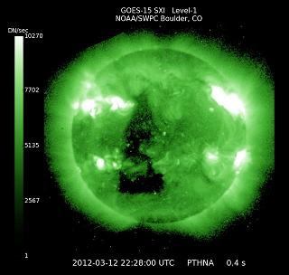
Triangular Coronal Hole on the Sun 3/12/2012
1290 days after the Triangular Sign on the Sun above, on 9/23/2015, Pope Francis is scheduled to meet with President Obama in the White House.
9/23/2015 is the Hebrew Day of Atonement. The Day of Atonement is the most solemn day in the Hebrew year and the only day of the entire year that YaHuWaH Elohim commands His people to fast.
Double Sevens and Double Judgment
Revelation 18:4 And I heard another voice from heaven, saying, Come out of her, My people, that ye be not partakers of her sins, and that ye receive not of her plagues.
5 For her sins have reached unto heaven, and YaHuWaH hath remembered her iniquities.
6 Reward her even as she rewarded you, and double unto her double according to her works: in the cup which she hath filled fill to her double.
Please be aware that the official long term goal of the Catholic Church is to rule the world.

On 9/24/2015 Pope Francis is scheduled to address both houses of the United States Congress. This will be the first time in history that a Pope has addressed Congress. We need to be aware that 9/24/2015 is precisely 14 years and 14 days inclusive (on the 14th day) after 9/11/2001.
On 9/25/2015 Pope Francis is scheduled to address the United Nations in New York City, the site of the 9/11 attacks, 14 years and 14 days after 9/11/2001, a doubling of sevens.

This doubling of sevens timeline may indicate the application of another severe judgment upon end times Babylon the Great.

Pope Francis is the first Jesuit Pope in history. The Jesuits are a secretive military branch of the Vatican that covertly infiltrates governments, churches, and societies. It's a historical fact that when the Pope ruled parts of Europe 400+ years ago millions of people were murdered for rejecting Catholic theology.

Additional info available here: http://www.joybysurprise.com/Alerts_Page.html

