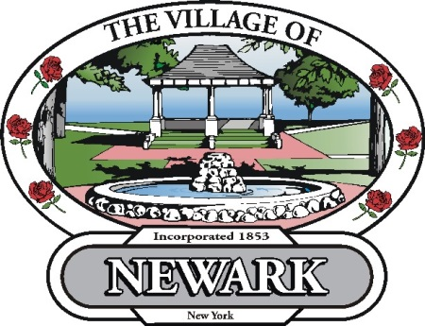

Village Of Newark
2014
Spring Brush Pickup
April 14- May 16
The following items will be picked up;
- Tree limbs (up to 6”diameter and 3’ long
- Limited leaves (please wait until leaves are picked up)
- Grass Clippings
- Shrubbery trimmings
- Similar brush material
The village will not pick up boards, logs, furniture, boxes, cardboard, or metal objects of any kind
Please Do Not deposit material on pavement.
The Village of Newark DPW, 100 Wood Lane is open to accept material in our drop off designated area.

