WELCOME TO
HOLY SPIRIT LUTHERAN CHURCH
A Member of the Evangelical Lutheran Church in America, New Jersey Synod
1220 Bayshore Rd., Villas, NJ 08251, 609-886-2414,
holyspiritlutheran@comcast.net, holyspiritvillas.com, facebook.com/holyspiritvillas
Vicar Vince Piekarski can be contacted at any time for conversation or prayer through call or text at 412-225-0287, or through email at vpie8282@gmail.com.
SUNDAY, FEBRUARY 1ST, 2026
FOURTH SUNDAY AFTER EPIPHANY
10:30AM WORSHIP SERVICE WITH HOLY COMMUNION


We, the Evangelical Lutheran Church of the Holy Spirit, are People of God, who
are called by the Holy Spirit to pray, worship, joyfully proclaim Jesus Christ,
and compassionately witness and serve others in Christian Love.


We are glad that you joined us for Worship today! Thank you for enriching our time together! We would like to get to know you better, and for you to get to know us better too. Brochures, welcome gifts, prayer shawls, Bibles, and other items are available throughout the church. We would be happy to show you around and share about our ministries. Please do not hesitate to speak up and ask questions.
Also, please make sure you sign-in on our clipboard on the podium in the lobby.


Our Worship Services are conducted in coordination with our Conference Call.
Join us at 657-390-7423 or 701-802-5170, with access code 8221190#.
You may need to dial 1 first depending on your phone plan. After logging in please announce your name and feel free to talk with others until we get started.


SANCTUARY CANDLE FOR FEBRUARY
Given to the Glory of God & In Memory of JAMES P. ROONEY
by Del McKenna & Children.
ALTAR CANDLES FOR FEBRUARY
Given to the Glory of God & In Memory of CLAIRE MILLER
by Jean, Phil, & Bob Zimmerman.
CONFERENCE CALL CHECK-IN, WELCOME, & ANNOUNCEMENTS
(Vicar (V), Assistant (A), Reader (R), and Congregation (C).)

INTRODUCTION
A. Who are the blessed ones of God? For Micah, they are those who do justice, love
kindness, and walk humbly with God. For Paul, they are the ones who find
wisdom in the weakness of the cross. For Jesus, they are the poor, the meek, the
merciful, the pure in heart, the peacemakers, those who mourn, and those who
hunger for righteousness. In baptism we find our blessed identity and calling in
this countercultural way of living and serving.

PRELUDE
(Music offered by our Organist at the start of our Worship Service.)
Glorified, Blessed, and Worthy

CHIMES
(Music offered by our Organist at the start of our Worship Service.)
Alleluia

V. We invite you to stand as you are able.

CONFESSION & FORGIVENESS
(All may make the sign of the cross, the sign that is marked at baptism.)
V. Blessed be the holy Trinity, ☩ one God,
the Creator of heaven and earth,
the Word who spoke life into being,
the Wind stirring the waters.
C. Amen.

V. Let us turn in confession to the one who knows us completely.

(Silence is kept for reflection.)

V. Mighty God, lover of justice,
C. you call us to life in community,
but we have served our own interests at the expense of our neighbors.
We have sown deceit where honesty was needed.
We say the right words, but our hearts are far from you.
Turn us to seek your face.
Knit us together and give us the mind of Christ,
that we may do justice, love mercy,
and walk humbly with you, our God.
Amen.

V. The former things have passed away,
and new things God now declares:
Like a spring of water that never fails,
God covers you in the righteousness of Christ,
and forgives your sin in ☩ Jesus’ name.
May the Spirit give you strength to live for others,
and bless you with the gift of peace.
C. Amen.

GATHERING HYMN
(We invite you to sing along.)
Lutheran Book of Worship—Green Book
82—As with Gladness Men of Old
(4 Verses)

APOSTOLIC GREETING
V. May the grace of our Lord Jesus Christ, the love of God,
and the communion of the Holy Spirit be with you all.
C. And also with you.

KYRIE
V. In peace, let us pray to the Lord.
C. Lord, have mercy.

V. For the peace from above, and for our salvation, let us pray to the Lord.
C. Lord, have mercy.

V. For the peace of the whole world, for the well-being of the church of God,
and for the unity of all, let us pray to the Lord.
C. Lord, have mercy.

V. For this holy house, and for all who offer here their worship and praise,
let us pray to the Lord.
C. Lord, have mercy.

V. Help, save, comfort, and defend us, gracious Lord.
C. Amen.

HYMN OF PRAISE
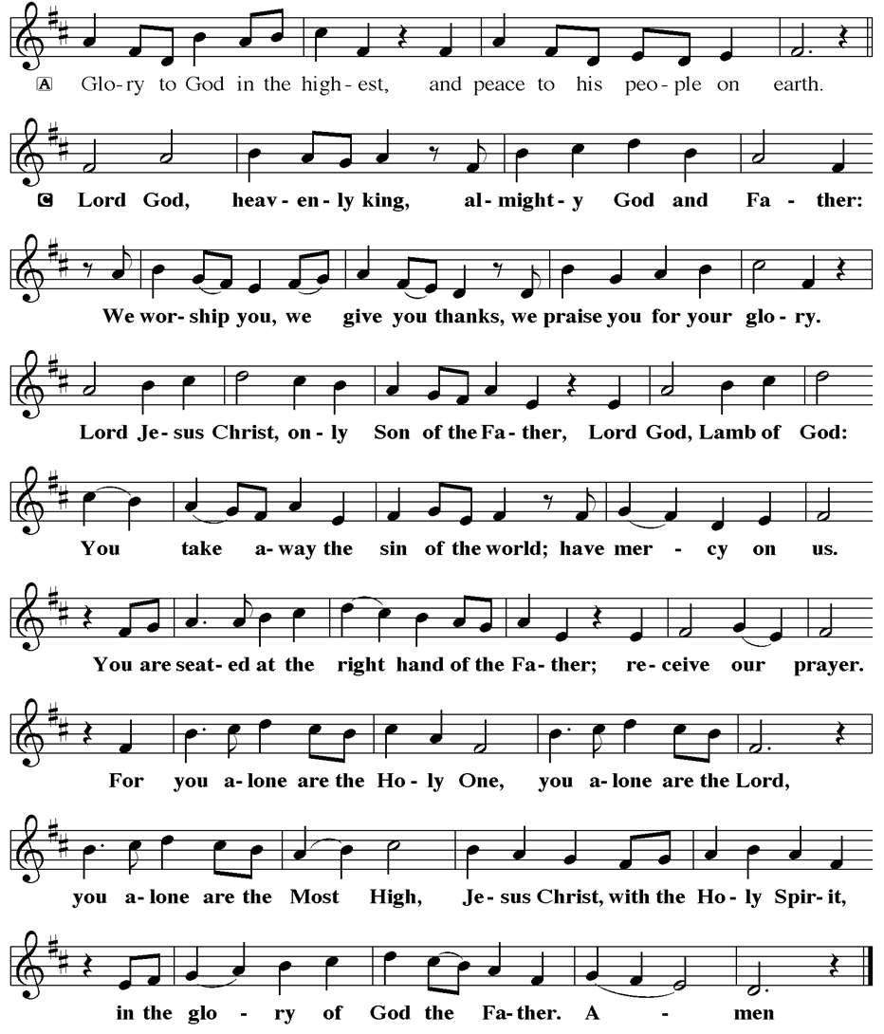
PRAYER OF THE DAY
V. The Lord be with you.
C. And also with you.

V. Let us pray,
Holy God, you confound the world’s wisdom in giving your kingdom to the lowly
and the pure in heart. Give us such a hunger and thirst for justice, and
perseverance in striving for peace, that in our words and deeds the world may
see the life of your Son, Jesus Christ, our Savior and Lord.
C. Amen.

(We invite you to be seated for our Readings and Psalm.)

FIRST READING
With the mountains and the foundations of the earth as the jury, God brings a
lawsuit against Israel. God has “wearied” Israel with a long history of saving acts.
God does not want or expect lavish sacrifices to attempt to earn divine favor.
Rather God empowers the people to do justice, to love loyalty to God, and to
walk shrewdly in God’s service.

R. Our First Reading is from the 6th Chapter of Micah (Verses 1-8).

R. 1 Hear what the Lord says:
Rise, plead your case before the mountains,
and let the hills hear your voice.
2 Hear, you mountains, the case of the Lord,
and you enduring foundations of the earth,
for the Lord has a case against his people,
and he will contend with Israel.

3 “O my people, what have I done to you?
In what have I wearied you? Answer me!
4 For I brought you up from the land of Egypt
and redeemed you from the house of slavery,
and I sent before you Moses,
Aaron, and Miriam.
5 O my people, remember now what King Balak of Moab devised,
what Balaam son of Beor answered him,
and what happened from Shittim to Gilgal,
that you may know the saving acts of the Lord.”

6 “With what shall I come before the Lord
and bow myself before God on high?
Shall I come before him with burnt offerings,
with calves a year old?
7 Will the Lord be pleased with thousands of rams,
with ten thousands of rivers of oil?
Shall I give my firstborn for my transgression,
the fruit of my body for the sin of my soul?”
8 He has told you, O mortal, what is good,
and what does the Lord require of you
but to do justice and to love kindness
and to walk humbly with your God?

R. This is the Word of the Lord.
C. Thanks be to God.

PSALM
R. Our Responsorial Psalm is from the 15th Psalm.
C. Lord, who may abide upon your holy hill? (Ps. 15:1)

R. 1 Lord, who may dwell in your tabernacle?
Who may abide upon your holy hill?
2 Those who lead a blameless life and do what is right,
who speak the truth from their heart;
C. Lord, who may abide upon your holy hill? (Ps. 15:1)

R. 3 they do not slander with the tongue, they do no evil to their friends;
they do not cast discredit upon a neighbor.
4 In their sight the wicked are rejected, but they honor those who fear the Lord.
They have sworn upon their health and do not take back their word.
5 They do not give their money in hope of gain,
nor do they take bribes against the innocent.
Those who do these things shall never be overthrown.
C. Lord, who may abide upon your holy hill? (Ps. 15:1)

SECOND READING
According to the world’s standards of power and might, the message of the cross
seems stupid and offensive. Yet this word reveals the paradoxical way God has
chosen to work power and salvation through weakness, rejection, and suffering.
Hence the message of the cross becomes true wisdom and power for believers.

R. Our Second Reading is from the 1st Chapter of 1st Corinthians (Verses 18-31).

R. 18 The message about the cross is foolishness to those who are perishing, but to
us who are being saved it is the power of God. 19 For it is written,
“I will destroy the wisdom of the wise,
and the discernment of the discerning I will thwart.”
20 Where is the one who is wise? Where is the scholar? Where is the debater of
this age? Has not God made foolish the wisdom of the world? 21 For since, in the
wisdom of God, the world did not know God through wisdom, God decided,
through the foolishness of the proclamation, to save those who believe. 22 For
Jews ask for signs and Greeks desire wisdom, 23 but we proclaim Christ
crucified, a stumbling block to Jews and foolishness to gentiles, 24 but to those
who are the called, both Jews and Greeks, Christ the power of God and the
wisdom of God. 25 For God’s foolishness is wiser than human wisdom, and
God’s weakness is stronger than human strength.

26 Consider your own call, brothers and sisters: not many of you were wise by
human standards, not many were powerful, not many were of noble birth. 27 But
God chose what is foolish in the world to shame the wise; God chose what is
weak in the world to shame the strong; 28 God chose what is low and despised in
the world, things that are not, to abolish things that are, 29 so that no one might
boast in the presence of God. 30 In contrast, God is why you are in Christ Jesus,
who became for us wisdom from God, and righteousness and sanctification and
redemption, 31 in order that, as it is written, “Let the one who boasts, boast in the
Lord.”

R. This is the Word of the Lord.
C. Thanks be to God.

V. I invite you to stand as you are able to announce the Gospel Acclamation.

GOSPEL ACCLAMATION
C. Alleluia. Rejoice and be glad, for your reward is great in heaven. Alleluia.
(Matt. 5:12)
GOSPEL READING
Jesus opens the Sermon on the Mount by naming those who are blessed in the
reign of God.

V. The Holy Gospel According to Matthew, the 5th Chapter (Verses 1-12).
C. Glory to you, O Lord.

V. 1 When Jesus saw the crowds, he went up the mountain, and after he sat down,
his disciples came to him. 2 And he began to speak and taught them, saying:
3 “Blessed are the poor in spirit, for theirs is the kingdom of heaven.
4 “Blessed are those who mourn, for they will be comforted.
5 “Blessed are the meek, for they will inherit the earth.
6 “Blessed are those who hunger and thirst for righteousness,
for they will be filled.
7 “Blessed are the merciful, for they will receive mercy.
8 “Blessed are the pure in heart, for they will see God.
9 “Blessed are the peacemakers, for they will be called children of God.
10 “Blessed are those who are persecuted for the sake of righteousness,
for theirs is the kingdom of heaven.
11 “Blessed are you when people revile you and persecute you and utter all
kinds of evil against you falsely on my account. 12 Rejoice and be glad, for
your reward is great in heaven, for in the same way they persecuted the
prophets who were before you.”

V. This is the Gospel of the Lord,
C. Praise to you, O Christ.

(We invite you to be seated.)

SERMON
(Delivered by Vicar Vince Piekarski.)

(Following the Sermon, we invite you to stand as you are able.)

HYMN OF THE DAY
(We invite you to sing along.)
Lutheran Book of Worship—Green Book
383—Rise Up, O Saints of God!
(4 Verses)

APOSTLES’ CREED
V. God has made us his people through our Baptism into Christ. Living together in
trust and hope let us confess our faith together using the Apostles’ Creed.
C. I believe in God, the Father almighty,
creator of heaven and earth.

I believe in Jesus Christ, God’s only Son, our Lord,
who was conceived by the Holy Spirit,
born of the Virgin Mary,
suffered under Pontius Pilate,
was crucified, died, and was buried;
he descended to the dead.
On the third day he rose again;
he ascended into heaven,
he is seated at the right hand of the Father,
and he will come to judge the living and the dead.

I believe in the Holy Spirit,
the holy catholic church,
the communion of saints,
the forgiveness of sins,
the resurrection of the body
and the life everlasting.
Amen.

PRAYERS OF INTERCESSION
V. As God’s beloved children united in Christ, let us pray for the church, the whole
human community, and the well-being of the earth, our home.

(A brief silence.)

A. God our wisdom, renew the church in the power of the Spirit, that it may do
justice, love kindness, live humbly, and boldly proclaim Christ crucified. We pray
for social justice and humanitarian aid ministries. Merciful God,
C. receive our prayer.

A. God our source, we honor you by caring wisely for your creation. We pray for the
health of old growth forests, ice caps, and ocean currents. Preserve the diversity
of life on earth. Merciful God,
C. receive our prayer.

A. God our righteousness, raise up visionary leaders who serve with integrity and
respect human rights. Increase freedom in every nation. Protect educators,
journalists, artists, and religious activists who are reviled for speaking truth.
Merciful God,
C. receive our prayer.

A. God our advocate, you give hope to all who suffer because of persecution,
poverty, or war. Reunite separated families and bring orphaned children to safety.
Comfort any who grieve or suffer in any way; especially:
BettyAnn Rich-White (Church Member)
Chip & Marie Hand (Church Members)
Lynn Bargstadt (Church Member)
Frank Ford (Church Member)
Carol Amundsen (Church Member)
Kim McGinley (Church Member)
Anthony DeLuca (Church Member)
Frank Brunner (Church Member)
Joan Sommerman (Church Family)
Arleen Kinka (Church Family)
Rick Lang (Church Family)
Suzie Clark (Rose Lang's Friend)
Francis Clock (Dianna DeNote’s Family)
Andrew Hudak (Rose Lang’s Friend)
Viena Murtha (Bob Fritsch’s Friend)
Sharon Waicus (Skip & Bonnie Millard's Friend)
Karen O'Brien (Paul Bowker's Friend)
Dustin Irizzary (Mary Melnicoff's Family)
The Bryan Family (Wanda Bryan's Family)
Craig Brearey (Judy Brannan & Mary Melnicoff's Friend)
Sarah Dutton (Frank Ford's Family)
Christina McNasby (Fran Green’s Family)
Mark Stephen Dennis (Diana DeNote's Family)
Bill Lodge (Skip & Bonnie Millard's Friend)
Ron Anderson (Bill Kelly's Friend)
Bud Brearey (Judy Brannan & Mary Melnicoff's Friend)
Mary Skain (Kathy Poehler's Friend)
Robert Chaplin (Mary Melnicoff's Friend)
Jack Wieckouski (Theresa & Kim McGinley's Family)
Carolyn Santarpio (Bob Fritsch's Friend)
Harry (Judy Brannan's Friend)
Janet K (Philomena Noak's Friend)
Michael Hart (Diana DeNote's Friend)
Rocco Leonard DeNote (Diana DeNote's Family)
Sherri Lynn (Bob Fritsch's Friend)
John Bannco (Bob Fritsch's Friend)
Nancy Pazarinie (Bob Fritsch's Family)
Jane & Paul Eiben (Rose Lang's Friend)
Joe DiMassimo (Judy Brannan & Mary Melnicoff's Friend)
Denny Papst (Rose Lang’s Friend)
Mike & Alice Rhoades (Rose Lang’s Friends)
Chris (Judy Brannan's Friend)
Helen Ehlers (Judy Brannan's Friend)
Leanne Bueth (Joan Kilcoyne's Family)
Janett MacFarlane (Carol Amundsen's Friend)
Thish Kelly (Theresa & Kim McGinley's Family)
Edward Chapleski (Allison Call's Family)
Scott Levin (Rose Lang's Friend)
Alice Ann Dennis (Diana DeNote's Family)
Nancy Taylor (Ted & Diane Bell's Family)
Santa Isabel Lutheran Church (Elizabeth, NJ)
Messiah Lutheran Church (Oakland, NJ)
Joyce Thompson (TDPWC Member)
Barbara Paynter (Leon Stitt’s Family)
Ruth (Anthony & Vincent Bruno's Family)
William T Hodgetts (Pastor William Hodgetts’ Family)
Paul Bowker (Church Member)
BettyAnn & Bill Whitman (Mary Melnicoff's Friends)
Bob Poole (Kathy Poehler's Family)
David Smith (Heather & Vicar Vince Piekarski’s Family)
Joe Smith (Heather & Vicar Vince Piekarski's Family)
Barbara Hoitink (Lucas & Sabrina Munson's Family)
Kathy Raynor (Philomena Noak & Mary Melnicoff’s Friend)
Jordan (Carol Amundsen's Friend)
Jeremy Pochatko (Vicar Vince Piekarski's Friend)
Ann Wieckouski (Theresa & Kim McGinley's Family)
Rich (Kim McGinley's Friend)
Gloria Sutton (Church Member)
Elizabeth McCafferty (Mary Melnicoff's Friend)
Amy Johnson (Ted Bell's Sister)
Jerry & Marlana (Carol Amundsen's Friend)
Theresa Dolan (Joan Kilcoyne's Family)
Sandy Bloomberg (Judy Brannan's Family)
Simon (Carol Amundsen's Family)
Chuck & Carol Pearson (Carol Amundsen’s Friends)
Jane Dougherty (Carol Amundsen's Friend)
Bill Ransing & Family (Frank Ford’s Friends)
Barbara Brosius (Philomena Noak's Friend)
Barbara Schmiedel (Bob Fritsch's Family)
Cathy Bell (Ted & Diane Bell's Family)
Doreen Kinzler (Church Member)
(Additional Names Added Prior to the Worship Service.)
A. Merciful God,
C. receive our prayer.

A. God our blessing, we pray for the children and youth of this congregation, and for
parents, grandparents, mentors, teachers, and youth ministers who model love
for their neighbor and care for others. Merciful God,
C. receive our prayer.

A. God our joy, we give thanks for the lives of those before us who journeyed
humbly with you. Merciful God,
C. receive our prayer.

(Here other intercessions may be offered.)

V. Watch over all of us who are worried and suffering, and especially those whose
names we now say aloud or hold within our hearts (pause). Merciful God,
C. receive our prayer.

V. Confident that the Holy Spirit receives our prayers and answers us, we commend
all for whom we pray to God’s loving-kindness made known to us in Christ Jesus
our Savior.
C. Amen.

SHARING OF THE PEACE
V. May the peace of the Lord be with you always.
C. And also with you.
V. Now, let us share God’s Peace with one another.



(Please respect your neighbor if they desire to still only offer a peace sign or wave.)

(Following the Sharing of the Peace, we invite you to be seated.)

OFFERING
V. We now worship God with our tithes and offerings, wine and bread for use in holy
communion, and monetary gifts to support our ministry for service in God’s name.
Our Ushers will be around to your pews to pass the Offering Plates.

(Ushers come forward to get the Offering Plates from the Assistant.)

(Vicar and Assistant prepare the Altar for Communion.)

OFFERING SONG
(We invite you to sing along.)
Worship & Praise
156—What Have We to Offer?
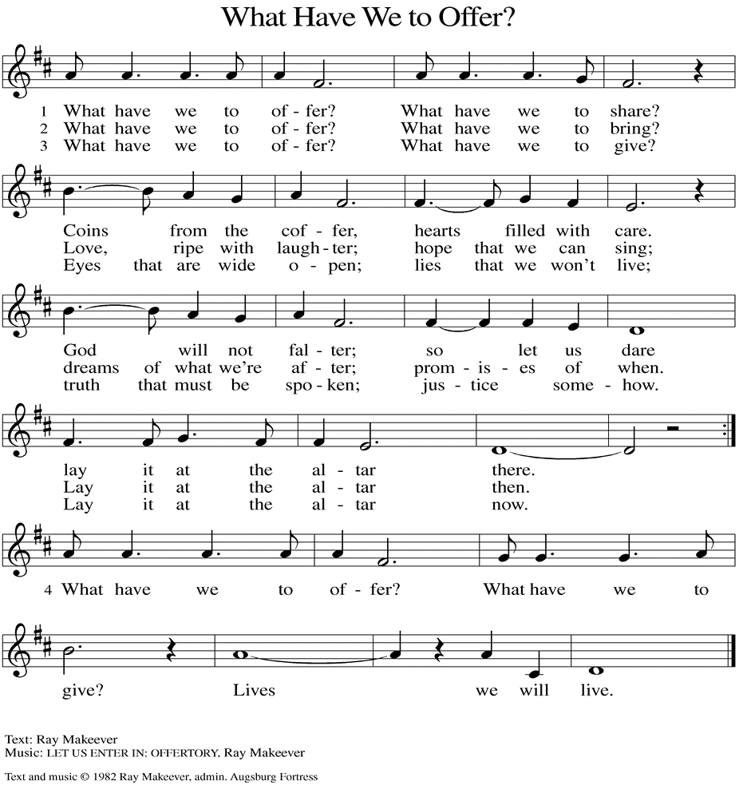
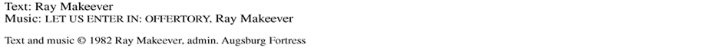

(Usher(s) brings the Tithes and Offerings up front to the Assistant.)

V. We invite you to stand as you are able.

OFFERING PRAYER
V. Let us pray,
God of majesty,
no eye has seen, no ear has heard
what you have prepared for those who love you,
yet in this meal you reveal the wideness of your mercy.
Use what we have gathered
to feed us with the reign of God come near,
Jesus Christ, our Savior and Lord.
C. Amen.

GREAT THANKSGIVING
V. The Lord be with you.
C. And also with you.

V. Lift up your hearts.
C. We lift them to the Lord.

V. Let us give thanks to the Lord our God.
C. It is right to give him thanks and praise.

V. It is indeed right and salutary that we should at all times and in all places offer
thanks and praise to you, O Lord, holy Father, through Christ our Lord; who rose
beyond the bounds of death and, as he promised, poured out your Spirit of life
and power upon the chosen disciples. At this the whole earth exults in boundless
joy. And so, with the Church on earth and the hosts of heaven, we praise your
name and join their unending hymn:

SANCTUS
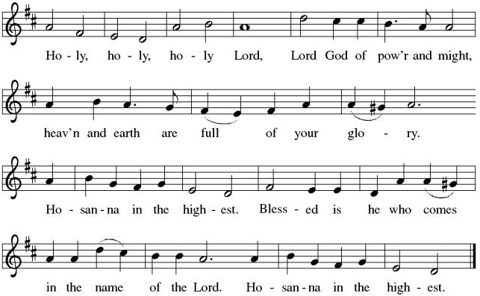

THE EUCHARISTIC PRAYER
V. Blessed are you, Lord of heaven and earth, in mercy for our fallen world you gave
your only Son, that all those who believe in Him should not perish, but have
eternal life. We give thanks to you for the salvation you have prepared for us
through Jesus Christ. Send now your Holy Spirit into our hearts that we may
receive our Lord with a living faith as He comes to us in His holy supper.
C. Amen. Come, Lord Jesus.

V. In the night in which he was betrayed our Lord Jesus took bread,
he gave thanks; broke it, and gave it to his disciples, saying:
Take and eat; this is my body, given for you.
Do this for the remembrance of me.

V. Again, after supper, He took the cup, he gave thanks,
and gave it for all to drink, saying:
This cup is the new covenant in my blood,
shed for you and for all people for the forgiveness of sin.
Do this for the remembrance of me.

THE LORD’S PRAYER
(We ring the bell throughout the Lord’s Prayer at all services to
invite those in the community to join in praying the Lord’s Prayer.)
V. May we now join with one another and pray together as Jesus has taught us.
C. Our Father, who art in heaven, hallowed be thy name, thy kingdom come,
thy will be done, on earth as it is in heaven. Give us this day our daily
bread; and forgive us our trespasses, as we forgive those who trespass
against us; and lead us not into temptation, but deliver us from evil. For
thine is the kingdom, and the power, and the glory, forever and ever.
Amen.

LAMB OF GOD

(We invite you to be seated.)

HOLY COMMUNION
V. Communion here is pretty simple, and all who are baptized and believe in Jesus
Christ are welcome at the table.

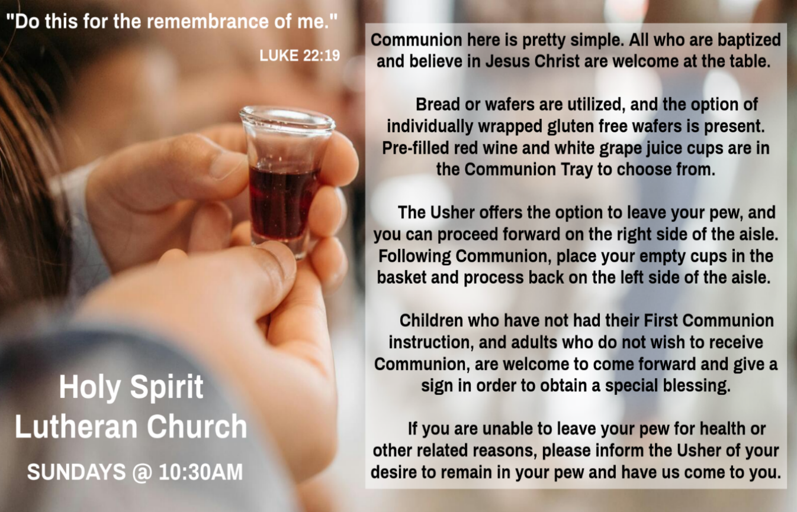

INVITATION TO COMMUNION
V. Here is the Lamb of God who takes away the sin of the world!
Come to the table; taste and see.
C. Amen.

(Distribution of Holy Communion)

COMMUNION HYMN
(Please enjoy various music offered by our Organist during your
quiet time, prayer, and reflection following Holy Communion.)

(Vicar and Assistant remove Communion Vessels from the Altar.)

V. We invite you to stand as you are able.

POST COMMUNION BLESSING
V. May the body and blood of our Lord Jesus Christ strengthen us and keep us
always in His grace.
C. Amen.
POST COMMUNION CANTICLE
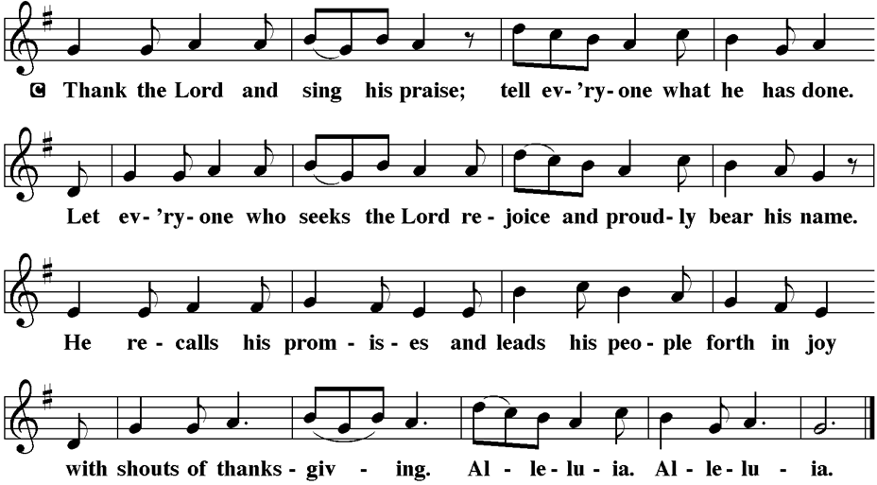

PRAYER AFTER COMMUNION
A. Let us pray,
Radiant God,
we have seen your glory in the face of Jesus Christ.
In the sacrament of his body and blood
you have drawn us to your heart.
Send us from this table with delight,
that our lives may reflect the beauty of your love,
and bear witness to all we have seen and heard,
through Jesus Christ, our Savior and Lord.
C. Amen.

BLESSING
V. May the triune God,
who has put a new song in your mouth
and tuned your heart for praise
☩ bless you now and forever.
C. Amen.

SENDING HYMN
(We invite you to sing along.)
With One Voice—Blue Book
723—The Spirit Sends Us Forth to Serve
(4 Verses)

(Assistant extinguishes the Altar Candles half way through the Sending Hymn.)

(Vicar processes out once the Altar Candles have been extinguished.)

(We invite you to be seated.)

BIRTHDAYS, ANNIVERSARIES, & ANNOUNCEMENTS
(Offered by Assistant and Congregation.)

BIRTHDAY
2nd Chrissy Thomas

DISMISSAL
A. Go in peace. Do justice. Love mercy.
C. Thanks be to God.

POSTLUDE
(Music offered by our Organist as we depart following our Worship Service.)
All Praise to Thee

LICENSES & EXPIRATION DATES
Worship Service Content is used via permission through Augsburg Fortress Liturgies Annual License #SB144368. The next Subscription Renewal Date is 2/28/2026.
Our Hymns and Worship Music are used via permission through CCLI One
License #11327166. The next Subscription Renewal Date is 1/31/2027.


CONFIRMATION & SUNDAY SCHOOL
“Here We Stand” allows our young folks to go through a 2-year process while focusing on the Bible and Luther’s Small Catechism. Studies for year two of our program have resumed. Classes are on Sundays from 9-10AM.

WORSHIP MINISTRY
The most important thing we do each week is gather together as God's people to Worship. God is the center and focus of everything we do. Participating in Worship is active, as Liturgy means the work and actions of the people gathered. Everything we do during the week to prepare for Worship, and everything we do as we Assist in leading Worship is important. We are thankful for all the wonderful work being done. If you have questions, or are interested in any position, reach out to Vicar Vince.
Sign-up sheets are located on the bulletin board between the church offices.

PREACHING AT BROOKDALE
Vicar Vince will be preaching at Brookdale Senior Living in Cape May Court House, TODAY, Sunday, February 1st, at 1PM. Holy Communion will follow the service.

BIBLE STUDY & FAITH DISCUSSIONS
Bible Study & Faith Discussions was started in order to focus on various readings,
books, Bible verses, people of faith, and other general topics. Group Members offer
various points of view while reviewing the Bible and various aspects of faith while
being respectful and supportive of each other. Come join us on Tuesdays at 6PM.

FOOD PANTRY
Open every Thursday, and the last Saturday of every month, from 10AM to 1PM. 103 people were served in December and 971 people were served in 2025. Donations can be dropped in the outdoor drop-box, in the money jug in the back of the Church, mailed into the Church Office, or placed in the Offering Plate. Volunteers are needed. Sign-up sheets are located on the bulletin board between the church offices. If you have questions or need training see Heather, Vicar Vince, or Bonnie.
A special thank you goes out to all who donate, pray, and help in any way!

Thursday, 2/5 | Thursday, 2/12 | Thursday, 2/19
Garnet, Patti, Kim, & Theresa | Joe & Garnet | Patti & Bob

COMMUNITY FOOD DONATIONS, DELIVERIES, & MORE
Our local North Cape May Acme provides us with Expiring Soon, Recently Expired, and Slightly Damaged Food and Items weekly. Kathy helps those in need by delivering items each Saturday in the community, brings leftover items to the Church for church members in need, and those who visit the food pantry during the week. Additional items are taken over to the Branches Outreach in Rio Grande on Monday.

BULLETIN ENTRY DEADLINE
The Bulletin is printed on Thursdays during Church Office Hours. Changes need to be submitted to Vicar Vince no later than Thursday by 4PM. Thank you!

CHURCH OFFICE HOURS
Open Thursdays from 6PM to 8PM. It is open to serve the Congregation, the Community, and to handle the business of the Church. Feel free to stop in to talk, pick-up or drop off something, pray in the Sanctuary, or for whatever reason.

ANNUAL CONGREGATIONAL MEETING
2025 is over and we have wrapped up the books and reports in preparation for 2026. The new year will bring about several new things and changes I am sure, but one thing is for certain, we will be meeting as a Congregation for our Annual Meeting. We will discuss and review things, as well as vote on a new budget. Please compile your committee reports and submit them to Vicar Vince ASAP. We will be meeting NEXT, Sunday, February 8th after our Worship Service together. We also have three seats that have been vacated by council members who have chosen to come off following their time of service. We currently have one person interested in a seat. If you are interested or have questions please see Vicar Vince.

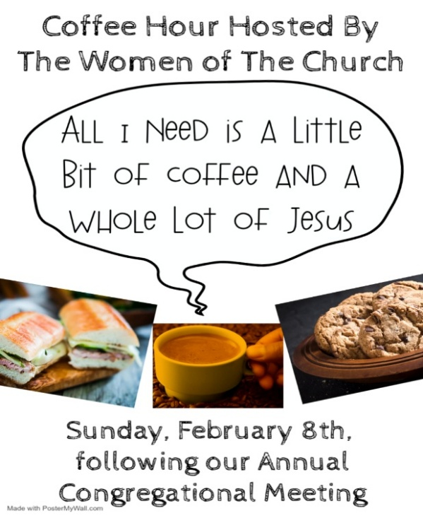

NEW 2026 CHURCH DIRECTORY
The 2025 Church Directory is by the Church Office on the bookshelves. We continue keeping it updated, but we undoubtedly miss a few changes or have made a few errors. The printed church directories have spaces for changes in info, new people’s info, notes, and your favorite Bible verses. If you have changes or updates, please inform the Church Office to keep us up to date. Our 2026 Church Directory will be made available to you the week following our Annual Congregational Meeting.

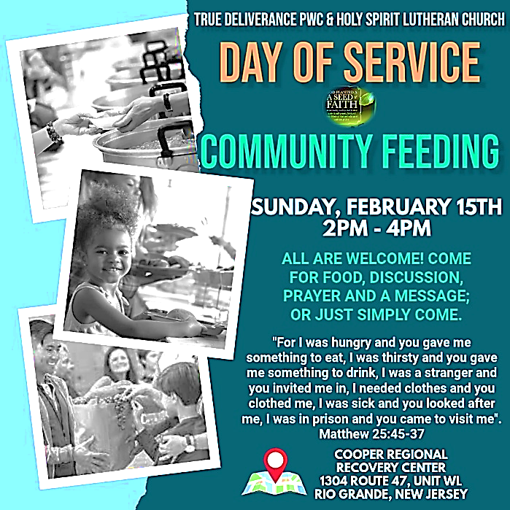
CHURCH COUNCIL
Share your comments, concerns, questions, or joys with one of our Church Council Members who can bring them back to our meetings. Visitors are always welcome to attend and listen to what is going on in and around the church. Join us In- Person or on our Conference Call at our next Meeting on Tuesday, February 17th, at 6PM.

PREACHING AT BROOKDALE
Vicar Vince will be preaching at Brookdale Senior Living in Cape May Court House, on Wednesday, February 18th, at 1PM. Holy Communion will follow the service.

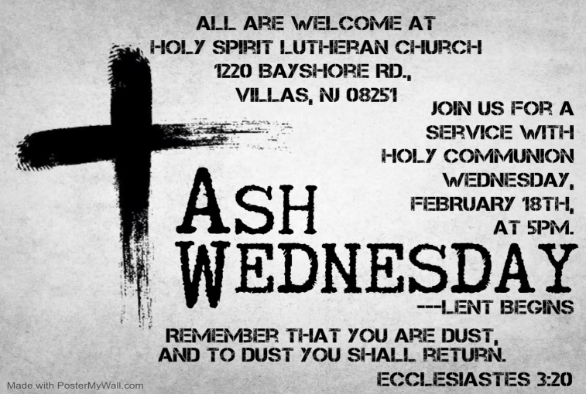

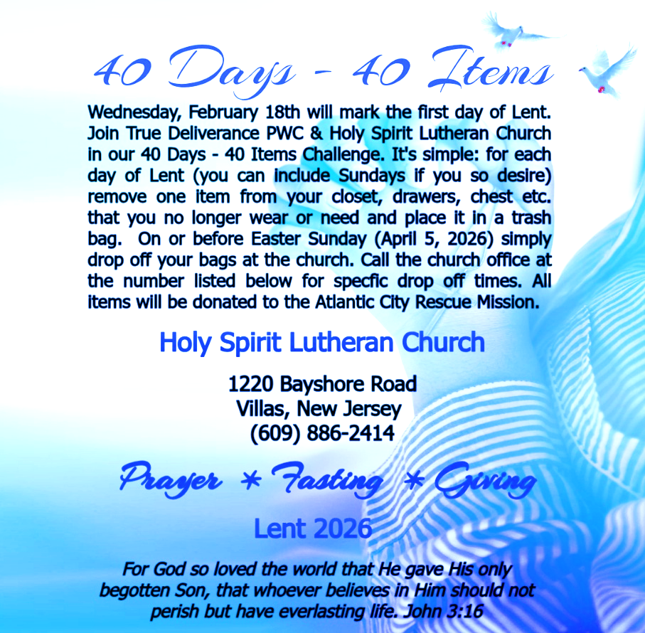
MISSION DISTRICT MEETING
Our annual meeting of the Southern Mission District will be on Saturday, February 21st, at 10am at Christ Lutheran Church in Whiting. The partial agenda for our time together is election of a clergy member to the Synod Council. We will be joined by Bishop Christa Compton. Please see Vicar Vince if you would like to attend.

DONATION STATION
Get on the train and place all purchased items in the specified project donation bins located on the counter by the front doors. See Heather for more information.


WOMEN OF THE CHURCH
They will be on Winter Break and will Resume Meetings on Monday, March 2nd, at 6PM. New members are always welcome to attend! Contact Judy for more info.

NEWSLETTER
Collect information, stories, pictures, and reports for our next publication. Everything needs submitted to Vicar Vince in-person or via email at vpie8282@gmail.com.
The deadline for information to be submitted for Spring is Sunday, March 15th.

NEW JERSEY SYNOD ASSEMBLY
Assembly will transition back to a one-day event on Saturday, May 30th, 2026. We are awaiting more details. Mary & Judy are considering attending with Vicar Vince.

TITHES, OFFERINGS, & ENVELOPES
We worship God with our tithes and offerings. We hear in scripture, “Each of you must give as you have made up your mind, not reluctantly or under compulsion, for God loves a cheerful giver.” (2 Corinthians 9:7) Envelopes can be dropped in the offering plate, mailed to the church, or dropped in the locked mailbox. Thanks for your support in the mission of our church, its ministries, the NJ Synod, etc!

SPACE AVAILABLE
​​​​​Interested in utilizing our Fellowship Hall for a Party or Event? There is a suggested $50 refundable security deposit, and it is $250 for facility use. No alcohol or games of chance permitted due to ELCA policy. Please contact Vicar Vince for more info.

ED GREEN CAPITAL IMPROVEMENT FUND
We are seeking out a new fundraiser at this time. We also have the donation bin in the back of the church and we have our Annual Church Rummage Sale to raise funds. Thanks for your continued donations, prayers, and support!

HOME COMMUNION MINISTRY
A Minister is available if you have a loved one, or if you desire services. We look forward in sharing the Word and Holy Communion! Please inform Vicar Vince, Kathy, or the Church Office so plans can be made for visits.

PRAYER SHAWL MINISTRY
Prayer Shawls, Lap Quilts, Scarves, and other items have been made with love. Blessed items are located in the Narthex, and are free for anyone. Members of the group continue working at home on new stitches and patterns. We are blessed to be able to continue collecting new items. We have a donation station of yarn and other items located in the Narthex. You can find some new supplies for your next creation!

PRAYER LIST
Our Prayer List continues to lengthen and we realize the important need for prayers and healing. Sometimes the unfortunate result is that someone has passed away, and the words “The Family & Friends of” appear before someone’s name. However, sometimes we forget names are still on the list and their health has improved and they can be removed. Please share various stories as we continue to pray for strength and healing. Names can be added or removed from the list on the clipboard in the Narthex prior to the Worship Service, by calling the church office, or addressing it on the Conference Call. Please let us know the relation to the person(s) you listed so we can be more mindful with our prayers. Names will stay on the list until removed by the person(s) who requested prayer.

LIBRARY
New books are added to our library from time to time. Several are borrowed and read and exchanged. Who knows, you might find one particularly interesting and share that with someone as well. Reading is a great way to pass spare time, learn, and explore. You may find some fresh ideas for prayer, ways to grow more spiritually, ways to grow closer to God, or some opportunities to understand our faith more. We also have an extended library located in Vicar Vince’s office. There are Bibles of various translations, books from his personal collection, books inherited from Pastor Leah, movies, past Bible Study Curriculums, and more. Visit the library between the church offices, or just ask to be able to check things out.

INTERESTED IN BECOMING A NEW MEMBER
Have you been attending our church for a while? Have you just recently returned to church after being away for a bit? Maybe you transitioned from another church,
or just started to recently attend our church. We are glad to have you, and would love to have you as a member of our Congregation. See Vicar Vince for more info.

BAPTISM
We are a church whose unity is in Jesus Christ, who gathers us around word and water, wine and bread. Baptism is a significant part of our faith journey as we come from the baptismal waters to live a new life as children of God. Our baptism sets us out on a lifelong journey that is characterized by our relationship to God, our relationship to our faith community, our relationships in our community and the wider world. Living our baptismal covenant means living a life of growth in the faith practices of discipleship. Please see Vicar Vince for more information.

FIRST COMMUNION
Although no particular age for first communion is prescribed by The Use of the Means of Grace, one guideline is offered. Because admission to the Sacrament is by invitation of the Lord to the baptized, "baptized children begin to commune on a regular basis at a time determined through mutual conversation that includes the pastor/vicar, the child, and the parents or sponsors involved, within the accepted practices of the congregation.” Each congregation is encouraged to ask the question of readiness for first communion, establish their own policies regarding age and practice, and accompany that practice with catechesis appropriate to the age of the communicant. If anyone has questions, please see Vicar Vince.

FAVORITE HYMNS
Carol is willing to play some of your favorite hymns for the Prelude & Postlude each Sunday during our Worship Service. Feel free to let her know of your suggestions.

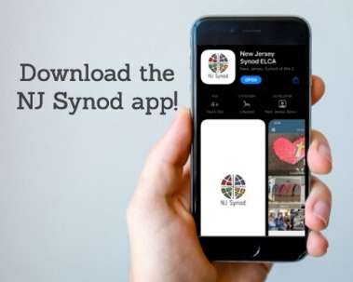
There is a weekly e-newsletter connecting our synod together with weekly prayer, upcoming events, synod and churchwide activities, mission stories, congregational activities, & more. Sign up at www.njsynod.org/stay-connected or download the app.
VICAR APPOINTMENT ON MARCH 19TH, 2023
A Memorandum of Understanding on the Matter of Pastoral Appointment
In Theological Education for Emerging Ministries (TEEM) Candidacy
TO: Congregation Council, Holy Spirit Lutheran Church, Villas
FROM: The Rev. Tracie L. Bartholomew, Bishop, New Jersey Synod

Dear Brother and Sisters in Christ,
This memorandum is in support of your discussions with Vincent Piekarski as pastor of Holy Spirit, Villas. Because this is not the usual pattern for completing the educational and candidacy requirements for ordination, it is my hope that this memorandum will both provide guidelines and engage in conversation with those who are invested in this process.

I would say at the outset that because Vincent is an outstanding candidate for the Ministry of Word and Sacrament, we will all want to do whatever is necessary to assure that his placement serves the mission of the church in the best possible fashion.

The following notes reflect my own understanding of this matter:
(1) The appointment for Vincent will begin on April 1, 2023. At this time, Vincent
will assume all responsibilities of a regularly called pastor, including presiding at
the Sacrament of Holy Communion and Baptism at Holy Spirit, Villas.
(2) A pastoral appointment in the TEEM process is an option for completing
seminary educational requirements and the steps of the candidacy process.
Upon completion of the candidacy process and seminary education, the
candidate may receive and accept a call to ordained ministry from the
congregation where the appointment is being served.
(3) This appointment is jointly supervised by the Office of the Bishop and the TEEM
pastor’s seminary. A mentoring relationship with a local pastor is required for the
length of this appointment.
(4) The synod of candidacy origin will be responsible for the approval process.
(5) Upon approval for ordination, the congregation would be expected to extend a
call to the pastoral appointee.
(6) Compensation for the TEEM pastor will be according to the guidelines of the New
Jersey Synod. All normal forms of compensation should be in place for the term
of the appointment, including stipulation that base salary and housing shall be in
accord with synod guidelines for first call at time of ordination.
(7) The ELCA Portico benefit plan for lay persons in full-time church service should
be used for the pastoral appointee up to the time of ordination, whereupon the
benefit package is to be converted to the plan for ELCA clergy.

(8) A decision for Pastoral Appointment is made with the agreement of a synod and
its candidacy committee, and the ELCA, normally represented by the regional
staff person of each in consultation with the seminary and its Director for
Contextual Education.
(9) Pastoral Appointment in a TEEM Candidacy is an option that is to serve the
mission of the Church in a particular and vital way and is not to be viewed or
used as a means to circumvent the normal candidacy process and/or first call
placement process.

In the specific case of Vincent, the New Jersey Synod remains responsible for the candidacy and approval process, and has agreed to this proposal for Appointment at Holy Spirit, Villas.

Continued blessings to both Holy Spirit and Vincent Piekarski as you embark on this journey of mutual ministry. As partners in ministry, we walk with you and rejoice in this new relationship.

VICAR VINCE’S DAY OF REST
A day of rest can have physical, mental, and spiritual benefits. “Mittwoch,” German for mid-week, or Wednesday, is the day that Vicar Vince will use to recharge and do some other things. Please do not hesitate to reach out if there is an emergency!

VICE PASTOR UPDATE
Pastor William Hodgetts continues to attend our Church Council Meetings
and provides Supervision and Support to Vicar Vince.

WHAT IS THE EVANGELICAL LUTHERAN CHURCH IN AMERICA?
The ELCA was formed in 1987 by the merger of three Lutheran Church bodies –
the ALC (American Lutheran Church), the LCA (Lutheran Church in America), and the AELC (Association of Evangelical Lutheran Churches). Learn more at elca.org.

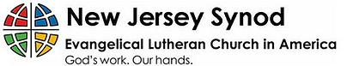
The New Jersey Synod is a geographical grouping of Evangelical Lutheran Church in America (ELCA) congregations that share the mission and ministry of the Church on the New Jersey territory. It is one of 65 synods in the ELCA. The NJ Synod is comprised of 143 congregations, which include over 45,000 baptized members.

TRUE DELIVERANCE PRAISE & WORSHIP CENTER
Reverend Maria Brooks and True Deliverance Praise & Worship Center utilize our facilities from 1-4PM on Sundays. TDPWC hosts or assists with other events throughout the year. TDPWC hosts a Prayer Line on Mondays, Wednesdays, & Fridays at 5PM on the Conference Call 1-657-390-7957; & Bible Study on Thursdays at 6:30PM on Zoom. See Rev. Brooks for more information.

ADDITIONAL OFFERINGS FROM OUR FRIENDS & NEIGHBORS
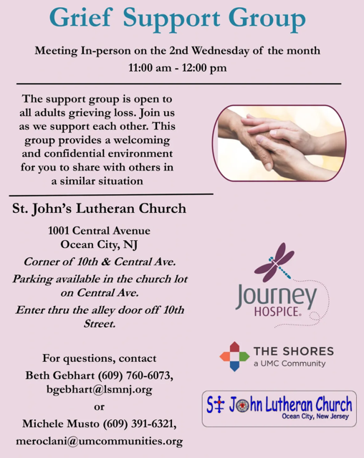
JUST FRIENDS
Promotes a spirit of fellowship among adults 50 years and older. Bring your own lunch to enjoy, beverages and deserts are provided. Everyone is welcome regardless of faith or parish affiliation. The group meets in Our Lady Star of The Sea Parish Hall on the last Wednesday of the month from 12Noon to 2PM from September through May. For more info call Martine Simonis 609-884-5312 x 110.

2025 FINANCIAL STANDING
DECEMBER INCOME | $18,368.12
DECEMBER SPENDING | $6,154.14
DECEMBER GAIN OR (LOSS) | $12,213.98
2025 INCOME | $89,570.50
2025 SPENDING | $81,652.42
2025 GAIN OR (LOSS) | $7,918.08
ED GREEN CAPITAL IMPROVEMENT FUND | $2,058.55
FOOD PANTRY FUND (SOCIAL MINISTRY) | $13,621.22
CD | $26,414.45

CHURCH STAFF & VOLUNTEERS
VICAR
Vicar Vince Piekarski
VICE PASTOR
Pastor William Hodgetts
ORGANIST & PIANIST
Carol Amundsen
CHURCH OFFICE, SUNDAY SCHOOL, & FOOD PANTRY
Heather Piekarski
CHURCH COUNCIL PRESIDENT
Mary Melnicoff
CHURCH COUNCIL VICE PRESIDENT
Judy Brannan
CHURCH COUNCIL TREASURER
Bonnie Millard
CHURCH COUNCIL SECRETARY
Vicki Rinier
CHURCH PROPERTY
Wayne Rand

