**January Member Meeting & Program**

**WHAT: January 9, 2023 RMGA Membership Meeting**

**WHEN: DATE - 6:00 pm – Networking, 6:15 pm – Short Meeting, 6:30 pm**

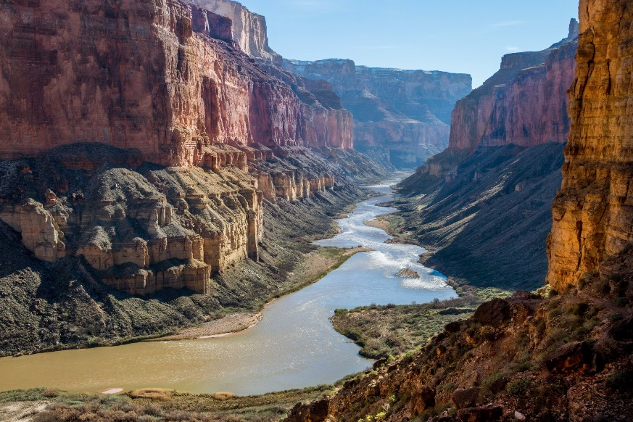**PROGRAM NAME: The Colorado – A River in Peril**

**PROGRAM:** Member Steve Kaverman, Tourism Champion, will be presenting The Colorado - A River in Peril. We will look back at the Colorado River Compact of 1922, review the status of both major reservoirs and their dams, and consider the future of Colorado River water**.**

**WHERE: Via Zoom:** [**https://us06web.zoom.us/j/89399762242**](https://us06web.zoom.us/j/89399762242)

**Meeting ID: 893 9976 2242**

**One tap mobile - +17193594580,,89399762242# US**

**GUESTS:**  Members are encouraged to invite potential members as guests to meeting.

**MEETING NIGHT CONTACT**: Mark Blaising. Contact Blaising303@gmail.com or by text 303-263-8647; Zoom issues: Tom Jensen 303-968-0515

