Pleasant Township Board of Trustees Meeting Highlights
Date _July 8, 2025______________ Next Resolution No._ 36—07-08-2025_ _

- Call to Order -- The meeting tonight will also be on WebEx.
- Please stand for a moment of silence. --Pledge of Allegiance--Roll Call
- Visitors –
- Minutes to approve- No minutes
- Financial Reports – Paula
  - MOTION to pay expenditures. - $36,516.22
- Department Reports
- Franklin County Sheriff’s Dept-Community Liaison, Deputy Adkins, 1120- Cell: 614-809-5843
  - None
- Road Department- Robert Bausch, Superintendent
- Timberlake paving.
- Timber lake grant meeting. At the next meeting we will have a presentation and need residents to attend and fill out comment cards.
- Rolling Hills lane east.
- Graessle road traffic. Try to get the speed trailer out there and more patrol cars. The laws do not allow “No Thru” signs.
*Any updates for this from last meeting----6296 Oakhurst Drive where he was forced to remove rocks to keep people out of his yard said a roofing company has driven along the edge putting ruts so large he can’t mow. He has contacted the roofing company, they said they would put down grass seed. He said it needs more than grass seed. They will be putting dirt and seed down next week.
*Did you get the email I forwarded about an overgrown pine tree at 5575 Cardinal Dr. that sticks out into the township Right of Way and into the road. It’s on a curve, which already makes it tough to see oncoming traffic, and the tree just makes it worse. It’s also scratched up some neighbors’ cars since there’s not much room to pass when another vehicle is coming the other way. On top of that, it’s a concern for kids who play outside in the area, drivers have to swerve or hug the other side of the road to avoid the tree, and that’s not safe with kids nearby. It looks like the homeowner doesn’t live there full-time, so they might not be aware it’s causing these issues. Would the township be able to check it out and possibly get it trimmed up and back since it’s in the ROW? Will work on this next week.
- Fire Dept. – Chief Whiting
  - Apparatus
- PM Station Truck
- Grass fighter pump issue, waiting on a part to fix.
Personnel
  - Equipment
- Hurst tool cutters OOS, working with a replacement.
- Training
- Collapse training
- Station
- The concrete walkway was completed.
- Topsoil filled in and grass seed planted, replacing dead bushes and repairing pavers.
- Water softener issue- the plumber has been contacted.
- HVAC was serviced. Ordered a new thermostat.
- Waiting on quotes from companies.
- Community Risk Reduction
- Building inspections
- Installation of Smoke alarms
- Billing
- No issues.
- Dispatching
- Locution weekly update meeting. – Will be changing the run cards.
- EMS
- Received a grant from the State of Ohio for $4785.14 for EMS training.
*From last meeting--Nancy would like to have a printed copy of longevity for everyone for my records in keeping track of funds and go back to a printed copy each meeting of hours worked with a breakdown of overtime and part time hours. We used to get this, and I found it very helpful in decision making.
- Old Business-
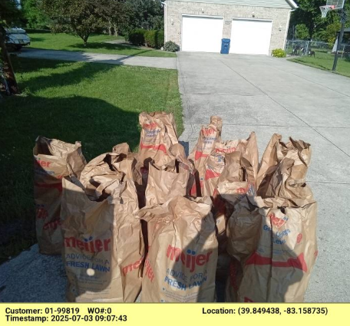
  - In regards to the issue from last meeting from Local Waste about the Norton Rd closing and they could not get to 2944 Norton Rd. They have found a place to turn around and they can get to that address.
  - Local Waste cannot pick up dirt. From Local Waste Daily review--LAMBERT RD- Emailed- We are unable to service bags full of dirt with yard waste. The dirt will need to be removed from the yard waste bags to be collected on the next normal service day.
  - Robert has “YARD WASTE” stickers if anyone needs them.
- New Business –
  - Set a date for Special meeting to do the Budget. Needs adopted by July 15th and submitted to the county by July 20th. Motion to hold a Special Meeting Monday July 14, 2025 for the purpose of the budget.
  - Randi received an email about our meeting highlight notes are all the same from March 11 on. I have forwarded that to David, he is looking into it.
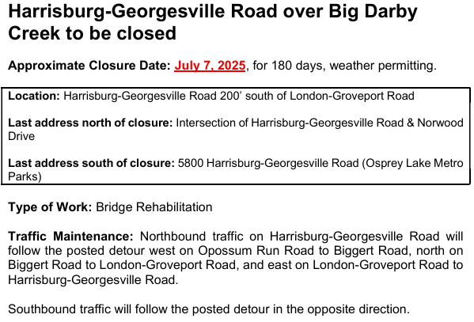
  - Paula received an email from Michelle at Acrisure for renewal for the Provident Accident & Health Policy #PRCO-92378-OH10154- Premium Due & Effective: 9/1/2025. This is for our part-time employees, it was previously VFIS. (Acrisure bought them and Burnham & Flowers) Resolution_36 renew our present plan with Acrisure effective 9-1-25 in the amount of $1,999.
- Announcements -.

A special meeting of the Franklin County District Advisory Council will be held on Thursday July 24, 2025, at 6 p.m. The District Advisory Council meeting is required by state statute (Ohio Revised Code 3709.03) for the purpose of appointing members to the Board of Health. This special meeting is needed to appoint a person to fill a vacated term on the board due to a resignation. The DAC meeting will be held at Franklin County Emergency Management & Homeland Security, 5300 Strawberry Farms Blvd., Columbus, OH 43230. You will receive an email with an agenda and meeting materials prior to the meeting so you have time to review. After the DAC meeting, the Franklin County Township Association will hold their quarterly meeting at 6:30 p.m. at Franklin County Emergency Management & Homeland Security, 5300 Strawberry Farms Blvd., Columbus, OH 43230 and DAC attendees are invited to attend. Food will be provided. Please register no later than Thursday July 17 to RSVP.
- Clerk Updates- Paula
- Miscellaneous correspondence
- Speaker Sheets- (come to the podium to be heard on WebEx)
  - George Spohn 6600 Gay Rd. attended about barking dogs on his road. They are inside all day and put out at night and bark all night. A relative of the dog owner came to his house with a gun. He has called the Sheriff’s Dept. many times and it is going to court on June 17, 2025. George just wants to deescalate this neighborhood problem.
- Adjourn

