NSCAA ACADEMY
“Coaching in the Game Methology.”
By: Jeff Tipping
NSCAA Director of Coaching

One of the most important additions we have made to our Academy during my tenure has been the introduction of “Coaching in the Game” methodology to our instructional and testing field components. Simply put “Coaching in the Game” (CIG) involves coaching players in an even sided game with limited or no artificial teaching conditions (e.g. coned areas, limits on touches, uneven numbers in certain areas of the field, etc.). The CIG session is the ultimate test of a coach’s knowledge and expertise as it tests an individual’s ability to analyze the game and addresses very specific areas, areas which are directly related to the actual game and the needs of the players within the game.

We have, since our inception in 1983, adhered to the German, “Whole-Part-Whole,” coaching methodology introduced to the U.S.A by Dettmar Cramer in the early 1970’s. It is important to note that we still strongly hold to the “Whole-Part-Whole” philosophy espoused by Cramer. We are very happy indeed with the development of our coaches since 1983, we have grown enormously in sophistication and understanding of techniques and tactics. Often times, however, we feel as though many of us are not entirely sure where the “part” of the “Whole-Part-Whole.” Formula fits into the real game.

For example, an exercise we use extensively in our academy is one versus one. Many of our coaches are comfortable with teaching one versus one in a grid (with two small goals, etc.) and understand the progression and succession of coaching points in one versus one exercises. But many of our coaches are clearly not quite sure where it fits into a game. Additionally, the defensive demands on an outside fullback in one versus one are different than the demands on a central midfielder. In either case, players must make decisions and execute techniques in relation to other attacking and defending players in the area of the field where they operate and within the overall defending philosophy of the team. “Coaching in the Game” configuration tests a coach’s understanding of not only the techniques and tactics of one versus one situations but also where the dozens of varieties of one versus one actually fits into a real game.

Figure 1, shows a right back (#2) closing down the left attacking flank player (#11), who has received a ball from a central defender (#5). The (#2) will be closing a player down who is facing him and able to run at him with the ball.

In Figure 2, a central midfielder (#8) is closing down a player who is receiving the ball from a center back (#5) and is, probably, facing the wrong direction. In this case the (#8) must try and close the back down quickly before (#4) can turn without fouling her and without exposing herself by over-committing herself should (#4) play a quick combination with (#8). The scenarios require different techniques and tactical processes although they are both one versus one scenarios.

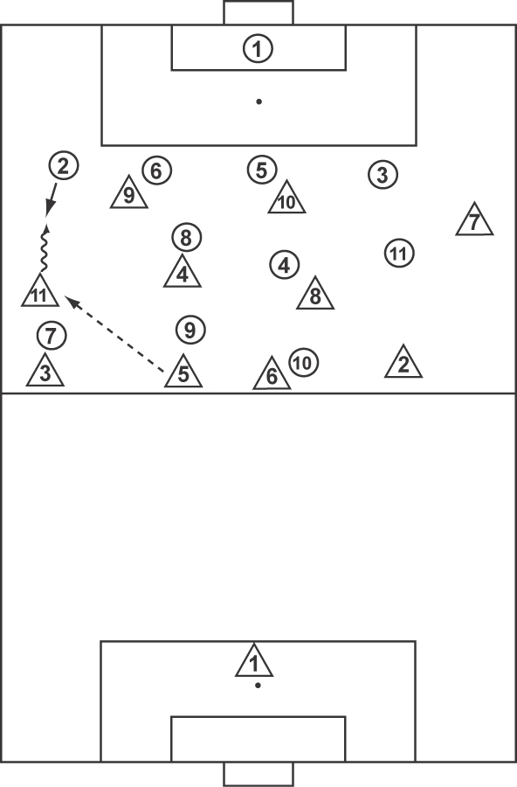 | 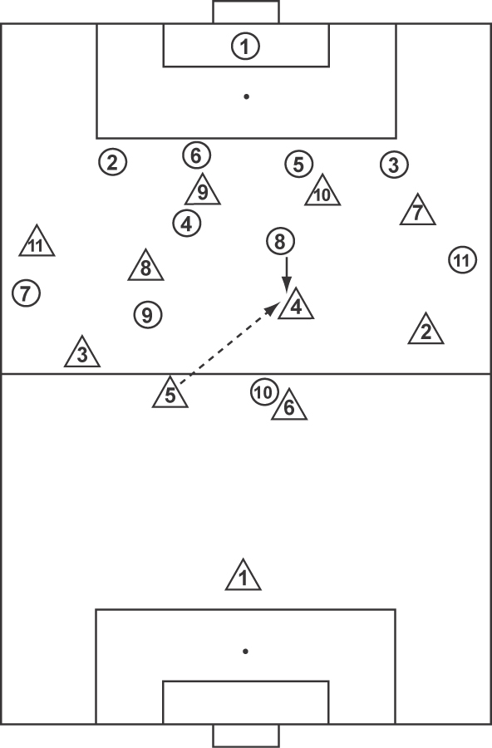
Figure 1 | Figure 2

Figures 3 and 4 show the “part” stage of teaching these two defending techniques but neither can really take into account the big picture of how these techniques work in the “whole” as illustrated in Figures 1 and 2. We believe a coach must have the ability to help players see where different techniques and tactics occur in various areas of the field. “Coaching in the Game” helps them do this. CIG methodology is a vital teaching skill for many other reasons, not least being that there are many important game situations, which must be brought to the practice field which cannot be replicated in grids, coned areas, conditioned games, etc.

Important considerations:
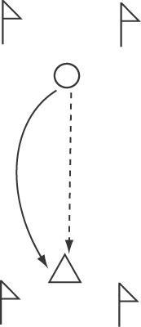 | 
Figure 3 | Figure 4

- Knowledge - CIG is an advanced teaching technique. It requires a coach who understands when, where and how it is best utilized:
  - This method of coaching is appropriate for older players (12 + years of age).
  - CIG frequently is used at the culmination of a practice to reinforce the theme(s) of practice or highlight an issue from a past or previous game.
  - Is generally used for about 10-20 minutes and is rarely used for a full practice.

- Management – CIG methodology is demanding on a coach’s ability to manage large numbers of players on the field at the same time. The numbers involved are generally six versus six through eleven versus eleven.

- Experience – Coaches using CIG methodology must have a good picture of what they want to get out of the session. Coaches who have not watched a lot of soccer will struggle with this technique.

- Match Analysis Skills – To maximize the benefit of CIG, a coach should focus on very specific patterns or teaching points. The teaching points or “themes” are based on the coach’s analysis of a past match or other match analysis observations. Coaches who have not developed good match analysis skills will struggle to derive value from CIG sessions.

Critical factors in CIG methodology:
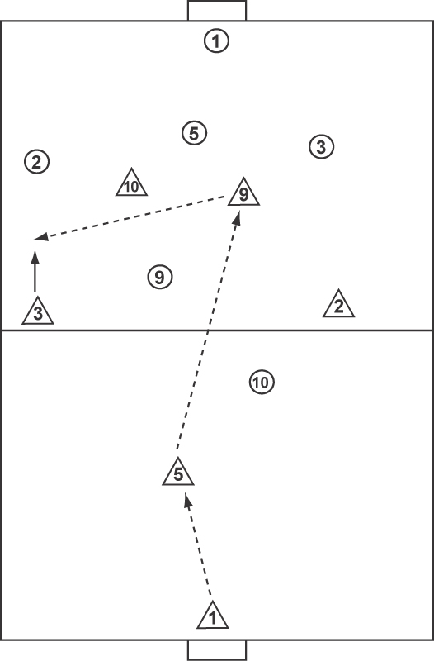

Theme - “Teach (#2) how to close player down from front.”

In the NSCAA National Diploma the coaching candidates are asked to develop a CIG theme in a six versus six format. The coaches are asked to arrange the team into a 1-3-1-1 or 1-3-2 alignment and begin the session with two opposing teams on the field at the same time. One coach is asked to begin the game and to allow the game to flow for a few minutes. Following an appropriate period the coach then begins to make coaching points. As a session progresses these interruptions become less frequent.

For CIG methodology to be completely effective, the following factors are essential:

- Positioning of players – players must be in starting positions, which are realistic and compatible with the theme of the session.
- Restarting Technique – the restarting technique involves the identification of a “trigger” player. The coach indicates to both teams or to the specific players “We are live when (#3) takes his first touch of the ball.” As the session progresses and becomes more game like, the coach may say “We are live when (#9) passes to (#3).” The coach may eventually progress the instructional portion of the session to the point where the players are live when (#5) releases the ball to (#9).

- Method of Attaining Repetition – Obviously, if the theme is “defending one versus one” it is imperative that the opposition have the ball so defending scenarios can constantly be created. One way we can accomplish this is by giving the defending team an easy goal scoring option, which puts them back on the defensive. The goal for the defending team, in this session, is to drive the ball to the opposing goal in the air so the goalie can catch it and re-start the exercise. Other goals we can give the defending team could be to pass ball to the coach, run ball over a line or try and kick the ball into a predetermined target area.

- Specific Coaching Points – Coaches should have an idea of the specific coaching points they wish to make before the session commences. The customary coaching points in a session on “Closing Down from the Front” are speed of approach angle of approach, body shape and communication. These four key reaching points be coordinated with the movement of other defenders and aligned with the overall defending philosophy of the team (channeling inside, double team, etc.).

- Coaching Flow – The coach allows the player to play for a few minutes and then begins to choreograph stoppage corrections and method of attaining repetition. As the session progresses, the teaching stoppages become less frequent as the players incorporate the new idea into the session. The session must, at some stage, be allowed to flow so the coach can observe if the players have digested the teaching points. It is an accepted principle in coaching that the more game like the session becomes the less repetition of the focus topic takes place. Hence the coaching skill is to recognize when it happens in the flow of the real game and reinforce that moment appropriately.

Coaching in the Game is one of the number of changes made in the Academy programs over the last few years. We believe it is an essential skill for our own coaches to develop. If you have not already attended an Academy, we invite you to join us to develop your instructional skills. The craft of coaching has many factors and tasks but improving players game understanding ranks as one of the most critical ones. CIG methodology helps players by showing them how techniques and tactics fit into the real game.

