RSAI 2022 Legislative Priority:
Broadband Internet Access

Background: The Iowa Capital Dispatch April 2020 reported Iowa as among the ten worst states for access to and affordability of high-speed Internet. Since the onset of the pandemic, inequitable access to high-speed broadband service has become obvious for students, parents and school staff as learning moved online. What was once known as the “homework gap” was now about access to education. Although necessary for schools, Internet connections are critical for a rural quality of life. As the Dispatch article stated, “Since the onset of the pandemic, access to high-speed broadband service has become essential as jobs and schools have shifted online, health care providers deliver remote care, people shop online and civic and social life goes virtual.”
The article quoted a report by BroadbandNow Research. Although the initial report from 2019 showed Iowa as #45 in the nation, the state has made strong gains. Iowa moved up from 45th to now, 36th in the nation, according to the 2021 Report. Improvements in coverage and price are noticeable. However, Iowa still ranks 49th in download speeds. See the progress in the graphics below:
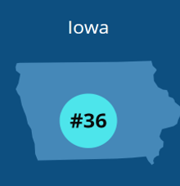
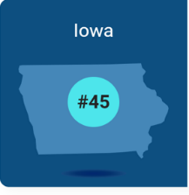
2019 |  | 2021
81.3% | Terrestrial Broadband Access | 88.8%
18.5% | Wired Low-Priced Plan Access | 79.7%
- Mbps | Average Speed Test | 193.9 Mbps
Not reported | Internet Providers in Iowa | 449
RSAI sends kudos to Iowa’s Legislature and the Governor for their 2020 broadband investment and expansion structure in SF 2400, which determined areas in Iowa needing high-speed Internet and set up a process for providing federal and potentially other resources and incentives to expand services. Iowa leaders in 2021 continued the priority, with HF 848 Broadband Grants, requiring 20% of grants to be in hard-to-serve areas with no high-speed providers and to meet speed criteria. This bill was passed unanimously. Additionally, HF 867 appropriated $100 million to the Empower Rural Iowa Broadband Grant Fund. Due to the overwhelming need and interest in the program – OCIO received 178 applications requesting a total of $300 million in October, so the Governor directed $200 million in federal funds to build on the state-invested dollars. The federal Infrastructure Act, November 2021, provided another influx of $500 million for broadband expansion to Iowa.
RSAI is encouraged by the energy and investment at both the state and federal level to connect all Iowans to high-speed, affordable Internet. RSAI members at the annual meeting, Oct. 26, 2021, affirmed a continued priority of access high-speed Internet that is affordable, to support education for students, connections and continuous learning for staff, and connect rural Iowans to health and workforce services necessary for our quality of life.

Internet Connectivity and Access: expanded access to high-speed Internet for all Iowans including incentives, investments, and creative solutions to close the technology gap for students, businesses and community members in rural Iowa. Low income should not be a barrier to internet access.

