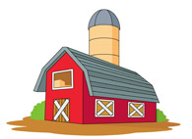
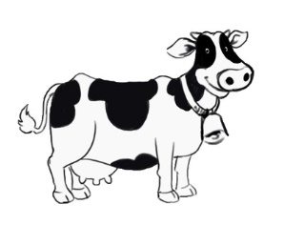
Lovetwo Farm

Spring, Summer & Fall Seasons 2017

RE: Real Cows! Real Farm! Real Fun!

Hello Friends:

Lovetwo Farm tours are educational farm tours that are guided throughout a REAL, WORKING dairy farm. We invite your school/organization to visit our farm. We are a family run, working dairy farm with over 120 cows and calves 250 acres of farm crops. We have many farm animals for you to see in addition to cows. We have “Patrick” the friendly camel and many others you will read about soon. Our farm tours are fun, educational and exciting for children & adults.

Lovetwo Farm is a fourth generation family farm located in the center of the state between State College, Harrisburg and Chambersburg. It is located in the small country village of East Waterford. In 2014 it became the first farm in the area to start robotic milking. The state-of-the-art robotic facility has the latest technology in the world of milking. It allows cows to be milked anytime day or night and tracks all types of important information about each cow. To learn more about this or other items we offer, –Lovetwo Farm.

Here at Lovetwo Farm our tours are very affordable and include a visit to the dairy barn, with an opportunity to see firsthand how the cows are milked with a Robotic Milker. They will also see where the cows eat and sleep. They will learn the importance of dairy nutrition. Then off to the calf area where you will get to meet the newborn calves. In the milk house, you will see how the milk is stored before it is hauled by the milk truck to be processed. Stroll out to the barnyard where you will see and visit many different animals including a camel, miniature horse, goats, miniature donkey, alpaca and rabbits. Both children & adults will learn many interesting facts about our animals. There will be feed available (nominal fee) so that everyone may feed the animals. Photos are permitted. There will also be an opportunity to see all of the different types of farm equipment and tractors. Everyone will also get to take a hayride and see the many crops we grow and learn what those crops are used for. Children/Adults are invited to bring a bagged lunch along and enjoy our picnic area too.

School & Organizational group hours vary based on the needs of the school or organization. Our tours usually last about 1.5-2 hours. Our farm is clean, safe and child friendly and includes wash sinks and a bathroom. Reservations are REQUIRED for all farm visits. Come and see what our farming is all about!

Sincerely,

Daniel Love
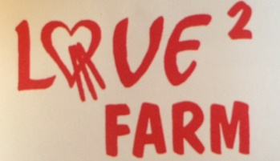
President/Lovetwo Farm, Inc.

DTL:dlm

Enclosure

417 Smokey Hollow Road ~ East Waterford, PA 17021
717-734-3335 ~ lovetwofarm@pa.net ~ www.lovetwofarm.net ~ Lovetwo Farm
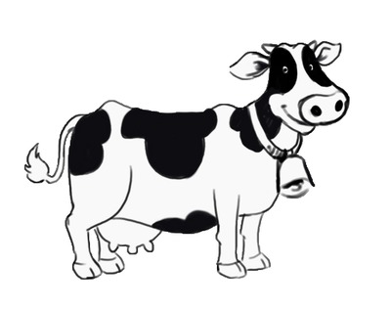
Lovetwo Farm

Hours of Operation
We’re open for tours April 1st – October 31st
Tours: 10:00 am, 12:00 noon, 2:00 pm
School group hours vary on the needs of the school ~ same with CIVIC and/or ORGANIZATIONS
Tours run approximately 1.5 to 2 hours
*Unexpected cold temperatures can alter opening date.

Reservations are Required for ALL Farm Tours
717-734-3335 ~ lovetwofarm@pa.net

2017 Admission Prices
Lovetwo Farm accepts Cash or Personal Checks. We are unable to accept credit cards at this time. Sorry for any inconvenience.

REGULAR ADMISSION:
*Reservations Required
Preschoolers: $5.00 each
Children: 5-12 yrs.: $10.00 each
Adults: $12.00 each

SCHOOL/CIVIC/ORGANIZATION/GROUP ADMISSION RATES:
*Reservations Required ~ Tours Monday – Friday ONLY
10 or more students or adults – Requires a $50 Deposit
5-12 yr. old students: $6.00
Parents/Chaperones: $8.00
Adults: $8.00

*If reservations are made for Groups, we do not have the ability to have rain dates. If there is rain, the tour will go on as scheduled with modifications. If the weather is threatening with lightening the tour will be cancelled. If cancellation takes place prior to the start of the tour refunds will be offered.

*Cancellation of a Group Reservation MUST be given in writing at least two weeks prior to receive a full refund of DEPOSIT.

417 Smokey Hollow Road ~ East Waterford, PA 17021
717-734-3335 ~ lovetwfarm@pa.net ~ www.lovetwofarm.net ~ Lovetwo Farm

Lovetwo Farm Tours – Policies

General Information:
We are a real working dairy farm. Photographs are permitted but not allowed to be sold or used in anyway without permission. As such, we have a variety of equipment, animals and areas which require your attention & respect. Some of these are open to you, others are private. Please direct all your questions and concerns to your guide, and follow all instructions accurately. We expect you to be attentive, stay together, follow directions and act responsibly at our farm. Some of the animals can kick and/or bite, and others are too young, small or restricted to protect themselves from all danger or accident. You are required to respect the animals at ALL times! DO NOT PICK UP THE ANIMALS.

In visiting Lovetwo Farm, Inc. you are required to have reasonable adult supervision (parent, guardian, teacher, chaperone or supervisor) to safely and effectively manage all minors in your group. While we do mandate what that should be, we reserve the right to determine when something represents a problem for us or others and take corrective action including ending a tour or asking someone to leave. You (as an adult, parent or supervisor) need to keep all children close at hand, oversee their activities at all times and watch for their safety around others, our buildings and active and stationary farm equipment. We ask that you stay with your Guide at all times throughout your tour.

Tours and activities vary throughout the seasons and may be revised, changed or even cancelled at any time for any reason. We do everything in our power to ensure your satisfaction and meet our commitments to all tours and activities. As a working farm however, tours, conditions, weather and even the needs of the livestock and crops change – often without notice. As a result, we reserve the right to cancel a tour at any time.

Liability:
Participating in any tours or activities at Lovetwo Farm, Inc. is at your own risk. We accept no responsibility, commercially or individually, for any claims, losses, damages or injuries associated with your visit or participation, be those physical or otherwise in nature. We accept no responsibility for the actions of any persons, individuals or parties at any time, be that in the presence or outside the presence or observation of your Guide, our family, our employees or assigns. You are responsible for any damages, liabilities, loss, and injury to any persons, property, goods, animals and livestock, including damage and/or loss to crop, feed, yield or produce by the result of you or your party’s action. In participating in our tours and activities, you agree to hold Lovetwo Farm, Inc., its employees, owner, and volunteers and assigns harmless for any and all actions, consequences or liabilities associated with your visit. You further accept all responsibility to these same matters in relation to any minor children in your group whether legal guardian or parent or not.

Photography:
We reserve the right to photograph, audio tape or videotape any or all (portions) of tours and activities, including all property, persons, or participants (except minors except with a photo release by parent or legal guardian) and to use these images, recordings and likenesses for promotional and other purposes.

Cancellations:
You have the right to cancel your tour with Lovetwo Farm, Inc. per the terms of any written documents pertaining to it, supplied at the time of reservation, booking, down-payment or such, if provided. In the absence of any written agreement, the following policies apply to cancellation:

- Tours may be cancelled two weeks prior to arrival, with no amount due.
- Tours may be cancelled without penalty due to weather, sickness or emergency.
- Cancellation by you, once a tour has commenced, refunds may not be given depending upon the reason or circumstances at the time.
- Cancellation by us, once your tour has commenced may, at the sole discretion of us, be awarded a refund provided the reason is NOT due to matters of failed supervision, endangerment to staff, animals, crop or equipment or any other reason potentially dangerous or problematic to the health and well-being of the farm. Cancellation of a Group MUST be given in writing two weeks prior to receive a full refund of DEPOSIT.
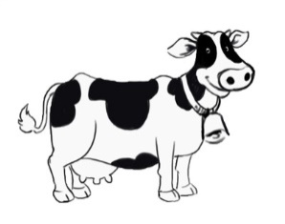
Lovetwo Farm

Reservation Form

Tour Request Date: _____________________________________________________________

Individual Registrant Name/Address, Email & Phone Number: _____________________________________
________________________________________________________________________

If Other Attendees will be on this Tour, Please attach a complete printed list of attendees (and ages if children) to this form.

School District/Civic Group/Organization Name & Name of Contact Person (if applicable): ______________________
_________________________________________________________________________

School District/Civic Group/Organization Address, Email & Phone # & Extension (if applicable): __________________ ________________________________________________________________________

Grade Level (schools only): _________________________________________________________

Expected # of Attendees: _____ Total Number of Adults: _____ Total Number of Children: ______

Tour Time Preference: ___________________________________________________________

Any Special Needs for Your Group (e.g., wheelchair, etc.) ________________________________________

Will Attendees be Bringing Their Own Bagged Lunch? __________________________________________

Transportation: Car __________Bus __________Van __________

- Please COMPLETE this form along with suppling us with a COMPLETE listing of Attendees.
- Please be sure to have each child’s parents COMPLETE and RETURN the attached “Photo Release Form” and bring it along with you the day of your trip – thank you.
- Payment information is on the attached.

417 Smokey Hollow Road ~ East Waterford, PA 17021 ~ 717-734-3335 ~ lovetwofarm@pa.net www.lovetwofarm.net ~ Lovetwo Farm
Lovetwo Farm
Payment Information Form
School/Civic Groups/Organization Group Rates:
Reservations required for ALL tours
10+ students/individuals qualifies as a group
Tours Monday – Friday ONLY (Saturday by special arrangement ONLY)

Preschoolers: $3.00 each
5-12 yr. old Students: $6.00 each
Adults, Teachers, Chaperones, Parents, etc.: $8.00 each

Lovetwo Farm accepts cash or check. ALL school groups are required to put down a $50 deposit when making reservations.

TOTAL DUE: __________

DEPOSIT AMOUNT: _______

BALANCE DUE: _________

*If reservations are made for Groups, we do not have the ability to have rain dates. If there is rain, the tour will go on as scheduled with modifications. If the weather is threatening with lightening the tour will be cancelled. If cancellation takes place prior to the start of the tour refunds will be considered.

*Cancellation of a Group Reservation MUST be given in writing at least two weeks prior to receive a full refund of DEPOSIT.

417 Smokey Hollow Road ~ East Waterford, PA 17021 ~ 717-734-3335 ~ lovetwofarm@pa.net www.lovetwofarm.net ~ Lovetwo Farm
Lovetwo Farm
Payment Information Form
Individual & Family Rates:
Reservations required for ALL tours
10+ people qualifies as a Group (requires different registration form)
Tours: Monday – Saturday ONLY

Preschoolers: $5.00 each
5-12 yr. old: $10.00 each
All Others: $12.00 each

Lovetwo Farm, Inc. accepts cash or check. A 50% deposit is due at the time of reservation.

TOTAL DUE: __________

DEPOSIT AMOUNT: _______

BALANCE DUE: _________

*If reservations are made, we do not have the ability to have rain dates. If there is rain, the tour will go on as scheduled with modifications. If the weather is threatening with lightening the tour will be cancelled. If cancellation takes place prior to the start of the tour refunds will be considered.

*Cancellation of a Reservation MUST be given in writing at least two weeks prior to receive a full refund of the DEPOSIT.

417 Smokey Hollow Road ~ East Waterford, PA 17021 ~ 717-734-3335 ~ lovetwofarm@pa.net www.lovetwofarm.net ~ Lovetwo Farm

Lovetwo Farm

Photo Release Form For Children & Minors

Lovetwo Farm, Inc. has my permission to use my child’s photograph publicly to promote the Farm. I understand that the images may be used in print, publications, online publications, presentations, websites and social media. I also understand that no royalty, fee or other compensation shall become payable to me by reason of such use.

Parent/Guardian Signature: ________________________________
Parent/Guardian Printed Name: ______________________________
Child’s Name: ________________________________________
Phone Number: _______________________________________
Name of School/Organization/Family: __________________________
Date: ____________________________________________

417 Smokey Hollow Road ~ East Waterford, PA 17021 ~ 717-734-3335 ~ lovetwofarm@pa.net www.lovetwofarm.net ~ Lovetwo Farm

