**Biology 111 Cell Division Lab**

**Mitosis vs Meiosis**All cells arise from existing cells through cell division. The offspring of this process are called **daughter cells**. In eukaryotes, there are two types of cell division: mitosis and meiosis.   
**Mitosis** is the type of cell division used for *growth, repair and replacement.* Each of the daughter cells produced from mitosis have the same number of chromosomes as the parent cell.   
**Meiosis** is the type of cell division that is responsible for producing *gametes.* These specialized cells have half the normal number of chromosomes. Gametes are the cells involved in sexual reproduction.

Mitosis and meiosis are related in in eukaryotes…  
**Sperm** and **egg** (the gametes) are produced by meiosis.

Fertilization occurs when sperm and egg fuse to form a single cell called a **zygote**.  
This zygote then undergoes mitosis…that single cell must undergo countless mitotic divisions to produce an adult. All adult plants and animals contain perpetually young populations of cells called **stem cells**. These are cells that are said to be **undifferentiated**, that is, they have not become specialized to perform a particular function. In plants we refer to tissues containing these cells as **meristem** tissue. It is located in the tips of roots and at the tips of branches. In those locations it is responsible for the production of cells that lead to the upward and downward growth of the plant. Meristem tissue is also responsible for the expansion of the girth of a tree that appears as tree rings if the tree is cut down. In meristem tissue, cells can be observed actively undergoing mitosis.

**Animal blastulas**

After any vertebrate zygote is formed, it begins to divide by mitosis to form a ball of 25 – 100 undifferentiated cells called a **blastula**. All vertebrate embryos go through this very early stage of development. In blastula cells, mitosis is actively occurring.

**Observing interphase and the stages of mitosis**

In this lab, you will examine plant meristem and animal blastula cells to observe interphase and mitosis. Below are descriptions of each to help guide your observations.

**Interphase –** cell appears to be at rest but in fact significant activities occur in this stage   
 including replication of the DNA in preparation for the ell to divide.  
 The nucleus appears to be stained but chromosomes are not visible.  
 There is a clearly intact nuclear membrane and the **nucleolus** is   
 likely visible. The nucleolus is a sphere found in the nucleus. It’s function  
 is to produce the cell’s ribosomes which are then transported to the   
 cytoplasm.

**prophase** – chromosomes have condensed and are visible, but are not lined up and may still   
 be centralized in the cell where the nucleus is. The nucleolus disappears. Late in  
 this stage the nuclear envelope begins to disappear. The **centrioles** (in animal  
 cells) begin to move to opposite poles.

**metaphase**– the nuclear envelope is completely gone at this stage. The chromosomes are all aligned across the equator of the cell. In animal cells, the **spindle fiber***s* are visible, radiating outward from the poles to the chromosomes.

**anaphase** – The **centromeres** come apart and the chromosomes separate into two sister chromatids, which are pulled toward the poles of the cell.

**telophase** – This stage is much like prophase in reverse. Spindle fibers disappear, the nucleoli reappear, and chromosomes de-condense to form chromatin. Two new nuclear envelopes form around the de-condensing chromosomes. **Cytokinesis** or division of the cytoplasm begins with the formation of a *cleavage furrow* in animal cells or the *cell plate* in plant cells.

**Exercise 1: Mitosis in plant cells**

1. Obtain a prepared slide of a longitudinal section through an onion root tip (*Allium*). Focus upon the meristem region of the root tip, shown in the diagram below, at high power.

2. Use the mechanical stage knobs to move around the slide to find and draw examples of all stages of mitosis as well as interphase. If your slide does not contain examples of all of these, choose an additional slide to view.

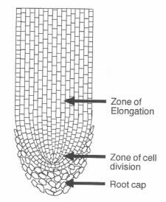

Cells beginning to elongate

**Meristem cells**

Root cap cells

**Exercise 2: Mitosis in animal blastula cells**

1. Obtain a prepared slide of cross-section through the blastula of a fish.

2. Use the mechanical stage knobs to move around the slide to find and draw examples of all stages of mitosis as well as interphase. If your slide does not contain examples of all of these, choose an additional slide to view.

In the space provided, draw animal cells representative of each phase, as seen under high power.

## Interphase Prophase Metaphase

Anaphase Telophase

In the space provided, draw plant cells representative of each phase, as seen under high power.

## Interphase Prophase Metaphase

Anaphase Telophase

**Recap of DNA structure:**

Deoxyribonucleic acid (DNA) is the molecule of heredity common to all forms of life. In eukaryotic cells, the DNA is contained in the cell’s nucleus, and in\ prokaryotes, the DNA is free in the cell cytoplasm. Regardless of the organism, DNA is structured and functions in the same way.

DNA is a polymer with individual units called **nucleotides**. Nucleotides are built of three parts: a five carbon sugar ring, a phosphate group, and a base. The base may be one of four types: adenine (A), guanine (G), thymine (T), or cytosine (C).

The nucleotides in a single strand of DNA are connected by **phosphodiester bonds**. These bonds form between the sugar ring of one nucleotide and the phosphate group of another. Phosphodiester bonds are strong, covalent bonds. They form what is called the **sugar-phosphate backbone** of DNA.

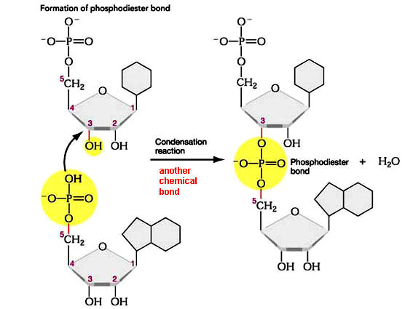

Dehydration synthesis

sugar

sugar

phosphate

phosphate

base

base

Modified from http://www.bio.miami.edu/dana/250/250SS10_7.html

Two individual strands of DNA join together to form a complete, double stranded DNA molecule. The two strands are bound together by hydrogen bonds between the bases of the nucleotides. These bases pair in specific ways: adenine forms hydrogen bonds with thymine, and cytosine forms hydrogen bonds with guanine. These are called the **base-pairing rules**. Hydrogen bonds are fairly weak bonds, thus, the two strands of a DNA molecule are fairly easy to separate. This occurs regularly during DNA replication in the S-phase of the cell cycle.

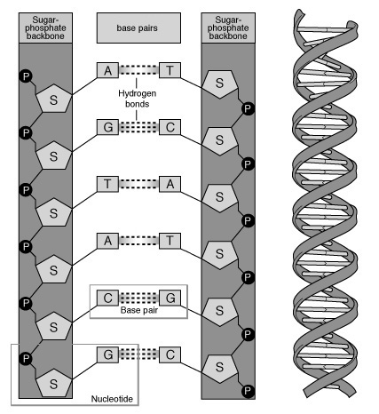

DNA double-helix

Image from http://cnx.org/content/m12382/latest/

Notice that the two strands of DNA are pointed in opposite directions, or **antiparallel** to one another. To see this most clearly, take a look at the orientation of the sugar rings in the diagram to the left.

Due to the angles of the hydrogen bonds and phosphodiester bonds, double stranded DNA forms a **double-helix** shape, shown in the diagram to the left.

The order of the bases in a given individual strand of DNA is called the **DNA sequence**. If the DNA sequence of one strand is known, the DNA sequence of the other strand is easy to determine by following the base pairing rules. Thus, the two strands of a double stranded DNA molecule are called **complementary strands**.

Subtle differences in DNA sequences are what cause the differences in appearance and chemistry between any two individual organisms. These differences may be quite substantial (as in the difference in DNA sequence between a human and a bacterium) or may be slight (as in the differences between a pair of siblings in a human family). To recognize and pinpoint differences in DNA sequence between individuals remains an important goal in research and in medicine.

**Try these questions…**

Which four monomers make up a DNA polymer?

Describe the structure of DNA monomers.

What is the arrangement of these monomers in a DNA polymer? Explain where there are covalent bonds and where there are hydrogen bonds.

Describe why we call DNA an anti-parallel double helix.