

2019

Ladies Singles Open

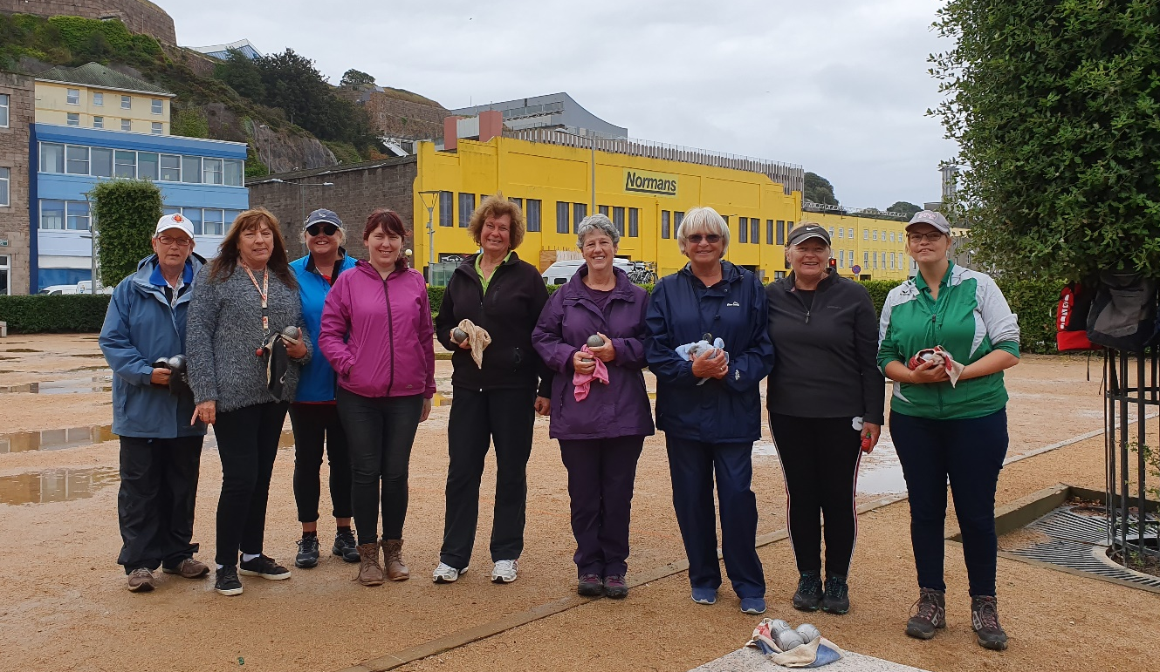

Liberations 2nd Annual Ladies Singles Open had 9 entries playing through the puddles to become the Champion.

Round 1 saw a very close match between Joy Hart and Jean Stewart, with the match tied at 12 – 12 Jean fired out Joy’s boule at 9 metres for a 13 – 12 win against the defending champion.

Wendy Ritzema, last years runner up hit the ground running taking 5 points off the first two ends and despite some great pointing from Brigitte Wendy ran out a 13 – 7 winner.

Aiming to get one over the Jersey players was Guernsey’s top female player in Delphine Renaud and she started off well with a 13 – 6 win over Cassie Stewart.

Mo De Gruchy also won with a 13 – 9 result over Susan Le Gresley. Lorna had a bye and therefore received a 13 – 7 win

In Round 2, Jean Stewart continue her fine form handing Mo a 13 – 0 defeat and Wendy made it two wins with a 13 – 3 result over Delphine.

Brigitte continued placing really well and this resulted in a big win over Lorna 13 – 1. Wth raining champion Joy winning a close one against Cassie 13 – 10.

Round 3 saw Jean have a bye so was on three wins from 3 and was joined by an impressive Wendy who beat Lorna 13 – 7 to make it three in a row.

Joy Hart came back into contention with her second win, this time over Delphine 13 – 8. Two close matches though as Susan Le Gresley beat Brigitte Ibitson 13 – 12 and Cassie Stewart beat Mo De Gruchy 13 – 10.

In Round 4 Wendy lost her first match as Joy Hart started to make her move to the top four. Lorna Limbrick got her second win with a 13 – 12 over Susan. Jean Stewart also lost her first match as Brigitte moved into contention winning 13 – 9. Delphine also won making it two wins with a 13 – 11 result over Mo.

Going into the final round many players had a chance of making the top four, Susan Le Gresley gave herself the best chance beating Wendy 13 – 12, but finished 5th due to points difference. Despite losing to Susan Wendy finished 4th 3 wins +15.

Brigitte made the top three finishing third with 3 wins + 17 much to her surprise after winning 13 – 5 over Cassie Stewart. Jean Stewart though finished top with a 13 – 6 win over Lorna, Jean with 4 wins + 23.

2018 champion Joy Hart finished second with a 13 – 7 win over Mo De Gruchy, Joy with 4 wins +19.

FINAL STANDINGS

1st Jean Stewart 4 Wins +23
2nd Joy Hart 4 Wins +19
3rd Brigitte Ibitson 3 Wins +17
4th Wendy Ritzema 3 Wins +15
5th Susan Le Gresley 3 Wins +3
6th Delphine Renaud 3 Wins +0
7th Cassie Stewart 2 Wins -9
8th Lorna Limbrick 2 Wins -18
9th Mo De Gruchy 1 Win -30

Semi Final 1 saw Jean Stewart take on the 2018 Runner Up Wendy Ritzema. This was incredibly close with Jean 12 – 11 down, then picked up two points on the next end to take it 13 – 12 ending Wendy’s hope of making another final.

In the other semi final Brigitte’s excellent placing just wasn’t enough as Joy was finding her form to make the final winning 13 – 8.

The third place play off saw another 13 – 12 (the 6th of the competition) with Wendy winning as she added third place to last years second place with Brigitte ending 4th.

The final was close at the start with it tied 3 -3 after four ends before Joy picked up a good three, Jean was playing catch up all they way after this but did have a number of chances to pick up a few extra points but did push Joy all the way eventually losing 13 – 10 as Joy retained her title.

So Joy Hart is the first and second Jersey Women’s Open Singles Champion.
(Pictured Below centre, on the left Jean and on the right Wendy)

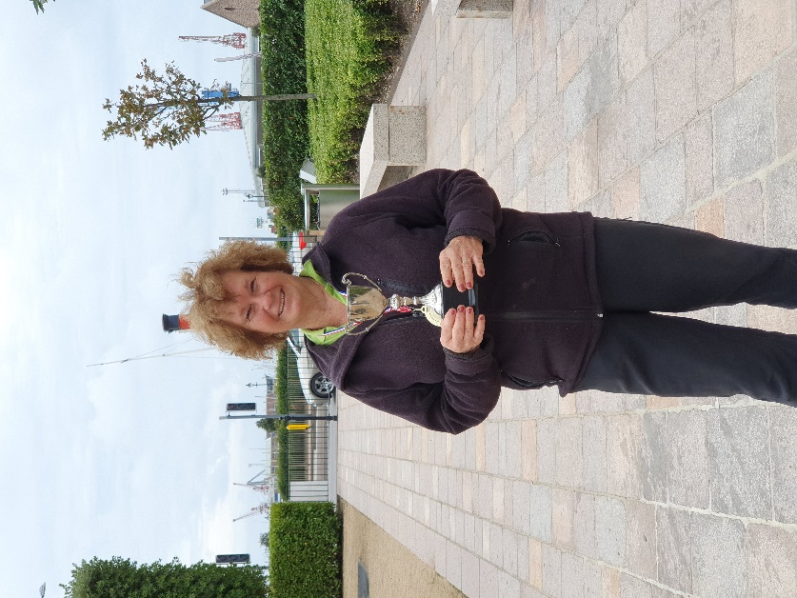

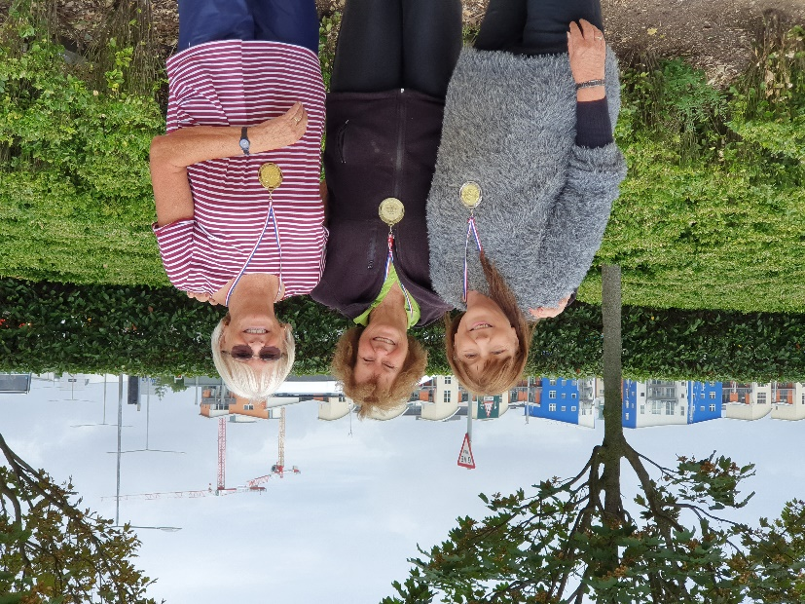

We hope you will all be back next year and hope you can help make it bigger and better.
Liberation Charity Triples Open
In Aid of Jersey Children’s Charity
Saturday 17th October 2019
Still Time to Enter

WEBSITE www.liberationpetanque.co.uk
EMAIL liberationpc@gmail.com

Kind Regards
Toby Northern
Chairman
Liberation Petanque Club SPONSORED BY



