

**WHAT**: MAY MEMBERSHIP MEETING –

**WHEN:** May 8, 2023

6:00pm – Networking

6:30 pm – Short Meeting – Celebrate RMGA’s 30th Anniversary

6:45pm -- Program

**WHERE:** Via Zoom

Join Zoom Meeting [**https://us06web.zoom.us/j/84038109657**](https://us06web.zoom.us/j/84038109657)

One tap mobile +17207072699,,84038109657# US (Denver)

**PROGRAM:** **Colorado Springs and Denver International Airport Presentations**

**Part 1) Visit Colorado Springs, Holly Taylor, Manager of Destination Services**

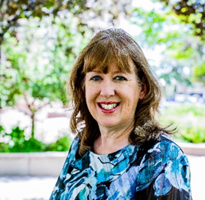Holly has lived most of her life in Colorado Springs and comes from a background of event planning and vendor relations. She has been with Visit Colorado Springs for four years helping to bring family and class reunions to the Springs as well as servicing all corporate, association, and wedding groups. Holly loves working with groups, helping them with attractions, restaurants, day meeting space and transportation. She enjoys driving through Garden of the Gods Park and is most likely to have plans for dinner and drinks with friends or family. You can ask Holly about the all the must-sees around Colorado Springs!

Holly will give us the inside scoop on places to see and how guides can utilize their services. Including additional contact information for colleagues like Lindsey Pevey who leads group sales and convention services.

Holly Taylor

Manager Of Destination Services

719-685-7626

[Holly@VisitCOS.com](mailto:Holly@VisitCOS.com)

**Part 2) Denver International Airport, Heather Kaufman Director of Arts & Events**

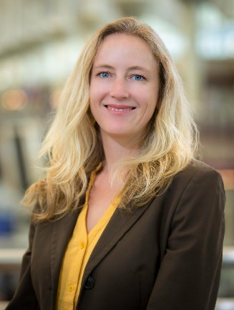Heather has been with the airport for approximately 8 years, responsible for overseeing the temporary art exhibits within the airport, DEN's robust campus wide permanent collection of public art, and manages all special events for both public and staff at the airport, including installations on the DEN Plaza, plus surprise and delight events in the Jeppesen Terminal and on the Concourses.

Heather is a 4th generation Colorado native; she grew up in Durango, CO and has been in the Denver area since 2003. Her passion for the Arts and Cultural scene in Denver extends far beyond her role at the airport, with past work history at both the Denver Botanic Gardens and the Denver Center for the Performing Arts, and she has been actively involved with SCFD and the CBCA.

Brief overview of the presentation to include:

• High level information on the Concourse Expansions, including the patios

• High level update/vision for Great Hall

• Vision 100 initiative

• Current and upcoming exhibits at DEN

• Overview of the public art collection- current

• Overview of new art coming

• Special Events planned for the summer at DEN

Heather will be giving an update to the current status of the airport and the many projects changing its face. Help us plan our FAM trip to DEN where we will have special access and see firsthand some of the many changes that are occurring.

Heather Kaufman

Director of Arts and Events

Global Communications, Marketing, Customer Service, Arts and Events

Airport Office Building | 9th Floor

8500 Peña Boulevard | Denver, CO 80249-6340

(303) 342-2526 | Cell (720) 442-6627

[Heather.Kaufman@flydenver.com](mailto:Heather.Kaufman@flydenver.com)

**MEETING NIGHT CONTACT:** Mark Blaising at Blaising303@gmail.com or by text 303-263-8647; Zoom issues: Mike Pearl at 303-868-0023.