Matabele Rebellion Grave Catalogue M-Z

NO PIC

MATHIESON, Tpr Robertson Balfour
Unknown; in the ‘Bezwy’ Hills

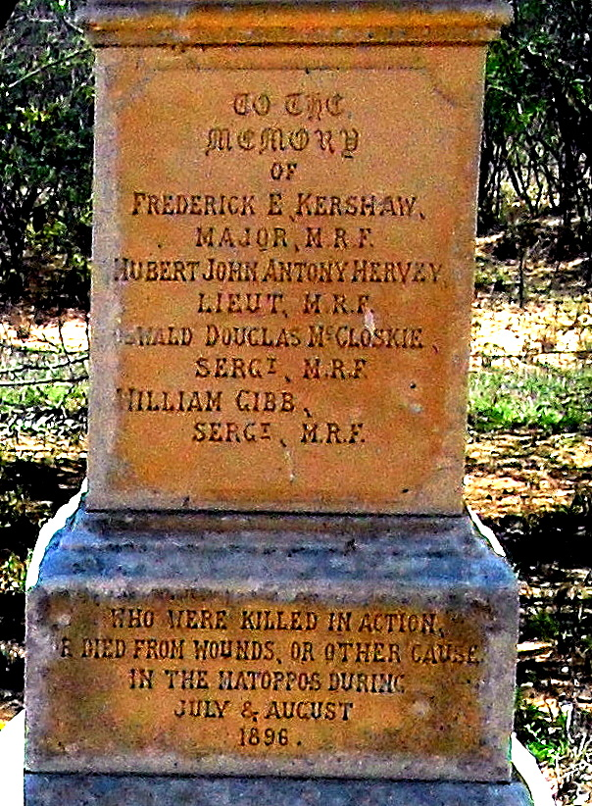

MCCLOSKIE, Sgt Oswald Douglas
Fort Umlugulu Cemetery, Matopos, Bulawayo

NO PIC

MCGEORGE, Tpr Ernest
Gweru (Gwelo) Cemetery

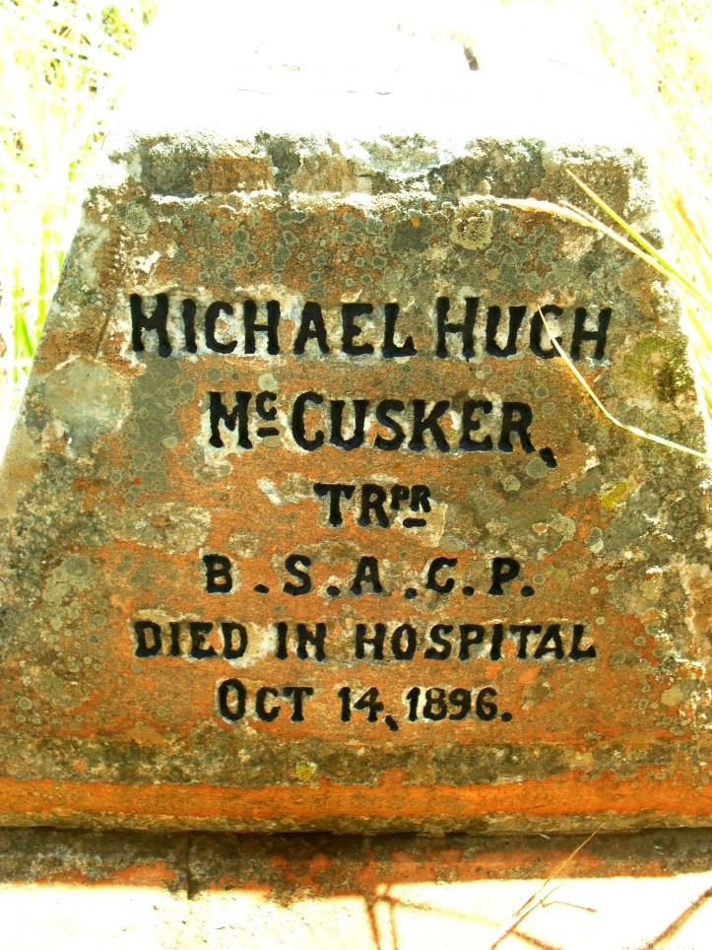

MCCUSKER, Tpr Michael Henry
Bulawayo General (Pioneer)Cemetery

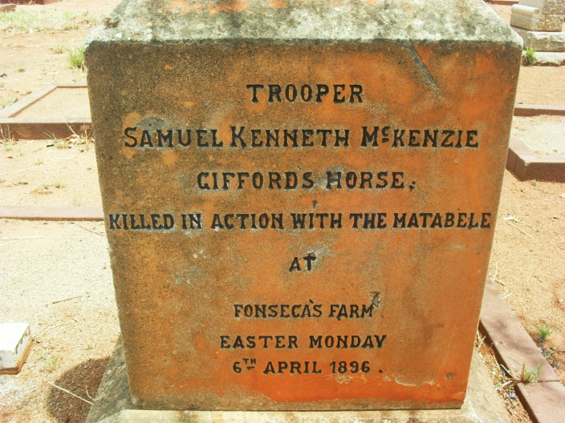
MCKENZIE, Tpr Samuel Kenneth
Bulawayo General (Pioneer)Cemetery

NO PIC

MCLEAN, Malcolm Robert
Gweru (Gwelo) Cemetery

NO PIC

MCVEAN (MCLEAN?), Tpr Archibald
Gweru (Gwelo) Cemetery

NO PIC

MEIKLE, Tpr Kenneth
Unknown; Mangwe?

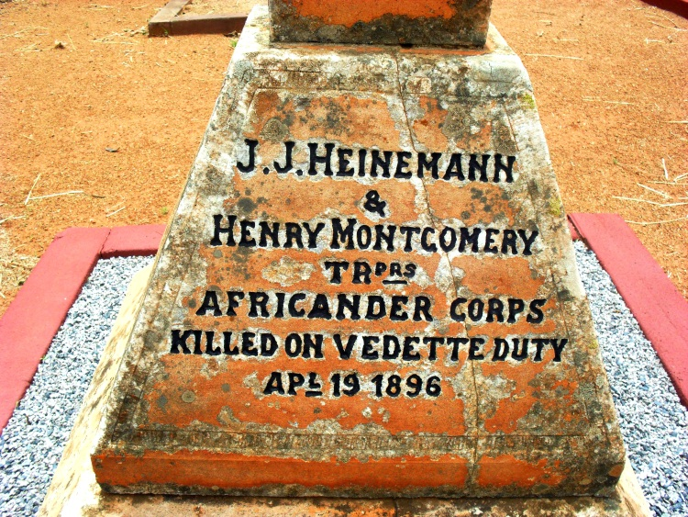

MONTGOMERY, Tpr Henry
Bulawayo General (Pioneer)Cemetery

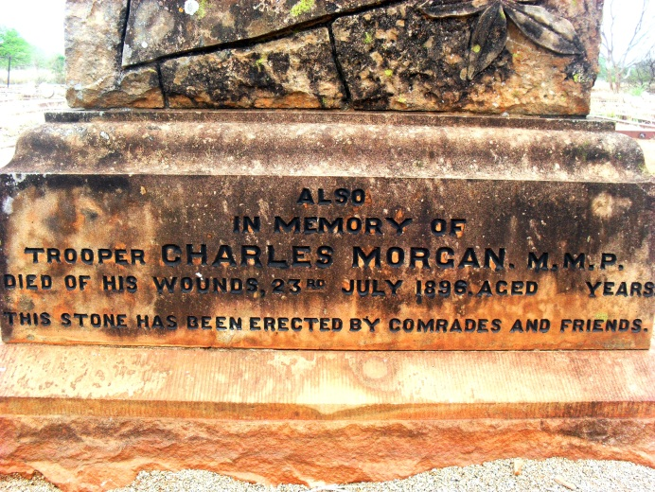

MORGAN, Tpr Charles Oglethorpe
Fort Umlugulu Cemetery, Matopos, Bulawayo

NO PIC

O’FARRELL, Tpr J.P.
Gweru (Gwelo) Cemetery

NO PIC

O’LEARY, Sgt Maj John Joseph
Unknown; Insiza?

NO PIC

O’REILLY, Tpr John
Unknown; North of Insiza?

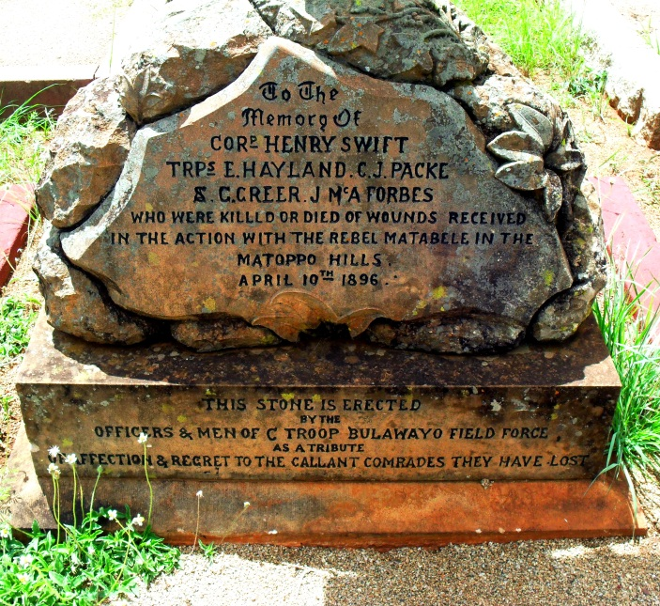

PACKE, Tpr Christopher John
Bulawayo General (Pioneer)Cemetery

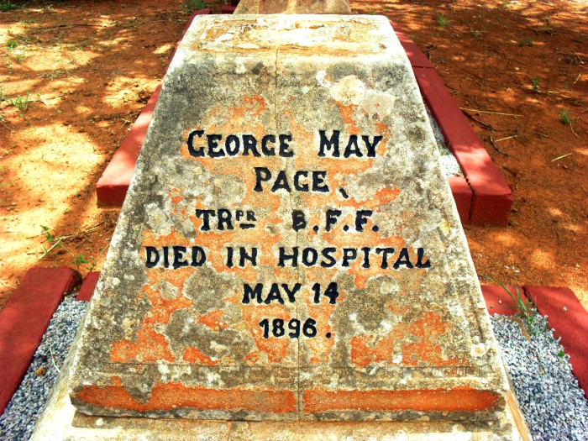
PAGE, Tpr George May
Bulawayo General (Pioneer)Cemetery

NO PIC

PARKER, Tpr Carrick
Unknown; Ft Rixon north of Insiza?

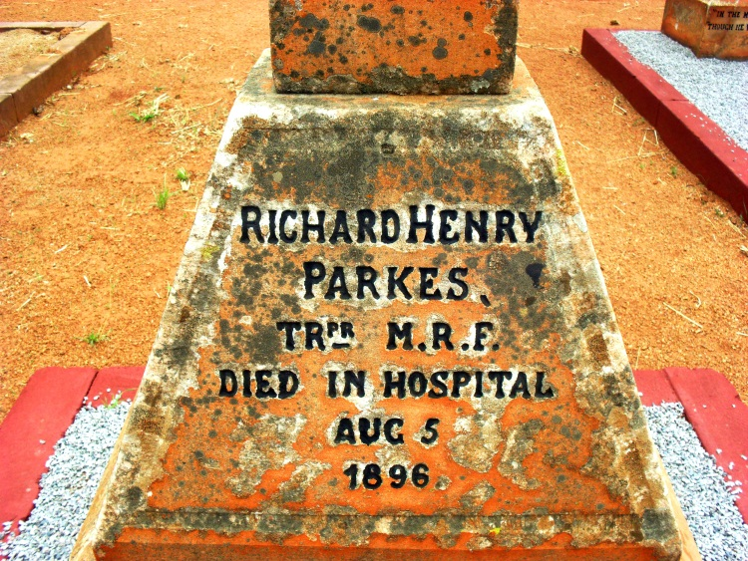

PARKES, Tpr Richard Henry
Bulawayo General (Pioneer)Cemetery
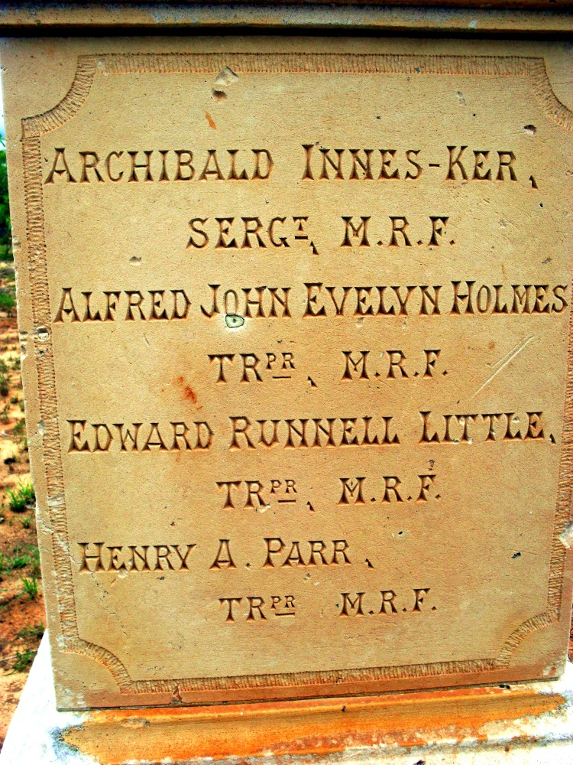

PARR, Tpr Henry A.
Fort Umlugulu Cemetery, Matopos, Bulawayo

NO PIC

PARRETT, L/Cpl J.
Gweru (Gwelo) Cemetery

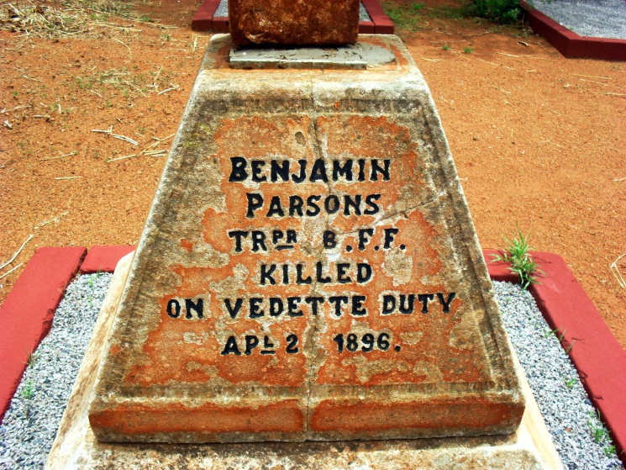
PARSONS, Tpr Benjamin
Bulawayo General (Pioneer)Cemetery
NO PIC

PERRY, Sgt Francis Charles
Unknown; near Spitzkop aka Finger Kop between Insiza and Belingwe

NO PIC

POPE, Quarter Master F. Jackson
Mberengwa (Belingwe)

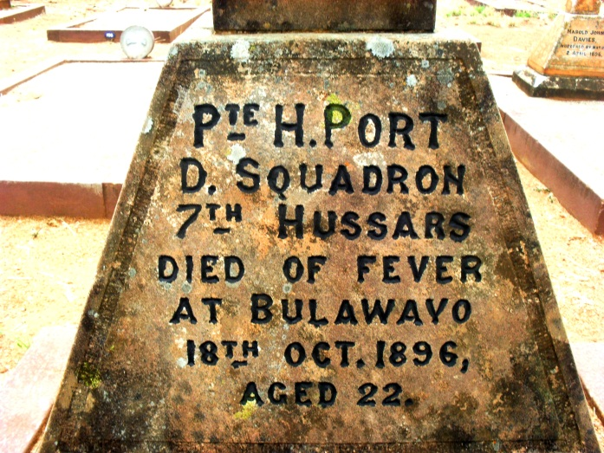

PORT, Pte Herbert Some records spell his name PORTE
Bulawayo General (Pioneer)Cemetery

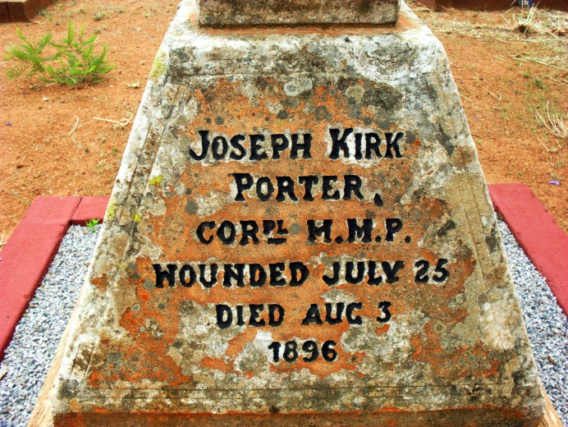
PORTER, Cpl Joseph Kirk
Bulawayo General (Pioneer)Cemetery

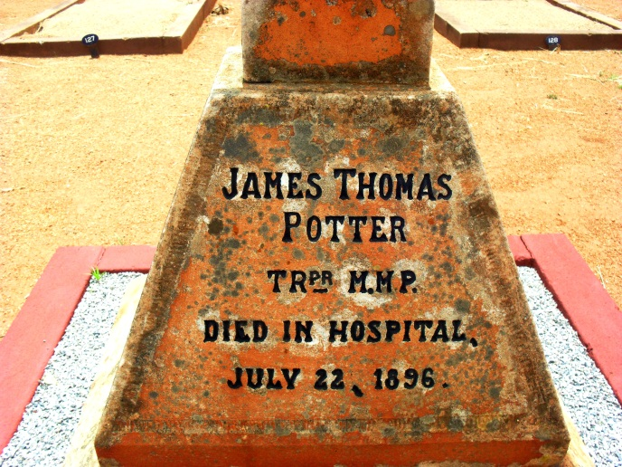
POTTER, Tpr James Thomas
Bulawayo General (Pioneer)Cemetery

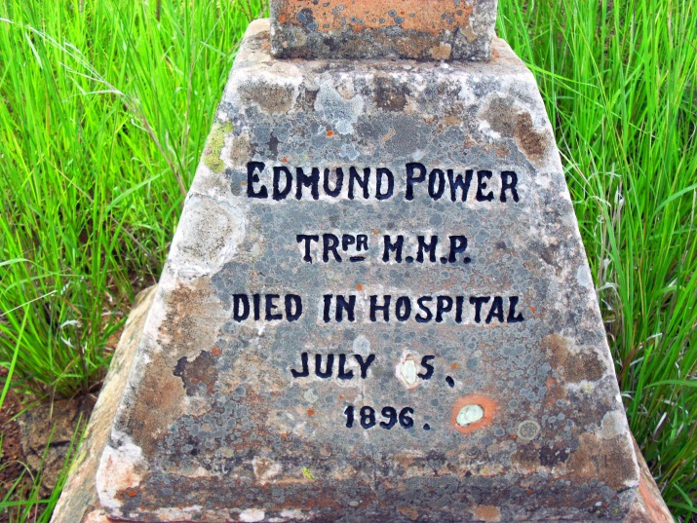

POWER, Tpr Edmund
Bulawayo General (Pioneer)Cemetery

NO PIC

PRINGLE, Cpl James F.
Unknown; near West's Store on the Hunter's Road, north of Inyati.

NO PIC

REIS, Tpr H.V.
Unknown; Tuli/Victoria road

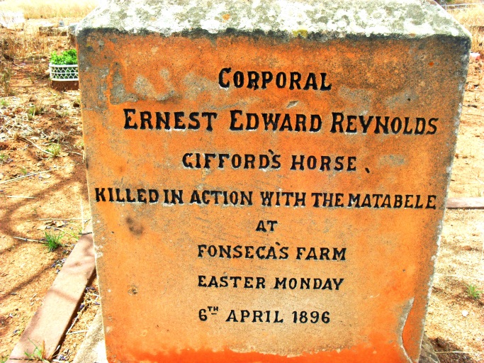
REYNOLDS, Cpl Ernest Edward
Bulawayo General (Pioneer)Cemetery

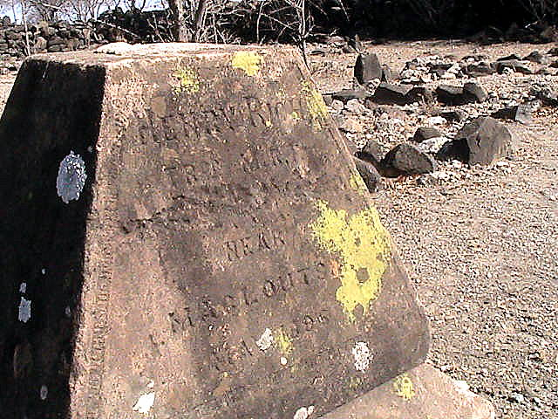

RICH, Tpr Henry
Bobonong Botswana, west of Tuli Circle (Ft Macloutsie)

NO PIC

ROTHMAN, Tpr George
Ft Rixon? Laager on the Insiza River

NO PIC

SELOUS, Eric Nugent
Gweru (Gwelo) Cemetery

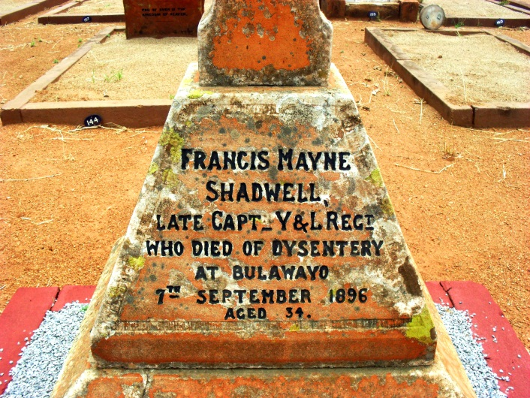
SHADWELL, Capt Francis Mayne
Bulawayo General (Pioneer)Cemetery
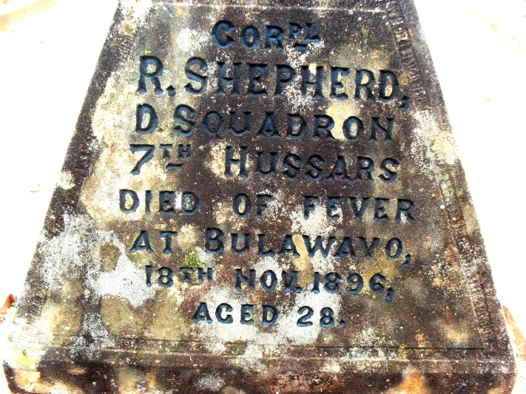
SHEPHERD, Cpl R
Bulawayo General (Pioneer)Cemetery

NO PIC

SMITH, L/Cpl William A.
Unknown; near Bonsor Mine; Gweru?

NO PIC

SOMAN, Tpr Edward
Gweru (Gwelo) Cemetery

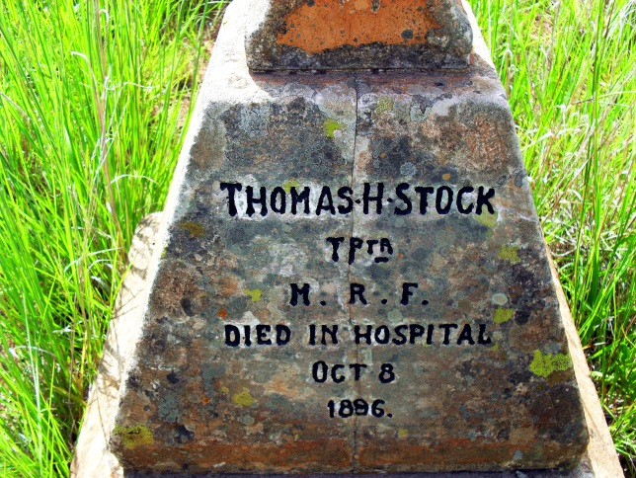

STOCK, Tpr Thomas Henry
Bulawayo General (Pioneer)Cemetery

NO PIC

STORY, Charles Frederick
Gweru (Gwelo) Cemetery

NO PIC

SUMMERVILLE, Tpr George
Unknown; Shangani area

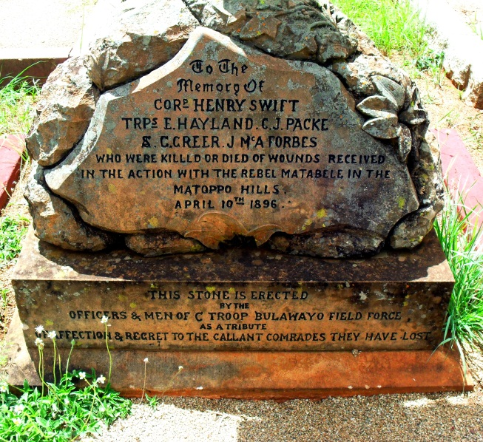

SWIFT, Tpr Henry
Bulawayo General (Pioneer)Cemetery

NO PIC

TALBOT, Cpl Frederick Walter
Unknown; Uwini’s Camp

NO PIC

USBORNE, Tpr C.
Gweru (Gwelo) Cemetery

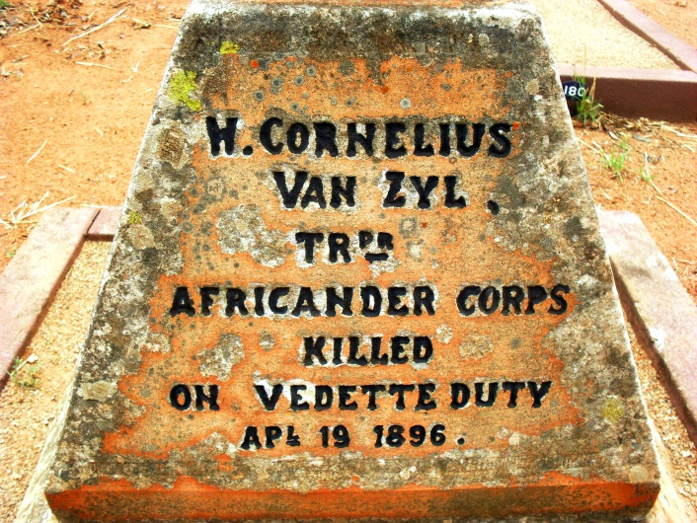
Van ZYL, Tpr Wynand Cornelius
Bulawayo General (Pioneer)Cemetery

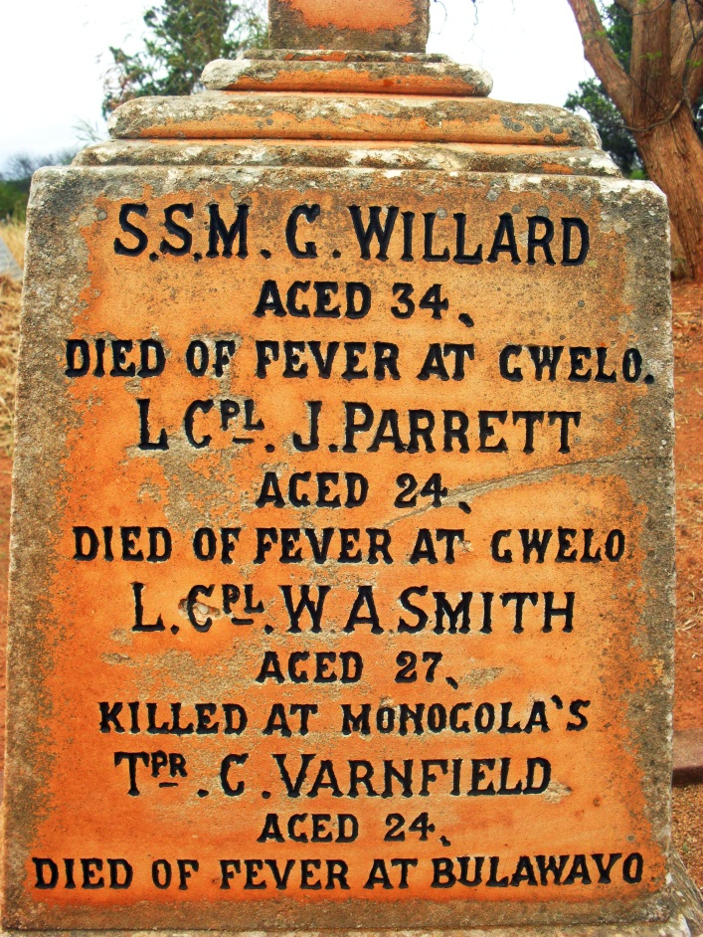
VARNFIELD, Tpr C.
Bulawayo General (Pioneer)Cemetery

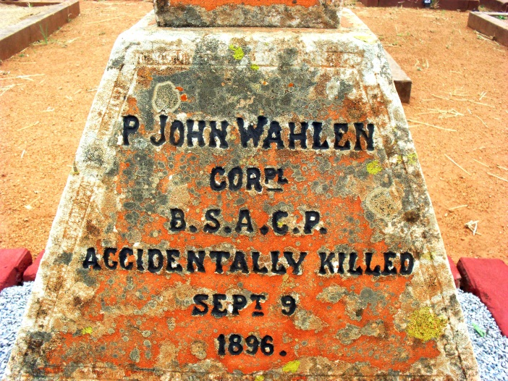
WAHLEN, Cpl P. John
Bulawayo General (Pioneer)Cemetery

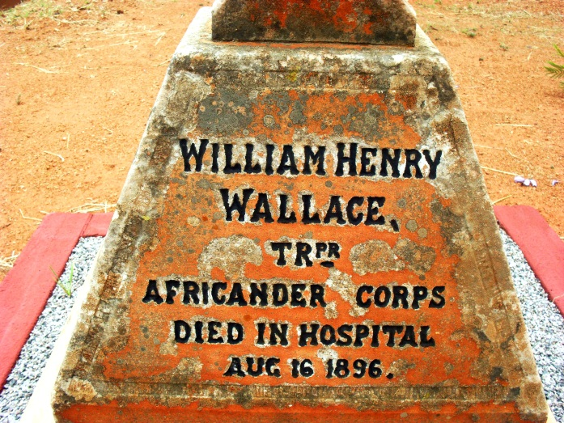
WALLACE, Tpr William Henry
Bulawayo General (Pioneer)Cemetery

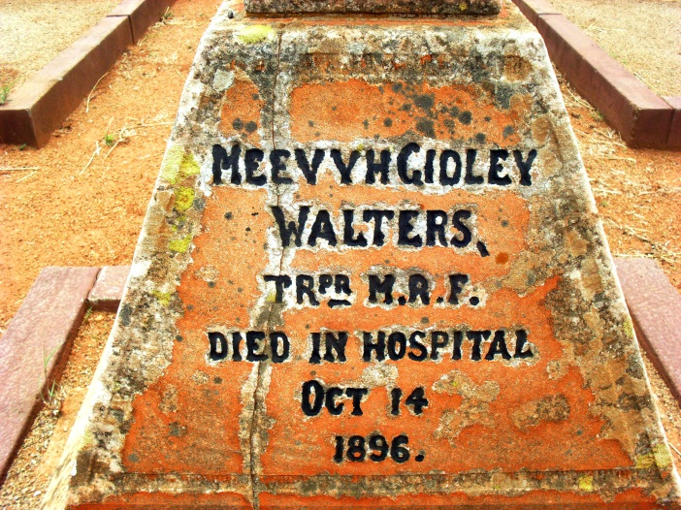

WALTERS, Tpr Mervyn Gidley
Bulawayo General (Pioneer)Cemetery

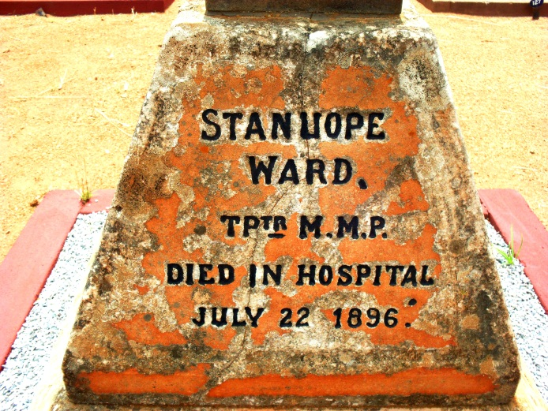
WARD, Tpr Stanhope
Bulawayo General (Pioneer)Cemetery

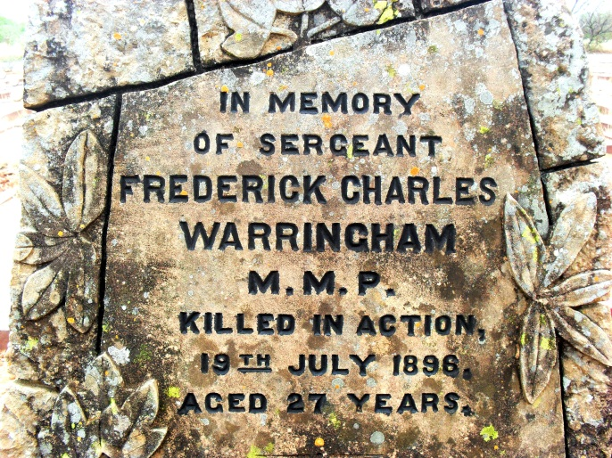

WARRINGHAM, Sgt Frederick Charles
Bulawayo General (Pioneer)Cemetery

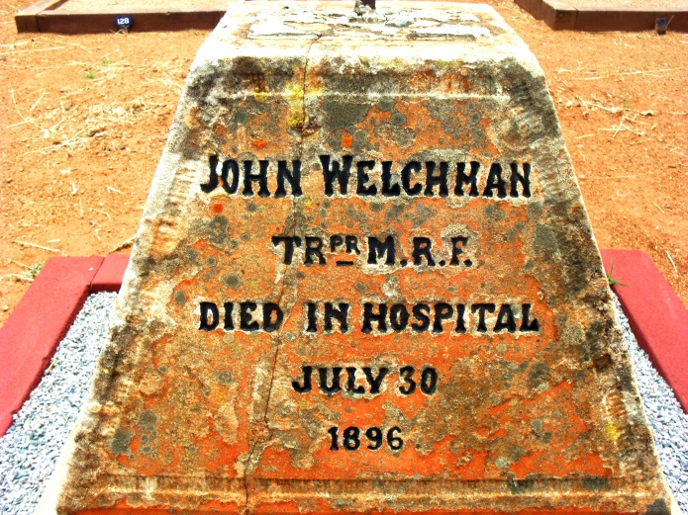
WELCHMAN, Tpr John
Bulawayo General (Pioneer)Cemetery

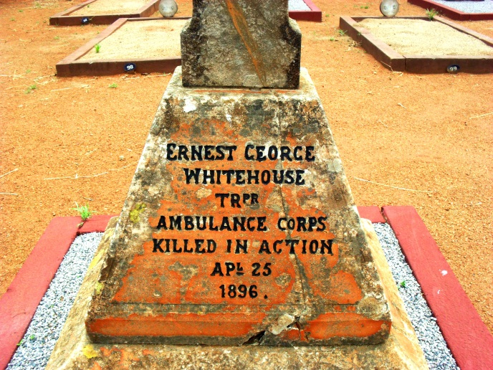
WHITEHOUSE, Tpr Ernest George
Bulawayo General (Pioneer)Cemetery

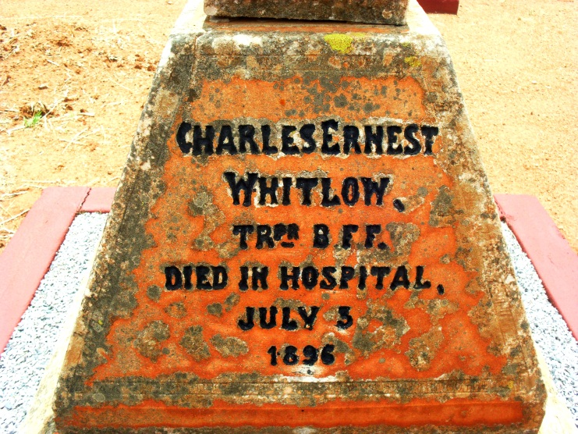
WHITLOW, Tpr Charles Ernest
Bulawayo General (Pioneer)Cemetery

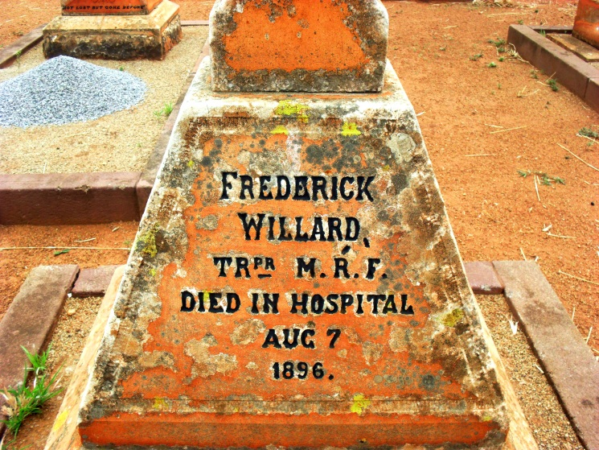
WILLARD, Tpr Frederick
Bulawayo General (Pioneer)Cemetery

NO PIC

WILLARD, Sqn Sgt Maj George
Gweru (Gwelo) Cemetery

NO PIC

WILSON, Tpr John Antoine Campbell
Unknown; Hope Fountain?

NO PIC

WOEST, Tpr John Tobias
Unknown; Mazezeteze’s Kraal, Belingwe

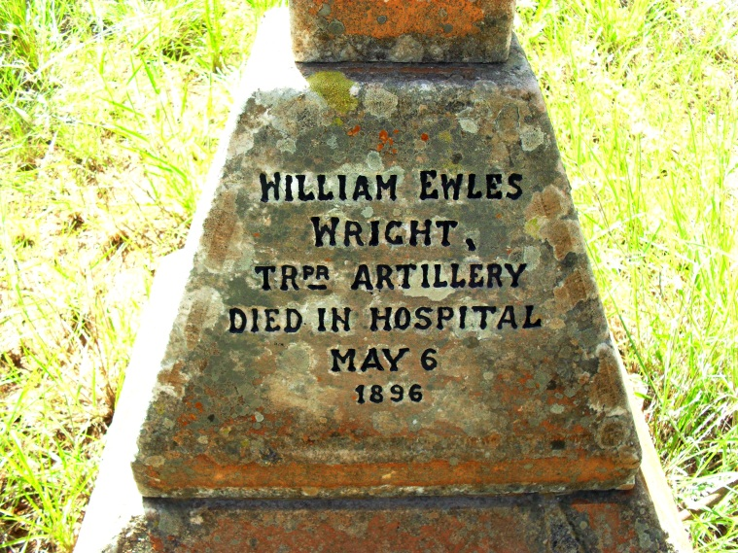

WRIGHT, Tpr William Ewles
Bulawayo General (Pioneer)Cemetery

