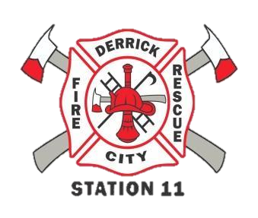
FEEL THE BURN
(IN COLOR) 5K
WALK/RUN

WHAT: This year we are doing our 5k in COLOR! .. again!
WHEN: August 11th, 2018 @ 9:00am race start – please arrive early to pick up your bag and bib (8:00 am). (Pre Reg Deadline is July 23rd)
WHERE: Derrick City Volunteer Fire Department – 451 Derrick Road- Derrick City, PA
COST: ADULT: $25.00 CHILDREN UNDER 12YRS: $15.00
Registration includes a T-shirt!
*** REGISTRATIONS ON OUR WEBSITE- WWW.DCVFD.COM UNDER THE CONTACT US TAB****
DON’T MISS OUT ON ALL THE COLOR FUN! BRING YOUR FAMILY & FRIENDS!

