2/26/2018 The 5/14/2018 Cluster of Events

It was recently announced that the United States Embassy in Tel Aviv, Israel, will probably be officially moved to Jerusalem on the date of Israel's 70th anniversary as a modern sovereign state, 5/14/2018.

Link: https://www.timesofisrael.com/us-to-move-embassy-to-jerusalem-on-may-14-day-of-independence-declaration/

The Cluster of Events Around 5/14/2018

There are several interesting events that cluster around the 5/14/2018, 70th anniversary date of the State of Israel.

1. The official ribbon cutting ceremony of the USA moving its Embassy to Jerusalem will probably occur on 5/14/2018.

2. The chiastic midpoint of the 70th year of the life of President Hassan Rouhani of Iran, a sworn enemy of Israel and the United States, occurs on 5/14/2018 at 2:54 AM Jerusalem time (counting noon on 11/12/1948 as the date and time of his birth). YaHuWaH Elohim has ordained that the central focus of President Rouhani's 70th year of life is the 70th anniversary of the modern State of Israel.

3. The 70th anniversary of modern Israel's protection by the United States of America (prophetic Babylon the great) occurs on 5/14/2018.

4. According to Jeremiah 29:10, YaHuWaH Elohim will visit His people after they have been under Babylon's protection for 70 Years in order to return them to the land of Israel. The reasons for YaHuWaH 's peoples to return to the land of Israel in modern times has been that the living conditions in various countries had grown intolerable for YaHuWaH 's people.

5. The Islamic month of Ramadan, when enhanced heavenly rewards (greater numbers of virgins awarded to the murderer) are promised to those Muslims who kill infidels for Allah, begins 5/15/2018 at sunset. The month of Ramadan begins about 29 1/2 days earlier each year and floats through the months of the Roman Calendar. It just happens to begin on 5/15/2018, one day after Israel's 70th anniversary during this particular year.

The graphic below illustrates the events listed above:

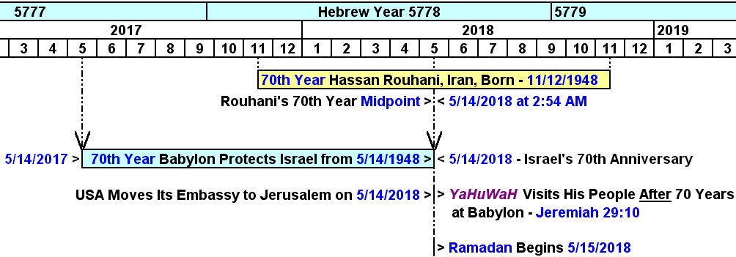

Jeremiah 29:8 For thus saith YaHuWaH of hosts, the Elohim of Israel; Let not your prophets and your diviners, that be in the midst of you, deceive you, neither hearken to your dreams which ye cause to be dreamed.
9 For they prophesy falsely unto you in My Name: I have not sent them, saith YaHuWaH .
10 For thus saith YaHuWaH , That after seventy years be accomplished at Babylon I will visit you, and perform My good word toward you, in causing you to return to this place.
11 For I know the thoughts that I think toward you, saith YaHuWaH , thoughts of peace, and not of evil, to give you an expected end.
12 Then shall ye call upon Me, and ye shall go and pray unto Me, and I will hearken unto you.
13 And ye shall seek Me, and find Me, when ye shall search for Me with all your heart.
14 And I will be found of you, saith YaHuWaH : and I will turn away your captivity, and I will gather you from all the nations, and from all the places whither I have driven you, saith YaHuWaH ; and I will bring you again into the place whence I caused you to be carried away captive.

Prophecies can have Multiple Fulfillments

Bad times are ahead for all the nations.

Biblical prophecies may have multiple fulfillments, although not exactly in the same way. The bible tells us that history is cyclical.

We know that at in 539 BC at the end of 70 years of Jewish captivity in ancient Babylon, Cyrus the king of ancient Persia (modern day Iran) defeated Babylon and caused the Jews to return to Jerusalem.
We know that the meaning of the name "Cyrus" (Hebrew - Koresh) is "like the sun". "Like the sun" is a precise description of the light and heat given off by nuclear fusion.

Note in the graphic above that the "king" of modern "Persia" (Iran), Hassan Rouhani, is curiously related via his heavenly ordained birth date to the end of modern Babylon the Great's 70 year protective association with the modern State of Israel.

The information presented above points to the existence of our heavenly Father and His intimate involvement in the affairs of nations and the lives of people. He's involved in a progressive revelation of who He is and what His plans are for the peoples of the earth.

He's looking for friends and companions. Who will be His friend and follow His instructions?

