
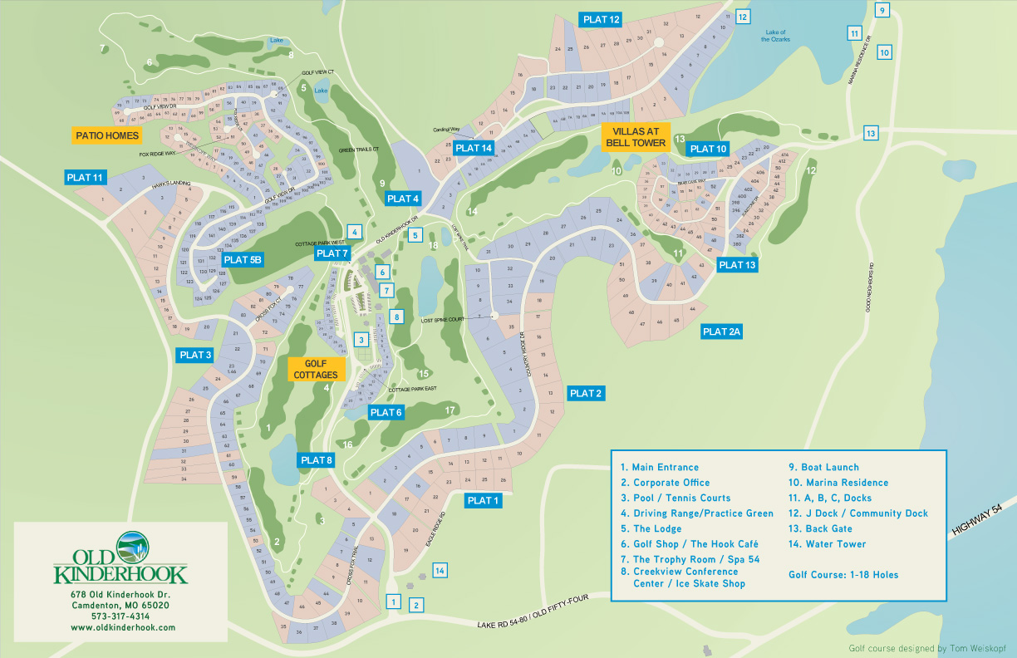
346 Country Ridge Dr.
Hwy 54 across Niangua-Arm bridge
Right on Lake Road 54-80
Right into Old Kinderhook Resort
Right on Country Ridge Drive
Right at 346 steep-grade driveway
Bell Tower Pool.
Amenities available to Kinderhook Castle renters at no additional cost:
- Tennis Courts, Community Pool, and Fitness Center (#3)
- Bell Tower Pool (not listed on map legend)
Amenities available at public cost (contact Old Kinderhook for reservations, hours, and prices):
- Tom-Weiskopf-designed golf course (#6) plus driving range and practice green (#4).
oldkinderhook.com/golf/ or 573.260.8530
- Spa 54 (#7).
oldkinderhook.com/spa/ or 573.319.2379
- Seasonal sand volleyball court or outdoor ice rink (#8).
oldkinderhook.com/the-sand/ or oldkinderhook.com/the-ice/ or 573.317.4314 (Front Desk)
- Seasonal Christmas Village family activities (#8).
oldkinderhook.com/play/christmas-village-at-old-kinderhook/ or 573.317.4314 (Front Desk)
- Hook Café informal dining (#6).
oldkinderhook.com/hook-cafe/ or 573.317.3575
- Trophy Room formal dining and bar (#8).
oldkinderhook.com/dining/ or 573.317.3560
- Boat launch (#9) and boat docks (#11).
oldkinderhook.com/boating/ or573.260.1247. Kayak rental: call Old Kinderhook 573.260.8530. Boat rental: call Montego Bay Marina 573.348.4911.

