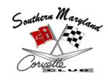

March 8, 2015
(NO MEETING HELD)

- Instead of holding a formal meeting in March, members cruised to Grid Iron Grill, in Callaway, MD, on Sunday, March 8, 2015. We met at 5:00pm for the dinner and social.

*Recorded by: Patrice Hopkins, 2013-2015 SMCC Corvette Club Secretary*

