Village of Innsbrook, MO
2025 Comprehensive Plan Update

May 30, 2025

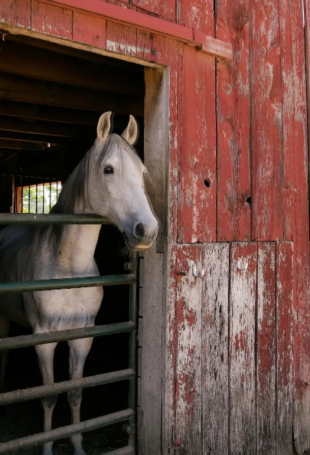






TABLE OF CONTENTS
Introduction 5
Section 1.0 Study Area & Background 5
Section 1.1 History 5
Section 1.2 Innsbrook Today 6
Section 1.3 Comprehensive Plan 7
Section 1.4 Zoning Ordinance 7
Section 1.5 Subdivision Regulations 8
Section 1.6 The Planning Process 8
Socioeconomic Conditions 10
Section 2.0 Nationwide Population Trends 10
Section 2.1 Innsbrook Population Characteristics 10
Section 2.2 Population Projections 11
Section 2.3 Age Characteristics 12
Section 2.4 Racial Composition 14
Section 2.5 Gender 14
Section 2.6 Income 15
Section 2.7 Housing 15
Section 2.8 Housing Affordability 17
Section 2.9 Educational Attainment (ages 25 and over) 18
Section 2.10 Community Tapestry 19
Section 2.11 Top Tapestry Segments 19
Infrastructure & Public Facilities 23
Section 3.0 Electrical Service 23
Section 3.1 Wireless Data Services 23
Section 3.2 Water Service 23
Section 3.3 Wastewater Service 23
Section 3.4 Stormwater 23
Section 3.5 Natural Gas 24
Section 3.6 Early Outdoor Warning System 24
Section 3.7 Zykan 24
Section 3.8 Existing Roads 24
Section 3.9 Future Road Design for the Village 24
Section 3.10 Environmental Framework 25
Section 3.11 Historic sites 25
Section 3.12 Transportation & Infrastructure Financing Options 26
Section 3.13 Village Hall 27
Section 3.14 School Districts 27
Section 3.15 Fire Protection 28
Section 3.16 Warren County Sheriff’s Department 31
Section 3.17 Warren County Ambulance District 31
Vision, Goals and Objectives 32
Section 4.0 Innsbrook’s Vision 32
Section 4.1 Natural Environment Goals & Objectives 32
Section 4.2 Land Use Goals and Objectives 33
Section 4.3 Transportation Goals & Objectives 35
Section 4.4 Infrastructure Goals & Objectives 37
Section 4.5 Funding Sources 39
Future Land Use 42
Section 5.0 Future Land Use & Zoning 42
Section 5.1 Future Land Use Recommendations 43
Section 5.2 Non-Urban 44
Section 5.3 Low Density Single-Family Residential 44
Section 5.4 Medium Density Residential 45
Section 5.5 Multi-family 46
Section 5.6 Mixed Use 46
Section 5.7 Future Land Use Matrix 49
Section 5.8 Growth Management 51
Section 5.9 Annexation 52
Section 5.10 Summary 53

Introduction
A Comprehensive Plan is the official document adopted by the Planning and Zoning Commission to serve as the legal and conceptual foundation of the Village’s Zoning Code. The purpose of the Comprehensive Plan is to promote the health, safety, and welfare of the community by preserving and protecting four (4) key interrelated quality of life factors which include social, economic, physical and environmental.
The Village’s commitment to protecting the quality of life through planning was first memorialized in June of 2003 with the adoption of the Village’s first Comprehensive Plan. The 2003 Plan was updated in October of 2011 in conjunction with the release of the 2010 US Census findings. To aid in the implementation of the Plan, the Village initiated a regulatory review and amendment process to update the Village’s original Zoning Code, adopted in 2009. The intent of the regulatory update was to make the Village’s zoning regulations consistent with the Comprehensive Plan. The 2013 Village of Innsbrook Comprehensive Plan is the second update to the original Plan. It is the culmination of more than ten (10) years of intense implementation efforts resulting in the development and ongoing updates to the Village’s Zoning Code and incremental actions to achieve the Plan’s goals and objectives.

Study Area & Background
Innsbrook is located in central eastern Warren County, five (5) miles south of Wright City and just over 50 miles from St. Louis. Neighboring communities include Foristell, Warrenton, Truesdale, and Marthasville. The study area includes Innsbrook’s current Village limits which consists of approximately 11.5 square miles (7,300 acres) of which over 10% (710 acres) is water and 9.94 square miles is land.

History
Native Americans: The study area was initially home to the Missouri and Osage Indians and later the Sac and Fox Nation of Missouri. The Missouri Indians eventually moved into Kansas and joined with the Oto Indians due to outbreaks of smallpox and warfare with the Sac Indians. In 1825, the Osage Indians ceded their land to Missouri and moved to Kansas. The Sac and Fox Nation of Missouri had their origins in the Great Lakes region and were two distinct tribes. However, pressure from the Iroquois and French on the Sacs and pressure from the Chippewa on the Foxes forced the two groups to the vicinity of current day Green Bay, Wisconsin. French attacks on the Sac and Fox authenticated the alliance effecting a confederation of the two tribes. They were forced to migrate south, during which time they attacked the Illinois Tribe and took their lands along the Mississippi River. The tribe eventually split into two groups, the Sac and Fox of the Mississippi.

In St. Louis, Missouri during 1804, tribe chiefs were persuaded to sign a treaty ceding to the US Government all Sac and Fox lands east of the Mississippi River as well as some hunting grounds to the west of the River. Efforts by the US Government to enforce the treaty angered the Sac and Fox, due in part because some of the Sac and Fox Indians were not aware and/or supportive of the treaty. From 1804 until the mid-1800’s, the Sac and Fox Indians continued to conduct raids in this area.

European Immigrants: The first European influence in the area came from French trappers. La Charette, settled by French trappers around 1766, was one of the first settled Villages in Warren County. It is believed to have been located where present-day Marthasville is now located. Based on the French trappers’ accounts of abundant hunting, more frontiersmen and settlers decided to immigrate to the area. Some of the early names include Col. Daniel Boone, his son-in-law, Flanders Calloway, Maj. Thomas Kennedy, and Anthony Wyatt. These men influenced the attitudes of others and soon the area became settled. However, the area was affected by various skirmishes with the raiding Sac Indians and the divided sentiments of the Civil War. One particular event that took place during the Civil War in September of 1863 resulted in the raid and burning of some buildings in Wright City.

The Boonslick Trail (now a portion of Hwy. M) facilitated cross-county travel and aided in the establishment of early settlements. This trail was initially used by Indians, trappers and fur traders. However, at some point in the early 1800’s, Daniel Boone and his son, Daniel Morgan Boone, surveyed and marked the trail. By 1819, stage lines were traveling the trail. The Boonslick Trail was one of the heaviest traveled passages in the mid 1800’s since it was a connector to the Santa Fe and Oregon Trails. The German influx that occurred in the mid to late 1800’s was largely due to the writings of Gottfried Duden, an early German immigrant, who described this area as being similar to the Rhine country in Germany.

Warren County was established on January 5, 1833 and named in honor of Gen. Joseph Warren, who fell at the battle of Bunker Hill during the American Revolutionary War. It was part of Montgomery County before incorporation. Warrenton is the county seat and the largest city in Warren County.

Innsbrook Today
Innsbrook is a short drive from St. Charles County and less than (60) minutes from downtown St. Louis. It offers the calm serenity of the country with easy access to Downtown St. Charles, Downtown St. Louis and all the cities and attractions in between. The Village of Innsbrook was formally incorporated in July of 1998, but the community had existed much longer. Innsbrook started as a weekend get-away for seasonal living in 1971. From there, it evolved to include a golf course, conference center, year-round living, cultural center and more. Through tireless efforts by concerned people and residents of the area, the Village of Innsbrook was incorporated in 1998 with the intent to have a stronger voice in planning and land development and to preserve and enhance the natural beauty of the region.

The Village was incorporated as a 4th Class city which refers to a municipality with a population between 500 and 2,999. Innsbrook is governed by a Board of Trustees composed of five (5) Board Members who serve a two-year term. Three (3) trustees board positions up for reelection on odd years and two trustees board positions are elected on even years. The Village of Innsbrook is unique as the majority of the residential properties are part of the Innsbrook Resort which follow the Innsbrook Homeowners Association (HOA) plus surrounding residential & agricultural properties. The Village od Innsbrook Homeowners Associations (HOA) maintains the roads, sewer, and other amenities within the Resort and is governed by three (3) trustees who represent all residents who live or own property inside the gates of the Resort.

The Village is considered a low-density area where on average there is three or more acres of land per dwelling unit. Encompassing more than 6,000 acres, the Village of Innsbrook is the largest Municipality in Warren County. The population density is approximately 55.5 residents per square mile, the lowest of any incorporated area in Warren County. Although approximately 600 residents are registered to vote and claim Innsbrook as their full-time home, the population increases dramatically on weekends and holidays where the Village size increases three or four times the full-time residents. Therefore, the Village of Innsbrook faces challenges and opportunities that are often associated with a growing, prospering community comprised primarily of recreational/second homes and nationally successful seasonal events. These challenges and opportunities include managing traffic and crowding during summer holidays and Resort sponsored events; providing affordable public services that Innsbrook residents have come to expect; and diversifying the Village’s economy to ensure revenues remain stable for the long term. This Plan was developed to help address these issues and seize the opportunities that make Innsbrook a great place to live, recreate, and retire.

Comprehensive Plan
This and previous comprehensive plan governing the entire Village limits, which includes the Resort. The 2025 Innsbrook Comprehensive Plan Update builds upon the Village’s 2013 Comprehensive Plan. The 2013 Comprehensive Plan has served Innsbrook well, however, recent commercial development, increase in traffic congestion and safety issues, and changes in our national and regional economy all pointed to the need to reconnect with the residents of Innsbrook to update the Plan. The intent of the Comprehensive Plan is to serve as a rational land use guide to help direct future land use, zoning, subdivisions of land and manage the quality, timing, and intensity of future growth. Missouri State Statutes; RSMo 89.340, describes the purpose and content of the Comprehensive Plan as follows:
“The commission shall make and adopt a city plan for the physical development of the municipality. The city plan, with the accompanying maps, plats, charts and descriptive and explanatory matter, shall show the commission's recommendations for the physical development and uses of land, and* may include, among other things, the general location, character and extent of streets and other public ways, grounds, places and spaces; the general location and extent of public utilities and terminals, whether publicly or privately owned, the acceptance, widening, removal, extension, relocation, narrowing, vacation, abandonment or change of use of any of the foregoing; the general character, extent and layout of the replanning of blighted districts and slum areas The commission may also prepare a zoning plan for the regulation of the height, area, bulk, location and use of private, nonprofit and public structures and premises, and of population density, but the adoption, enforcement and administration of the zoning plan shall conform to the provisions of sections 89.010 to 89.250.”

Zoning Ordinance
Zoning is the "legal" tool the Village uses to carry out the recommendations of the Comprehensive Plan. The Village is granted this regulatory authority by the State Statutes, Chapter 89, which gives the Village zoning authority over the entire Village, including the Resort. Therefore, all changes in zoning, special use permits, building permits, etc. shall be reviewed and approved by the Village. Specifically, a zoning ordinance regulates items relative to the use of land, including, but not limited to, height and size of buildings, size of lots, building setbacks and parking. It establishes definitions, standards and procedures for the Village's governing body to review and approve specific land developments. There are other ordinances and regulations that supplement the zoning ordinance, such as subdivision regulations, landscaping requirements and sign controls. The description and purpose of the zoning ordinance according to Missouri State Statutes (RSMo 89.040) states:
“Such regulations shall be made in accordance with a comprehensive plan and designed to lessen congestion in the streets; to secure safety from fire, panic and other dangers; to promote health and the general welfare; to provide adequate light and air; to prevent the overcrowding of land; to avoid undue concentration of population; to preserve features of historical significance; to facilitate the adequate provision of transportation, water, sewerage, schools, parks, and other public requirements. Such regulations shall be made with reasonable consideration, among other things, to the character of the district and its peculiar suitability for particular uses, and with a view to conserving the values of buildings and encouraging the most appropriate use of land throughout such municipality.”
Decisions regarding land use and zoning should be consistent with the Village’s Comprehensive Plan and Zoning Regulations. To increase the legal defensibility of the Village’s decision-making, the Village’s Zoning Regulations and Comprehensive Plan should be compatible. Therefore, anytime a Comprehensive Plan is updated, the Village should then review and update the Village’s Zoning Code to ensure it is consistent with the Comprehensive Plan.

Subdivision Regulations
Subdivision regulations are another legislative tool used to implement the Comprehensive Plan by guiding the subdivision and development of land. Subdivision regulations provide coordination of otherwise unrelated plans as well as internal design of individual sites for all properties within the Village, including the Resort. Subdivision regulations should be reviewed and updated periodically to make sure the regulations keep pace with the latest development and l building trends. The general purposes of the subdivision regulations is provided in Missouri State Statutes RSMo 89.410 and states:

“The planning commission shall recommend and the council may by ordinance adopt regulations governing the subdivision of land within its jurisdiction. The regulations, in addition to the requirements provided by law for the approval of plats, may provide requirements for the coordinated development of the city, town or village; for the coordination of streets within subdivisions with other existing or planned streets or with other features of the city plan or official map of the city, town or village; for adequate open spaces for traffic, recreation, light and air; and for a distribution of population and traffic; provided that, the city, town or village may only impose requirements for the posting of bonds, letters of credit or escrows for subdivision-related improvements as provided for in subsections 2 to 5 of this section.”

The Comprehensive Plan and regulatory documents used to implement the Plan (the Subdivision Regulations and Zoning Code) should be consistent. Zoning changes and amendments to the Zoning Code should be in harmony with the Comprehensive Plan. Therefore, once the Village officially adopts the 2025 Comprehensive Plan Update, the Village’s zoning and subdivision regulations should be reviewed and updated as needed to be in accordance with the Comprehensive Plan.
.

The Planning Process
The intent of the planning process was to make sure the community’s values and expectations are consistent with the vision, goals, and objectives contained in the Village’s Comprehensive Plan. The first phase of the Comprehensive Plan Update involved the analysis of the project area’s existing conditions and the preparation of the Existing Conditions Report, contained herein. This Chapter summarizes public services, schools, socioeconomic characteristics, and existing development constraints. This Chapter serves as the foundation upon which the plan was created.

The second phase of the planning process is public engagement. A “values-driven” approach was utilized to manage the public engagement process. This involved looking at planning and urban design issues from the resident’s point of view to better understand their values, vision, and expectations for the future. Several different interactive public engagement activities were utilized to help generate community involvement and identify citizen-defined issues and areas of consensus. The activities included one-on-one stakeholder interviews, town hall meetings, ongoing public meetings with the Comprehensive Plan Steering Committee, and a Citizen Survey mailed to each resident and posted on the Village’s Website. The results of the public engagement program provided the Steering Committee and Consultant with first-hand knowledge of Innsbrook’s strengths, weaknesses, opportunities, and threats from the citizens’ perspective. An overview of the public engagement process and summary of the information gathered is provided in Public Engagement Summary, included in this Plan as Appendix A.

For the third and final phase of the planning process, the goals, objectives, and implementation strategies of the 2013 Plan were reviewed and updated based on the citizen-defined issues, values, and vision statements provided during the public engagement process. Once the goals, objectives, and implementation strategies were updated and accepted in concept by the Steering Committee, they were included in this Plan.

This Plan will provide the Village Board of Trustees, the Planning & Zoning Commission, and Village Staff the focus and direction necessary to make well informed decisions concerning land use, economic development, transportation, and public improvements. The successful implementation of the Plan’s goals, objectives, and recommendations will help ensure the community’s vision for the future is realized and transcends to future generations. The vision for the future according to the residents of Innsbrook is:

“To preserve Innsbrook’s rural atmosphere, family-friendly values, & natural beauty while promoting well-planned development specifically suited to the active lifestyles of Innsbrook’s current and future residents and property owners.”

Socioeconomic Conditions

Nationwide Population Trends
In 2020-21, the National migration rate stood at 8.4%, which was the lowest domestic migration rate since the late 1940s through 1960s, when roughly 20% of Americans moved annually. Overall, more people moved out of rural areas than moved into them in 2020. This resulted in a reduction in the rate of population growth in rural and small-town America. This reduction in the mobility and drop in rural and small-town populations can be attributed to many social and economic conditions present during the last half of this decade that decreased one’s mobility and thus ability to relocate.

Counties that experienced the highest population losses were suburbanizing counties adjacent to metro areas. Another nationwide trend contributing to population decline is the reduction in birth rates, which is evidenced by the declining average household and family size. The overall slowdown in U.S. population mobility contributed directly to a decline in non-metro population growth causing the first break in suburbanization since World War II. Regions experiencing both natural increase and net in-migration include growing metro areas and the adjacent areas affected by the suburbanization process. In more rural areas, such as Innsbrook, these growth areas often possess some kind of natural amenity (e.g., lakes, mountains, etc.) that makes them attractive to mobile residents or retirees.

The 2020 Decennial Census revealed some major population changes in Missouri, including declining populations in St. Louis City and other major urban areas, growing populations in the fringe counties and changes to racial demographics. During the decade following 2010, the US grew by 7.4% but Missouri only grew by 2.8%. Meanwhile, from 2010 to 2020 the population of the City of St. Louis declined by 5.5%, a loss of 17,716, which continued the City’s population loss for the 7th decade in a row, dating back to the 1950s.

Innsbrook Population Characteristics
Source: U S Bureau of Census, Village of Waterloo GIS data
According to the 2020 US Census, the population of Innsbrook was estimated at 596, an increase of 8.0% from the 2010 population of 552. By way of comparison, Warren County grew by 9.3%, Table 1.0 below compares the population change for Warren County and Innsbrook.

Table 1.0 US Census Bureau Decennial Population Estimates
 | 2000 | 2010 | 2020 | Est. 2024
Innsbrook | 469 | 552 | 596 | 627
% Change | N/A | 17.7% | 8.0% | 5.1%
Warren County | 24,525 | 32,513 | 35,532 | 38,730
% Change | 25.6% | 32.6% | 9.3% | 9.0%

The Village’s location, quality of life, and natural amenities will continue to retain and attract residents. However, future population growth and stability will require ongoing investment in the Village’s infrastructure and future annexation. The Village’s population is anticipated to stabilize over the next decade while maintaining a positive growth rate, as shown in the following population projections.

Population Projections
Two (2) growth scenarios were used to identify future population projections for the Village of Innsbrook out to 2040. The first scenario uses linear regression to forecast the population based on historical US Census data for the Village of Innsbrook (Figure 1). The second scenario is based on historical US Census data for Warren County and assumes the Village will follow Warren County’s population growth trends.

According to the linear regression “Scenario A” (Figure 1), Innsbrook’s population will continue growing strong and increase by an estimated 12.9% per decade for the next two (2) decades. The projected 2030 population according to Scenario A (following Innsbrook’s historic growth pattern) is 673 in 2030 and 759 by 2040. The forecasting provided through the “trend extrapolation method” yields similar results, with Innsbrook reaching approximately 680 in 2030 and 750 in 2040.

Figure 1: Innsbrook Population Projection “Scenario A”
Source: US Census Bureau
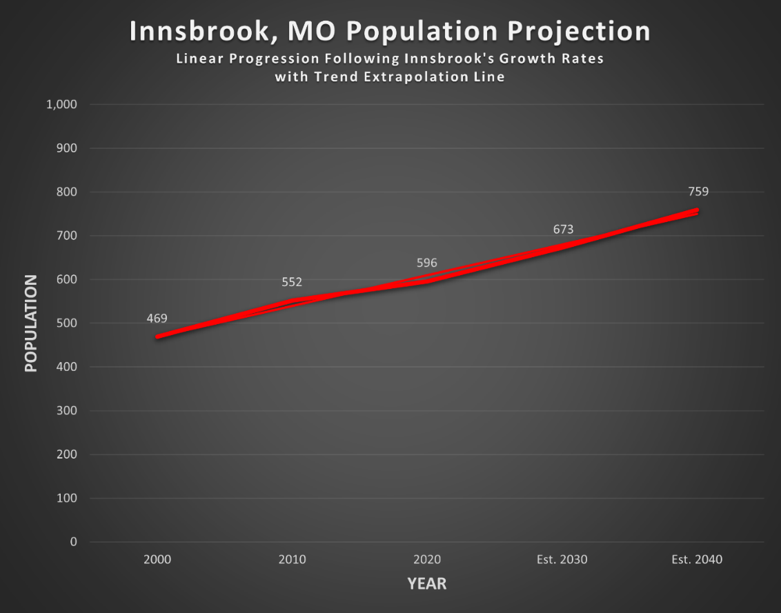

Figure 2 illustrates the linear regression population projection using Warren County’s growth rate to forecast the future population growth of Innsbrook. The County’s average population growth for the last 30 years is 22.1%. For this population projection we applied the County’s growth rate of 22.1% per decade to Innsbrook’s predicted population growth. Based on this method of population projection, the Village’s population will be an estimated 728 in 2030 and 889 in 2040. A trend extrapolation line was plotted along Scenario B to project Innsbrook’s population. According to the extrapolation trend line, the estimated 2030 and 2040 populations are 750 and 850 respectively.

Figure 2: Innsbrook Population Projection “Scenario B”
Source: US Census Bureau
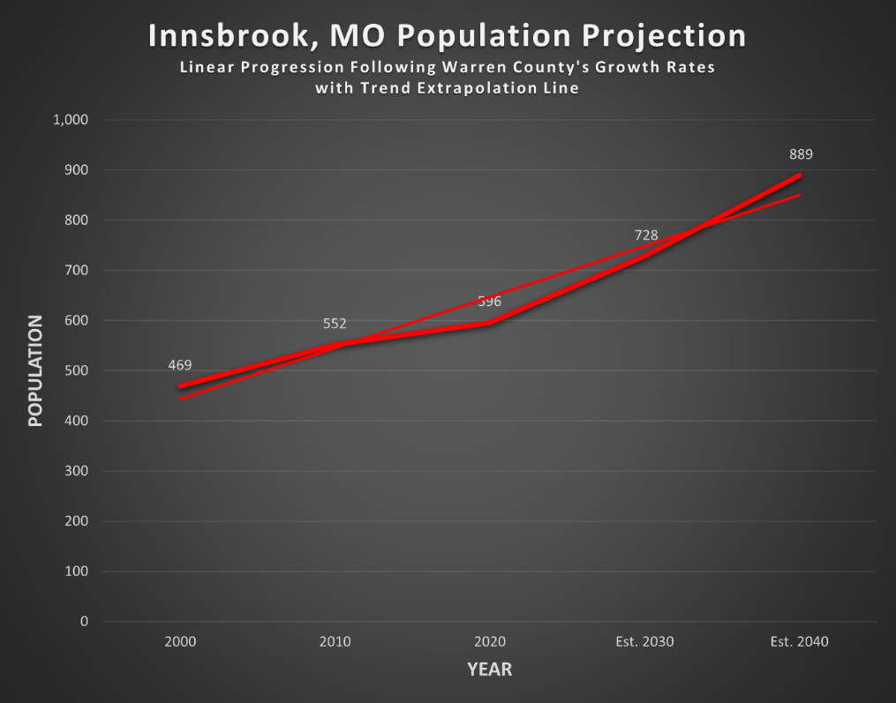

The difference between the two scenarios (A & B) was +55 for the 2030 projections and +130 for the 2040 projection. The linear regression model based on Warren County’s past growth rates generated higher population projections. The trend extrapolation methods applied to both scenarios resulted in higher projections for 2030 but lower ones for 2040. All projections were made assuming no annexations. In the absence of future annexations, the Village’s only viable option to grow is to increase family and household sizes, most viably through new residential construction.

Age Characteristics
Innsbrook’s population is spread out with 6.7% under the age of 18 and 93.4% over the age of 18 according to the 2022 American Community Survey (ACS). By way of comparison, in 2000 the Village’s population was spread out with 9% under the age 18 and 91% over the age of 18. The median age according to the latest American Community Survey (ACS) estimate is just over 55. More specifically, the age of Innsbrook’s population is broken down as follows. The 2022 ACS estimates are provided below followed by the official 2010 US Census Decennial estimates in (parenthesis).
- 0.9% (2.6%) are under the age of 5.
- 11.5% (7%) are between the ages of 5-19
- 17.2% (7.7%) are between the ages of 20-34
- 19.5% (20.3%) are between the ages of 35-54
- 15.6% (31.7%) are between the ages of 55-64
- 35.2% (30.8%) are age 65 or older.
The percentage of Innsbrook’s population over 65 has increased 4.4% in the last decade. However, the largest increase occurred in the Village’s youngest adults between the ages of 20-34 . This age cohort increased by 9.5% or more than twice the population of residents 65 and over. The age cohort with the largest decline (over 16%) occurred in the Village’s population between the ages of 55-64. Innsbrook’s median age of over 55, almost 17 years older than the Nation’s median age of 38.5. By way of comparison, the US had the youngest median age followed by Missouri (38.8), Warren County (41.3), Lake Saint Louis (43.5), Perry (45.5) and Foristell (47.5). According to these findings, Innsbrook’s population is aging in place, suggesting that mature adults and seniors feel comfortable living in Innsbrook and/or Innsbrook is attractive to mature adults and seniors looking for new housing to live out their retirement. Table 2.0 provides the median ages and a comparison of the age cohorts for Innsbrook, the peer communities, the County, State and Nation.

Most cities in the US are following the national trend of aging populations with median ages getting older. It is estimated that 12,000 Baby Boomers will turn 65 today, and all remaining Boomers will cross that threshold by 2030. This means by 2030, 1 in 5 Americans will be age 65 or over. Over 50% of the Village’s population is already 55 or older, resulting in a median age of over 55.
Table 2.0 Age Cohort Comparison 2018-2022 (%)
Age Cohort | Innsbrook | Perry | Foristell | Lake St, Louis | Warren County | Missouri | US
Under 5 | 0.9 | 6.8 | 4.9 | 3.1 | 5.7 | 5.9 | 5.7
Under 18 | 6.7 | 15.8 | 29.3 | 19.8 | 23.4 | 22.3 | 22.1
18 and older | 93.3 | 84.2 | 70.7 | 80.2 | 76.6 | 77.7 | 77.9
65 and older | 35.2 | 20.2 | 28 | 20.4 | 17.6 | 17.3 | 16.5
Median Age | 55.1 | 45.5 | 47.5 | 43.5 | 41.3 | 38.8 | 38.5

The Village’s advanced median age (55.1) is also the result of the Village’s low concentration of children under the age of 18. The percentage of the Village’s population under 5 and under 18 were the lowest of all peer entities surveyed. Innsbrook’s low percentage of young children is an indicator that the Village might not provide the conveniences, comforts, housing, family services, schools or affordability desired among young, growing families. These are all characteristics of a thriving, self-renewing community.

Since its inception, Innsbrook has been a popular destination for families and professionals who choose to own a second home and “weekend” in a rural lake-side community, close to home. The majority of the homes (chalets) located in the Innsbrook Resort are not primary residences; they are restricted as second-homes or recreation only. Therefore, the young families and chalet owners who “weekend” within the Village are property owners, but not recognized as residents in the US Census. This analysis only accounts for the primary residents of the Village included in the decennial US Census and not seasonal property owners. Based on this data, the Village’s age characteristics confirmed that Innsbrook is very popular among seniors and retirees and not home to many young families with school age children.

Most homes within the Resort that are permitted as primary residences are not suited to young adults, families starting out, or first-time buyers due to their price, design, HOA fees, restrictions, and/or access to schools and family services. Likewise, many of the homes within the Village, outside the Resort, are also unsuited to young, growing families or first-time homeowners because they are older, more difficult to maintain and often include multiple acres which makes them unaffordable for many buyers. As a result, the lack of housing for first time home- buyers and young families is a major impediment to attracting families and young adults to the Village of Innsbrook. The Village has very little control over housing, as over 95% of the housing stock is located within the Resort. Despite these challenges, Innsbrook’s population is showing slight gains in the younger age cohorts (5-19 and 20-34) from 2010 to 2022, suggesting the Village is attracting young families.

This Plan recommends the Village continue to locate commercial services and conveniences at key transportation nodes (where two major highways intersect) or along commercial corridors and separated from single family homes. This will provide better access to commercial retail, grocery, personal services, medical services, pharmacies, and other seasonal sales to serve the Village’s current and future population and provide convenience to the thousands of property owners and weekend visitors. These establishments are also critical to providing a revenue stream for the Village that is reliable, diverse and long-lasting.

Racial Composition
According to a report by the National League of Cities, the Hispanic population in small cities at least doubled, growing over 100% in the Midwest. The Asian population is also on the rise, growing by more than 60% in the Midwest. Similarly, the African American population in small cities also increased across all regions, particularly in the Midwest (114%). However, the Village of Innsbrook’s population shows very little racial diversity. The Village’s population trails the State and Nation in all minority classes. Innsbrook’s distance from the urban core of the St. Louis Metropolitan Area and other areas where minorities have migrated over the last twenty (20) years may contribute to Innsbrook’s low percentage of minorities. Table 3.0 provides a comparison of the racial composition for Innsbrook and the peer communities, Warren County, Missouri, and the US.

 | Table 3.0: Racial Composition Comparison (2020 US Census)
Race |  | Innsbrook | Perry | Foristell | Lake St, Louis | Warren County | Missouri | US
African American |  | 3% | 0% | 0.9% | 5.5% | 3.5% | 12.9% | 14.3%
Asian |  | 0% | 0% | 1.5% | 1.8% | 1,1% | 2.8% | 7%
White |  | 85.5% | 83% | 94.9% | 87.6% | 91.1% | 79.4% | 65.9%
Hispanic |  | 7.8% | 0% | 2.1% | 4.6% | 3.7% | 4.6% | 18.7%

Gender
The Village of Innsbrook’s male population is 5% higher than the female population. Of all the peer entities surveyed, Innsbrook and Lake St. Louis were the only male dominated populations. Nationally there are 0.8% more females than males and statewide there is only 1.2% more females than males. The fact that Innsbrook has 5% more males is a noteworthy finding. This may indicate that Innsbrook has more single-male head of households and/or more male widows than the state and national averages, which would indicate certain social, domestic and financial needs. Table 4.0 provides a summary of a gender comparison between Innsbrook and the peer entities.

Table 4.0: Gender Comparison (2022 ACS)
Gender | Innsbrook | Perry | Foristell | Lake St, Louis | Warren County | Missouri | US
Male | 52.5 | 48.4 | 44.4 | 50.3 | 49.9 | 49.4 | 49.6
Female | 47.5 | 51.6 | 55.6 | 49.7 | 50.1 | 50.6 | 50.4

Income
According to the 2000 US Census, the median income for a household in the Village was $65,833, and the median income for a family was $70,156. Males had a median income of $51,875 versus $35,000 for females. The per capita income for the Village was $40,434. Just 0.6% of families and 1.6% of the population were below the poverty line; none of those under the age of 18 and 3.0% of those age 65 or over were living in poverty, which is very low in comparison to local, state and national averages.

According to the 2018-2022 American Community Survey, conducted on behalf of the US Census Bureau, the median household income in the Village increased over 120% from $65,833 in 2000 to $145,156 in 2022. The median income for a family in Innsbrook was $161,875 in 2022, an increase of 130.7% from the 2000 US Census. By way of comparison, the household income in Innsbrook is well above the income reported for the US, Missouri, Warren County and all peer cities, see Table 5.0 for a comparison of the various income characteristics.

Table 5.0: Income (2022 ACS)
Income | Innsbrook | Perry | Foristell | Lake St, Louis | Warren County | Missouri | US
Median household income | $145,156 | $47,981 | $107,841 | $114,230 | $75,531 | $65,920 | $75,149
Median family income | $161,875 | $57,989 | $112,750 | $139,310 | $84,619 | $84,745 | $92,646
Per capita income | $64,465 | $22,613 | $49,540 | $57,945 | $34,909 | $36,745 | $41,261
Unemployment | 9.4% | 1.2% | 0.6% | 3.8% | 4.8% | 4.3% | 5.3%
Persons below poverty level | 2.9% | 14.8% | 3.1% | 3.5% | 10.2% | 12.8% | 12.5%
Definitions:
*Family: a householder and one or more other people related to the householder by birth, marriage, or adoption.

**Household: A household consists of all people who occupy a housing unit regardless of relationship. A household may consist of a person living alone or multiple unrelated individuals or families living together

The City of Perry had the highest percentage of individuals living in poverty with 14.8% followed by Missouri and the US (12.8% and 12.5%). Innsbrook had the lowest poverty rate with only 2.9% followed by Foristell (3.1%) and Lake St. Louis (3.5%). Table 5.0 also includes a comparison of the unemployment and poverty levels.

Housing
According to the 2022 ACS, there were 1,608 housing units in the Village, 1,231 of which were classified as seasonal, recreational, and occasional use and the remaining 377 were classified as primary residences. This represents 96.7% of the Village’s total housing stock. By way of comparison, only 25.2% and 32.6% of the housing units in Missouri and the US, respectively were classified as seasonal. Warren County had the next highest percentage of seasonal housing with 64.5%, but this is a direct result of the Innsbrook Resort. This must be considered when looking at the following housing data as well as the previous sections addressing age characteristics, income, and population.

According to the 2000 US Census, there were 222 housing units. The households included the following characteristics:
- 9.0% had children under the age of 18 living with them.
- 75.2% were married couples living together.
- 0.5% had a female householder with no husband present.
- 22.1% were non-families.
- 16.2% of all households were made up of individuals living alone.
- 5.9% had someone living alone who was 65 years of age or older.
- The average household size was 2.11.
- The average family size was 2.31.
According to the 2010 US Census, there were 282 housing units, an increase of 27% or 60 housing units since 2000. The households included the following characteristics:
- 8.2% had children under the age of 18 living with them.
- 72.3% were married couples living together.
- 1.1% had a female householder with no husband present.
- 25.9% were non-families.
- 22.3% of all households were made up of individuals living alone.
- 14.5% had someone living alone who was 65 years of age or older.
- The average household size was 1.96.
- The average family size was 2.23.

According to the 2022 ACS, the total number of housing units was 377, an increase of 33% from 2010 and an increase of 70% or 155 units from the 2000 Census. The following data provides general characteristics of the household make-up and compares the information to the 2000 Census.
- 5.7% had children under the age of 18, a decrease of 3.3% from the 2000 Census.
- 79.4% were married couples living together, an increase of 4.2%%.
- 3.9% had a female householder with no spouse present, an increase of 3.4%
- 14.9% were non-families, a decrease of 7.2%.
- 4.7% of households were made up of individuals living alone, a decrease of 11.5%.
- 48% had someone living alone who was 65 or older, an increase of 42.1%.
- The average household size was 2.6.
- The average family size was 2.8.
Innsbrook’s average household size increased slightly from 2.11 (2000) to 2.6 (2022) as did the average family size from 2.31 (2000) to 2.8 (2022). Meanwhile, the peer cities displayed reductions in household and family sizes. The reduction in household size has been a nationwide trend as more and more baby boomers reach retirement age. The fact the average household size in Innsbrook (2.6) is slightly smaller than that of Warren County (2.7), Foristell (2.8) and is the same as the US (2.6), demonstrates that individuals without children (singles, empty-nesters, and retirees) are comfortable living in Innsbrook as are young families which is slowly causing an increase in the Village’s average household and family size.

The average home value in Innsbrook, according to the 2014 ACS, was $548,869. This is significantly higher than all peer cities, the County, State and US averages. This information suggests that Innsbrook’s housing stock may not provide an adequate supply of affordable housing options, and that homeowners may have less income for other personal expenditures. The percentage of renter-occupied housing in Innsbrook was non-existent as there are no known apartments or rental units in the Village.

The percentage of vacant housing in Innsbrook was 79.2%, which was well above all peer cities, County, State and US averages. Foristell and Lake St. louis had the lowest vacancy rates at 2.5%. The US vacancy rate was 10.8, which was slightly lower than Missouri (12%) and Warren County (15.9%). Again, the vacancy rate in Innsbrook is a direct result of over 95% of the Village’s housing stock being seasonal. Regardless, the Village should continue to monitor the Village’s seasonal housing and employ strict VRBO regulations and code enforcement efforts to ensure vacant structures do not become a nuisance or safety hazard. The rationale for this recommendation is based on comments heard from the public and from members of the Village’s Planning & Zoning Commission and Board of Trustees, the majority of which expressed concerns regarding rental (VRBO) properties. Table 6.0 provides a summary of the Village’s housing tenure and value.

Table 6.0 Housing Tenure and Value
Housing Tenure and Value | Innsbrook | Perry | Foristell | Lake St, Louis | Warren County | Missouri | US
Owner-Occupied Housing (2013) | 98.2% | 80.8% | 76.4% | 78.5% | 80.4% | 67.6% | 64.8%
Renter-Occupied Housing (2013) | 1.8% | 19.2% | 23.6% | 21.5% | 19.6% | 32.4% | 35.2%
Total Vacant Housing Units | 79.2% | 25.8% | 2.5% | 2.5% | 15.9% | 12% | 10.8%
Average Home Value | $548,869 | $124,731 | $485,651 | $395,187 | $273,874 | $251,591 | $399,434
Average Rent | n/a | $591 | $900 | $1,395 | $962 | $1,036 | $1,436
Avg. HH Size | 2.6 | 2.48 | 2.8 | 2.5 | 2.7 | 2.4 | 2.6
Avg Family Size | 2.8 | 3.3 | 3.3 | 2.8 | 3.1 | 3.1 | 3.2
Source: U.S. Census Bureau/ ACS 2018-2022

Housing Affordability
Housing affordability is a key component in the long-term vitality of a community. Housing affordability is not simply the price one pays for rent or mortgage; it is a function of household income or wealth relative to a housing unit’s price or rent. Housing affordability is based on how much a household spends on housing costs as a percentage of their total household income. “Affordable housing” is defined as housing that costs occupants less than 30% of their gross income for gross housing costs, including utility costs. A household that spends 30% or more of its income on housing costs is considered to be financially burdened. For example, if a family’s income was $100,000, they would be considered financially burdened if they spent more than $2,500/month on housing. In other words, “affordable housing” would be housing that costs less than $2,500/month ($2,500 x 12 months = $30,000 (30% of $100K).

The percentage of home owners who pay 30% or more of their income on housing was 15.9% in Innsbrook. By way of comparison, only Perry has less homeowners who were financially burdened. Lake St. Louis (17.2%), Warren County (17.4%), Missouri (19.7%), Foristell (22.4%) and the US (25.6%) all had more homeowners who were financially burdened by paying over 30% or more on housing. This suggests that the salaries of most Innsbrook homeowners are sufficient to cover housing costs, despite the fact the Village has some of the highest home values in the region.

The median rent in Warren County was $962/month, according to the 2022 American Community Survey. The average rent was not provided for Innsbrook. Perry had the lowest gross monthly rent rates of all peer communities at $591 followed by the City of Foristell ($900). By way of comparison, the US had the highest gross median monthly rent at $1,436/month followed by Lake St. Louis ($1,395), Missouri ($1,036) and Warren County ($962). Warren County’s rental units are priced fairly or right in the middle; slightly below the State and National rates, yet slightly higher than Foristell and Perry. The percentage of renters who pay 30% or more of their income on housing was 46.4% in Warren County. By way of comparison, Warren County has less renters who are financially burdened than Perry (50%) and Foristell (46.9%), but more financially burdened renters than Lake St. Louis (25.6%), Missouri (39.8%) and the US (44.5%). Table 7.0 provides a summary of housing costs and affordability.

 | Table 7.0 Housing Cost and Affordability (2018-22)
Housing Cost |  | Innsbrook | Perry | Foristell | Lake St, Louis | Warren County | Missouri | US
Median Monthly Homeowner Costs |  | $2,189 | $967 | $2,466 | $2,013 | $1,417 | $1,436 | $1,828
% of Homeowners who spend 30% or more of income on housing |  | 15.9% | 7.2% | 22.4% | 17.2% | 17.4% | 19.7% | 25.6%
Average Monthly Rent |  | n/a | $591 | $900 | $1,395 | $962 | $1,036 | $1,436
% of Renters who spend 30% or more of income on housing |  | n/a | 50% | 46.9% | 25.6% | 46.4% | 39.8% | 44.5%
Source: U.S. Census Bureau/ ACS 2018-2022

Educational Attainment (ages 25 and over)
Table 8.0 shows the educational attainment of individuals over 25 years of age. According to the latest American Community Survey for the years 2018–2022, 96.6% of persons 25 and older in the Village of Innsbrook had a high school diploma or higher and 63.7% had a Bachelor’s Degree or higher, which was over twice the State average (31.2%) and three times higher than Warren County (19.2%). Innsbrook led all peer cities, Warren County, Missouri and the Nation with individuals who had a high school diploma or higher. The Village should continue to promote quality education and continue to be a leader in educational attainment.

 | Table 8.0: Educational Attainment (2022)
Educational Attainment |  | Innsbrook | Perry | Foristell | Lake St, Louis | Warren County | Missouri | US
High School Grad or GED |  | 13.7% | 54.6% | 23.3% | 16.5% | 38% | 30.5% | 26.4%
High School Grad. or higher |  | 96.6% | 96% | 97.2% | 96.6% | 88.3% | 91.3% | 89.1%
Bachelors or Advanced Degree |  | 63.7% | 16.8% | 44.5% | 49.7% | 19.2% | 31.2% | 34.3%
Source: 2018-2022 ACS

Community Tapestry
The Community Tapestry™ system is a proven segmentation methodology that utilizes 65 segments called “Tapestry Lifestyles” to classify communities based on their socioeconomic and demographic composition. These segments are broken down to the U.S. Census Block Group level throughout the United States. The system is used by planners and national retailer experts to identify localized purchasing patterns and select future development locations.

The following Section summarizes the top “Lifestyle Tapestry Segments” representative of the Innsbrook Planning Area. It is included in this Plan to provide a better understanding of the spending habits and lifestyles of the consumers within Innsbrook’s general trade area. This information provides retailers a profile of the local trade area and provides some quality of life indicators the Village should consider and be prepared to address in the future.

Top Tapestry Segments
53.13% Middleburg: Over half (53.13%) of Innsbrook’s residents fall within the “Middleburg” Lifestyle Tapestry Segment. Middleburg consists primarily of married couples living in single-family homes and characterized as follows:
Middleburg neighborhoods transformed from the easy pace of country living to semirural subdivisions in the last decade when the housing boom stretched beyond large metropolitan cities. Residents are traditional, family-oriented consumers. Still more country than rock and roll, they are thrifty but willing to carry some debt and are already investing in their futures. They rely on their smartphones and mobile devices to stay in touch and pride themselves on their expertise. They prefer to buy American and travel in the US. This market is younger but growing in size and assets. They share the following demographic characteristics:

- Median Age: 36.1
- Household Size: 2.75
- Median HH income: $59,800
- Median HH value: $175,000

Annual Spending Habits
- Credit Card Debt: $3,171.
- Apparel: $2,114.
- Medical Insurance: $5,265.
- Entertainment: $3,900
OUR NEIGHBORHOOD
- Semirural locales within metropolitan areas.
- Neighborhoods changed rapidly in the previous decade with the addition of new single-family homes.
- Include a number of mobile homes.
- Affordable housing, median value of $175,000 with a low vacancy rate.
- Young couples, many with children; average household size is 2.75.
SOCIOECONOMIC TRAITS
- Education: 65% with a high school diploma or some college.
- Labor force participation typical of a younger population at 66.7% (Index 107).
- Traditional values are the norm here— faith, country, and family.
- Prefer to buy American and for a good price.
- Comfortable with the latest in technology for convenience (online banking or saving money on landlines) and entertainment.
MARKET PROFILE (Consumer preferences are estimated from data by MRI-Simmons.)
- Residents are partial to domestic vehicles; they like to drive trucks, SUVs, or motorcycles.
- Entertainment is primarily family oriented, TV and movie rentals or theme parks and family restaurants.
- Spending priorities also focus on family (children’s toys and apparel) or home DIY projects.
- Sports include hunting, fishing, bowling, and baseball.
- TV and magazines provide entertainment and information.
- Media preferences include country and Christian channels.
HOUSING Median home value is displayed for markets that are primarily owner occupied; average rent is shown for renter-occupied markets. Tenure and home value are estimated by Environmental Systems Research Institute, Inc (Esri). Housing type and average rent are from the Census Bureau’s American Community Survey.
- Own: 73.4% (62.7 US)
- Rent: 26.6% (37.3% US)
- Median Home Value: $175,000 ($207,300 US)
RACE AND ETHNICITY (Esri data) The Diversity Index summarizes racial and ethnic diversity. The index shows the likelihood that two persons, chosen at random from the same area, belong to different race or ethnic groups. The index ranges from 0 (no diversity) to 100 (complete diversity). The diversity index for the Middleburgs is 48.5, the index for the US is 64
INCOME AND NET WORTH Net worth measures total household assets (homes, vehicles, investments, etc.) less any debts, secured (e.g., mortgages) or unsecured (credit cards). Household income and net worth are estimated by Esri.
- Median HH (household) Income: $59,800 (US $56,100)
- Median Net Worth: $115,300 (US $93,300)
AVERAGE HOUSEHOLD BUDGET INDEX The index compares the average amount spent in this market’s household budgets for housing, food, apparel, etc., to the average amount spent by all US households. An index of 100 is average. An index of 120 shows that average spending by consumers in this market is 20 percent above the national average. Consumer expenditures are estimated by Esri.

Housing: 90
Food: 93
Apparel & Services: 93
Transportation: 95
Health Care:94
Entertainment & Rec: 93
Education: 83
Pension & Social Security: 94
Other: 93

18.39% Rural Resort Dwellers Over eighteen percent (18.39%) of Innsbrook’s residents fall within the “Rural Resort Dwellers” Lifestyle Tapestry Segment. Rural Resort Dwellers consist primarily of mature married couples living in single-family homes and characterized as follows:

- Median Age: 54.1
- HH Size: 2.22
- Median HH Income: $50,400
- Diversity index: 23.
Although the Great Recession (2007-09) forced many owners of second homes to sell, Rural Resort Dwellers residents remain an active market, just a bit smaller. These communities are centered in resort areas, many in the Midwest, where the change in seasons supports a variety of outdoor activities. Retirement looms for many of these blue collar, older householders, but workers are postponing retirement or returning to work to maintain their current lifestyles. Workers are traveling further to maintain employment. They are passionate about their hobbies, like freshwater fishing and hunting.

OUR NEIGHBORHOOD
- Housing is owner-occupied, single-family homes, with some mobile homes.
- A strong market for second homes, these rural areas contain homes valued near the US median. Over half of the housing units are vacant due to a high seasonal vacancy rate.
- In this older market, 42% of households consist of married couples with no children at home, while another 28% are single person. Married couples with children at home have older school-age children.
- Set in scenic rural locations with proximity to outdoor activities, two vehicles are essential.
SOCIOECONOMIC TRAITS
- Rural Resort Dwellers residents are close to retirement. They’ve accumulated wealth and begun to shift their portfolios to low-risk assets. These active residents continue to work in skilled occupations.
- Simple tastes and modesty characterize these blue-collar residents. They shop for timeless, comfortable clothing but only when something must be replaced. They pay little attention to advertising and usually stick to the brands they know.
- They spend time with their spouses and also maintain a social calendar.

MARKET PROFILE
- Residents drive older domestic vehicles and prefer to spend their disposable income on gear to support their hobbies, which include fishing, hunting, and motorcycling.
- At home, Rural Resort Dwellers residents spend any free time working on their vehicles and maintaining their gear. They make frequent trips to their local hardware store for parts and tools. These hands-on consumers are also passionate about vegetable gardening.
- Their taste in TV shows reflects their hobbies—National Geographic, Discovery Channel, and the Weather Channel
HOUSING
- Own 81.1% (62.7% US)
- Rent: 18.9% (37.3% US)
- Median Value: $209,200 ($207,300 US)

INCOME AND NET WORTH
- Median HH Income: $50,400 ($54,100 US)
- Median New Worth: $163,000 ($93,300 US)
AVERAGE HOUSEHOLD BUDGET INDEX

- Housing: 81
- Food: 90
- Apparel & Services:74
- Transportation: 96
- Health Care: 110
- Entertainment & Rec: 94
- Education: 54
- Pension & Social Security: 79
- Other: 9

Infrastructure & Public Facilities

Due to Innsbrook’s remote location and low density, the area is not served by extensive infrastructure nor does this Plan anticipate the need for extensive infrastructure as seen in highly urbanized areas. Currently, Cuivre River Electric Cooperative provides electricity for the entire area, and CenturyTel provides land telephone services for the entire area. Package treatment plants and individual septic systems are the primary source of wastewater treatment for residents. A private sewer system provides wastewater treatment for certain areas within the Innsbrook Resort. Public Water Supply District No. 2 provides water services to certain areas of the Village, while others have wells or a private water system. The only option for gas, outside the Resort, is propane.

Electrical Service
Cuivre River Electric Cooperative provides service to the Village of Innsbrook. Due to its status as a cooperative, Cuivre River is prohibited by State Statute from providing electricity to any Village with a population greater than 1,500. Therefore, we anticipate Cuivre River Electric Cooperative to provide electrical service for the Village for the foreseeable future.

Wireless Data Services
There are presently five (5) companies providing wireless service to some or the entire Village and this number is expected to increase. Personal communications services will continue to improve with the advent of new technology. High speed internet service is available in the Village via CenturyTel (aka Brightspeed) and Spectrum.

Water Service
Public Water Supply District No. 2 provides a central water system for certain areas in the Village of Innsbrook. Innsbrook Resort manages their own central water system for certain properties within the resort. Residents outside the Resort rely on wells or cisterns for potable water. According to Charles Krakosky, an engineer working with Public Water Supply District No. 2, there are no plans to extend water and sewage utilities to the intersection of F and M Highways. Utility extensions would be reconsidered as development is proposed and on a case by case basis.

Wastewater Service
Private septic systems service some residents in the Village while a private wastewater treatment system services all residents within the Innsbrook Resort. Older chalets are serviced by septic systems, while all new chalets built are on the private wastewater treatment system. There is no public sewer district currently in existence at this time.

Stormwater
The Village of Innsbrook’s only method of stormwater management is the natural environment. The Village does not have enough impervious surfaces to warrant a central system of collection or disbursement. With erosion control standards, site disturbance restrictions, best management practices, preservation of farmland and other requirements, the need for a central storm water system should be minimal. This Plan recommends requiring all future development to provide stormwater management onsite based on the functional equivalency method wherein the predevelopment rate and quantity of run-off is equal to the post-development stormwater runoff.

Natural Gas
The use of natural gas in our area involves the use of a propane tank that is filled by a hauler of your choice. There are no natural gas lines servicing our area. The provider of natural gas in our vicinity is Ameren UE. Their main high-pressure line is approximately 5-miles from the Village and at this time, we do not have the population to warrant the expenditures to construct the lines to the Village limits or within the Village.

Early Outdoor Warning System
The Innsbrook area is not served by an early outdoor warning system. Several alternatives to such a system are under study, the results of which will be incorporated into a Village Emergency Plan. The Village of Innsbrook will coordinate with surrounding areas to obtain funding for the installation and operation of the system selected during this study.

Zykan
According to the 2024 Missouri Registry Annual Report, the Zykan Property (1251 Muenz Road) does not currently pose a significant public health risk for Innsbrook residents and visitors due to the low contaminant levels from the site's landfills. The site is outside the Village limits and should remain outside the Village limits.

Existing Roads
Public roads in the Village include State Highway F and two (2) County Roads; Stracks Church and Schuetzenground. Currently, there are no Village owned roads, however, there are over 100 miles of privately owned roads that provide access to the residents of the Village. While the State and County roads are designed to move vehicles, some of the privately owned roads accommodate pedestrians and other forms of non-motorized transportation in addition to vehicles. The private roads are narrower and contain more curvature then typical streets built today, which studies have shown, slow down speeds and make them more appealing to the current and future homeowner.

Future Road Design for the Village
Streets, at one time, were the social gathering spot for the neighborhood. Children played in them and neighbors gathered in them for street parties and socializing. However, the design of today’s streets lend themselves to miniature speedways because they are wide, straight stretches of pavement. Today, the streets have been taken over by vehicles, leaving no room for the social activities or play areas of yesteryear. For these reasons, this Plan recommends the Village of Innsbrook encourage the design of new streets to include a pedestrian realm and social focal points. These, along with the following design elements are key principles of the Great Streets movement:

- Streets should be narrow, to heighten drivers awareness and promote safer, slower driving.
- All streets should provide pedestrian ways that reduce vehicle miles traveled (VMT)
- Include traffic calming enhancements such as bump-outs (curbed features that restrict drive-lane widths and reduce the distance pedestrians need to cross a road), narrowed lane widths, raised pedestrian crossings, roundabouts, etc. that calm/slow traffic and raise drivers’ awareness of pedestrian crossings.
- Reduce the number and frequency of access points by combining driveways and following MoDot’s standards for access management.

To create streets that are social focal points, the vehicle speed must to be reduced. One factor shown effective in reducing speed is a narrow undulating street. Another effective tool in reducing speeds are trees along or near the road edge. This is not referring to newly installed trees typically found in subdivisions of today. This refers to the mature trees found in established woods that are left in place during construction of a development. The Village contains many private roads that are narrow, undulating, and bordered by large mature trees and we wish to see that design continued in new street construction.

Environmental Framework
The environment provides the natural and physical context within which land use activities take place. The intent of this plan is to minimize the negative impacts on the environment. The following sections provide a brief overview of the environmental framework of Innsbrook and identify some of the more sensitive environmental elements that must be considered in future development and land use decisions.

The Village of Innsbrook is fortunate in that there are few physical factors which impede or restrict development. Such physical features may include poor or unstable soil conditions, environmentally sensitive areas such as wetlands or endangered species habitat, topographical conditions such as steep slopes or extensive floodplain, and extensive areas of archeological significance. However, as development radiates out from the Innsbrook Resort, the physical features start to play an increasingly important role in the development process. More specifically, the presence of karst topography and the hazards associated with it (sink holes, caves, and hydrology) in Warren County need to be considered.

The Innsbrook area has only a few areas of concern with regard to flooding since it is situated at the crest of two drainage basins. Floodplain and flood prone areas exist along a number of streams in the Innsbrook area, including along Charrette Creek. This plan recommends preserving Innsbrook’s natural steams and riparian buffers along these streams via conservation easements and/or establishing a greenway system to protect these areas from future clearing or development.

Historic sites
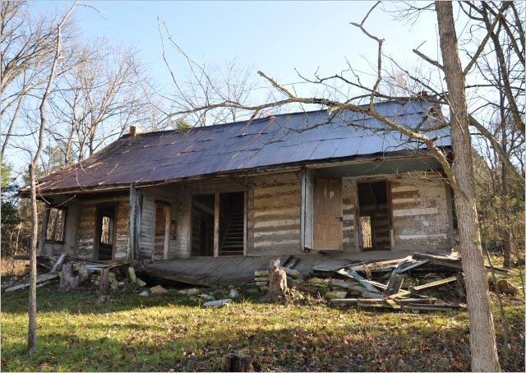
The National Register of Historic Places is the nation's official list of cultural resources worthy of preservation. Authorized under the National Historic Preservation Act of 1966, the National Register is part of a national program to coordinate and support public and private efforts to identify, evaluate, and protect our historic and archeological resources. While there are numerous criteria for listing, it is required that a property must be at least 50 years old to be eligible for consideration. There are several structures within the Village that are over 50 years old, but none on the National Register.

The Village has a Historical Society that meets regularly and is charged with promoting the following vision: “restore and preserve historic structures and adjacent properties within the Village of Innsbrook in order to educate and deepen the understanding of the legacy of the land and its inhabitants with the hope of bringing friends and neighbors together to celebrate the Innsbrook area history in a natural recreational setting”.
The Historical Society is very proud of the Historic Village located within the Resort which includes a fully restored 1880's log cabin, a restored tobacco barn, a restored 1909 one-room school house, and modern restrooms. The Innsbrook community is welcome to visit and enjoy the Historic Village year-round. The 1880’s log cabin’s unique breezeway design was common throughout the Southeastern United States during the 19th and 20th centuries to help cool the occupants in the hot, humid southern climate. Breezeway homes were also known as “Dogtrot Homes”, “Dog-Run Homes” and Possum-Trot Homes”.
The Historic Village is used as a meeting place, a rest stop on a nature trail, and as a music venue. It is also an interpretive/learning center with period furniture, tools, building techniques, and educational signage. The cabin is located below Alpine Dam. The grounds around the cabin are shaded and provide elevated views of a scenic valley.

Transportation & Infrastructure Financing Options
There are various financing options available to municipalities for funding infrastructure, transportation, community development, and other improvements. The following is a summary of options available. Section 4.5 provides additional fundings sources the Village should consider in the implementation of the recommended public/capital improvements provided in this Plan.

Current Sources of Revenue

Property Taxes
Currently, the Village of Innsbrook's tax rate on real estate property is $0.1273 per $100.00 of assessed value. The Village does not assess a tax on personal property.

Sales Tax
Current sales tax is set at 0.875%. This applies to only goods and services sold within the Village.

Utility Tax
The Village currently has no utility tax.

Fees
Fees within the Village are mainly for construction. Other fees include business licensees for VRBO operators, and permits for building and zoning.

Motor Fuel Tax:
Missouri receives fuel tax of 17 cents a gallon on motor fuel (gasoline, diesel fuel, kerosene, and blended fuel) from licensed suppliers on a monthly basis. The tax is passed on to the consumer purchasing fuel at retail. The tax is distributed to the Missouri Department of Transportation, Missouri cities and Missouri counties for road construction and maintenance. There are about 700 licensees, including suppliers, distributors, transporters and terminal operators. Consumers may apply for a refund of the fuel tax when fuel is used in an exempt manner, such as off-road use like farming or construction.

Contingency Funds
The Village of Innsbrook currently has about $130,000 in reserve that could be used for future projects or any budgetary shortcomings of a slow economy.

Village Hall
At the time of this writing, the Village had two (2) part-time employees that serve as Village Clerk/Village Administrator and responsible for the administrative duties of the Village. Staff is working to improve communication between the Village, the permanent residents and all property owners. A new Facebook page has been launched and will be promoted over the next several months. Staff is also recommended to post all public notices, agendas and other Village news on the Village’s website and make all pending zoning applications available for review at the Village Hall on online.

School Districts
Wright City R-II School District: The Wright City R-II School District is located in an area that is changing and growing. It covers approximately 84 square miles and is located primarily in Warren County. In 2004, Warren County’s designation was changed from rural to being included as a part of the St. Louis Metro Statistical Area. The total population of the District during the 2020 Census was 12,367, an increase of 15% (10,768) from 2010.

In 2020, the Wright City R-II School District had 1,768 students and 132 faculty/staff members. The District is comprised of five (5) schools: Wright City Early Education Center, Wright City West Elementary(preschool-4th), Wright City East Elementary (preschool-4th), Wright City Middle School (5 - 8), and Wright City High School (9 - 12). All five (5) campuses are located in Wright City. The District is a past recipient of the “Accreditation with Distinction in Performance” award.

Warren County R-III School District: The Warren County R-III School District occupies the western two-thirds of Warren County and covers 200 square miles. The total population of the District during the 2020 Census was 19,486. As of 2020, the District had an enrollment of 2,997 students and 226 faculty/staff members. Warren County has been one of the fastest-growing counties in Missouri, and the enrollment is projected to continue to significantly increase over the next 20 years. This District is also a past recipient of the “Accreditation with Distinction in Performance” award.

A map of the Wright City and Warren County School District boundaries is provided on the next page.

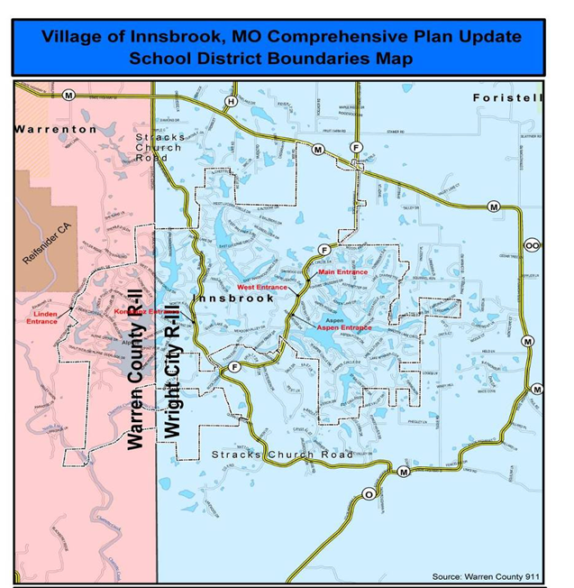
Fire Protection
The Village is now served by the Wright City and Warrenton Fire Protection Districts. As property is annexed to the South, the Village will then be served by the Marthasville Fire Protection District as well. The Village has been working actively with all of these districts to ensure services are properly coordinated.

Wright City Fire Protection District
In the mid 1800’s, the Village of Wright City was formed as a railway stop for the Western Expansion. During the mid to late 1800’s, a Volunteer Fire Brigade was formed for the Village of Wright City. In 1895, the Wright City Fire Department was formed. At that time, a Hand Drawn Hose Reel was purchased which is still in possession of the Fire District today. In 1947, the Wright City Fire Department purchased its first Motorized Pumper, which the Fire District today still has in its possession. For financial support, the Wright City Fire Department used a Fire Tag System. The Wright City Fire Protection District was formed in 1972 by vote of the citizens and moved to its present location at 396 West North 2nd Street.

The District is located in East Central Missouri, approximately 45 miles west of the City of St. Louis. The District currently protects approximately 92 square miles in the North East portion of Warren County and on the Southern portion of Lincoln County. The incorporated cities within the District’s boundaries include, City of Wright City, Foristell, Village of Innsbrook, and Incline Village. The current ISO rating as of 1989 is class 6; when structures are within 1,000 feet of a fire hydrant and 9 when a dwelling is not within 1,000 feet from a fire hydrant.

The District is governed by a five (5) member Board of Directors (the Board) elected at large to 6-year terms. The day-to-day operations of the District are managed by the Fire Chief under the direction of the Board. In addition to certain administrative duties, the Fire Chief makes recommendations to the Board concerning the budget, building plans, staffing and purchasing.

The District currently has 25 full-time paid employees, the Fire Chief, Assistant Fire Chief/Training, Administrative Assistant, Lieutenant, three (3) Captains, and 18 Firefighters. The Wright City Fire District’s current tax levy is $0.5769 per $100 assessed valuation.

Warrenton Fire Protection District
Currently, the District has 14 full-time employees. The District is also served by five (5) elected board members. The following is a brief history of the Warrenton Fire Protection District:
- In 1939, the Village of Warrenton authorized a volunteer fire department that was paid for by the municipality.
- In 1951, the name was changed to the Warrenton Rural Fire Protection Inc. and later renamed the Warrenton Rural Volunteer Fire Department. The department was funded by a “Fire Tag” membership system.
- In 1967, fire station #2 was built on South Highway 47.
- In 1988, the Warrenton Fire Protection District was formed by voter approval with the largest percentage “YES” vote in County history with 89%. The District covers 124 square miles.
- In 1993, the construction of HQ and Station #1 was authorized and built on Fairgrounds Road to improve the response north of Warrenton. In 1999, Station #3 was constructed in Pendleton to improve the protection on the western side of the District.
- In 2002, the first fulltime Fire Chief was hired and became the second District within the County to have a full time Chief. Also in 2002, Arch Helicopters agreed to a trial use of the helipad located at Station #1. They are still using it today.
- In 2004, the District hired a fulltime Fire Marshal and implemented fire codes within the District.
- In 2009, a new Fire Station # 2 was constructed on South Highway 47.

Marthasville Fire Protection District
Little is known about the department’s early history during the 20th century. We do know the department had a band, which held concerts and served meals to raise money for department uniforms. The following is a brief history of the Marthasville Fire Protection District:
- In 1928, the town of Marthasville took over the reins of fire protection, although little is known of its management or personnel
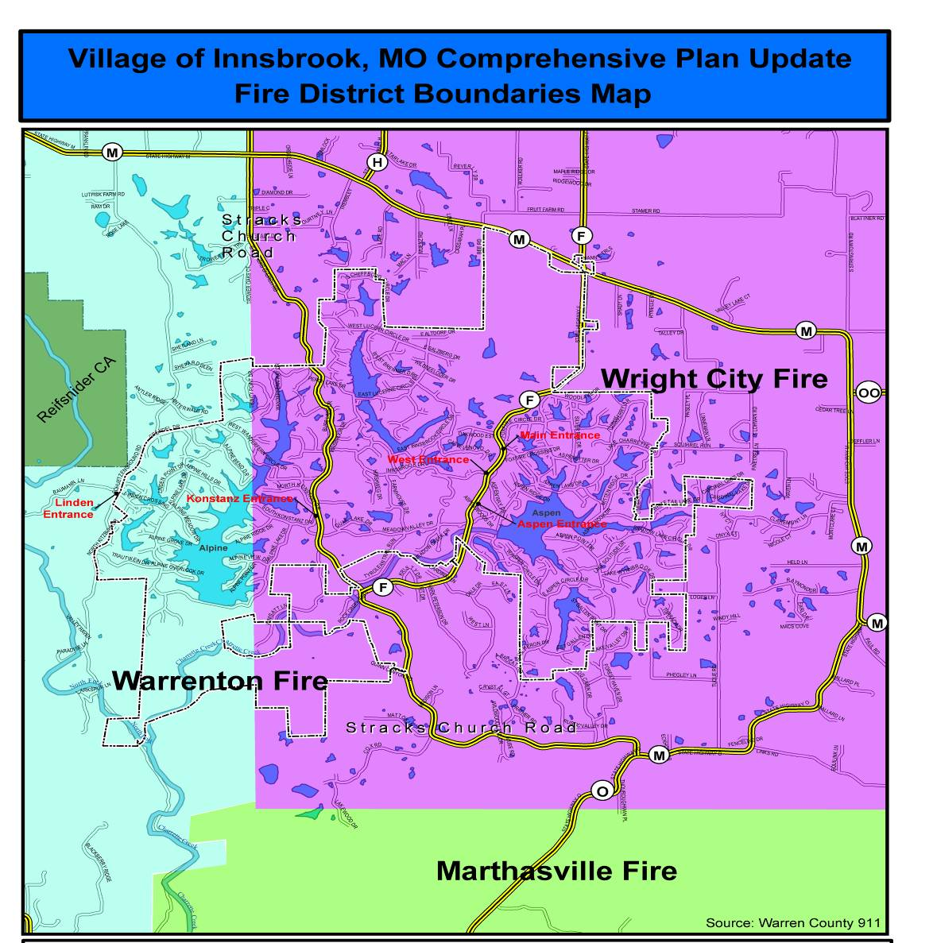
- In 1945, the Village’s Board of Aldermen decided to relieve the Village of Marthasville from fire protection responsibilities and the Marthasville Volunteer Fire Department, was founded.
- There was no tax money available to support the new Department, so funding was provided by a rural tax system. The Department set their protection boundaries at five (5) miles.
- In 1948, the Department moved to new quarters at the corner of Main and 3rd Streets. The building still stands today and is used by the Village of Marthasville.
- The new firehouse was built with mostly volunteer labor provided by its members. It was already too small when it was dedicated in 1970, so the addition of the ambulance required a new, bigger firehouse.
- By the end of the 1960s, the Department’s protection area increased to an 11-mile radius. Rural dues were increased to $7 a year.
- In 1976, the Marthasville Fire Protection District was formed with the protection radius increasing to 18 miles. The 1977 budget was approximately $14,000, enabling the department to add a station in Treloar and renovate the station in Marthasville, adding more space.
- During the Flood of 1993, the firehouse was staffed almost around the clock every day when the river was at or near its highest crests.
- In 1997, the third station in Dutzow was dedicated. Moreover, like the other two stations, it was built with volunteer labor from its ranks and the residents of the Dutzow community.
- The volume of calls also increased dramatically over the years. In the 1960s, the average number of calls annually was 25. During 2023, the number climbed to 450 calls.
The Department can boast of several firsts in Warren County. They were the first to have diesel powered automatic transmission equipped fire apparatus, they had the first power hydraulic (Jaws of Life) extrication equipment, the first thermal imaging equipment and they are the only department equipped and trained for ice rescue.

Warren County Sheriff’s Department
The Warren County Sheriff’s Department serves the Village of Innsbrook. The Department consists of 77 full-time employees who patrol the approximately 430 square miles that comprise Warren County.

Warren County Ambulance District
A six (6) person Board of Directors governs the Warren County Ambulance District. The medical staff is composed of a total of 37 full- and part-time employees: 24 paramedics, eight (8) emergency medical technicians (EMT's), and five (5) administrative staff, which includes the Chief Executive Officer, Executive Assistant/ Human Resources, Chief Medical Officer, Patient Account Manager, and a full-time Property Manager. The District covers an area of approximately 250 square miles, covering the northern two-thirds (2/3) of Warren County with seven (7) Advanced Life Support ambulances, three (3) battalion chiefs, and one mass casualty incident (MCI) trailer. The District currently operates out of four (4) locations. The headquarters is located at 604 Fairgrounds Road, Warrenton, MO.
The District primarily operates on two (2) sources of income: a $0.4931 per $100 assessed valuation tax rate and a service fee with mileage/medications. The District does participate in the Medicare, Medicaid and Blue Cross/Blue Shield insurance programs and accepts assignments from these insurance companies. The office staff bills insurance companies direct when all information is obtained from the patients.

Vision, Goals and Objectives
The following goals, objectives and recommendations were co-authored by the participants engaged in the planning process. The intent is to create a citizen-driven Comprehensive Plan that is a representation of the values and vision of the community that will serve as a solid foundation for future land use and development decisions.

Innsbrook’s Vision
The purpose of the Comprehensive Plan is to protect the health, safety, and welfare of the Innsbrook community. The intent is to provide the necessary vision, goals, and strategies to implement the recommendations and purpose of this Plan. The vision, as determined after studying the values and critical issues provided by the community

VISION: To preserve Innsbrook’s rural, family-friendly values & natural beauty while promoting well-planned development specifically suited to the active lifestyles of Innsbrook’s current and future residents and property owners.
The identification of goals, objectives, and implementation strategies is an essential component of a comprehensive plan. Goals are broadly written statements that represent the outcomes that Innsbrook should strive to achieve in the next ten (10) years. Objectives and implementation strategies are more specifically written recommendations or steps the Village should take to implement the Comprehensive Plan’s vision and goals. Together they form an actionable work program the Village should follow when making decisions regarding future growth and development. Some strategies will be clear Objectives the Village should take, while others will be recommendations for additional planning work, more study, or further public input. Implementation performance measures are also provided for each planning element to help track implementation efforts. Much of the recommended tracking information is already collected by the Village. The intent of including the performance measures is to encourage the Village to continue tracking this information to quantify implementation efforts and aid in obtaining grants and other sources of outside funding. Recommended goals, objectives, implementation strategies and performance outcome measures were development for each of the following planning elements:

- Natural Environmental
- Land Use
- Transportation
- Infrastructure

Natural Environment Goals & Objectives

Goal 1: Stewardship. The Village of Innsbrook will provide stewardship of the natural environment.

Objective: Enforce the rules and regulations in the Village Zoning Code that place the natural environment as priority, while allowing for balanced growth and the regulations regarding septic systems that restrict lagoons on lots 3-acres or more used for residential purposes only.

Goal 2: Preservation. Preserve and enhance the quality of the natural environment, which is a reason why residents choose to live here.

Objective: Enforce Chapter 10 of the Zoning Regulations which calls for creative blending of mixed uses that take advantage of such features as terrain and vegetation while preserving an open, uncrowded feeling and Section 10.2.2, which addresses landscaping, street trees, tree preservation, and tree replacement during development.

Goal 3: Enforcement. Conserve and improve the health of the existing wildlife habitat.

Objective: Enforce the Village Zoning Regulations (Chapters 4-10) to keep tight control of site disturbance and site development standards to allow for the continued flow of wildlife.

Goal 4: Complimentary Development. Ensure development is complimentary to the adjacent natural and built environment.

Objective: Enforce the design standards that require smart development practices and the way sites are developed.

Goal 5: Water Quality. Maintain and enhance water quality.

Objective: Require erosion control methods and site disturbance restrictions for all development.

Objective: Enforce Sections 9.1.7 and 9.5 paragraphs 1-3 of the Zoning Regulations to protect sensitive areas such as streams, riparian areas, steep slopes, wetlands, flood plain.

Goal 6: Site Disturbance - Site disturbance, including grading and clear cutting, shall be kept to a minimum. The areas for site disturbance shall be limited to improvements, such as infrastructure, building site, and circulation.

Objective: Enforce the Village’s site disturbance regulations for all development.

Goal 7: Revegetation. Revegetation will be required such that the site is returned as close to its original condition and site disturbance is repaired. Erosion control methods will be mandatory as specified by the Village of Innsbrook.

Objective: Enforce the Village’s Zoning Regulations (Section 9.1.7 and 9.5) that address revegetation and erosion control methods.

Land Use Goals and Objectives

Goal 8: Growth Boundaries. Expand growth boundary limits through voluntary annexation.

Objective: Promote the Village of Innsbrook, the mission of the Village and protection offered via the Village’s Zoning Regulations to residents adjoining the corporate limits.

Goal 9: Historical Preservation. Preserve the history of the area.

Objective: Encourage the preservation of buildings, family names in new development, significant farms, etc.

Goal 10: Regulate VRBO – Regulate the crowding, congestion and other negative land use externalities associated with short term rentals by implementing the following regulations:
.
- Include on the Village’s web-site that the business license is an annual fee and must be renewed by May 31st. If payment is not paid by July 1, a past due notice should be mailed and the total owed of all past due fees, plus a $25 convenience/administration fee.
- When a rental business license is requested, require a copy of the application agreement with Innsbrook Resort to document how many guests & cars are allowed.
- Encourage Innsbrook Resort staff to inform people after they have been approved to rent, they must get a business license from the Village of Innsbrook.
- Keep track of complaints by address from the Security Report that is given to the Village monthly.
- Meet with the Innsbrook Resort staff quarterly to discuss new construction permits, business licenses and security concerns.

Objective: Enforce the farmland preservation regulations (AFM District Regulations)

Goal 11: Diversified Housing - Ensure that there is a diversified housing stock available to all existing and potential residents.

Objective: Enforce Chapters 4-7 and 9-10 of Zoning Regulations that provides and allows for various land uses and types of development and promotes design that preserves the openness and beauty of our natural surroundings.

Goal 12: Maintain Rural Character. Maintain and enhance rural character while providing for growth.

Objective: Enforce the Zoning Regulations (Chapters 5-7) which include regulations designed to preserve the scenic views and natural attributes of the area.

Goal 13: Promote Outdoor Recreational Tourism – Make the Village of Innsbrook a destination for outdoor recreation and a center for performing and cultural arts.

Objective: A bike shop, outdoor outfitter, specialty fishing/boating store, archery shop, etc, are recommended to create a connection to the outdoor resources offered with the Village and attract outdoor recreation enthusiasts. The objective is to increase the duration and frequency visitors are willing to spend in Innsbrook and encourage healthy, active lifestyles.

Objective: Currently the center for the Village is the Innsbrook Resort which hosts the Innsbrook Institute, art exhibits, and the outdoor Concert Series. These events will be redirected to the Town Center when developed. Specific areas in the land use plan will be set aside for the cultural arts.

Objective: Promote events put on by the Warren County Fine Arts Council, Innsbrook Corporation and other similar organizations on the Village’s website and ongoing announcements.

Goal 14: Sense of Place - Create a sense of place by promoting and encouraging development that blends with the architectural character of the Resort.

Objective: Produce and adopt zoning or design guidelines that defines and promotes the desired architectural character and regulates/prohibits undesirable design and/or use of exterior building materials.

Goal 15: Parks and Open Spaces - Encourage parks and public open space for the community and region as a whole.

Objective: Coordinate with Boonslick Regional Planning Commission and the Resort to create public spaces and trails.

Transportation Goals & Objectives

Goal 16:Human Sized Streets - Promote and encourage narrower, human size streets are safe, reduce the cost of construction, and preserve the existing trees.

Objective: Adopt regulations governing the construction of streets that will result in narrower streets where appropriate.

Objective: Work with current and future developers to design subdivisions in harmony with the natural environment to provide as little impact on the environment as possible. Future direction will be incorporated in a Transportation Plan.

Goal 17: Street Restoration - Encourage the restoration of existing roads and bridges to ensure they provide access for fire trucks and meet the latest transportation standards.

Objective: Work with the existing owners along those streets by showing them the benefits of streets that meet the latest safety and design standards.

Objective: Continue implementation of the Transportation Plan which includes recommendations regarding street design, safety and non-vehicular/multi-modal travel.

Goal 18: Paths and Sidewalks - Create an interconnected series of paths and sidewalks within new development leading to the Town Square. These paths can serve as roads in certain instances with special signage to alert motorists of non-motorized activity.

Objective: Require MoDOT, Warren County and property owners to provide easements for paths wherever development of improvements are proposed.

Objective: Implement the pedestrian and trail recommendations provided in the Transportation Plan by requiring new development to contribute their proportional share in both the cost and easement dedication to the path system as recommended and/or laid out in the Transportation Plan.

Objective: The Resort has a system of paved and non-paved trails that are used for horseback riding, hiking and biking as well as limited motor and non-motor vehicles. This Plan recommends creating better connectivity between the various trail segments and better access (albeit limited) to non-Resort users.

Goal 19: Regional Path System - Encourage and promote a regional path system connecting the communities and focal points, such as Reifschneider State Park, Katy Trail, local parks, etc.

Objective: Coordinate with Boonslick Regional Planning Commission to help facilitate a regional path system.

Goal 20: People Movement - Identify future needs for the movement of people. There may be a need for an east-west connector in the future.

Objective: Identify the corridor in advance of major development.

Objective: Coordinate transportation planning, improvements and financing with the Innsbrook Resort.

Goal 20: Transportation Plan - Identify future needs for the movement of people and vehicles around and through the Village and implement and update the Transportation Plan as needed.

Status: A working group was formed under the leadership of Mr. Bob Vogler and the Village Planner. The group worked closely with the Boonslick Regional Planning Commission, the Missouri Department of Transportation, and surrounding communities in the development of the plan. The Village’s 1st Transportation Plan was adopted and is included as part of this Plan by reference. The Plan’s main objective are as follows:

Objectives:
- Maintain the safety and cleanliness along the all roadways.
- Maintain and enhance gateways leaving and entering the Village to ensure a positive identity. Options include utilizing art, landscaping, and signage.
- Obtain easement or right-of-way for the proposed trails, bikeways and other pedestrian amenities. Create an “Opportunity Traces Map” showing areas already being used by pedestrians and cyclists and incorporate these areas into the recommended comprehensive trail system.

Figure 1.0: Roadway incorporating a bike lane on the shoulder with “Share the Road” signage as well as additional right-of -way provided to accommodate a tree lined sidewalk separated from the road for safety.

Infrastructure Goals & Objectives
The following are the active goals and objectives for the “Infrastructure Principle”.

- Keep Residents Well Informed: This plan recommends the following:
- Facilitate and encourage citizen participation at meetings.
- Place relevant information regarding Village business, upcoming meeting agendas, past meeting minutes, and promotional information regarding future events on the Village’s website and in social media outlets.
- Provide opportunities for residents to speak out about future capital improvements, significant public expenditures, land use development, and annexation plans.
- Continue the development and coordination of media releases to promote the strengths of Innsbrook and to keep the community informed of the latest public improvements, economic development successes, and other achievements within the community.
- Create a Facebook page for Innsbrook and explore other social media outlets to promote Innsbrook, maintain a social media presence, and provide a convenient option for social media users to access information about Innsbrook.

Goal 21: Underground Utilities - Maintain the present practice of placing utilities underground and facilitate the placement of existing aboveground utilities underground.

Objective: Enforce the Village’s Zoning Regulations that require utilities to be placed underground.

Objective: Coordinate with the utility companies on placing existing above ground utilities underground.

Goal 22: Wastewater Treatment - Eliminate individual septic systems for all permanent residents, eliminate all non-residential lagoons and eliminate all residential lagoons on lots less than 3 acres.

Objective: Facilitate the creation of a wastewater treatment district for the Village of Innsbrook. Educate the residents about the benefits of a central sewer system.

Status: This Objective has been partially accomplished within the Innsbrook Resort through the installation of central package sewage treatment facilities. Studies are continuing on ways to extend this capability to all Village residents. The primary limit to creation of a wastewater treatment district is obtaining sufficient funding both for the construction and maintenance of such facilities.

Goal 23: Public Water System - Eliminate wells and cisterns for all permanent residents.

Objective: Coordinate with Public Water Supply District No. 2 to expand their service area to provide central water for all residents of the Village of Innsbrook.

Status: The Creation of a Water District or Municipal Water system is yet to be determined. The cost of operating a system cannot be justified without the acquisition of both the Innsbrook Resort Water system as well as the acquisition of the Water District No.2’s system. The Village will continue to work towards a public water and sewer system.

Goal 24: Storm Water Management - Create a storm water management program that minimizes storm water runoff and does not allow the additional discharge created from an improved lot onto adjacent properties.

Objective: Enforce the Village’s Zoning Regulations that require less site disturbance, narrower roads, multiple uses such as road/paths/underground utilities, leaving site in natural condition or returning to natural condition- See Stormwater Regulations, “PD” Regulations and Section 9.5 of the Zoning Regulations.

Objective: Enforce the Village’s Zoning Regulations that require storm water be handled on site with slow release onto adjacent properties. See Stormwater Regulations.

Goal 25: Infrastructure within the ROW - Major infrastructure should be placed within the right-of-way of existing roads/paths that service the residents thereby reducing the need for additional site disturbance.

Objective: Enforce the Village’s Zoning Regulations that require utilities within the right-of-way.

Goal 26: Technology Advancement - Work to ensure residents are provided with the latest technological opportunities available while being sensitive to the natural environment.

Objective: Actively coordinate with these providers on using existing structures for placement of equipment.

Status: Collocation of cellular antennae on the water tower has been encouraged to minimize the environmental impact of additional cell towers. The Village will continue to keep track of and update regulations for these capabilities.

Goal 27: Warning System - Create and install an advanced warning system for our area.

Objective: Coordinate with Wright City Fire Protection District, Warren County Emergency Services, Warren County, and Boonslick Regional Planning Commission for funding to install and operate an early outdoor warning system.

Goal 28: Central Water Treatment - Provide for a central water treatment district.

Objective: Secure funding.

Goal 29: Emergency Plan – Prepare an Emergency Management Plan for the Village that integrates with the plans of Warren County, surrounding municipalities, fire districts, ambulance district, and law enforcement departments.

Objective: Appoint an Emergency Plan Working Group of volunteers and charge them with the task of developing, adopting and implementing the Village of Innsbrook Emergency Plan.

Funding Sources

There are several financing methods and/or sources to be considered to finance public infrastructure, they include but are not limited to, the following:

General Obligation Bonds: General Obligation Bonds are secured by the issuer’s unlimited taxing power and full faith and credit. The bond may be paid from taxes or any unrestricted reserves, but requires voter approval and can be used for major street/road projects. The interest rate for bond financing is typically lower than the interest rates a Village could typically obtain from a bank.

Revenue Bonds: Revenue Bonds are for self-supporting projects- typically self-supporting water and sewer projects. Revenue bonds require voter approval. The bonds are secured and paid from user revenue.

Special Assessments: Special assessments and financing districts can be utilized to fund transportation enhancements. Special Assessments are levied on private property for the construction or improvement of street and other public infrastructure specifically benefitting the assessed private property. The levied special assessments are often based on a property’s street footage, lot size and/or ability to benefit from the improvements. Special assessment districts include community improvement districts (CID), transportation development districts (TDD), and neighborhood improvement districts (NID) and typically paid off with interest, over a period of years.

Community Improvement District (CID): A CID is either a political subdivision with the power to impose a sales tax, a special assessment, or a real property tax; or a non-profit corporation with the power to impose special assessments. Established per RSMo Sections 67.1401 to 67.1571, public improvements include sidewalks, streets, alleys, overpasses and underpasses, traffic signs and signals, utilities, water, storm, and sewer systems. For example, the Village of Innsbrook could pass an ordinance that requires developers along Hwy F to dedicate one percent (1%) of the total project “development costs” to a Community Improvement District (CID) fund. “Development costs” could exclude the cost of land, off-site improvements and public improvements necessary to meet the minimum requirement of local, state or federal laws. To add flexibility to the development dedication, the following options should be considered;
- A maximum of 60% of the required dedication can be used towards onsite enhancements, with a minimum of 40% contributed to the Village of Innsbrook public enhancement fund.
- Up to 100% of the required dedication could be allocated to the cost of developing a natural, historical, cultural, recreational or artistic public enhancement, either on-site or at another location as approved by the Village;
- Payment of the full public enhancement fund (100%) to the Public Enhancement Fund.
Transportation Development District (TDD): Created pursuant to Sections 238.200 to 238.280 of the RSMo, a TDD is a separate political subdivision of the State. In general, a TDD serves to fund, promote, plan, design, construct and/or maintain on or more projects in such activity. Projects may include street, highway, intersection, signalization or signage. Funding of TDD projects may be accomplished through the creation of District-wide special assessments or property or sales taxes with a majority vote or petition approval.

The Neighborhood Improvement District (NID): A geographically bounded area within which certain public improvements (i.e., sidewalks) are financed by the Village through the issuance of notes or bonds, which in turn are repaid by levying assessments against property within the NID created pursuant to RSMO Sections 67.453 to 67.475. A NID may be established two ways: (1) by a petition of at least two-thirds of the owners of record of all the real property located within the proposed NID requesting that the Village approve the NID, or (2) by the Village’s submission of a question to all qualified voters residing within the proposed NID at a general or special election. A NID is financed by the issuance of a general, rather than limited, obligation bonds. General obligation bonds are secured by the general revenue of the Village. A NID can be established anywhere; there is no requirement that a NID suffer from conditions of blight. To pay for the public improvements, the Village levies assessments that are over and above any property or sales tax already being imposed.

Tax Increment Financing (TIF): Created pursuant to Sections 99.800 to 99.866, Tax Increment Financing (TIF) is a development tool designed to help finance certain eligible improvements to property in designated redevelopment areas (TIF Districts) by utilizing the new, or incremental, tax revenues generated by the project after completion. Upon the creation of a TIF District, the current property values within that district become a base value from which it cannot decrease. Any projects or improvements that cause an increase in value over that base would create an increment in value and the incremental tax revenues from that increment in value are paid to a "special allocation fund". The proceeds of the fund are then used to reimburse the developer for eligible project costs or to retire indebtedness incurred to cover those costs. Eligible project costs are the total of all reasonable or necessary costs incurred or estimated to be incurred and any costs incidental to a redevelopment plan or project. Specifically, these costs include, but are not limited to:
- Costs of studies, surveys and plans
- Professional service costs (architectural, engineering, legal, financial, etc.)
- Property assembly costs (acquisition, demolition, clearing and grading)
- Costs of rehabilitating, reconstructing, remodeling of existing structures
- Costs of construction of public works
- Financing costs, including issuance interest and reserves.

Impact Fees: An impact fee is a charge paid by the developers of a new development to cover the cost of major local capital projects necessitated by the development. The entity paying the fee should be directly related to and benefited by the actual identified public infrastructure improvement. The fees are often per residential unit, per finished floor area (FFA) for commercial property. Revenues collected from the impact fees are deposited and earmarked until expenditures for the improvements start.

Future Land Use
The Future Land Use Plan includes the current limits of the Village of Innsbrook and strategic growth areas located in unincorporated Warren County. The Plan considers the compatibility of various land use categories and shows generally how land should be utilized or preserved to best meet the goals of this Plan. It provides an understanding of existing conditions and market forces as well as guidance for future development impacts within the Village. Factors such as compliance with the Village’s Zoning Regulations, impact on existing development, capacity of the Village’s transportation system, latest development trends, the impact on the natural environment and community input should all be considered when reviewing new development or zoning changes. The intent of this Plan is to accommodate a wide range of market-driven land uses and development configurations with the understanding that land use and development is constantly evolving and changing. Therefore, the recommendations of this plan should be considered with a sense of flexibility. Development proposals that do not exactly match the Future Land Use Map and Plan recommendations, but reflect market place demands, should be given reasonable consideration provided they do not present significant public service burdens or negatively impact the health, safety, or welfare of the community. The Plan provides a well-defined framework for implementing the goals and objectives recommended to achieve the community’s vision for the future. The Future Land Use categories include.

Non-Urban
Low Density Residential
Medium Density Residenital
Multifamily
Commercial
Mixed Use / Planned District

The Future Land Use Map is included as part of the Comprehensive Plan and displays the recommended land use designations for the Village and the recommended growth boundaries. The future land use designations/categories are described in the Future Land Use Matrix at the end of this Section.

Future Land Use & Zoning
The Comprehensive Plan Future Land Use Map does not replace the Village’s Official Zoning Map, rather, it’s the legal and conceptual foundation for the Village’s zoning. According to State Statutes, all municipalities that have zoning, must have a Comprehensive Plan. The Future Land Use Map is a graphic representation of the recommended future land uses; the Zoning Map is a graphic representation of locally enacted laws that regulate the use of property. According to the Missouri State Statutes, future zoning decisions should be consistent with the Comprehensive Plan and the Plan’s Future Land Use Map. Therefore, amendments to the Official Zoning Map (i.e. rezonings) should be reviewed for consistency with the Comprehensive Plan and Future Land Use Map. If a zoning change is made that is not consistent with this Plan, the Plan should be “forwarded” or updated and the Future Land Use Map amended to align with the zoning change.
Unless or until hereafter rezoned, all land within the Village may continue to be used for the same purposes as it was being used prior to the adoption of this Plan subject to the requirements of the Village’s Zoning Regulations. If the future land use designation is different than the official zoning, the parcel shall continue to be used in accordance with the permitted zoning. If the zoning of property is different than the designation on the Future Land Use Map and the property owner wishes to use the property in accordance with the Comprehensive Plan, the owner may petition the Village to rezone the property subject to the rezoning requirements and procedures.
For example, if a property is zoned for agriculture (“AFM”) but designated “Residential” on the Comprehensive Plan Future Land Use Map, the property owner could continue using the property in accordance with the “AFM” zoning. However, if the property owner wanted to develop the property residentially, they could petition the Village to rezone to residential (RL”) and the Comprehensive Plan would support the rezoning. This is one example of how the Comprehensive Plan could add value to property by providing more options with regard to future land use and development. Additionally, property is taxed based on zoning / existing land use. The higher intensity the zoning/land use, the higher the tax. As a result, property zoned agriculture costs the least in taxes. If the agriculture property is designated “residential” on the Future Land Use Map, it could be rezoned to residential whenever the property owner decides to subdivide and develop the property. This allows the property owner to pay the minimal amount in property taxes while utilizing the property as agriculture and/or preserving the land, but also give the owner the option of commanding residential values in the future sale of the property when/if its rezoned residentially in accordance with the Comprehensive Plan.
In summary, the use of property and the development of that property are legally limited by the official zoning of the property. If a property owner wanted to change the use or type of development allowed on their property, and the desired use is consistent with the Future Land Use Map, this Plan would support the rezoning.

Future Land Use Recommendations
The Village should consider annexing areas that might be developed in the near future to ensure greater control over the timing, density, use, and type of development provided the annexation does not financially burden the Village. The Innsbrook Corporation is incrementally annexing property they have purchased to ensure the Resort can accommodate the future growth and the demand for new permanent and seasonal homes. Annexation is typically followed by the installation of new roads, utilities and the construction and sale of homes/chalets. This ensures the Resort is buffered by development and open space that complements the Resort, which also compliments the Village.
When an area is brought into the Village, the official zoning district should be that which corresponds to the Future Land Use Plan and designation as shown on the Future Land Use Matrix. For example, areas designated “Non-Urban” should be zoned “AFM”, unless the petitioner specifically requests and obtains approval of a different zoning request pursuant to the Village’s rezoning rules and regulations. If a property is rezoned to a zoning district that is different than the corresponding zoning district as shown on the Future Land Use Map, the Comprehensive Plan should be updated accordingly.
The following strategies and recommendations are intended to create opportunities for a wide range of uses and development scenarios while ensuring continuity through design and the use of physical and natural buffers between dissimilar uses. The future land use recommendations are based upon the past patterns of growth, the existing conditions analysis, anticipated development, and the need to create harmony between the built and natural environments. The intent of the future land use recommendations is to provide the focus and direction necessary to turn community goals into productive community action and replace or significantly revitalize existing deteriorating structures and underutilized sites with market-driven uses and sustainable site designs.

Non-Urban
The Non-Urban future land use category includes agricultural land, open space, and undeveloped areas. Future development should be limited to agriculture uses or agriculturally related uses, single-family dwellings, private clubs, outdoor recreational uses, and open space. Residential areas not served by public sewer or water should provide at least three (3) acres per house lot. The intent of the Non-Urban land use designation is to minimize the impact of urban development on agricultural land and the natural environment. Consumptive land use practices such as strip commercial development and sprawl-inducing conventional single-family residential subdivisions are discouraged in areas designated Non-Urban. Urban development should be located in an area designated Commercial, Residential or Planned/Mixed Use on the Future Land Use Map. These areas are generally adjacent to existing development and better served by roads and public utilities and infrastructure. The rational for designating areas Non-Urban is to preserve irreplaceable open space & income generating farmland and to maintain Innsbrook’s rural resort atmosphere. The Non-Urban designation is most compatible with the Village’s Agriculture Forest Management “AFM” Zoning District.

Low Density Single-Family Residential
Low density single-family residential areas are characterized by single-family detached dwellings with lots 3-acres or larger when not served by public sewer or water. Smaller lots should be considered when public sewer and water are provided. Low-medium density residential areas should be limited to single-family detached residential dwellings, parks and institutions. No multiple-family development is recommended in areas designated low-medium density residential.

There is demand for new single-family housing ranging from first time home buyers to high-end custom homes and seasonal chalets serving as 2nd homes. Some new housing could be accommodated within the current Resort limits where public improvements are already in place or substantially complete. Areas designated for low density single family residential use are shown in yellow on the Future Land Use Map. The majority of the area designated single family is within the Resort and mostly developed. Over 90% of the Village’s single-family structures are seasonal chalets that were not designed or built to be used as primary residences. Many of these structures are 30 years old or older and 12-15% are used as short-term rental properties. This Plan encourages the rehabilitation and preservation of these existing chalets. Reinvesting in the Village’s existing building stock, both within and outside the Resort, is necessary to retrofit existing homes (chalets) to address the latest trends in the housing market and create a self-renewing housing stock.
There are opportunities for new housing along Highway M, Stracks Church Road, and Schuetzenground Road north of the current Village Limits and north of Highway O and along Stracks Church Road south of the current Village Limits. The majority of this area is flat, undeveloped land that provides excellent access and therefore, well suited for future residential development. However, much of this land is currently located outside the Village current limits and will need to be annexed and rezoned prior to any future development. This Plan recommends rezoning the land when the development is ready to proceed rather than preemptively zoning the land. The intent is to allow the land to be used agriculturally or to preserve open space until such time the property is poised and ready for development.
New single-family homes and chalets are recommended as “infill development” on empty lots adjacent to existing development or as replacement of a substandard or outmoded home or chalet. This pattern of development will minimize the costs associated with providing services to new residential areas and avoid incompatible mixes of land use. The densities and land uses of infill should be consistent with the existing homes adjacent to the infill site and comply with the Village’s Zoning Regulations. Infill development will help renew the Village’s housing stock by adding vitality and value to the Village’s existing housing stock. Infill development should take advantage of locations that provide connections to public utilities and access to existing roads. All infill and residential redevelopment should blend with the surrounding land uses with regard to character, density, height and massing. The following restorative development options are recommended to help stabilize, diversify, and expand the Village’s housing stock. They include:
- The restoration of older homes to include the latest housing trends and sustainable building practices. These include open concept floor plans, modern kitchens, ground level master bedrooms and the use of energy efficient HVAC systems, ENERGY STAR compliant windows and doors and the latest roofing, siding and decking materials
- The development of vacant parcels adjacent to existing residential development with new residential homes.
- The replacement of substandard homes or outdated homes with market-rate housing.
Investing in existing homes/chalets and the construction of residential infill are the preferred development options. These options keep the existing rural residential character of the Village intact and reduce the demand for new, disbursed residential development. New residential development is more expensive, requires expanded utility runs, new or improved roads and sidewalks, expands public service boundaries and is less environmentally sustainable than fixing up an old home or constructing a new chalet on an infill location. However, infill and restorative residential development alone does not meet the needs of all future homebuyers nor provide the supply of homes needed to accommodate the Village’s anticipated growth. Therefore, several areas are designated for single family development on the Future Land Use Map. Generally, these areas are located adjacent to major roadways, existing residential development and offer the topographic advantage of flat, well drained soils that are served by public utilities or can be served

Medium Density Residential
With a limited inventory of starter homes nationwide, many potential 1st time homebuyers are renting longer and prolonging the purchase of their first home. Meanwhile, the price for single family housing continues to rise as the demand for new home construction goes up and the price of land, labor and construction materials increase. As a result, the availability of “attainable (affordable) homes” is limited. To keep the costs of attainable homes down, homes and lots are becoming smaller, resulting in a high demand for small or in some cases tiny homes, attached single-family homes, modular homes, and a wide range of rental options such as duplexes and apartments. Across all residential segments, there is an increased emphasis on outdoor amenities and access to recreational trails, parks and open space. Innsbrook’s proximity to hundreds of lakes, trails and woodlands is a big reason the Resort has enjoyed decades of successful primary and secondary home growth. The “tiny-house” movement has embraced the “A-Frame” home for its simple elegance, affordability, and practicality and nowhere in the Midwest are there a higher concentration of A-frame chalets than Innsbrook. This plan recommends the Village encourage the future development of a wide variety of new and restored A-frame homes with a focus on bringing the Village’s housing stock into compliance with the latest building and safety codes, starting with the homes/chalets that are rented.

Senior housing is also gaining momentum. Over the past few years, senior housing represented less than 10% of all new housing construction nationally. This rate is anticipated to double over the next ten (10) years due to the aging of the Baby Boom Generation and the functional obsolescence of older independent living facilities. As a result, the demand for senior housing is strong and growing. Owner-occupied attached single-family dwellings, known as villas, are extremely popular in the current housing market, especially for seniors and other homeowners looking to down-size yet still maintain ownership of their homes. Villas consist of common-wall or shared wall construction resulting in energy and construction savings, individual garages, private yards, professionally landscaped common areas, and homeownership is generally required. Maintenance of the public and private outdoor areas is typically provided by property management organizations. The Village should consider allowing villas as a viable redevelopment solution in areas designated as Medium Density Residential or Mixed Use on the Future Land Use Map or in areas zoned for attached single family dwellings.

Multi-family
There is an influx of young adults (Millennials), one-person households, and couples with no children entering the housing market and looking for 1st time homes in western St. Charles County and Warren County. The St. Louis house hunters are learning the farther they drive, the more affordable the housing; they have learned to “drive till they qualify”. These individuals oftentimes cannot find or afford a starter home, so they choose rental options over home-ownership because apartments provide the flexibility needed to respond to job changes, lifestyles on the go, and relationship choices. Due to the number of new multi-family developments recently developed, under construction or approved within St. Charles County, new multi-family development is not supported within the Village as the supply has been met for at least the next 5 years.

The Village should anticipate multi-family development and restrict them to areas designated Mixed Use on the Future Land Use Map and require a complimentary commercial/retail component connected to all future multi-family to help generate sales tax and other forms of revenue. This is necessary to help pay for the future impacts of the development on the roads, infrastructure, and other Village services. All future multi-family development located adjacent to single family should provide on-site buffering or screening. Any development that creates traffic congestion, noise, or other conditions that would interfere with the enjoyment of adjacent properties should be prohibited or at least mitigated and/or regulated to the extent permitted by law.

Mixed Use
New experimental entertainment and recreation uses are emerging and reenergizing the commercial sector. The latest concepts such as “retail-tainment” are centered on unique activities and learning experiences that utilize recreation, sport, art, amusement, cultural heritage, and of course food to comfort consumers and increase the duration and frequency of visits. As retailers face increasing competition from on-line sales, communities must find innovative ways to attract consumers and create reliable sources of revenue. This Plan recommends a mixed-use development that incorporates these latest development concepts. According to the information gathered from the public engagement process, there is support for development that provides in-town options for commercial services, dining, and shopping. The Village’s elected and appointed officials expressed a need to diversify and grow the Village’s revenue via retail sales and commercial development to help pay for public services and infrastructure. Based on this direction and our knowledge and expertise of the current and anticipated market conditions, real estate development and the Innsbrook community, this Plan recommends the Village plan a mixed-use town center anchored by a variety of commercial, retail, hospitality, entertainment, recreation and residential uses at or near the intersection of Highway F and M.
One land use scenario recommended is the development of a state-of-the-art adventure, recreation, & sporting complex. It should be a thematic development that builds upon the character of the Resort and similarly focused on active living with an abundance of opportunities for adventure, horse/rodeo events, sporting fields/courts, and art & entertainment. Innsbrook’s residents, seasonal property owners and booming weekend population is thirsty for adventure and active living; which is also trending nationally. This Plan recommends Innsbrook focus on the undeveloped land near F and M seize the opportunity to draw national attention by developing a family-friendly adventure-sporting destination that creates lasting memories. The complex should include a residential component that offers a variety of living and ownership options. Such a development would support and bolster tourism by bridging the gap between three (3) of the State’s most prominent urban areas; St. Louis/St. Charles, Springfield and Kansas City.

A hotel / lodge should be considered as a focal point to anchor the development at Highway F and M. The lodge is imagined to be a 3-4 story building consisting of heavy timber and natural stone construction with a mix of luxury suites/condos and market rate rooms with connections to the outdoors via Julliette balconies and private patios. A central thematic restaurant embracing the outdoors will serve as a meeting place. A rooftop restaurant and bar with a beer garden/patio is envisioned to create a space for seasonal celebrations with scenic views and alfresco dining and entertainment. The lodge should also feature a grand ballroom with smaller adjoining event spaces to host a wide range of weddings, conventions, and formal and informal social gatherings. The lodge should feature a wide variety of built in amenities on-site and integrating into the adjacent development. The lodge will serve as the anchor and be the center of a master planned development consisting of commercial, retail, residential, recreation, and park offerings comprising a campus-like retreat similar to Pere Marquette near Grafton, IL or Big Cedar in Branson, Mo. The intent is to create a flexible environment that is active during all seasons and for all reasons; a town center that can transform into a spontaneous marketplace during the day, a festive fairground during the weekends and summer holidays, and a central meeting place where residents and visitors can meet and mingle.

The design of the development at Highway F and M (aka “Town Center” or “Uptown IBK”) should be unique, memorable and contextual. The architectural designs throughout the Resort are steeped in the building traditions found in the farmlands and alpine areas of Austria. To reinforce this unified design theme, the new development at F & M should utilize a blend of traditional and modern styles clad in natural materials and colors that are found within the Resort and inspired by the simple utilitarian to the eclectic craftsman styles of Austria. The unique names of streets and places within the Resort were also inspired by the names of roads and geographical areas of Austria and should be echoed in the new development. The intent is to create a destination getaway that is gracefully cohesive with the Resort and adjoining areas. All development should be family-friendly, pedestrian-oriented, embrace the outdoors and promote healthy, active living.

Visual and physical access to the development at Highway F & M is essential to its success. Direct access from Highway F and M is needed at strategic locations and separated from other intersections. The roadway and design of the Town Center should ensure dramatic, uninterrupted views of the development itself. One exception would be the use of deflected views, where a bell tower, steeple or other architectural feature is intentionally placed in a viewshed and framed by the development. Pedestrian, bike, Ebike, golfcart, and side x sides access to and from the Resort is necessary, to make the F & M development a seamless extension of the Resort and manifest the vacation/weekend vibe. This access and connection should be subject to Resort, Village and State rules and regulations. Access to the Resort should remain restricted, even to the non-vehicular public.

Future Land Use Matrix
Description (Corresponding Zoning) | Density | Recommended Uses
Non-Urban (“AFM”)  Shaded green on the Future Land Use Map | Min. lot size: No less than 3 acres. | - Farms & Agriculture Uses  - Single Family  - Public & Institutional Uses
Areas designated as “Non-Urban” are primarily undeveloped areas and include farms, woodlands and single-family homes on acreage. These areas are generally not connected to public infrastructure or utilities and not recommended for urban development. Uses should be limited to future parks, recreational, and agricultural uses or single-family homes. New single-family homes should be located on lots 3 acres or greater or as approved by the Board of Trustees. Any utility, infrastructure, or road improvements should be the responsibility of the owner/developer. The preservation of natural areas and open spaces is recommended. |  | 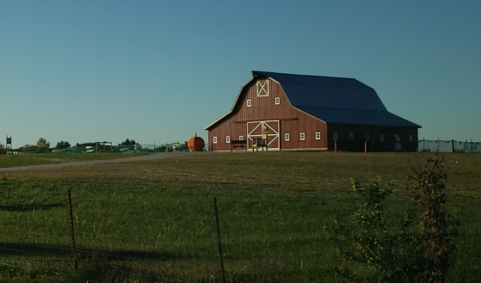
Low Density Residential (“RL”)  Shaded yellow on the Future Land Use Map | Min. lot size: 3 acres, or as approved by the Board of Trustees. | - Single Family  - Modular Homes- Special Use  - Public & Institutional Uses
Areas designated “Residential” are intended for single-family detached homes on lots three (3) acres or more. All homes should be served by public utilities and zoned “RL”. Planned developments may contain smaller lots, but should generally maintain the same permitted density as conventional residential districts. All development should be served by streets and stormwater management facilities that meet Innsbrook’s subdivision & zoning requirements. All subdivisions should include street trees, street lights, and sidewalks, the cost of which should be paid for and installed by the developer prior to the occupancy of any dwellings. |  | 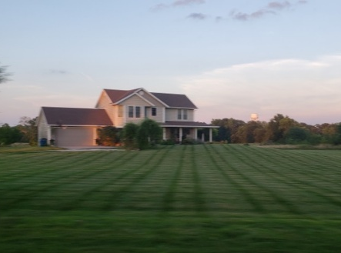
Medium Density Residential (“RM”)  Shaded orange on the Future Land Use Map | Min. lot size: 20,000 SF detached or 24,000 SF for attached villas with sewer & water and as approved by the Board of Trustees. | - Single Family  - Single Family Attached (Villas)  - Cluster/Conservation Sub Design  - Modular Homes- Special Use  - Public & Institutional Uses
The Medium Density Residential classification provides for a mix of housing types in a neighborhood setting. Attached single family villas, duplexes, and detached single family dwellings are all appropriate uses when zoned “RM”. Each dwelling requires a minimum of 20,000 square feet of lot area. Conservation subdivision design that reduces the cost of development by reducing the length of utility lines and roads is recommended. All subdivisions should include street trees, street lights, and sidewalks, the cost of which should be paid for and installed by the developer prior to the occupancy of any dwellings. |  | 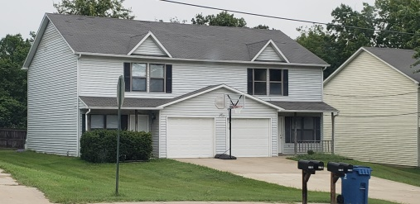

Future Land Use Matrix (continued)
Description (Corresponding Zoning) | Density | Recommended Uses
Multifamily (“MF”)  Shaded brown on the Future Land Use Map | Min. lot size: 10,000 SF per unit with public sewer and water and approved by the Board of Trustees. | - Multifamily  - Single Family  - Single Family Attached, Villas.  - Duplexes, Triplexes, & Condos  - Public & Institutional Uses
Areas designated as “Multifamily” are intended for a mix of residential densities and uses including senior housing, assisted living facilities, apartments, condos, villas, duplexes and single-family dwellings. All multifamily development should contain at least 10,000 square feet of land per dwelling unit. Multifamily development should have direct access to a collector or arterial roadway and provide buffers between less intense residential developments. All infrastructure improvements should be paid for and installed by the developer. Single or unified ownership of all multi-family structures and common use areas is required. Multifamily development should be permitted as a special use, require a public hearing and review/approval by the Planning & Zoning Commission and Board of Trustees. Architectural design guidelines are recommended to ensure all multi-family development is attractive and in harmony with the neighboring uses. |  | 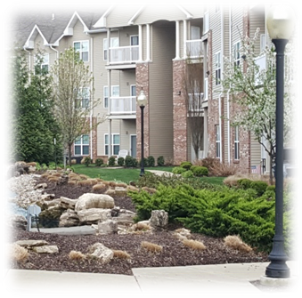
Mixed-Use/Downtown ( “CN”,“CH” “PD” and all “R“ Districts when combined w/ non-residential uses)  Shaded purple on the Future Land Use Map | Min. lot size: Sewer & water required & 75 acre minimum district size for or as approved by the Board of Trustees as a “PD”. | - Commercial Service & Retail  - Office, Medical, Financial  - Planned Development  - Public & Institutional Uses
Areas located at Highway F and M should be targeted for future mixed-use development. Buildings should be designed to the human scale with unifying architectural and landscape designs. Multifamily development, condos and villas are recommended when they are part of a planned mixed-use development and complimented with active retail, entertainment, dining and hospitality uses. Stand-alone residential development should be discouraged. Mixed-use development should be compact, walkable, attractive, green and safe. A new mixed-use zoning district or overlay is recommended to govern the review/approval and requirements of all mixed-use development. |  | 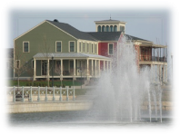  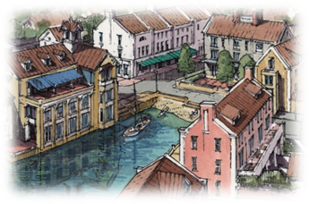
Commercial (“CH”) | Min. lot size: Sewer & water required & 2-acre minimum lot size or as approved by the Board of Trustees. | - Commercial Service & Retail  - Convenience stores, gas station  - Public & Institutional Uses
Areas designated “Commercial” are recommended for retail sales, commercial services, convenience stores, and automobile-oriented sales and services. All development should have direct access to a major road and provide buffers or screening between less intense uses. Monument signage (in lieu of pole signage) should be encouraged. |  | 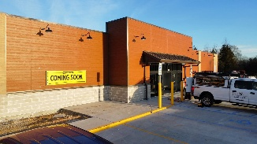

Growth Management
As the Village of Innsbrook grows over the next 10 years, there are several factors that could threaten agricultural lands, cause unwanted side effects, and hinder efficient, well planned development. Low density residential development adjacent to municipal limits and uncoordinated street development result in land consumptive sprawl that has an adverse impact on the manner in which an area develops. Therefore, this plan must include growth management as a tool to make intelligent future land use decisions.

Growth management can be described as a conscious public decision to restrain, accommodate or encourage development. Management techniques can be applied to any type of growth, but of particular concern to the Village of Innsbrook is the current and future supply of quality commercial, residential and industrial development opportunities. The growth of the land uses mentioned above are managed in part by proposing areas of commercial, residential and industrial growth on the Future Land Use Map and developing strategies for each district. In addition to proposing land uses, the Village can manage growth by extending the Village boundary and concentrating municipal services within the planning area. This strategy will minimize sprawl and the inefficient use of the land, resources and municipal services. The purpose for managing growth in the Village of Innsbrook are multi-fold, they include:

- the preservation of farmland and the income generating potential of the natural land,
- the prevention of overextending municipal services and infrastructure,
- the prevention of vacancies and thus economic decline within existing Village neighborhoods and commercial areas, and control the types and quality of development at the Village periphery.
The Village of Innsbrook should encourage annexations of land contiguous to the Village and served by utilities or areas where pre-annexation agreements exist regarding the provision of services. The cost of extending utilities should, to the extent possible, be shared by the developer. The rational for imposing growth management and preserving the area’s agricultural land, as provided by the American Farmland Trust, includes:
- It’s the only farmland we’ve got; when it’s gone, it’s gone forever.
- American farms ensure a safe and plentiful food supply.
- Many American families and rural communities are supported by their farmland.
- Saving farmland helps control sprawling development.
- Farms and ranches provide wildlife habitat.
- Urban-edge farms provide fresh, local produce for Village residents.
- Farming is a better economic use of the land than scattered development.
- Farms provide a direct link to our agricultural heritage and America’s history.
- Farms provide jobs.
- Farmland provides scenic open space.

Annexation
The community has expressed support for annexation throughout the comprehensive planning process. Many believe annexation is necessary to preserve the natural character of the area and provide for future residential growth. In response to the community’s support, the Future Land Use Map identifies the Village’s recommended growth areas for voluntary annexation. However, strategies must be in place prior to any annexation to extend public services, due to the Village’s inability to provide centralized services to adjacent unincorporated areas at this time

Partnerships between the Village, property owners and developers should be established early in the process to help avoid unanticipated repercussions during or after the annexation process. The Village should initiate pre-annexation agreements with adjoining land owners. Future development and land use decisions within the Village Limits shall comply with the Village’s Zoning Regulations and in accordance with the Plan’s land use recommendations.

Annexation of any land into the Village of Innsbrook should be considered carefully. While each situation is different, the end result should provide specific benefits to the Village as well as the annexing area. The areas of land on the Future Land Use Map that fall outside the Village’s limits are the areas the Village should consider for future annexation. Before any annexation decisions are made, the following general questions should be considered.

- Will the annexation lessen demand to develop in-fill property or redevelop existing sites and buildings within the current Village boundary?

- Will the annexation place any unacceptable political, financial, physical or operational demands or expectations upon the Village for the provision of services or infrastructure?

- Will the annexation allow for more appropriate guidance of future development within the annexation area?

- Will the annexation bring existing land uses into the Village that are desirable and have some benefit to the Village in terms of revenue or the sense of community?

- Is the annexation in the best interest of the Village as a whole?

- Does the annexation make economic sense from both long and short range perspectives?

- Will the value of existing properties within the Village be preserved or enhanced by the annexation?

Annexation Procedures
The Board of Trustees processes all annexation petitions and determines if they comply with State Statutes. The procedures for annexing unincorporated land in Warren County can be summarized by two methods of annexation; voluntary and involuntary annexation.

Under the voluntary method, residents in affected portions of Warren County petition the Village to request annexation. The owners of the property must fill out an annexation application and provide a plan legally delineating the area to be annexed and provide proof that the proposed annexation meets the statutory criteria. The petition is then reviewed by the Planning & Zoning Commission and their recommendation forwarded to the Board. After public hearing and consideration of the Commission’s recommendation, the Board shall determine if the annexation is reasonable and necessary. If the Board agrees, the annexation can be approved without the time and expense of an election. If the voluntary annexation includes several properties, annexation can only be accomplished through a petition process with 100% of the annexing property owners, agreeing to the annexation.

Involuntary annexations can only be accomplished through a petition process involving 100% of the annexing property owners and requires a “Plan of Intent”. The proposal must legally delineate the area to be annexed and provide proof that the proposed annexation meets the statutory criteria. The annexation petition must be presented at a public hearing. Following the public hearing, an election is held for registered voters in the Village and registered voters in the annexation area to vote separately on the annexation. The vote must be a simple majority in favor in both the Village and the annexation area to be approved.

Summary
The rate, manner and location in which the Village of Innsbrook allows residential, commercial and agricultural land uses should result in minimal impact on the existing uses within the Village. The challenge faced by the Village of Innsbrook is finding a balance between investing in new development and infrastructure versus reinvesting in what the Village already has.

The potential for commercial development exists in the areas as indicated on the Future Land Use Map. Future commercial development in these areas can be used to generate Village tax revenue, expand employment opportunities, and increase shopping and entertainment alternatives for area residents as well as tourists and travelers. However, this growth must not occur in a manner that compromises the area’s rich agricultural resources, open woodlands and wildlife corridors.

Notes:

Urban Design: Themes to consider include equestrian, Alpine Craftsman styles. Austria Farmland Traditional Architecture. "Don’t make it look like a municipality". Let the owners weigh in on the various vignettes (sample communities) and go with the most supportable and then prepare a Character-driven plan that provides the framework to create character-driven development, co-authored by the Innsbrook community. Provide a good resort / recreation character. We want a "Community Village Feel".

Cottage Courts: Chalet-rustic or cowboy-chic styling to the south…more affordable / moden style to the north. Cottage courts might work (see New Town St. Charles) Include small clusters of small homes or "Lanai Cottages" that contain 2- master suites that form a "U" with common area/kitchen at the bottom of the U and with a lanai courtyard or deck in between the bedrooms in the middle of the U.

Themes: Quiet enclave with unique identity. Consider equine / horse / ranch / stables / western or cowboy chic. Incorporate the “brand” in everything – IBK logo, letterheasd, signage, architecture, provide connections to the history of Warren County / Innsbrook that provides a richness or authenticity to the Brand. Paved surfaces, light posts, lighting, trails/sidewalks, signage, hitching posts – real or decorative. Use stables, riding arenas, barns, silos, fencing, ranch – A frame architectural, materials, and massing into the built environment

Gateway Features: The entry of the focus area should include a primary gateway feature and subordinate gateway elements leading to sub-areas within the focus area.

Financing: Conservation study to identify land use characteristics that have positive correlation with blight.

Hooks: Brunch every Sunday. Happy hour every Friday. Weekly seasonable celebrations…i.e. NYE, St. Patrick’s Day, Derby Day, Cinco De Mayo, Earth Day, Easter, etc. festivities,

Transportation: Connections and multi-model is critical. These are the public improvements that need outside funding.
- "The existing gravel road to the south that goes nowhere is where the tunnel wants to go to connect to the Resort. This is just S of HWY F."
- "Behind Wags and Whiskers and the Village Hall create another road (reverse frontage road) that connects to the new development while taking traffic off F and M. Acquire another 20 acres to the east"

Nature: "Working with the ground / land and existing trees and topography is important. We don’t like to move stuff- retain existing features. Bring in and embellish water features."

