ECO ORCA CLASS MARCH 2025 Dinosaurs
SUNDAY |  |  |  | MONDAY | TUESDAY | WEDNESDAY | THURSDAY | FRIDAY | SATURDAY
 |  | 23 |  | 24 | 25 | 26 | 27 | 28 | 1
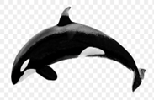 |  |  |  |  |  |  | 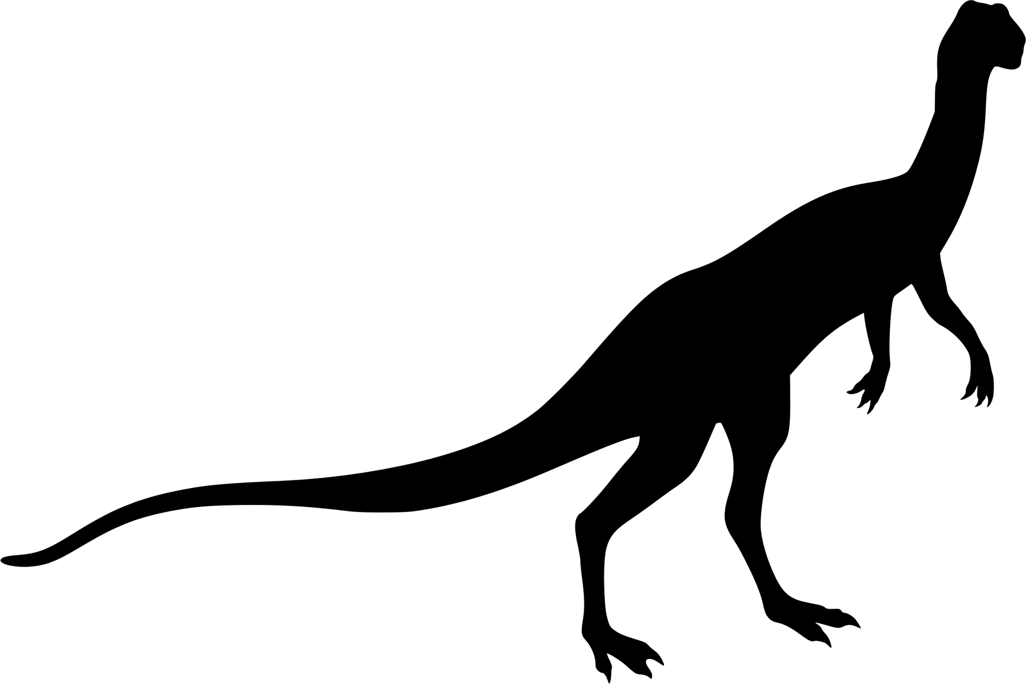
 | 2 |  |  | 3 | 4 | 5 | 6 | 7 | 8
 |  |  |  | JDF Upper Park | Cole Bay Beach | Cook St  Park | Aylard Farm Petroglyphs | Devonian Beach
 | 9 |  |  | 10 | 11 | 12 | 13 | 14 | 15
 |  |  |  | Rainbow  Park | Matheson Lake Trails | Royal Bay Park | Mt Doug Beach | Thetis Lake Trails | 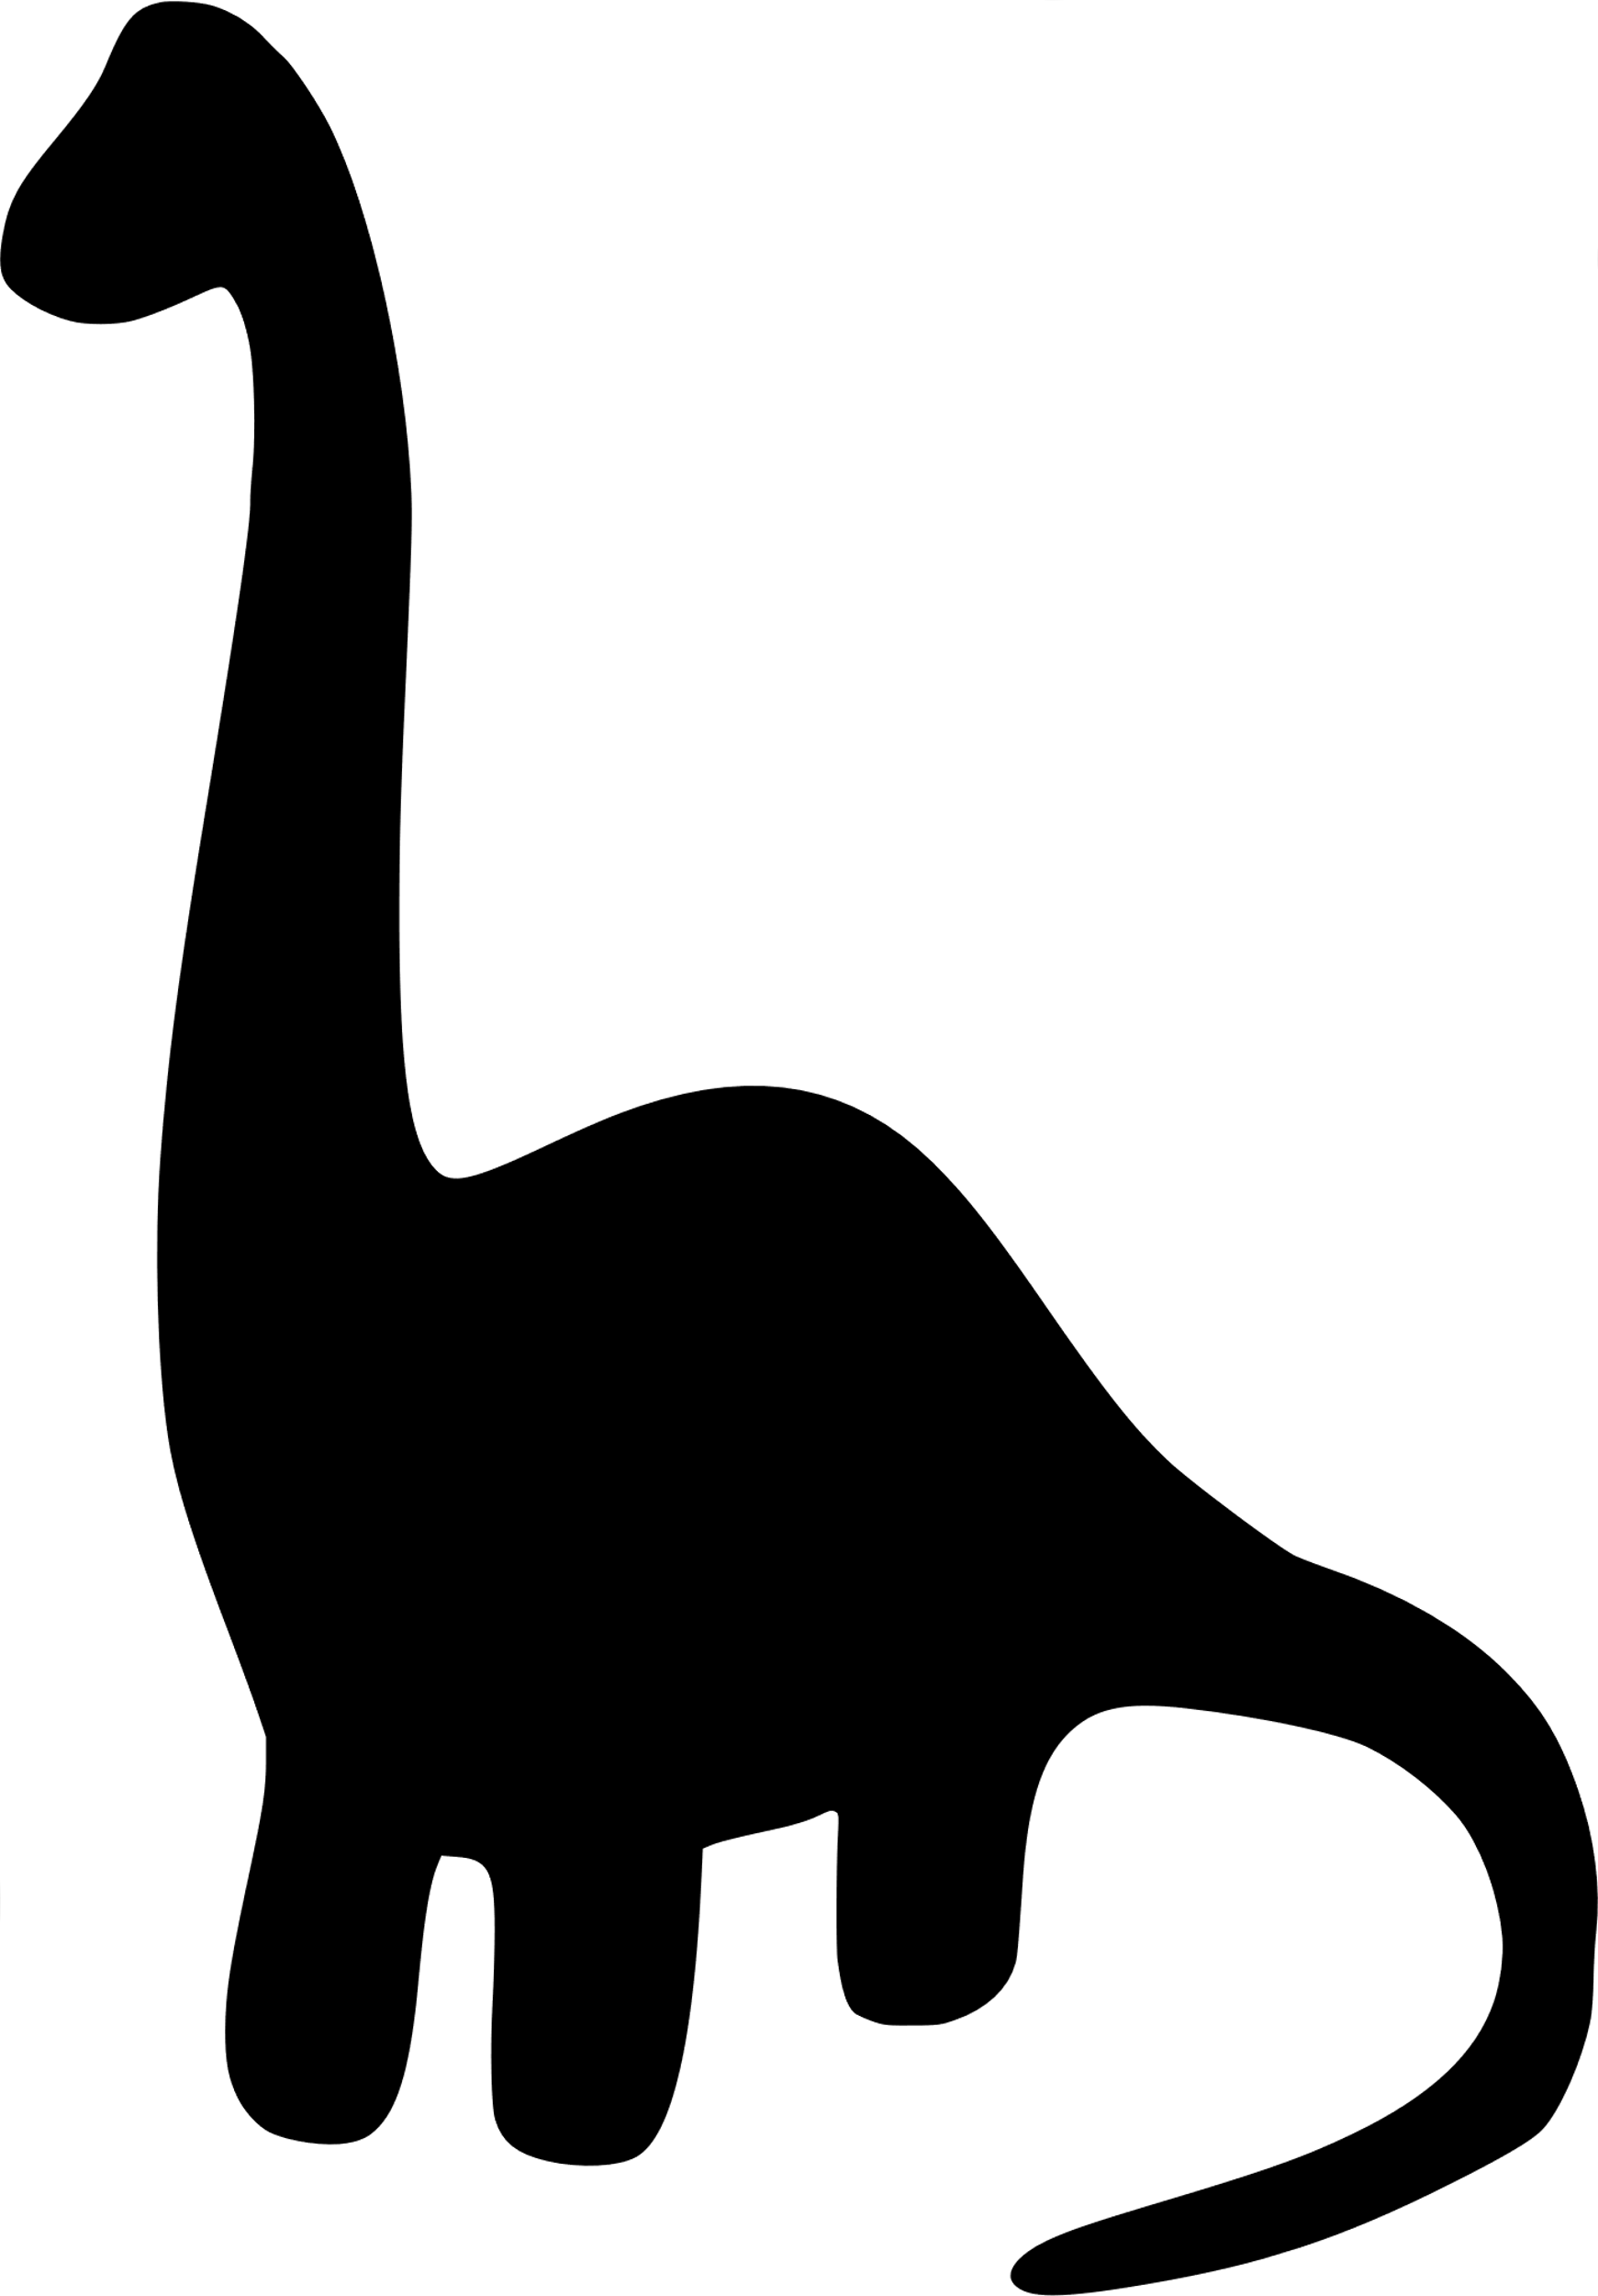
 | 16 |  |  | 17 | 18 | 19 | 20 | 21 | 22
Spring Break OSC |  |  |  | Central Saanich Park  St. Patrick's Day | Movie $12 | Cook St  Park | Beckwith  Park | JDF Park and Hockey
 | 23 |  |  | 24 | 25 | 26 | 27 | 28 | 29
Spring Break OSC |  |  |  | View Royal Park | Seaparc Skating $5 | Gyro  Park | Bowling $8 | Sooke Park
 |  |  | 30 | 31 | 1 | 2 | 3 | 4 | 5
 |  |  |  | Elk Lake Trails  Bug Hunt |  | 

