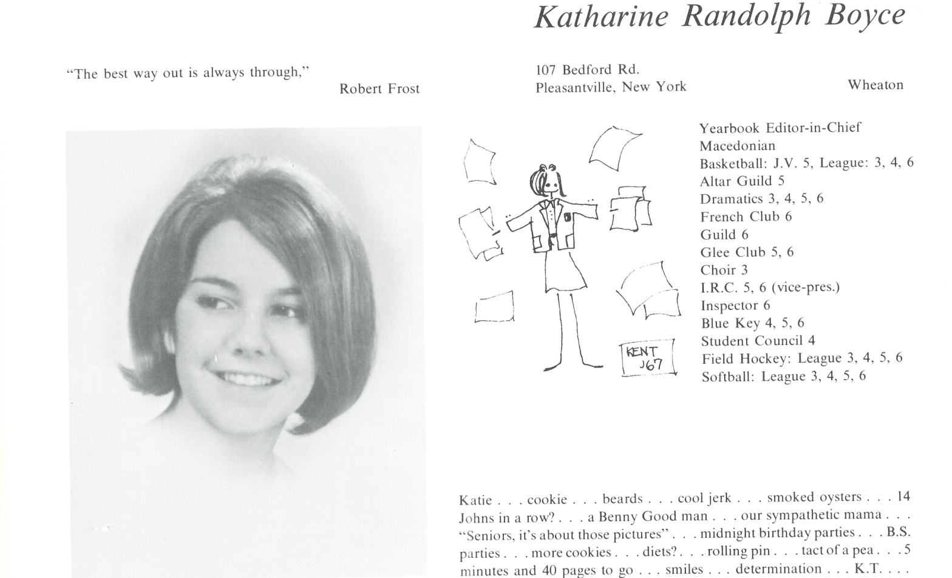

Katharine R. Boyce Reeder

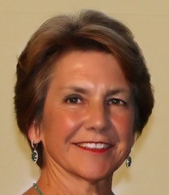Going by Kate Boyce Reeder, or some variation, I’ve worked in public policy, basically, since college. After 5 years as a Legislative Assistant and Press Secretary in the House of Representatives, I went to law school at Catholic University, and joined the law firm of Patton Boggs LLP. Over 30 years as partner seemed like enough, so I left in August, 2014 and formed my own firm, KRBR Consulting LLC, primarily assisting Native American and nonprofit clients. It’s been exciting to evolve from representing corporations and trade associations on federal election matters, to foreign governments on public policy matters, and founding my law firm’s Native American Affairs Practice Group, and then my own firm to work with Indian tribes and their enterprises, companies owned by Native Americans, and national Native American organizations.

In addition to pro bono representation, I’ve served on numerous non-profit boards. The local boards have included the Ballston Partnership (public-private group overseeing Ballston neighborhood development in Northern Virginia) in the 1980s, and for the last 10 years I’ve served as Board Vice President of the Child and Family Network Centers (CFNC), a charity that provides free, high quality preschool education and social services to low-income children and their families in neighborhoods throughout Alexandria, VA. As for national boards, in the early 1990s, I joined the Board of the National Organization on Fetal Alcohol Syndrome (NOFAS), and have long served as Board Chair. And, since 2014, I’ve been on the National Board of the Armed Services YMCA, serving as Board Secretary.

Of course, my pride and joy are my family – husband, Joe Reeder (shareholder, Greenberg Traurig LLP and former Undersecretary of the Army), four daughters (Rachael, mom and budding political activist in Leesburg, VA; Aubri, working for an international infrastructure development company in Dubai; Julia, a high school bilingual therapist in Denver; and Kelsey, a case manager in foster care in NYC) and two granddaughters (Anna and Kara in Leesburg). We’re usually working hard, and working out, but we also enjoy watching theater, ice hockey and tennis, and relish occasional trips with our girls or visiting our families.



______________________________________________________________

______________________________________________________________ ______________________________________________________________ ______________________________________________________________ ______________________________________________________________ ______________________________________________________________ ______________________________________________________________ ______________________________________________________________ ______________________________________________________________

Attach Picture in .jpg Format

______________________________________________________________

______________________________________________________________

___________________________________________________________________________________ _________________________________________________________________________________________________________________________________________________________________________________________________________________________________________________________________________________________________________________________________________________________________________________________________________________________________________________________________________________________________________________________________________________________________________________________________________________________________________________________________________________________________________________________________________________________________________________________________________________________________________________________________________________________________________________________________________________________________________________________________________________________________________________________________________________________________________________________________________________________________________________________________________________________________________________________________________________________________________________________________________________________________________________________________________________________________________________________________________________________________________________________________________________________________________________________________________________________________________

___________________________________________________________________________________