Strength, Soul, and Spark:
Celebrating the Gifts of Women
Thankoffering Service
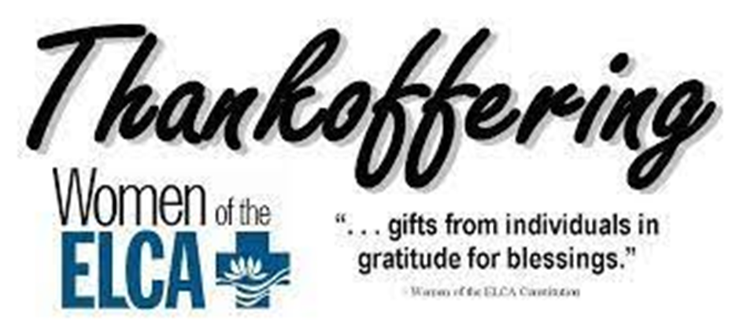
Saturday & Sunday, Nov 15 & 16, 2025
Christ Lutheran Church
“A Place Where You are Always Welcome”
Services: Saturday 5:30 pm and Sunday 10:00 am
Sunday School: 9:00 am (September- May)
600 North Main Street, Stockton, IL 61085 Office: 815-947-2033
Email: christlutheranchurch70@gmail.com http://www.christlutheranstockton.com
Ministers: ALL members of the congregation
Pastor: Rev. Chrissy Salser chrissytherev@att.net 815-988-9450
From Sundays and Seasons.com. Copyright 2017 Augsburg Fortress. All rights reserved. Reprinted by permission under Augsburg Fortress Liturgies Annual License #40643.New Revised Standard Version Bible, copyright 1989, Division of Christian Education of the National Council of the Churches of Christ in the United States of America. Used by permission. All rights reserved.
WELCOME: Thank you for joining us for worship today. We are glad you are with us. Communion will be served in the aisle or in your pew. All are welcome to share this meal. Jesus is our host and invites everyone. Those who would like to come forward, bread and wine will also be available in the front. When directed by the usher, come forward down the center aisle, Pr Chrissy will give you bread (she will be masked and wearing cloves) and then you will take a cup of wine (grape juice) from the tray. After taking communion, you will return to your seat by the side aisle. For those who are unable to come forward, communion elements can be found as you entered worship. At that part of the service, you are invited to take the bread and wine (or grape juice) when Pr. Chrissy leads. On Saturday’s offering is collected as you enter or leave worship. On Sunday we will pass the plate as a response to God’s grace. Online giving is available. Please see QR code on back of bulletin or visit our website.

Gathering: The Holy Spirit calls us together as the people of God.
PRELUDE
WELCOME AND ANNOUNCEMENTS
THANKSGIVING FOR BAPTISM
L: We gather in the name of our creator, redeemer +, and sustainer.
C: Amen.
L: Joined to Christ and named as God’s beloved, we give thanks for the gift of baptism that roots us in life, renews us in strength, and frees us to be bold.
L: We give you thanks, O God,
C: For at the beginning of time, your creative spirit moved over the waters, your Word brought new life, and you called it good.
L: We give you thanks, O God, for waters that sustain and heal.
You revealed a spring of water to Hagar, saving her and her son Ishmael.
You brought your people out of the waters of the Exodus, leading Miriam to shout out in song. You held Moses in the River Nile, where Pharaoh’s daughter would find him and care for him as her own. You kept the party going when, at Mary’s request, Jesus turned water into wine at a wedding. You led a Samaritan woman to a well, where she would be met by Jesus’ grace and given living water that lasts.
L: Even today, C: you shower us with life, and we praise you. With your living water, sustain our souls, show us empathy and welcome, give us strength, and lead us by your divine spark to lives of compassion and mercy. Amen.

GATHERING HYMN For All the Faithful Women ELW 419
Greeting:
P: The grace of our Lord Jesus, the love of God, and the communion of the Holy Spirit be with you all. C: And also, with you.
PRAYER OF THE DAY: (written by Zarah Van Dyk ‘26)
P: God of Glory, c: we are gathered today in your presence to celebrate and give thanks for all of the gifts and talents given to women. While we recognize the abundance we have, we also recognize the struggles of women in our own country and around the world. Sometimes these struggles are voiced or are internal conflicts that only You know about. Lord, bring peace and joy to our hearts today. Allow us to fully absorb the presence of you and of the community of strong women surrounding us. C: Amen
Word: God speaks to us in scripture reading, preaching, and song.
CHILDREN’S MESSAGE Leisa Hubb

FIRST READING: Ruth 1:7-16 Naomi and Ruth (soul)
Ruth is a story of deep faithfulness, empathy, and compassion amid adversity. The story's soul demonstrates the power of love to triumph over hopelessness and to bridge great differences. For women like Ruth and Noami, whose empathy heals generational wounds, we give thanks.
⁷So Naomi set out from the place where she had been living, she and her two daughters-in- law, and they went on their way to go back to the land of Judah. ⁸But Naomi said to her two daughters-in-law, "Go back each of you to your mother's house. May the LORD deal kindly with you, as you have dealt with the dead and with me. ⁹The LORD grant that you may find security, each of you in the house of your husband." Then she kissed them, and they wept aloud. ¹⁰They said to her, "No, we will return with you to your people." ¹¹But Naomi said, "Turn back, my daughters, why will you go with me?...No, my daughters, it has been far more bitter for me than for you, because the hand of the LORD has turned against me." ¹⁴Then they wept aloud again. Orpah kissed her mother-in-law, but Ruth clung to her.
¹⁵So Naomi said, "See, your sister-in-law has gone back to her people and to her gods; return after your sister-in-law." ¹⁶But Ruth said, "Do not press me to leave you or to turn back from following you! Where you go, I will go; where you lodge, I will lodge, your people shall be my people, and your God my God.
R: Holy Wisdom, Living Word C: Thanks be to God.

REFLECTION

PSALM: Psalm 139:1-14 God’s compassionate creativity (spark)
The spark of the divine dwells within each of us. For the cosmic creativity of God, whose presence accompanies and inspires all, we give thanks.
O Lord, you have searched me and known me.
² You know when I sit down and when I rise up; you discern my thoughts from far away.
³ You search out my path and my lying down and are acquainted with all my ways.
⁴ Even before a word is on my tongue, O Lord, you know it completely.
⁵ You hem me in, behind and before, and lay your hand upon me.
⁶ Such knowledge is too wonderful for me; it is so high that I cannot attain it.
⁷ Where can I go from your spirit? Or where can I flee from your presence?
⁸ If I ascend to heaven, you are there; if I make my bed in Sheol, you are there.
⁹ If I take the wings of the morning and settle at the farthest limits of the sea,
¹⁰ even there your hand shall lead me, and your right hand shall hold me fast.
¹¹ If I say, “Surely the darkness shall cover me, and night wraps itself around me,”
¹² even the darkness is not dark to you; the night is as bright as the day,
for darkness is as light to you.
¹³ For it was you who formed my inward parts; you knit me together in my mother’s womb.
¹⁴ I praise you, for I am fearfully and wonderfully made. Wonderful are your works;
that I know very well.
REFLECTION
GOSPEL: Matthew 9:18-25 The women who bled for twelve years (strength).
Through a bold woman, Jesus demonstrates God’s mercy and power by accepting the unacceptable and curing the incurable. Even the dead receive new life. For unnamed women who fight to be seen and heard, we give thanks.
P: The Holy Gospel according to Matthew, the ninth chapter.
C: Glory to you, O Lord.
18 While [Jesus] was saying these things to them, suddenly a leader came in and knelt before him, saying, “My daughter has just died, but come and lay your hand on her, and she will live.” 19 And Jesus got up and followed him, with his disciples. 20 Then suddenly a woman who had been suffering from a flow of blood for twelve years came up behind him and touched the fringe of his cloak, 21 for she was saying to herself, “If I only touch his cloak, I will be made well.” 22 Jesus turned, and seeing her he said, “Take heart, daughter; your faith has made you well.” And the woman was made well from that moment. 23 When Jesus came to the leader’s house and saw the flute players and the crowd making a commotion, 24 he said, “Go away, for the girl is not dead but sleeping.” And they laughed at him. 25 But when the crowd had been put outside, he went in and took her by the hand, and the girl got up.
P: The Gospel, the Good News made real for you. C: Praise to you, O Christ!

REFLECTION

HYMN OF THE DAY Canticle of the Turning ELW 723
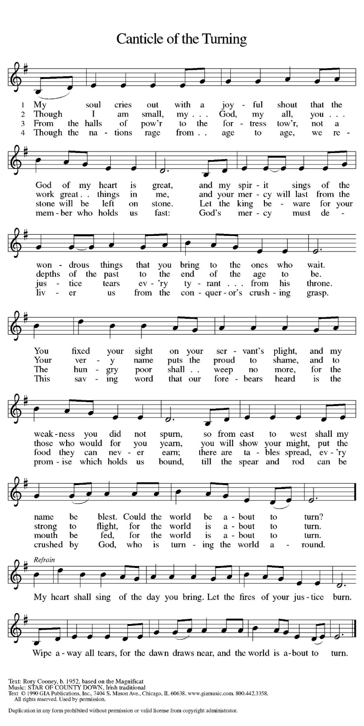

APOSTLES’ CREED:
I believe in God, the Father almighty, creator of heaven and earth.
I believe in Jesus Christ, God’s only Son, our Lord, who was conceived by the Holy Spirit, born of the virgin Mary, suffered under Pontius Pilate, was crucified, died, and was buried; he descended to the dead. On the third day he rose again; he ascended into heaven, he is seated at the right hand of the Father, and he will come to judge the living and the dead.
I believe in the Holy Spirit, the holy catholic church, the communion of saints, the forgiveness of sins, the resurrection of the body, and the life everlasting. Amen.
PRAYERS OF THE PEOPLE:
L: In solidarity with your people from every nation and knit together with all of creation, we boldly pray for the church, our world, and all those in need.

L: Inspire your church, like Ruth and Naomi, to extend arms of compassion and empathy in times of challenge. Equip communities to be welcoming, to show mercy, and to lean into relationships so that all people may know your care. God our soul,
C: Hear our prayer.

L: Guide leaders to reflect the spark of your divine wisdom. Open eyes to see the goodness of your created world and encourage the tender care of those cast aside. Reveal yourself in unexpected places and in the leadership of those called to help. God our Spark,
C: Hear our prayer.

L: Bring healing, like the woman who bled for twelve years, to all who are suffering. Give strength to the weary, uplift the lowly, and amplify the voices of those quieted. Breathe new life into forgotten places, end wars, rejuvenate lands, and uplift spirits. God our Strength,
C: Hear our prayer.

L: Trusting in your love for us, we offer these prayers and whatever else weighs heavy upon us to you, in the name of Jesus. C: Amen.
PEACE
L: The peace of Christ be with you always. C. And also with you.

OFFERING: Our offering is a significant act of worship; we worship God through our giving. The ministry of this congregation is completely dependent upon your partnership and generosity. Offering is collected as you enter worship on Saturday. We will pass the offering plate on Sundays. Online giving is available. THANKOFFERING WILL BE COLLECTED AT THIS TIME. PLEASE COME FORWARD WITH YOUR GIFT.
LAMB OF GOD This Is Christ’s Body ACS 967
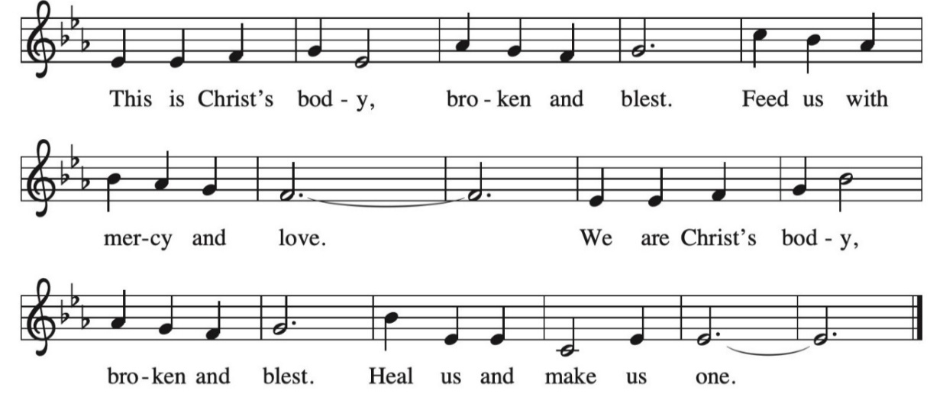
OFFERING PRAYER:
L: God of Abundance, C: You create goodness in everything we offer. Use these gifts to bless the world. Strengthen ministries, empower leaders, and inspire generosity so that all may know your love. Reveal this love to us once again as we gather at your table that we might embody your compassionate care in all we do. Amen.
A LITANY FOR VETERANS
On this day, we remember those who have served in our armed forces.
Prince of Peace, even as we pray for an end to war,
We give thanks for our soldiers’ courage, for their love of country,
and for their work to bring peace to our world.
Healer of All, bind up the wounds of all who have served.
Show us how to comfort those who are hurting.
Merciful God, all suffer the cost of war.
We remember widows and widowers, orphans,
and all those separated from those they love.
We pray, Gracious God, that swords will be turned into plowshares and that peace will reign.
We give thanks for all who have served. Shield from danger those who bravely protect us. With them, may we glory not in war, but in your love and righteousness. Strengthen us to be your peacemakers in the world. Amen.
COMMUNION LITURGY:
In the night in which he was betrayed, our Lord Jesus took bread, and gave thanks, broke it and gave it to his disciples, saying: take and eat; this is my body, given for you. Do this for the remembrance of me. Again, after supper, he took the cup, gave thanks and gave it for all the drink, saying: this cup is the new covenant in my blood, shed for you and for all people for the forgiveness of sin. Do this for the remembrance of me.
THE LORD’S PRAYER:
Our Father, who art in heaven, hallowed be thy name, thy kingdom come, thy will be done on earth as it is in heaven. Give us this day our daily bread; and forgive us our trespasses, as we forgive those who trespass against us; and lead us not into temptation but deliver us from evil. For thine is the kingdom, and power, and the glory, forever and ever. Amen
INVITATION TO COMMUNION:
P: Jesus welcomes sinners and eats with them. Come to this meal of mercy.
Please come down the center aisle, take the bread, then receive a cup (wine is dark, juice is light, return to your seats via side aisle.) Those who prefer to take communion in your pews, we will take all together after all are served.
DISTRIBUTION OF COMMUNION:
P: This is the body of Christ given for you. (All take bread).
P: This is the blood of Christ shed for you. (All take the wine).
COMMUNION HYMN: I Come with Joy ELW 482 (next page)
TABLE BLESSING:
P: May the body and blood of our Lord Jesus Christ strengthen you and keep you in His grace. C: Amen.
PRAYER AFTER COMMUNION:
P: Generous God, C: We give thanks!
P: You’ve gathered us together across generations and created a place at the table for each of us. C: We give thanks!
P: Strengthen us with this meal of your love poured out, fill us with compassion, and nourish us until we meet again. C: We give thanks!
P: In the name of Jesus Christ, C: Amen.
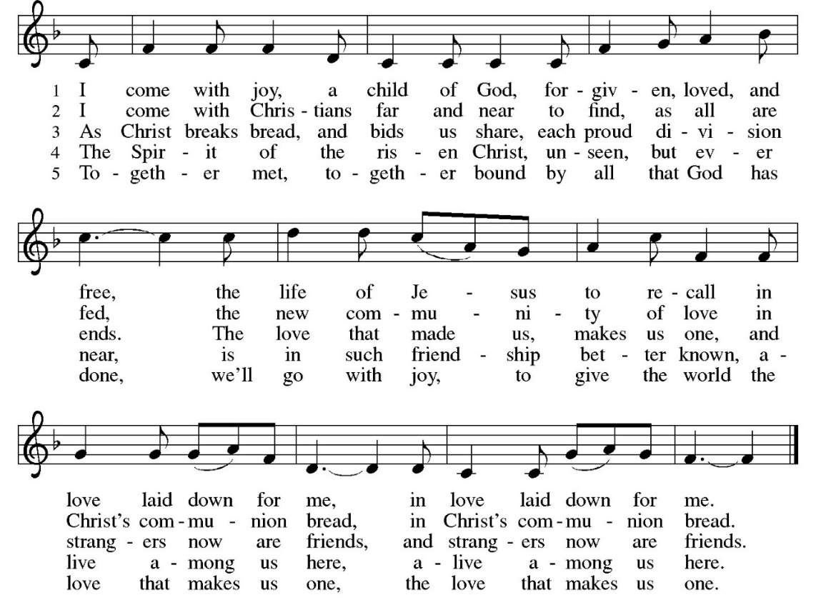

SENDING: God blesses us and sends us in mission to the world.
BLESSING: (written by Carter Horman‘28)
P: Receive the blessing of God who breathes creativity into every soul and lights up every vision with purpose. Bless the women of the world with the strength that they need, with empathy that brings us together, and with gratitude that moves us all forward. May your love be our guide, and your justice our song that we sing and live out each day.
C: Amen.

SENDING HYMN Praise the Lord, the Almighty ELW 859 (Next page)
DISMISSAL:

P: Go in peace to love and serve the Lord!
C: Thanks be to God.

POSTLUDE
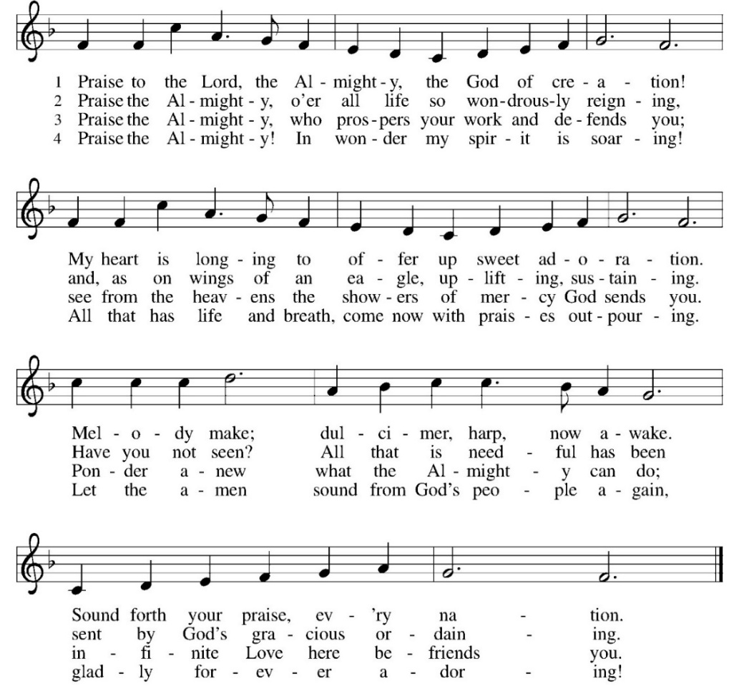

IN OUR PRAYERS TODAY: Teresa Hesselbacher, Elaine Schlicting, Darlene and Walt Steffes, Bob Schreck, Delores Wampfler, Marge and Gerald Arnold, Don & Judy Brudi, Diego Gonzalez, Grayson Raab, James Dieter, Christine Happ, Kay Hesselbacher, Mary Lou Bunker, Lillian Sefford, Joe Karr, Jeff Encheff, Judy Wilson, Russ Synder, Don Kunz, Johnny Blair, Jim Sullivan, Sally Duran Salser, Darrel Lindstrom , the family and friends of Tony Romero. To add someone to the prayer list please contact Pastor Chrissy
Updated address: Teresa Hesselbacher Rm D16 Alden Debes 550 South Mulford Rd Rockford, Il 61108 cell phone 608-482-3720
CELEBRATING BIRTHDAYS / ANNIVERSARIES: Jake Marek, Brittney Arnold, Grant and Amanda Stocks


SeptemberTotals: As a way to improve communication around finances, we are sharing the following information: *these numbers reflect online giving contribution
2025
 | September | Year to date
Offerings: | $10,542 | $89,468
Expenses: | $10,168 | $93,340
Overall Gain / Loss | $375 | ($3,871)
Thanks be to God for your gifts for the ministry of  Christ Lutheran Church *these numbers do not reflect online giving- only offering in worship |  |  |  | Offering/ Attendance  Saturday Nov 8  Sunday Nov 9
Current Expense | $2,895.00 | Building Fund | $10.00 | Nov 8 | 11
Benevolence | $10.00 |  |  | Nov 9  Sunday School | 50  28
 |  | Total
  $ 2,915.00

ONLINE GIVING: Your gift has a big impact on our ministries and those we serve. Scan this code or visit our website to give online today.

Upcoming Events
- November 15- 8 am Breaking Bread at Copper Leaf Cafe
- November 15 5:30 pm thankoffering worship
- November 16 9 am Sunday School- packing OCC Shoe Boxes
- November 16 10 am WELCA Thank offering
- November 17-25 Operation Christmas Shoe Box Drop off
- November 18- 11:30 am Community Table
- November 19- 9 am Bible Study (SMA chapter 13) (Luke 23:33-43)
- November 19- 7 pm Church Council
- November 21-22 Confirmation Retreat at LOMC
- November 23- Sunday school begin working on the Christmas program
- December 4- noon- WELCA Christmas Potluck
- December 21- 10 am Children’s Christmas Program

ANNOUNCEMENTS
THANKOFFERING: join us for worship November 15 & 16 as the women of the church are invited to help lead worship. The Thankoffering service is an opportunity to say thank you to God for the many things that God continues to provide. Special Thankoffering envelopes are available for your special donation to the Women of the ELCA.
BLESSING BOX: the need is great. Consider making a special donation of money or bringing items for the blessing box. During this time of food insecurity, we would like to always keep the blessing box full. If blessing box is full, please put items in the narthex. Some items to consider bringing are apple sauce cups or squeeze pouches, fruit snacks, crackers (individual serving sizes), granola bars, pop tarts, individual cereal cup, fruit cups, instant hot cereal, canned soup/ stew, canned meat, SpaghettiOs, canned fruit and vegetables, instant food (rice, potatoes), pasta, pasta sauce.
CONFIRMATION CLASS: students in grades 7th & 8th grade and older who would like to learn more about their faith, will gather on the 2nd and 4th Sundays of the month from 8:30-9:45 am. Please sign up online
or talk to Pastor Chrissy.
ITEMS NEEDED FOR 2026 BIBLE SCHOOL: in the back of the church, we are collecting your plastic milk bottle lids, small plastic pop bottles and assorted plastic bottle lids. Plastic 8 oz pop bottles. Please collect and bring them in!
OPERATION CHRISTMAS CHILD BOX DROP OFF: will take place here Monday November 17-24 Times are M, W, F, Sat 9 am to noon and T, Th, Sunday 3-6. Volunteers are needed! Please see Nancy Rice to sign up.
CONFIRMATION CLASS: the students will be attending the Fall Retreat at LOMC. We will meet on Friday at 5 pm. Please plan on feeding the class member prior to dropping them off. A packing list was sent home with students last class. They will be back in time for worship on Saturday night and can be picked up after worship. Please pray for the youth and the chaperones as they encounter God and build relationship with each other and God.
THE COMMUNITY TABLE: The Community Table is an opportunity for outreach to the local community. This is a twice a month meal on the first and third Tuesday of the month at 11:30, here at Christ to gather for food, fellowship and fun, if you are interested in volunteering please talk with Janet Haas or Debbie Goebel. Join us Tuesday, November 18th. All are welcome.
OPERATION CHRISTMAS CHILD SHOE BOX: start collecting items as we will be having a packing party this year for the shoe boxes. You can still pack your own if you want! Items needed: personal care items (toothbrush, wash cloth, comb or brush, nail clippers, water bottles, flashlights, hair accessories), School Supplies (pencils, pencil sharpeners, erasers, crayons, colored pencils, markers, notebooks, calculators, scissors, rulers, glue sticks, drawstring bags), remember items will be packed in shoe boxes. Packing party will be Sunday November 16th at 9 am during Sunday school in the fellowship hall.


AMAZON WISH LIST: did you know that everyday items used at the church are items you could contribute? Find our list here or on our Facebook page. Thank you! https://www.amazon.com/hz/wishlist/ls/TWP5U0RAGGAY?ref_=wl_share

