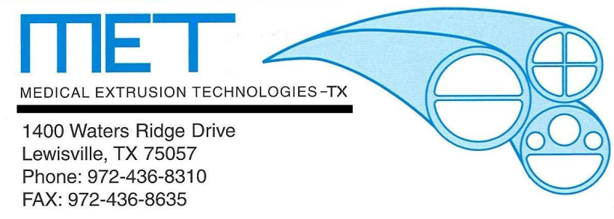

For Immediate Release - January, 2012
Medical Extrusion Technologies, Inc. (MET) is pleased to announce the addition of Brian Frechette to our Lewisville, TX manufacturing location. In his new role, Brian will serve as General Manager/Plant Manager for our growing operations in Lewisville, which focuses on extrusion and expansion of Fluoropolymers and other engineered materials. Brian and his family recently relocated to the Lewisville area from Minneapolis, MN. Most recently, Brian was employed by St. Jude Medical (previously AGA Medical) in the Supply Chain Operations group in Plymouth, MN. Prior to his time at St. Jude Medical, Brian served in a variety of roles with Donaldson Company Inc. in Bloomington, MN. Brian’s extensive supply chain, operations, and industry knowledge will allow us to further refine our operational excellence and customer focus.
When asked what Brian is looking forward to the most in his new role, he responded, “I am looking forward to working with the strong team at Medical Extrusion Technologies, Inc., and focusing on continuous operational improvement and growing Medical Extrusion Technologies, Inc. market share in the medical segments which we serve”.
Please join us in welcoming Brian into his new role with Medical Extrusion Technologies, Inc.

