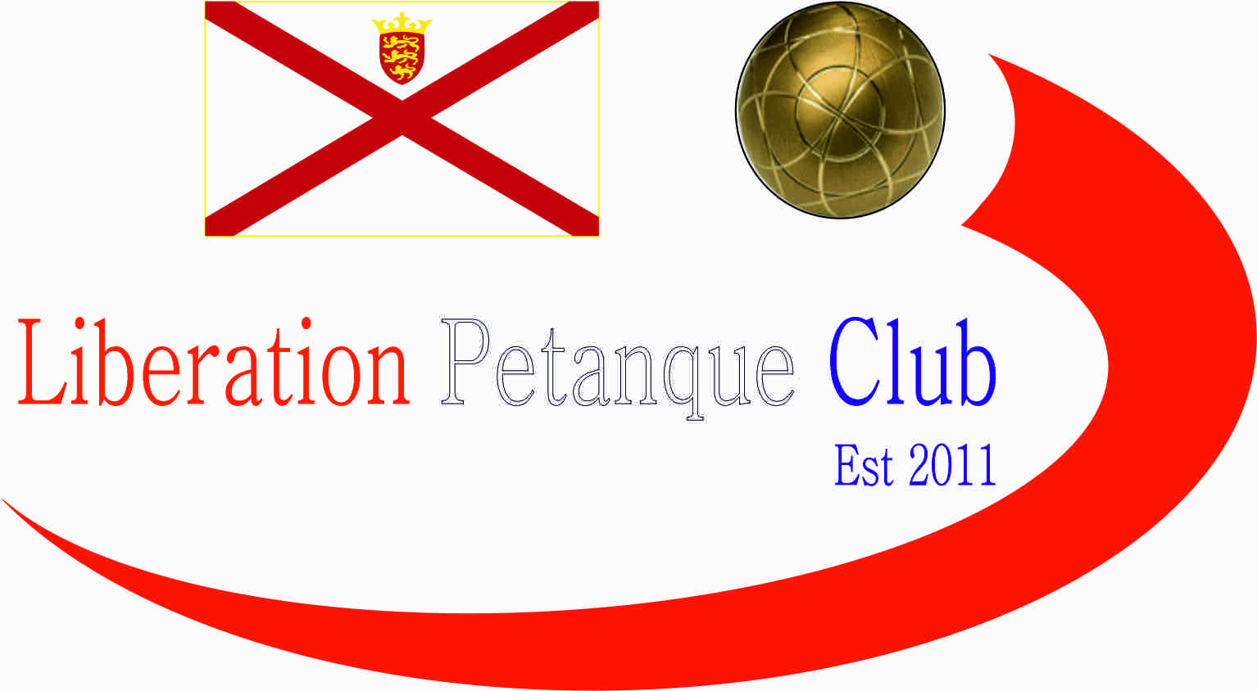  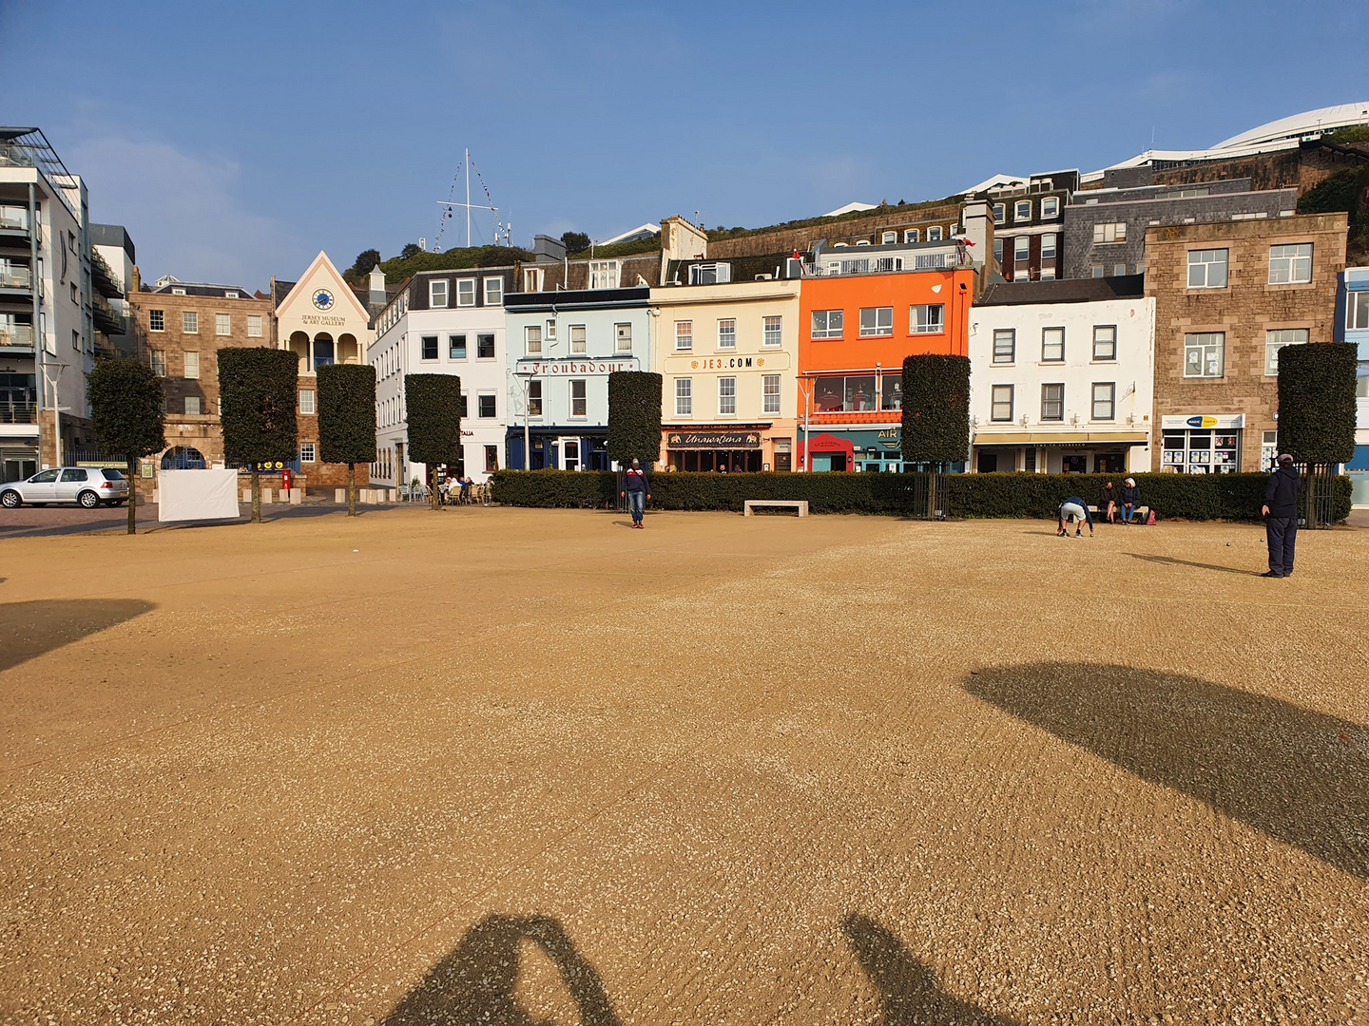  - 2026  open competitions  We are pleased to announce we will again be holding our Annual Doubles and Singles Opens in 2026.  Entry Fee’s are £10.00pp for our Island Open Competitions.  Singles Open _______________________________  Doubles Open Player 1 _______________________  Doubles Open Player 2 _______________________  Contact No. _____________ Email ____________________
  Competition Dates
  Doubles – 11th April
  ____
  Singles – 27th June
  ____
  ____
  Liberation peranque club
  www.liberationpetanque.co.uk
  Club Email - liberationpc@gmail.com
  Bacs Payments to: Sort Code – 30-94-61 Account No. 15475463
Liberation Petanque Club

