
RICK A SHACKET
DO, MD(H)
Main Office:

Rick A. Shacket
Office: 602.492.9919 Mobile: 602.920.1023

Name: _______________________________________ DOB: ___________ Date: ___________

PLACE OF PROCEDURE

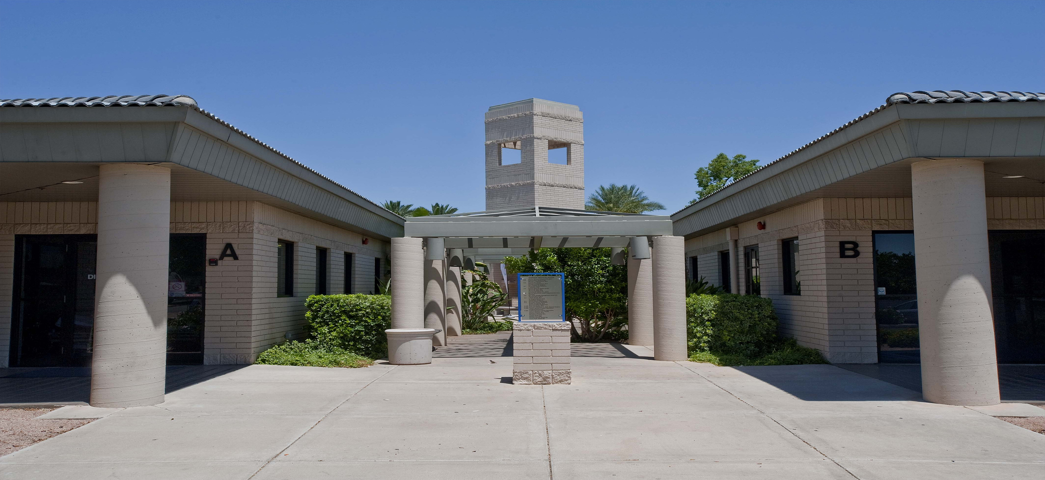

Warner Park Surgery Center
604 W Warner Rd.
Chandler, AZ 85225
480) 899-2571

Your surgery is scheduled on:
Date: _________ Time: _________ Arrival Time: _________

❑ If you do not have a scheduled time written above, and you do not get a call from us within five working days, please call Dr. Shacket’s office to schedule your procedure.
Scheduling Number (602) 492-9919

