OG&E
Rib Crib - Muskogee

OG&E
Okie Country 101.7, KTFX-FM
QuikTrip Corporation - Tulsa
O Rib Crib - Muskogee
Roofs by Riggs - Muskogee
Sooner Surplus Sales – Muskogee
Sound on the Move - Muskogee
The Castle – Muskogee
The Community State Bank – Poteau
The Generator Guy - Tulsa
Three Rivers Photography Club
Trish’s Stitches – Quinton
TTCU - FEDERAL CREDIT UNION - Miami
TTCU – FEDERAL CREDIT UNION - Muskogee
Union Pacific Railroad
Walmart – Checotah
Walmart - Muskogee
Walmart - Tahlequah
Yaffe Iron & Metal CO., INC.

The Eastern Oklahoma State Spelling Bee
Gratefully Acknowledges These Generous Sponsors

Holloway’s Blueprint & Copy Shop
Homeland Employee Owned – Muskogee
House of Webster – Springdale, AR
H&R Block – Muskogee
Indian Capital Technology Center
I’m A Basket Case - Muskogee
Jeannie Glover, Agent State Farm – Tulsa
Lake Region Electric Cooperative - Hulbert
Lakeland Florist – Muskogee
Lamar Advertising Company – Tulsa
Lillian Jayne Real Estate - Muskogee
Love Bottling Company – Muskogee
MC Baldwin Inc. – Matt and Mary Baldwin
Meridian Brick – Muskogee
Muscogee (Creek) Nation
Muskogee Art Guild
Muskogee Beacon
Muskogee Civic Center
Muskogee Federal Credit Union
No Man’s Land Beef Jerky - Enid

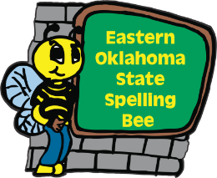

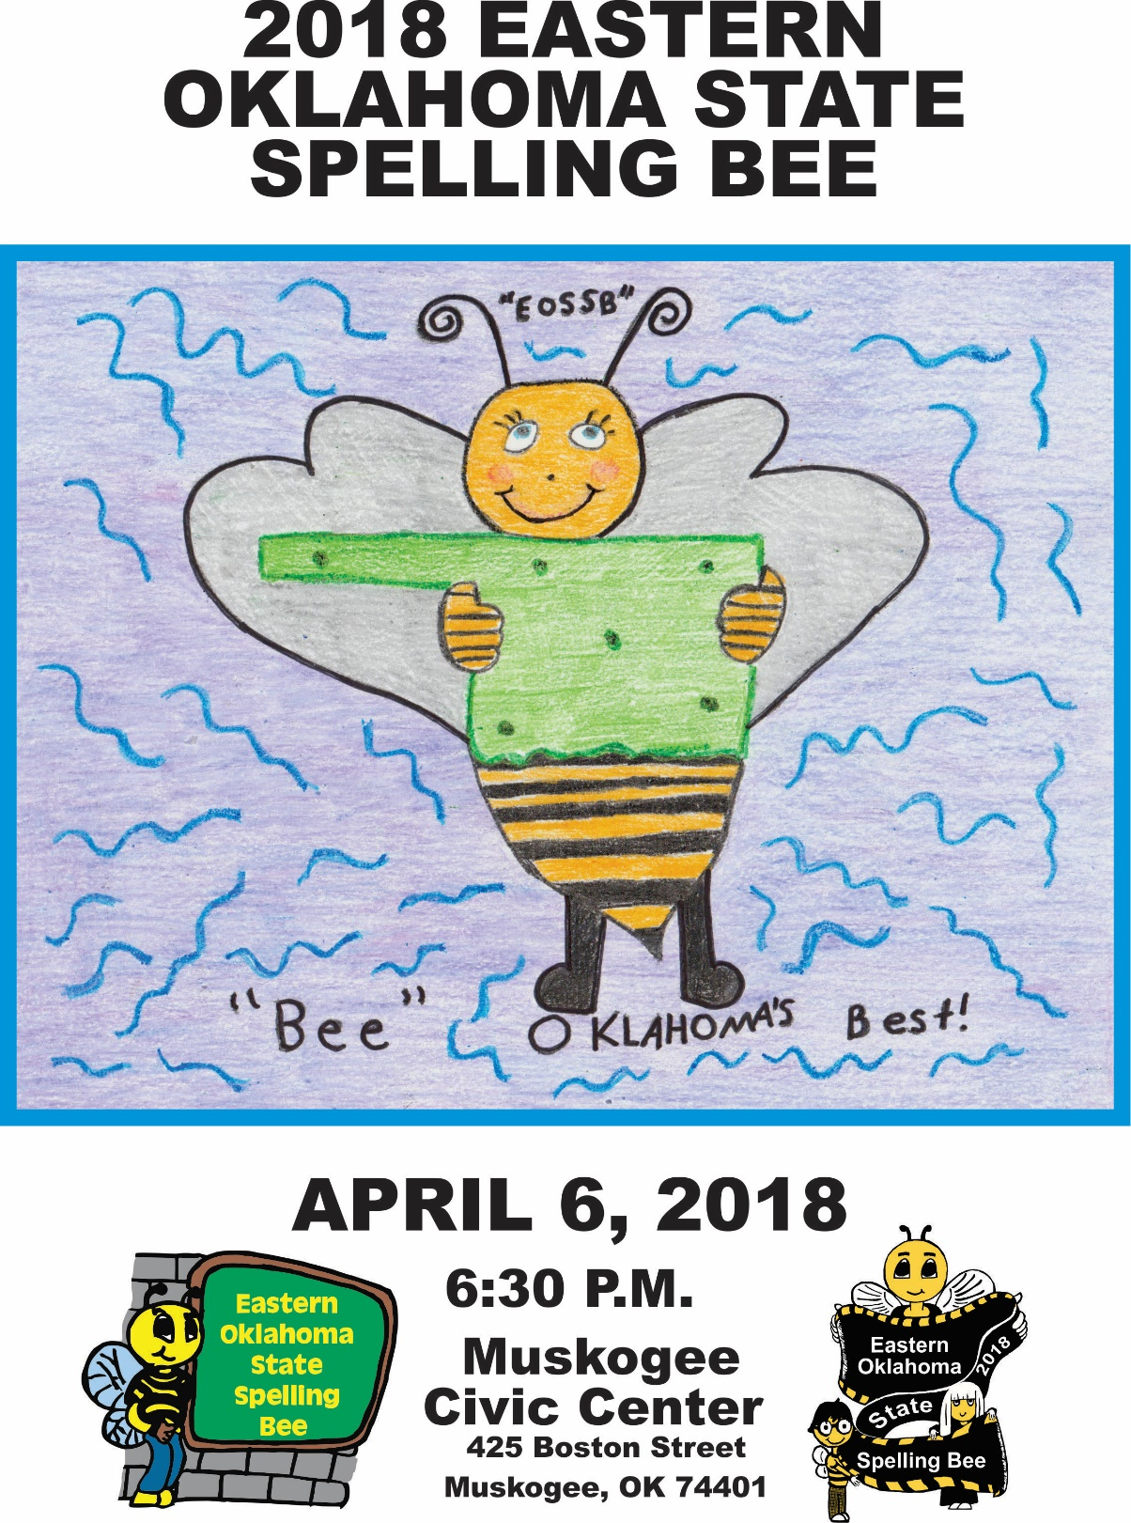

2018

EASTERN OKLAHOMA STATE SPELLING BEE

Welcome to the 9th annual Eastern Oklahoma State Spelling Bee
The purpose of this competition is to help students improve their spelling, increase their vocabularies, learn concepts and develop correct English usage that will help them all their lives.

Eastern Oklahoma State Spelling Bee Procedure
This is an oral competition conducted in rounds until only one speller remains. Each speller has been assigned a random number. There is no advantage associated with a particular high or low number.

The speller approaches the microphone when it is his or her turn to spell. A speller who correctly spells his or her word remains on stage and waits for the next round.

One of the judges will ring a bell after a speller completes the misspelling of a word. The speller is asked to leave the stage and sit with family members. Once a speller has misspelled a word he or she should not leave the auditorium until the end of the round.

A speller may question the pronouncer about a word’s pronunciation, definition, part of speech, use in a sentence and origin. Once having started to spell a word, the speller may start over, but the letters or sequence of letters already spoken may not be changed.

Protest Procedure for Spelling Bees
Any question relating to the spelling of a word should be referred to the Spelling Bee Coordinator immediately in writing, on an official protest form. This should take place before the student affected would have received their next word had they stayed in the contest.

The judges are in complete control of the BEE.
Their decision shall be final of all questions and protests.

The Eastern Oklahoma State Spelling Bee
Gratefully Acknowledges These Generous Sponsors

Connors State College
Cook Construction – Fort Gibson
Cross Telephone Company
Cruis’n Angels
Dal-Tile, INC.
Da’Sawyers Eats & Sweets
David S. Wilson, M.D.
Economy Pharmacy
Elite Storage – Muskogee
Fairfield Inn & Suites - Muskogee
First Bank & Trust Co. – Wagoner
First National Bank & Trust of
Okmulgee – Henryetta - Wewoka
First Pryority Bank - Pryor
Firstar Bank
Fort Gibson State Bank
Georgia Pacific
Golden Corral – Muskogee
Gore Green Country Drug, Inc.
Griffin Food Company
Guy’s Snacks
Henderson’s Coffee Co.- Muskogee
Harrison Tire & Supply - Muskogee

3 Rivers Auto Collision - Muskogee
Aceco Party Store - Muskogee
Acme Engineering & Manufacturing Corp.
Action Imprints – Muskogee
Advanced Workzone Services – Muskogee
American Bank of Oklahoma
Armstrong Bank
Ashby St. Outdoor Advertising
AT&T Oklahoma
BancFirst – Muskogee
BancFirst - Tahlequah
Bank of Cherokee County
Bank of Eufaula
Bank of Oklahoma – Muskogee
Bare Bones Filmworks - Muskogee
Bebb’s Flowers – Muskogee
Bravado Wireless
Cagle’s Flowers & Gifts – Muskogee
Casey’s General Stores, Inc.
Charlie’s Chicken East - Muskogee
Cherokee Nation
City of Muskogee
Communication Federal Credit Union

Thank You Volunteers!
Pat Adams
Susie Armstrong
Debbie Buckmaster
Miriam Goodin
Andy Killingsworth
Matt Mocha
Sue McBride
Joanna Riley
Patti Sallee
Charlie Thompson
Gary Thomson
Tiffany Wiedel

Special Thanks!
Bill Goodwin
Tom Carment
Lillian Jayne
Gordon Wallace
Best Buy – Muskogee
Frito Lay – Tulsa
Guy’s Snacks
My Place Bar-B-Q East - Muskogee
No Man’s Land Beef Jerky
QuikTrip Corporation
State Representative Avery Frix
U.S. Congressman MarkWayne Mullin

“THANK YOU”
EASTERN OKLAHOMA STATE SPELLING BEE JUDGES

Aanje Wilkerson, Judge
VA Regional Office
Veterans Claim Examiner
Muskogee

Music
Richelle Zampella
Saxophonist
3 time EOSSB Champion
Oklahoma School for the Blind -Muskogee

EOSSB Host Hotel
Fairfield Inn & Suites - Muskogee

Robin Adair, Pronouncer
Muskogee County District Judge

Missy Chandler, Head Judge
Accountant, Loftis Furniture
Muskogee

Angie Brewer, Judge
Human Resources Generalist
Kirby-Smith Machinery, Inc.
Oklahoma City, OK

Matt White, Judge
General Manager
Yaffe Iron &
Metal Co., Inc. - Muskogee

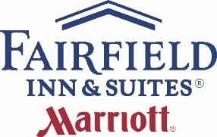

Eastern Oklahoma State Spelling Bee

School Representatives
2018

Cave Springs Schools
Kaylee Walker Newman #170
Kya Poafpybitty #79

Central Public Schools
Cadence Hall #101
Cameron Holmes #61

Checotah Intermediate School
Ariana Vogt #55
Emma Steinman #115

Checotah Middle School
Alazander Ball #16
Isabelle Fowler #176

Crowder Schools
Logan Owens #75
Zane Whitfield #146

Donald P. Sloat Junior High
Kyle Newell #105
Macey Brooks #96

Dunbar School
Brogan Parker #109
Nevaeh Sitton #139

Eufaula Elementary School
Jadence Efurd #196
Johna Bumgarner #42

Eufaula Middle School
Joseph Reiter #95
Christian Stevenson #78
Afton Elementary School
Kenzi Price #138
Xander Westfall #41

Afton Middle School
Jeana Paul #100
Harmony Westfall #158

Allen Bowden School
Khai Johnson-Lopez #63
Dylan Swartz #52

Bearden Elementary School
Nikki Deere #2
Jacob Morphis #110

Braggs Public School
Austin Giveus #83
Destiny Bechtolol #173

Briggs School
Anna Scott #163
Marley Jennings #65

Brushy Public Schools
Emily Gregory #187
Sierra Wooten #70

Buffalo Valley School
Jace Hunter #88
Elijah Fuller #194

Cameron Public Schools
Jazmin Fernandez #178
Journi Fox #91

Eastern Oklahoma State Spelling Bee

School Representatives
2018

School Representatives
2018

H Hartshorne Elementary
Bryona Polm #201
Jadalynn Zhugnina #56

Henryetta Elementary School
Kenleigh Kaler #67
Baylor Thompson #111

Henryetta Middle School
Bradley Dodson #43
Ethan Palmer #184

Hilldale Middle School
Gavin Williams #22
Kiarra Guerrero #114

Hilldale Upper Elementary
Mattie Pittman #82
Ever Ellis #8

Hodgen Elementary
Brody Cheshier #68
Sadie Thornhill #49

Hulbert Elementary
Max Purget #21
Kaylee Carey #35

Hulbert Junior High
Jaylyn Tannehill #195
Victorya Poorman #80

Inola Middle School
Gavin Parrish #144
Tyler Gleason #118
Fairland Elementary
Jaxon Bowers #168
Dylan Holum #7

Fairland Middle School
Mollie Maxon #90
Jonny Dingle #116

Fort Gibson Middle School
Logan Rhyne #182
Keri Combs #137

Glenn C. Moore Elementary School
Thadious Downing #6
Brayden Stewart #12

Gore Elementary School
Kennedy Williams #11
Kendra Huckbay #72

Graham - Dustin School
Kylie Crouch #93
Ayana Gonzales #58

Grand View School
Trace Russell #89
Hazel McLane #162

Gypsy Public School
Claire Tucker #192
Bobby Gambill #113

Haileyville Public Schools
Olivia Hauff #117
Murphy Peterson #98

Thank You

Ron Alexander
CEO, Sound on the Move - Muskogee

Samantha Cain
Competition Video Monitor

Bob Coburn
Mayor, City of Muskogee

Kimberly Fulton & Cole Hutson
Red Carpet Emcees
Oktaha High School

Clayton Fulton
Assistant to Director

Christopher James
Lisa McManus
Muskogee County Bee Keepers

Amy Lynn
Johnny Cooper
Muskogee Civic Center

Lane Masterson
Webmaster

Cliff Moore & Tom Twine
Dale & Pam Wenhamer
Three Rivers Photography Club

Pastor Dr. Stephen L. Wiley
Praise Center Family Church – Muskogee
Asst. Professor of Religion – Bacone College

Rohan Rajeev
2018 EOSSB Grand Marshal
2017 Scripps National Spelling Bee-Runner Up

Oscar Ray
CEO, Bare Bones Filmworks - Muskogee

Eastern Oklahoma State Spelling Bee

Hosts & Hostesses

Lane Masterson
Caitlyn Mocha
Jonita Mullins
Alexis Nelson
Cheryl Sanders
Pat Stout
Kay Turner
Chelsea Valdez
Gordon Wallace
Judy Lyn Whittington
Bethany Williams
Pam Williams

Susan Hoog, Director
Alice Adair
Sue Bishop
Amy Brady
Deborah Carment
Tom Carment
Carly Forrest
David Gill
Geri Gill
Denise Killingsworth
Donna Le
Cindy Lumpkin
Jan Mayfield

Connors State College PLC Group
and Phi Theta Kappa

Muskogee Federal Credit Union

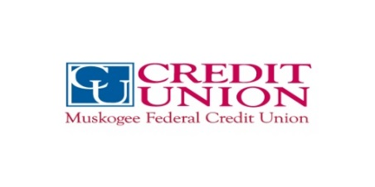

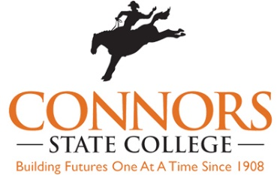

NSU President Leadership Class

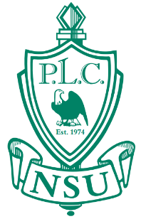


Jefferson Elementary
Liv Sharp #99
Zac Cross #147

Kansas Elementary School
Logan Vaughan #166
Alex Dugan #47

Kansas Middle School
Tommy Lee #104
Maddy Pruitt #154

Kansas Public Schools
Kaleb Jobe #44
Ethan Brown #31

Kellyville Upper Elementary
Abigayle Rains #62
Lily Rengger #37

Keota Public Schools
Jared Hickman #40
Carrick Meglemre #141

Kinta Public School
Ryder Edwards #14
Tristan Garvin #149

Krebs Public Schools
Brooklynn Allsup #50
Caden Martin #20
Leach Public School
Drake Allen #200
Lorelei Horney #18

Liberty School
Leah Johnson #86
Emilio Jack #9

Lincoln Elementary
Carver Raymond #186
Faith Buford #202

Maryetta Schools
Haven Eaton #53
Andraya Ford #74

Midway Elementary
Madalyn Mitcham #76
Anochee Griffin #1

Midway Public Schools
Veraniqua Howard #165
Jordyn Hollis #123

Mission Intermediate Grade Center
Jolie Heald #175
Leah Meyer #119

Moffett Public School
Isabell Swafford #199
Trenton Matthews #135

Eastern Oklahoma State Spelling Bee

School Representatives
2018

Eastern Oklahoma State Spelling Bee

School Representatives
2018

Eastern Oklahoma State Spelling Bee

School Representatives
2018

Monroe Public School
Jailee Romines #15
Jorge Martinez #126

Mounds Public Schools
Joseph Pennington #127
Ayden Archer #107

Norwood Public School
Archie Vance #160
Raegan Frazier #125

Okay Public School
Maddi Williams #190
Alex Collins #132

Oklahoma School For the Blind
Katelynn Zampella #185
Kolten Pennington #38

Okmulgee Primary School
Micheal Reed #145
Jace Hagy #120

Oktaha Public School
Allison Phillips #145
Preston Homes #120

Olive Elementary School
Gus Harding #198
Rachel Varnell #159

Paden Public School
Shaylin Brewer #180
Victoria Clanton #71

Pansy Kidd Middle School
Shelby Zink #131
Jessica Billings #172

Peavine Elementary
Pachia Nye #124
Abby Abernathy #112

Peggs Public School
Talyn Smith #4
Micheal Fitts #28

Pocola Elementary School
Rylan Waddell #129
Alli Lomon #81

Porter Consolidated Elementary School
Neil Guinn #66
Billy Dickey #103

Porter Consolidated Middle School
Drew Taylor #183
Ravein Milne #73

Porum School
Ally Bush #69
Ivy Rose Goad #189

Poteau Upper Elementary
Hudson Burdick #45
Pierce Ballard #97

Preston School
Chaz Lujan #151
Kierra Deville #197

G Thank You
old Sp Thank You

Gold Sponsors

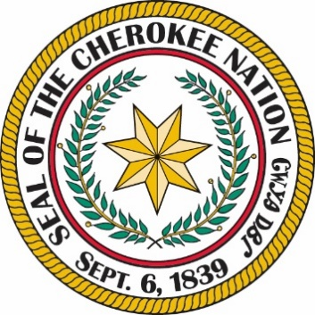




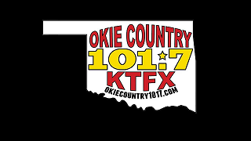

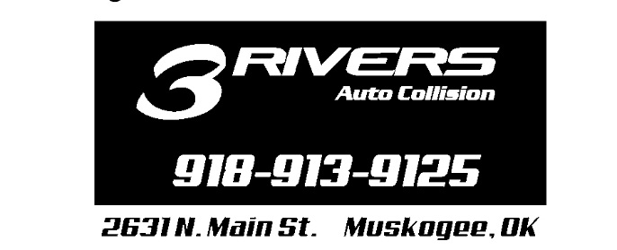

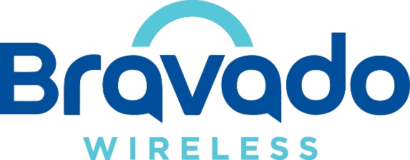



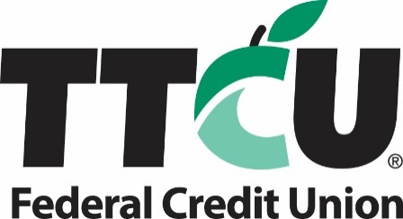

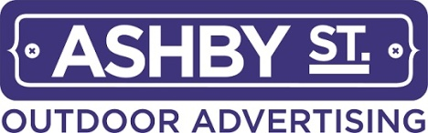



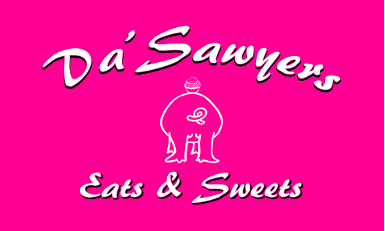

Presenting Sponsor

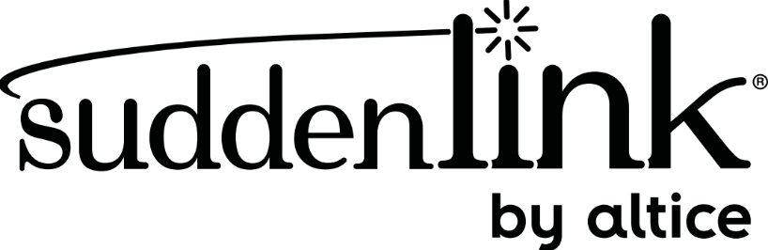

Platinum Sponsors

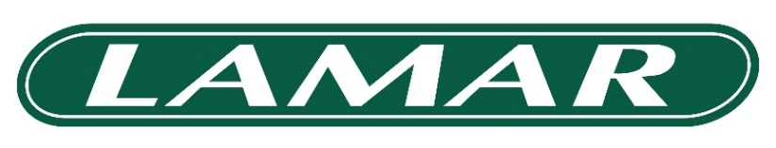

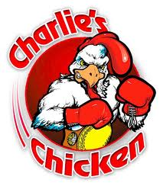

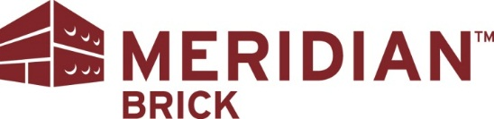




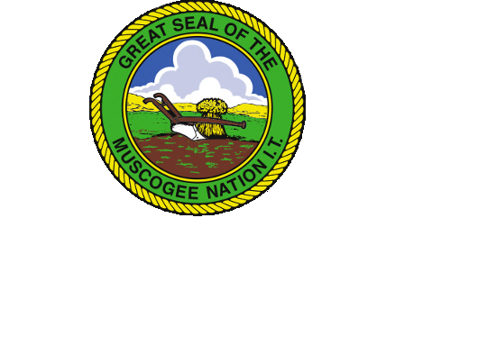
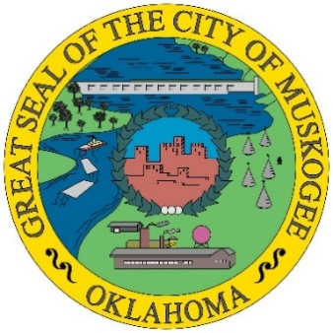

Eastern Oklahoma State Spelling Bee

School Representatives
2018

Quinton Elementary
Mabrey Cook #150
Makynlee Shelton #29

Red Oak Public Schools
Reed Kauk #51
Nolan Muncy #36

Roosevelt Elementary School
Sophie Schmidt #77
Ty Dale #179

Salina Elementary School
Kylee Martin #10
Jaela Littledave #17

Salina Middle School
Ty Moore #134
Skyler Owens #59

Salina Public School
Maliyah Moore #19
Caitlyn White #92

Savanna Public School
Ryan Autcubo #64
Ryan Wolf #156

Schulter Public School
Logan Moore #156
Matthew Barton #121

Sequoyah Middle School
Trinity Chaney #106
Zayne Clappe #94

Shady Point Schools
Jenson Rogers #60
Psalm Yandell #102

Shiloh Christian School
Robby Batson #142
Dalton Crumby #128

Spiro Middle School
Blake Dedmon #152
Ashlyn Perry #188

Spiro Upper Elementary
Sophie Dees #84
John Imbush #177

Stidham School
Emily Ford #48
Kylie Diaz #23

Stigler Grade School
Keira Parks #39
Jace Bibee #3

St. Joseph Catholic School
Ben Garcia #85
Mary O’Callaghan #5

Stilwell Elementary School
Camry Hardbarger #164
Javan Sanders #26

Stonebridge Academy
Kinlee Williams #108
Nellie Robinson #87

Eastern Oklahoma State Spelling Bee

School Representatives
2018
2018
Eastern Oklahoma State Spelling Bee
School Representatives
2018

Tahlequah Middle School
Brooke Postlewait #133
Katie Moore #181

Vian Middle School
Cason Wright #174
Elijah Stewart #157

Wagoner Middle School
Alana Baxter #167
Austin Gaither #33

Wainwright Public School
Gracie Bolding #13
Adriana Tate #122

Warner Elementary
Marissa Stidham #148
Alisyn Miller #143

Warner High School
Adam Thompson #161
Cooper Lange #27

Webbers Falls Public School
Kaylee Mullins #193
Brendon Goodman #171

Weleetka Public School
Alayna Polson #155
Aiden Matthews #25

Westville Elementary School
Audrey Bailey #57
Haylee Hill #169

Wilburton Elementary School
Rylie Studeman #169

Will Rogers Middle School
Mercedes Million #140
Kaden Whited #203

Wilson Elementary School
Madison Harjo #32
Patience Williams #130

Wister Public Schools
Zoe Moreno #25
Brysta Shatswell #46

Woodall Public Schools
Kenzie Snell #54
Jalynn Warren #34

Cassandra Gaines Art Winners

1st Place – Nicki Deere
Bearden School, Okemah, OK

2nd Place – Destiny Jennings
Stidham Public School

3rd Place – Nicole Rhodes
Keota Public Schools

4th Place – Lila Gragg
Quinton Elementary

2018 Eastern Oklahoma State

Spelling Bee Prizes!
For the Champion:
The champion will receive a $1,000.00 check for his or her school from the Eastern Oklahoma State Spelling Bee nonprofit organization. The Champion will receive for himself or herself the EOSSB championship trophy, a $500.00 cash prize, and two club seating tickets for an Oklahoma City Thunder basketball game.
For Second Place:
The runner-up will receive a $500.00 check for his or her school from the Eastern Oklahoma State Spelling Bee nonprofit organization. The second-place winner will receive for himself or herself the EOSSB second place trophy, and a $250.00 cash prize.
For Third Place:
The third-place student will receive a $250.00 check for his or her school from the Eastern Oklahoma State Spelling Bee nonprofit organization. The third-place winner will receive for himself or herself the EOSSB third place trophy, and a $100.00 cash prize.
For All Spellers:
Each contestant will receive a 2018 commemorative t-shirt and an engraved medal.

Please note that during the first intermission the EOSSB will be giving away tablets, watches, gift baskets, and other prizes. A random student number will be drawn to determine a winner. All students are encouraged to stay in the arena until the drawing has taken place.

Eastern Oklahoma State Spelling Bee Prizes!
