**OG&E**

**Rib Crib - Muskogee**

**OG&E**

**Okie Country 101.7, KTFX-FM**

**QuikTrip Corporation - Tulsa**

**O Rib Crib - Muskogee**

**Roofs by Riggs - Muskogee**

**Sooner Surplus Sales – Muskogee**

**Sound on the Move - Muskogee**

**The Castle – Muskogee**

**The Community State Bank – Poteau**

**The Generator Guy - Tulsa**

**Three Rivers Photography Club**

**Trish’s Stitches – Quinton**

**TTCU - FEDERAL CREDIT UNION - Miami**

**TTCU – FEDERAL CREDIT UNION - Muskogee**

**Union Pacific Railroad**

**Walmart – Checotah**

**Walmart - Muskogee**

**Walmart - Tahlequah**

**Yaffe Iron & Metal CO., INC.**

**The Eastern Oklahoma State Spelling Bee**

**Gratefully Acknowledges These Generous Sponsors**

**Holloway’s Blueprint & Copy Shop**

**Homeland Employee Owned – Muskogee**

**House of Webster – Springdale, AR**

**H&R Block – Muskogee**

**Indian Capital Technology Center**

**I’m A Basket Case - Muskogee**

**Jeannie Glover, Agent State Farm – Tulsa**

**Lake Region Electric Cooperative - Hulbert**

**Lakeland Florist – Muskogee**

**Lamar Advertising Company – Tulsa**

**Lillian Jayne Real Estate - Muskogee**

**Love Bottling Company – Muskogee**

**MC Baldwin Inc. – Matt and Mary Baldwin**

**Meridian Brick – Muskogee**

**Muscogee (Creek) Nation**

**Muskogee Art Guild**

**Muskogee Beacon**

**Muskogee Civic Center**

**Muskogee Federal Credit Union**

**No Man’s Land Beef Jerky - Enid**

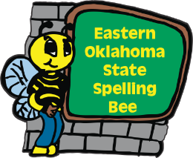

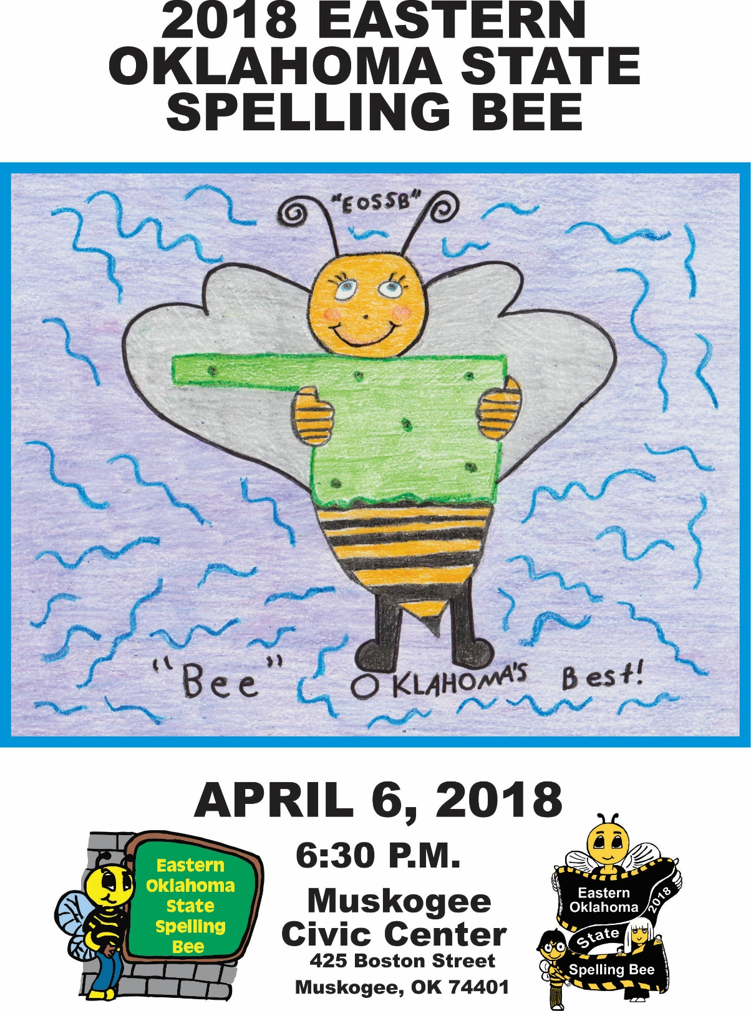

**2018**

**EASTERN OKLAHOMA STATE SPELLING BEE**

**Welcome to the 9th annual Eastern Oklahoma State Spelling Bee**

The purpose of this competition is to help students improve their spelling, increase their vocabularies, learn concepts and develop correct English usage that will help them all their lives.

**Eastern Oklahoma State Spelling Bee Procedure**

This is an oral competition conducted in rounds until only one speller remains. Each speller has been assigned a random number. There is no advantage associated with a particular high or low number.

The speller approaches the microphone when it is his or her turn to spell. A speller who correctly spells his or her word remains on stage and waits for the next round.

One of the judges will ring a bell after a speller completes the misspelling of a word. The speller is asked to leave the stage and sit with family members. Once a speller has misspelled a word he or she should not leave the auditorium until the end of the round.

A speller may question the pronouncer about a word’s pronunciation, definition, part of speech, use in a sentence and origin. Once having started to spell a word, the speller may start over, but the letters or sequence of letters already spoken may not be changed.

**Protest Procedure for Spelling Bees**

Any question relating to the spelling of a word should be referred to the Spelling Bee Coordinator immediately in writing, on an official protest form. This should take place before the student affected would have received their next word had they stayed in the contest.

**The judges are in complete control of the BEE.**

**Their decision shall be final of all questions and protests.**

**The Eastern Oklahoma State Spelling Bee**

**Gratefully Acknowledges These Generous Sponsors**

**Connors State College**

**Cook Construction – Fort Gibson**

**Cross Telephone Company**

**Cruis’n Angels**

**Dal-Tile, INC.**

**Da’Sawyers Eats & Sweets**

**David S. Wilson, M.D.**

**Economy Pharmacy**

**Elite Storage – Muskogee**

**Fairfield Inn & Suites - Muskogee**

**First Bank & Trust Co. – Wagoner**

**First National Bank & Trust of**

**Okmulgee – Henryetta - Wewoka**

**First Pryority Bank - Pryor**

**Firstar Bank**

**Fort Gibson State Bank**

**Georgia Pacific**

**Golden Corral – Muskogee**

**Gore Green Country Drug, Inc.**

**Griffin Food Company**

**Guy’s Snacks**

**Henderson’s Coffee Co.- Muskogee**

**Harrison Tire & Supply - Muskogee**

**3 Rivers Auto Collision - Muskogee**

**Aceco Party Store - Muskogee**

**Acme Engineering & Manufacturing Corp.**

**Action Imprints – Muskogee**

**Advanced Workzone Services – Muskogee**

**American Bank of Oklahoma**

**Armstrong Bank**

**Ashby St. Outdoor Advertising**

**AT&T Oklahoma**

**BancFirst – Muskogee**

**BancFirst - Tahlequah**

**Bank of Cherokee County**

**Bank of Eufaula**

**Bank of Oklahoma – Muskogee**

**Bare Bones Filmworks - Muskogee**

**Bebb’s Flowers – Muskogee**

**Bravado Wireless**

**Cagle’s Flowers & Gifts – Muskogee**

**Casey’s General Stores, Inc.**

**Charlie’s Chicken East - Muskogee**

**Cherokee Nation**

**City of Muskogee**

**Communication Federal Credit Union**

**Thank You Volunteers!**

**Pat Adams**

**Susie Armstrong**

**Debbie Buckmaster**

**Miriam Goodin**

**Andy Killingsworth**

**Matt Mocha**

**Sue McBride**

**Joanna Riley**

**Patti Sallee**

**Charlie Thompson**

**Gary Thomson**

**Tiffany Wiedel**

**Special Thanks!**

**Bill Goodwin**

**Tom Carment**

**Lillian Jayne**

**Gordon Wallace**

**Best Buy – Muskogee**

**Frito Lay – Tulsa**

**Guy’s Snacks**

**My Place Bar-B-Q East - Muskogee**

**No Man’s Land Beef Jerky**

**QuikTrip Corporation**

**State Representative Avery Frix**

**U.S. Congressman MarkWayne Mullin**

***“THANK YOU”***

**EASTERN OKLAHOMA STATE SPELLING BEE JUDGES**

**Aanje Wilkerson, Judge**

VA Regional Office

Veterans Claim Examiner

Muskogee

**Music**

**Richelle Zampella**

Saxophonist

3 time EOSSB Champion

Oklahoma School for the Blind -Muskogee

**EOSSB Host Hotel**

**Fairfield Inn & Suites - Muskogee**

**Robin Adair, Pronouncer**

Muskogee County District Judge

**Missy Chandler, Head Judge**

Accountant, Loftis Furniture

Muskogee

**Angie Brewer, Judge**

Human Resources Generalist

Kirby-Smith Machinery, Inc.

Oklahoma City, OK

**Matt White, Judge**

General Manager

Yaffe Iron &

Metal Co., Inc. - Muskogee

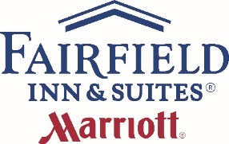

## Eastern Oklahoma State Spelling Bee

## School Representatives

**2018**

**Cave Springs Schools**

**Kaylee Walker Newman #170**

**Kya Poafpybitty #79**

**Central Public Schools**

**Cadence Hall #101**

**Cameron Holmes #61**

**Checotah Intermediate School**

**Ariana Vogt #55**

**Emma Steinman #115**

**Checotah Middle School**

**Alazander Ball #16**

**Isabelle Fowler #176**

**Crowder Schools**

**Logan Owens #75**

**Zane Whitfield #146**

Donald P. Sloat Junior High

**Kyle Newell #105**

**Macey Brooks #96**

**Dunbar School**

**Brogan Parker #109**

**Nevaeh Sitton #139**

**Eufaula Elementary School**

**Jadence Efurd #196**

**Johna Bumgarner #42**

**Eufaula Middle School**

**Joseph Reiter #95**

**Christian Stevenson #78**

Afton Elementary School

**Kenzi Price #138**

Xander Westfall #41

Afton Middle School

Jeana Paul #100

Harmony Westfall #158

Allen Bowden School

Khai Johnson-Lopez #63

Dylan Swartz #52

**Bearden Elementary School**

Nikki Deere #2

Jacob Morphis #110

**Braggs Public School**

**Austin Giveus #83**

**Destiny Bechtolol #173**

**Briggs School**

**Anna Scott #163**

**Marley Jennings #65**

**Brushy Public Schools**

**Emily Gregory #187**

**Sierra Wooten #70**

**Buffalo Valley School**

**Jace Hunter #88**

**Elijah Fuller #194**

**Cameron Public Schools**

**Jazmin Fernandez #178**

**Journi Fox #91**

## Eastern Oklahoma State Spelling Bee

## School Representatives

**2018**

## School Representatives

**2018**

H Hartshorne Elementary

Bryona Polm #201

Jadalynn Zhugnina #56

**Henryetta Elementary School**

**Kenleigh Kaler #67**

**Baylor Thompson #111**

**Henryetta Middle School**

**Bradley Dodson #43**

**Ethan Palmer #184**

**Hilldale Middle School**

**Gavin Williams #22**

**Kiarra Guerrero #114**

**Hilldale Upper Elementary**

**Mattie Pittman #82**

**Ever Ellis #8**

**Hodgen Elementary**

**Brody Cheshier #68**

**Sadie Thornhill #49**

**Hulbert Elementary**

**Max Purget #21**

**Kaylee Carey #35**

**Hulbert Junior High**

**Jaylyn Tannehill #195**

**Victorya Poorman #80**

**Inola Middle School**

**Gavin Parrish #144**

**Tyler Gleason #118**

**Fairland Elementary**

**Jaxon Bowers #168**

Dylan Holum #7

Fairland Middle School

**Mollie Maxon #90**

**Jonny Dingle #116**

Fort Gibson Middle School

Logan Rhyne #182

Keri Combs #137

Glenn C. Moore Elementary School

Thadious Downing #6

Brayden Stewart #12

Gore Elementary School

Kennedy Williams #11

Kendra Huckbay #72

Graham - Dustin School

Kylie Crouch #93

Ayana Gonzales #58

Grand View School

Trace Russell #89

Hazel McLane #162

Gypsy Public School

Claire Tucker #192

Bobby Gambill #113

Haileyville Public Schools

Olivia Hauff #117

Murphy Peterson #98



**Thank You**

**Ron Alexander**

*CEO, Sound on the Move - Muskogee*

**Samantha Cain**

*Competition Video Monitor*

**Bob Coburn**

*Mayor, City of Muskogee*

**Kimberly Fulton & Cole Hutson**

*Red Carpet Emcees*

*Oktaha High School*

**Clayton Fulton**

*Assistant to Director*

**Christopher James**

**Lisa McManus**

*Muskogee County Bee Keepers*

**Amy Lynn**

**Johnny Cooper**

*Muskogee Civic Center*

**Lane Masterson**

*Webmaster*

**Cliff Moore & Tom Twine**

**Dale & Pam Wenhamer**

*Three Rivers Photography Club*

**Pastor Dr. Stephen L. Wiley**

*Praise Center Family Church – Muskogee*

*Asst. Professor of Religion – Bacone College*

**Rohan Rajeev**

*2018 EOSSB Grand Marshal*

*2017 Scripps National Spelling Bee-Runner Up*

**Oscar Ray**

*CEO, Bare Bones Filmworks - Muskogee*

## Eastern Oklahoma State Spelling Bee

## Hosts & Hostesses

Lane Masterson

Caitlyn Mocha

Jonita Mullins

Alexis Nelson

Cheryl Sanders

Pat Stout

Kay Turner

Chelsea Valdez

Gordon Wallace

Judy Lyn Whittington

Bethany Williams

Pam Williams

Susan Hoog, Director

Alice Adair

Sue Bishop

Amy Brady

Deborah Carment

Tom Carment

Carly Forrest

David Gill

Geri Gill

Denise Killingsworth

Donna Le

Cindy Lumpkin

Jan Mayfield

**Connors State College PLC Group**

**and Phi Theta Kappa**

**Muskogee Federal Credit Union**

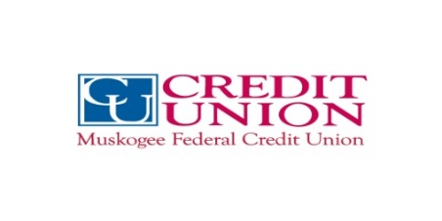

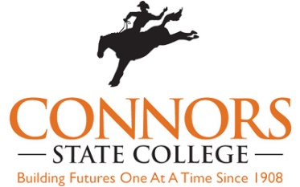

**NSU President Leadership Class**





**Jefferson Elementary**

Liv Sharp #99

Zac Cross #147

**Kansas Elementary School**

**Logan Vaughan #166**

**Alex Dugan #47**

**Kansas Middle School**

**Tommy Lee #104**

**Maddy Pruitt #154**

**Kansas Public Schools**

**Kaleb Jobe #44**

**Ethan Brown #31**

**Kellyville Upper Elementary**

**Abigayle Rains #62**

**Lily Rengger #37**

**Keota Public Schools**

**Jared Hickman #40**

**Carrick Meglemre #141**

**Kinta Public School**

**Ryder Edwards #14**

**Tristan Garvin #149**

**Krebs Public Schools**

**Brooklynn Allsup #50**

**Caden Martin #20**

**Leach Public School**

**Drake Allen #200**

**Lorelei Horney #18**

**Liberty School**

**Leah Johnson #86**

**Emilio Jack #9**

**Lincoln Elementary**

**Carver Raymond #186**

**Faith Buford #202**

**Maryetta Schools**

**Haven Eaton #53**

**Andraya Ford #74**

**Midway Elementary**

**Madalyn Mitcham #76**

**Anochee Griffin #1**

**Midway Public Schools**

**Veraniqua Howard #165**

**Jordyn Hollis #123**

**Mission Intermediate Grade Center**

**Jolie Heald #175**

**Leah Meyer #119**

**Moffett Public School**

**Isabell Swafford #199**

**Trenton Matthews #135**

## Eastern Oklahoma State Spelling Bee

## School Representatives

**2018**

## Eastern Oklahoma State Spelling Bee

## School Representatives

**2018**

## Eastern Oklahoma State Spelling Bee

## School Representatives

**2018**

**Monroe Public School**

**Jailee Romines #15**

**Jorge Martinez #126**

**Mounds Public Schools**

**Joseph Pennington #127**

**Ayden Archer #107**

**Norwood Public School**

**Archie Vance #160**

**Raegan Frazier #125**

**Okay Public School**

**Maddi Williams #190**

**Alex Collins #132**

**Oklahoma School For the Blind**

**Katelynn Zampella #185**

**Kolten Pennington #38**

**Okmulgee Primary School**

**Micheal Reed #145**

**Jace Hagy #120**

**Oktaha Public School**

**Allison Phillips #145**

**Preston Homes #120**

**Olive Elementary School**

**Gus Harding #198**

**Rachel Varnell #159**

**Paden Public School**

**Shaylin Brewer #180**

**Victoria Clanton #71**

**Pansy Kidd Middle School**

**Shelby Zink #131**

**Jessica Billings #172**

**Peavine Elementary**

**Pachia Nye #124**

**Abby Abernathy #112**

**Peggs Public School**

**Talyn Smith #4**

**Micheal Fitts #28**

**Pocola Elementary School**

**Rylan Waddell #129**

**Alli Lomon #81**

**Porter Consolidated Elementary School**

**Neil Guinn #66**

**Billy Dickey #103**

**Porter Consolidated Middle School**

**Drew Taylor #183**

**Ravein Milne #73**

**Porum School**

**Ally Bush #69**

**Ivy Rose Goad #189**

**Poteau Upper Elementary**

**Hudson Burdick #45**

**Pierce Ballard #97**

**Preston School**

**Chaz Lujan #151**

**Kierra Deville #197**

G **Thank You**

old Sp **Thank You**

**Gold Sponsors**

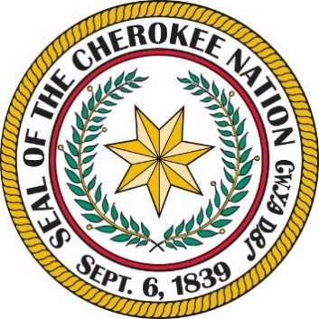



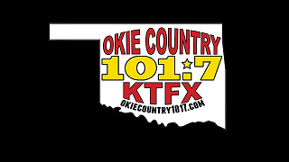

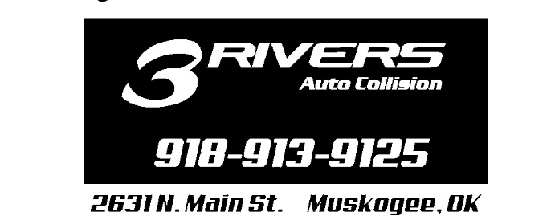





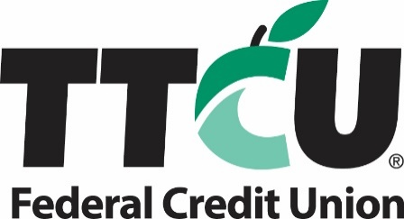

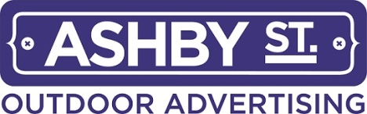





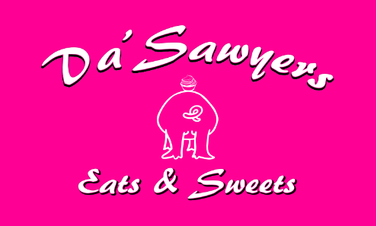

## Presenting Sponsor

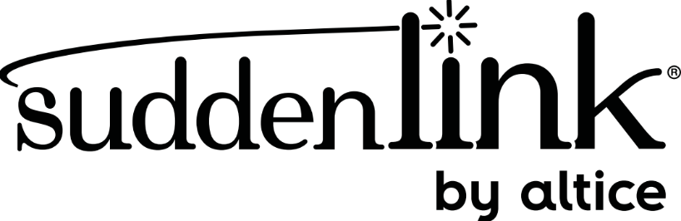

## Platinum Sponsors

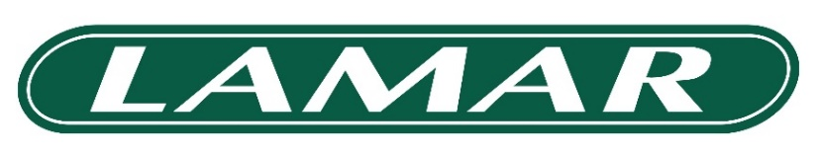

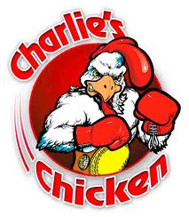









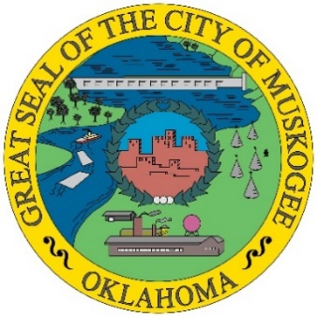

## Eastern Oklahoma State Spelling Bee

## School Representatives

**2018**

**Quinton Elementary**

**Mabrey Cook #150**

**Makynlee Shelton #29**

**Red Oak Public Schools**

**Reed Kauk #51**

**Nolan Muncy #36**

**Roosevelt Elementary School**

**Sophie Schmidt #77**

**Ty Dale #179**

**Salina Elementary School**

**Kylee Martin #10**

**Jaela Littledave #17**

**Salina Middle School**

**Ty Moore #134**

**Skyler Owens #59**

**Salina Public School**

**Maliyah Moore #19**

**Caitlyn White #92**

**Savanna Public School**

**Ryan Autcubo #64**

**Ryan Wolf #156**

**Schulter Public School**

**Logan Moore #156**

**Matthew Barton #121**

**Sequoyah Middle School**

**Trinity Chaney #106**

**Zayne Clappe #94**

**Shady Point Schools**

**Jenson Rogers #60**

**Psalm Yandell #102**

**Shiloh Christian School**

**Robby Batson #142**

**Dalton Crumby #128**

**Spiro Middle School**

**Blake Dedmon #152**

**Ashlyn Perry #188**

**Spiro Upper Elementary**

**Sophie Dees #84**

**John Imbush #177**

**Stidham School**

**Emily Ford #48**

**Kylie Diaz #23**

**Stigler Grade School**

**Keira Parks #39**

**Jace Bibee #3**

**St. Joseph Catholic School**

**Ben Garcia #85**

**Mary O’Callaghan #5**

**Stilwell Elementary School**

**Camry Hardbarger #164**

**Javan Sanders #26**

**Stonebridge Academy**

**Kinlee Williams #108**

**Nellie Robinson #87**

## Eastern Oklahoma State Spelling Bee

## School Representatives

**2018**

**2018**

**Eastern Oklahoma State Spelling Bee**

**School Representatives**

**2018**

**Tahlequah Middle School**

**Brooke Postlewait #133**

**Katie Moore #181**

**Vian Middle School**

**Cason Wright #174**

**Elijah Stewart #157**

**Wagoner Middle School**

**Alana Baxter #167**

**Austin Gaither #33**

**Wainwright Public School**

**Gracie Bolding #13**

**Adriana Tate #122**

**Warner Elementary**

**Marissa Stidham #148**

**Alisyn Miller #143**

**Warner High School**

**Adam Thompson #161**

**Cooper Lange #27**

**Webbers Falls Public School**

**Kaylee Mullins #193**

**Brendon Goodman #171**

**Weleetka Public School**

**Alayna Polson #155**

**Aiden Matthews #25**

**Westville Elementary School**

**Audrey Bailey #57**

**Haylee Hill #169**

**Wilburton Elementary School**

**Rylie Studeman #169**

**Will Rogers Middle School**

**Mercedes Million #140**

**Kaden Whited #203**

**Wilson Elementary School**

**Madison Harjo #32**

**Patience Williams #130**

**Wister Public Schools**

**Zoe Moreno #25**

**Brysta Shatswell #46**

**Woodall Public Schools**

**Kenzie Snell #54**

**Jalynn Warren #34**

**Cassandra Gaines Art Winners**

***1st Place – Nicki Deere***

**Bearden School, Okemah, OK**

***2nd Place – Destiny Jennings***

**Stidham Public School**

***3rd Place – Nicole Rhodes***

**Keota Public Schools**

***4th Place – Lila Gragg***

**Quinton Elementary**

## 2018 Eastern Oklahoma State

## Spelling Bee Prizes!

## 

**For the Champion:**

The champion will receive a $1,000.00 check for his or her school from the Eastern Oklahoma State Spelling Bee nonprofit organization. The Champion will receive for himself or herself the EOSSB championship trophy, a $500.00 cash prize, and two club seating tickets for an Oklahoma City Thunder basketball game.

**For Second Place:**

The runner-up will receive a $500.00 check for his or her school from the Eastern Oklahoma State Spelling Bee nonprofit organization. The second-place winner will receive for himself or herself the EOSSB second place trophy, and a $250.00 cash prize.

**For Third Place:**

The third-place student will receive a $250.00 check for his or her school from the Eastern Oklahoma State Spelling Bee nonprofit organization. The third-place winner will receive for himself or herself the EOSSB third place trophy, and a $100.00 cash prize.

**For All Spellers:**

Each contestant will receive a 2018 commemorative t-shirt and an engraved medal.

**Please note that during the first intermission the EOSSB will be giving away tablets, watches, gift baskets, and other prizes. A random student number will be drawn to determine a winner. All students are encouraged to stay in the arena until the drawing has taken place.**

**Eastern Oklahoma State Spelling Bee Prizes!**

