**2019 Indiana NSA**

**Hall of Fame-Board of Directors**

**  **

**Mike Hagy Jim Kimmel Zina Birnell**

**President Vice-President Secretary**

 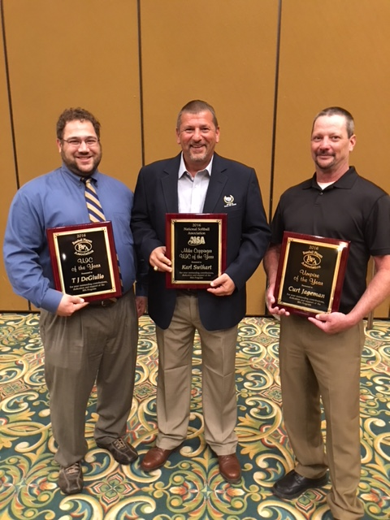 

**Shailen Johnson Karl Swihart Robert Cooper**

**Member Member Member**

** **

**Jack Carter Mike Della Rocco**

**Member Member**