

2015

Liberation Petanque Club

Singles Cup

Just 16 players took part in this year’s competition which was a dramatic drop from previous years, not helped by the rearranged date due to the Island Games. Playing 4 rounds under the Swiss system as with all Liberations competitions.

Round 1 saw Ross Payne lose to Nathan Wheller 13 – 6 in one of four shock results in round 1. Gary Cowburn beat Matt Buesnel 13 – 5, Brian Harris beat Keith Pinel 13 – 1 and Joey Le Clech beat Toby Northern 13 – 10.

Round 2 saw a little more normality as Toby beat Andrew Limbrick, Ross beat Lorna Limbrick. Andrew Bellamy-Burt beat Brian Harris 13 – 5 for two straight wins, but Nathan lost 13 – 12 to Geoffroy Buffetrille.

Round 3 was Callum’s worst match losing 13 – 1 to doubles team mate Andrew. David Siouville the 2014 champion beat Geoffroy 13 – 6 to keep his chances of retaining the trophy alive. Nathan lost his second successive match, this time 13 – 5 to Toby and Ross just won 13 – 12 against James Gennoe. Matt Buesnel continued to recover from his first round loss, beating Brian Harris 13 – 3.

The final round of the Swiss System saw Andrew beat David in a repeat of the 2012 final, this meant Andrew topped the rankings. Nathan Wheller beat Joey Le Clech 13 – 2, to take a top 8 spot. Toby beat Callum and Geoffroy beat Matt Buesnel and Ross beat Gary as the top eight finished as follows.

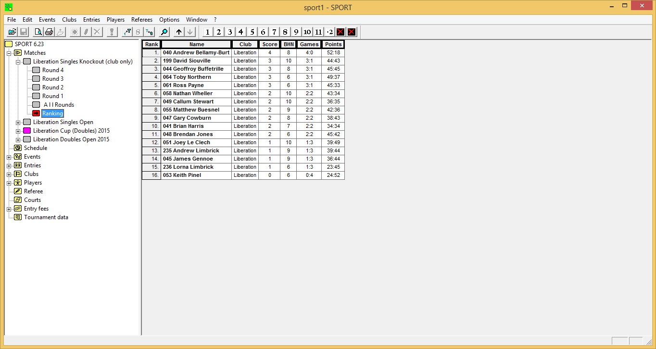

Champion

Ross Payne



Ranked 1st Andrew Bellamy-Burt v Ranked 8th Matthew Buesnel

Ranked 2nd David Siouville v Ranked 7th Callum Stewart

Ranked 3rd Geoffroy Buffetrille v Ranked 6th Nathan Wheller

Ranked 4th Toby Northern v Ranked 5th Ross Payne

The curse of the top ranked player struck again as despite conceding and average of less than 5 points per game in the first four rounds, Andrew lost to Matt, who ran out a comfortable winner. David Siouville beat Callum Stewart and it was one round too many for Nathan who lost to Geoffroy who is taking the club by storm since joining (must be the French blood).

Two club stalwarts in Ross and Toby were the last quarter final, with Ross holding off a fight back from Toby to win 13 – 10.

Ross played Matt and at 4 – 4 was a tight game before a carreaux gave Matt at 3 point lead, but that was it for Matt as Ross won 13 – 7.

David Siouville’s match with Geoffroy was a tight match, but David’s quest to retain his title ended, although he beat Matt for 3rd place and has now finished 1st, 2nd and 3rd in 4 years, not a bad record.

Ross was confident of a win now, and it showed in the final, as he showed more composure than his counterpart Geoffroy, especially in playing by street light, to win his first Club Singles Tournament.

Thank you to everyone who helped prepare for this competition and the running of it on the day which takes a great deal of time and effort. If you like to help out at future competitions please let me know.

Kind Regards,

Toby Northern

Chairman

Liberation Petanque Club

