Auto-Establish Nationwide Roll-Out Release 1.0
Auto-Establish is an automatic process taking traditional paper compensation claim(s) (VA Form 21-526EZ), received through the Intake Processing Center (IPC) via the Centralized Mail (CM) portal and converts the paper documents into an electronic packet.
Auto-Establish is intended to increase employee efficiency and improve claims processing timeliness, by allowing VA personnel to focus on more complex development activities.
As part of the conversion process, VA Form 21-526EZ is scanned and data fields are extracted to be used for automatic claims establishment. The enhanced Auto-Establish functionality will separate and perform data extraction on VA Form 21-526EZ, assign contentions, add special issues and flashes, and scan/upload VA Form 21-526EZ and all attached documentation to the VBMS eFolder.
Additional automatic actions taken include:
- Managing evidence in Veterans Benefits Management System/Modern Award Processing -Development (MAP-D) by citing documents in the same mail package as VA Form 21-526EZ
- Setting segmented lanes as special issues (first special issue for the first contention)

Auto-Establish will only establish disability compensation claims. Pension claims will be processed through the Centralized Mail Portal. For now, VA Form 21-526EZs containing pension information will be excluded.
Mail packages containing a Power of Attorney (POA) on VA Forms 21-22 and 21-22a will not be processed by Auto-Establish in Release 1.0. Auto-Establish will not establish any claims where VA Forms 21-22 or 21-22a are submitted with a VA Form 21-526EZ. These will be offramped and the IPC staff will process these packages as they normally would within the CM Portal and VBMS. Future Auto-Establish releases will include functionality to process VA Forms 21-22 and 21-22a.

Frequently Asked Questions (FAQs)
- I thought all compensation claims on VA Form 21-526EZ were automated through Auto-Establish ? Why do I see VA Form 21-526EZ claims in my mail queue?

Answer: There are several reasons why a claim cannot be automatically established, including:
- Incomplete VA Form 21-526EZ
- Duplicate Claim (DUP-C) for the Veteran
- Systems unavailability
- Claim packet submitted with VA Forms 21-22/21-22a

Please refer to M21-1, Part III.1.E.5.b for basic user mail role in Centralized Mail (CM) Portal or M21-1, Part III.ii.3.d or M21-1, Part III.ii.1.A.
- What is being updated in VBMS as part of Auto-Establish?

Answer: You will see the evidence from the mail packet, listed in VBMS in the manage evidence screen.
- How do you know the claim was established by Auto-Establish?

Answer: On the document, you will see a typed message in the right hand-corner of all pages of VA Form 21-526EZ that resulted in a successful Auto-Establish submission. Examples of the messaging are showing in Figures 1 and 2. Figure 1: Auto- Established claim from CM received through Direct Upload.
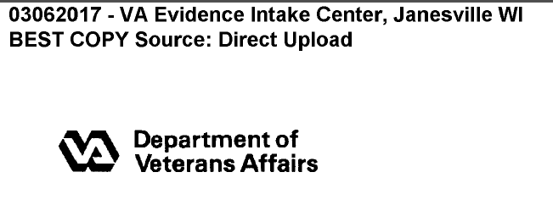

Figure 2: Auto- Established claim from CM

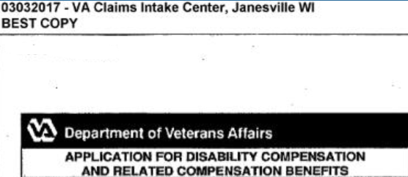
In VBMS, a pending End Product (EP) will appear on records that have successfully been established as a result of an Auto-Established submission.
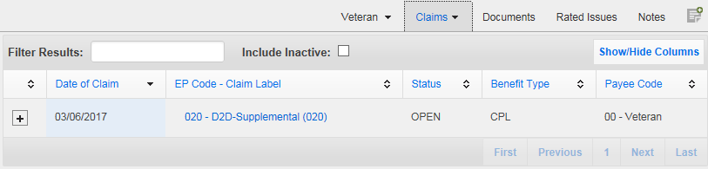
- Will the Auto-Established claim generate another EP or an EP 400 if there is a subsequent claim submitted?
Answer: If an EP is already in place for a claimant, an EP 400 will be created to capture any additional claim documents received for that claimant.
- I have been assigned a claim to work by National Work Queue (NWQ) where the EP exists, but the Auto-Establishment process did not make all the updates in VBA electronic systems.

Answer: Take the necessary actions to properly update VBA electronic systems. Refer to M21-1, Part III.i.1.4e, “Actions to Take When the IPC Fails to Properly Update VBA Electronic Systems.”

- How will I know when a claim is Auto-Established?

Answer: An Auto-Established claim appears with these claim labels:
- 110 - D2D-Initial Live Comp <8 Issues (110); or
- 010 -D2D-Initiatial Live Comp >8 Issues (110) ; or
- 020 -D2D-Supplemental ; or
- 400- D2D-Supplemental.

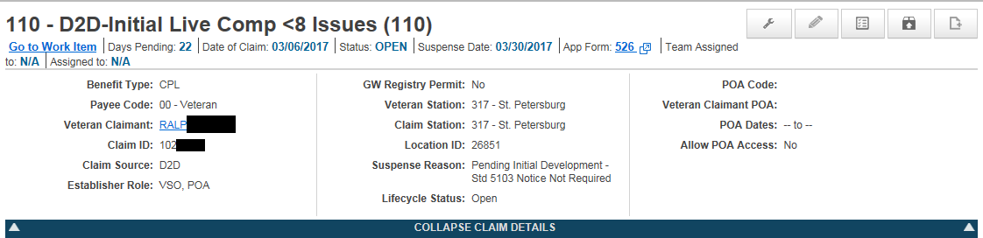
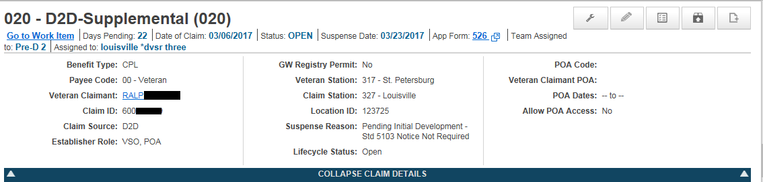

The document in the eFolder will also show ‘SMS’ under the columns: System Source, Uploading User Role:
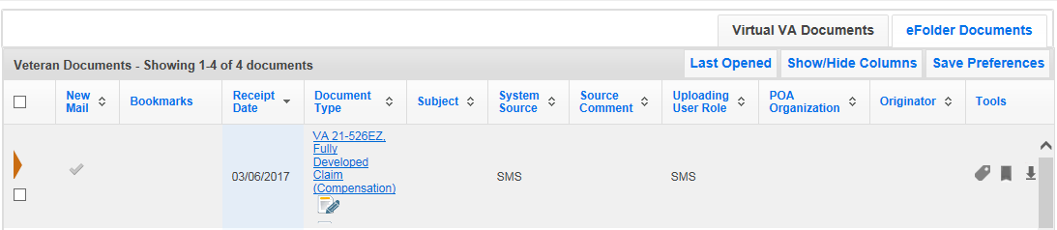

The content source display in the VBMS Document Properties screen will show as below:
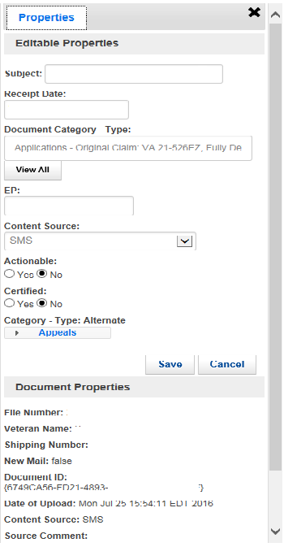
- I am responsible for creating and maintaining our Regional Office’s Auto Distribution rules. Do I need to adjust the rules to accommodate Auto-Established claims?

Answer: No, Auto-Established claims will not need to be routed differently than regular claims.

- I am responsible for maintaining our Regional Office’s Workforce Information Tool (WIT). Do I need to adjust the WIT to accommodate Auto-Established claims?

Answer: No, although Auto-Established claims may have some different procedures to develop a claim, they will not cause a change in the capacity model. Your office will continue to receive claims.
- I am consistently seeing the same error with Auto-Establish claims. For example, the wrong flash is being applied for homelessness. Is there a defined process for reporting such issues?

Answer: Yes, please route this to your Regional Office leadership and send to your District Director. They will in turn email the OC Mailbox (OC.VBACO@va.gov) with a request to expedite the resolution of the issues. Be sure to include example file numbers and a description of the issue. RO leadership should then use the Centralized Mail ticket process through the VCIP Issue Tracker to report.

- Will additional items not included in Release 1.0 be considered for future releases?

Answer: Yes, suggested future functionality will be prioritized and rolled out.

